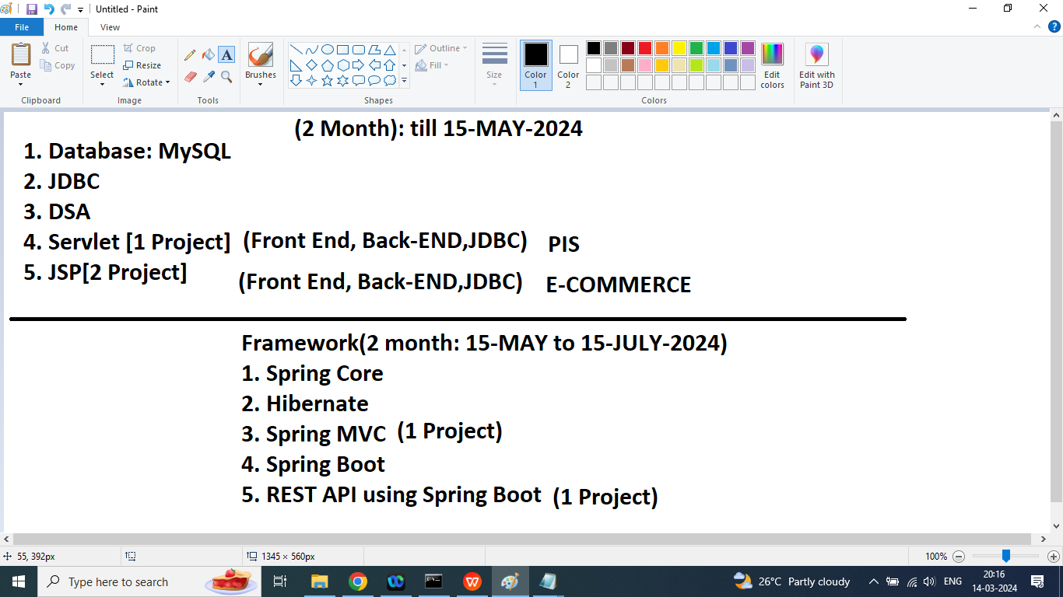

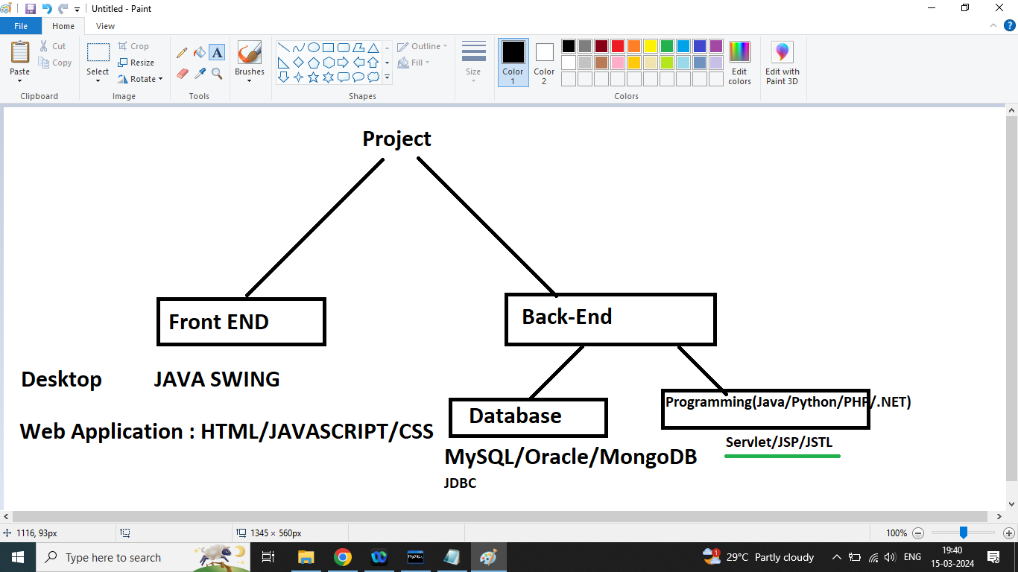

Q1. Explain Database in mySQL?

Ans:

Database(Schema): Database is a collection of tables.

Table(Relation/Entity): Collection of Rows and Columns

Row(Tuple) : Record

Column(Attribute,Field):

Prime Attribute:

Q2. Explain SQL?

Ans: SQL is a language of all Relational Databases.

MySQL

Oracle

SQLite

MSAccess

Sysbase

DB2

SQL Server

1. If we want to perform any task like
2. Database creation
3. Database deletion
4. Table creation
5. Change structure of the table
6. Delete column
7. Insert data into table
8. Update data from the table
9. Delete data

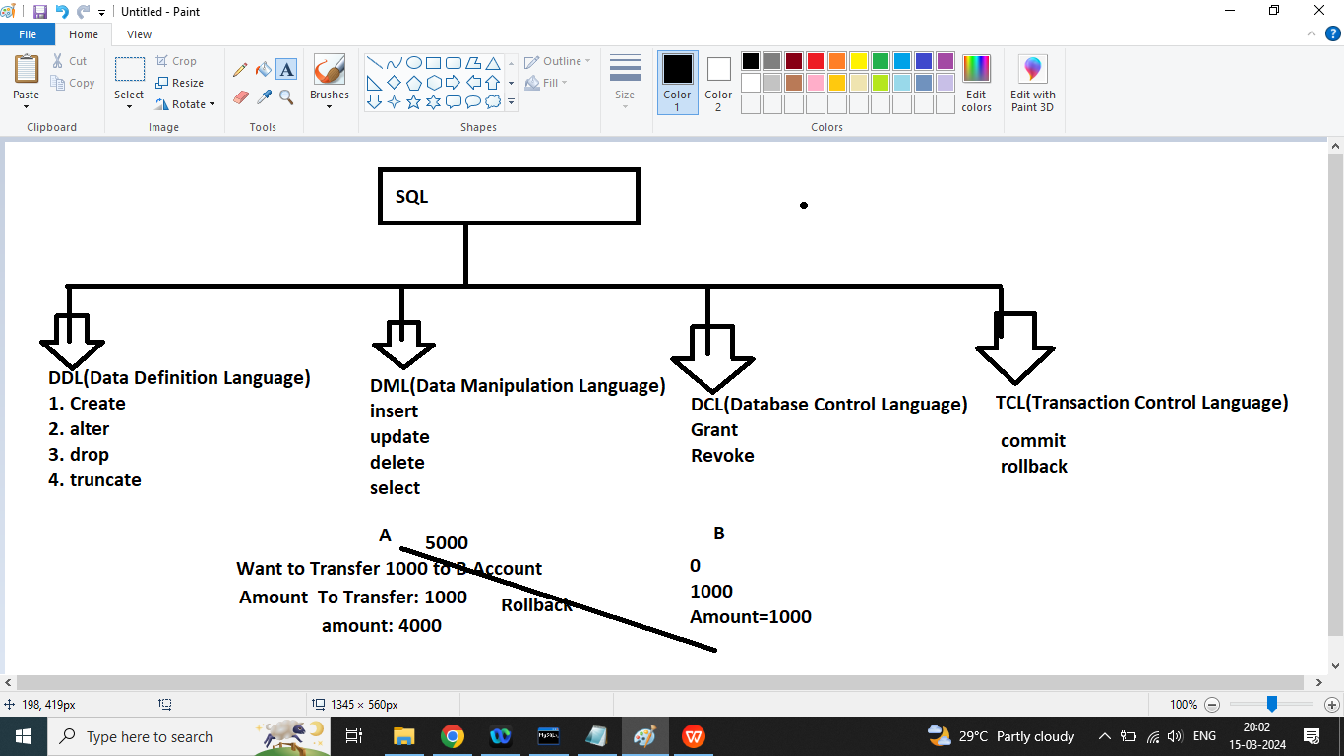

**Q1. How to create database in mysql?**

Ans:

If we want to create a database then we should go for create command (DDL)

Syntax:

Create database dbname;

Example:

Create database march15

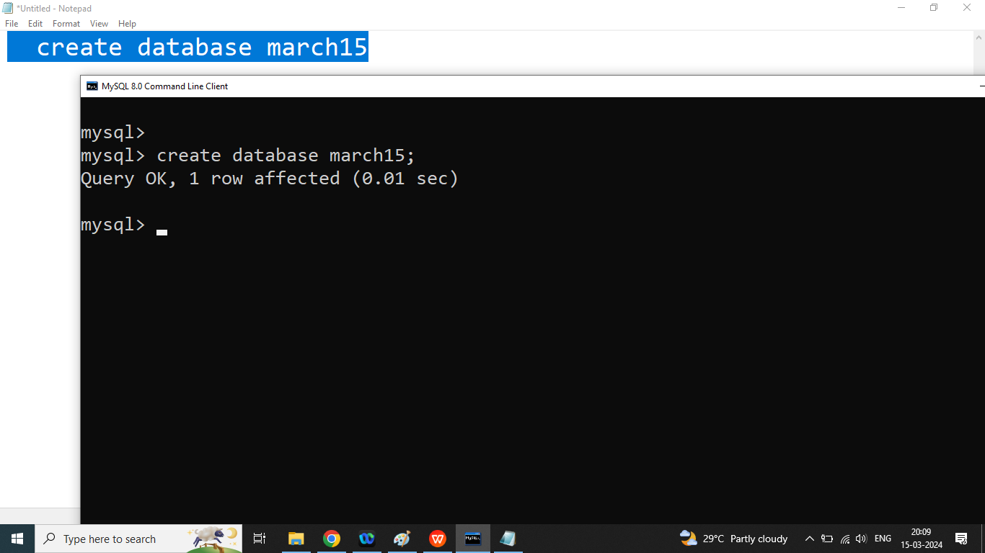

**Q3.How to display list of databases in mysql?**

Ans:

Show databases;

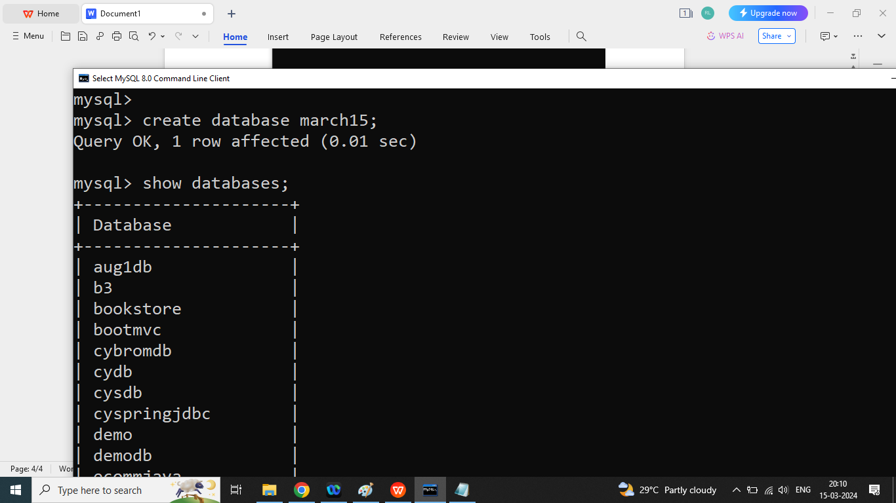

**Q3. How to select particular database in mysql?**

Ans:

Use databasename;

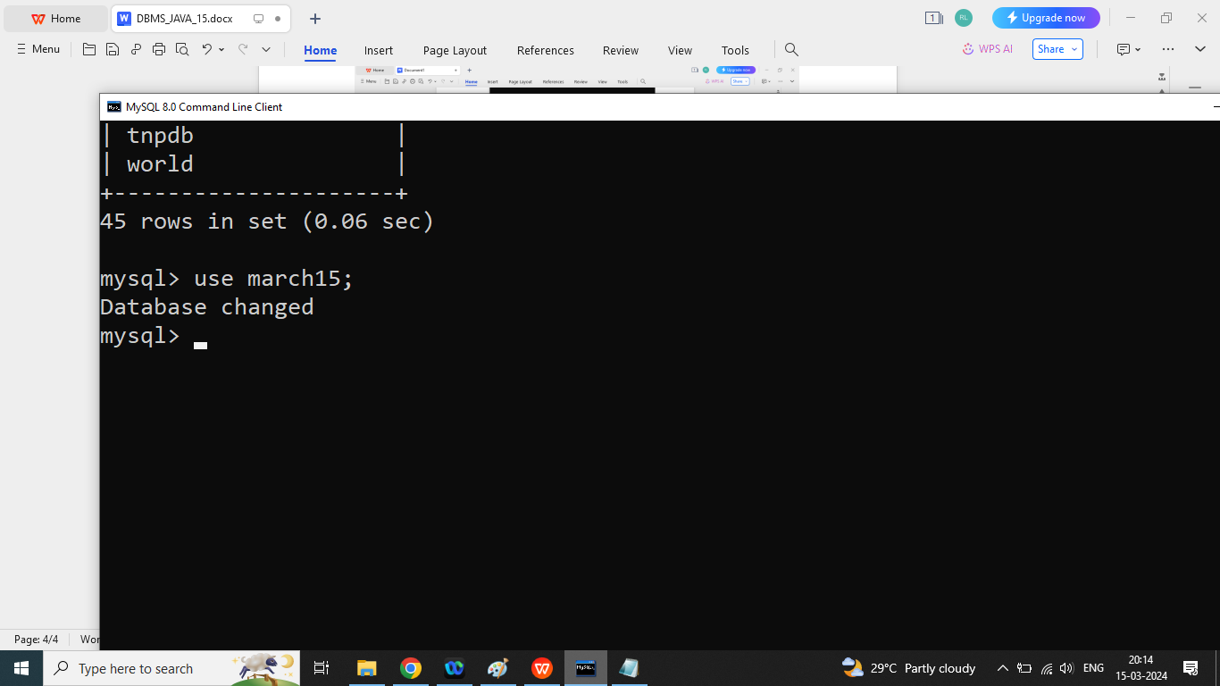

**Q4. How to delete database in mysql?**

Ans: if we want to delete database in mysql then we should go for drop command(DDL)

Syntax:

Drop database dbname;

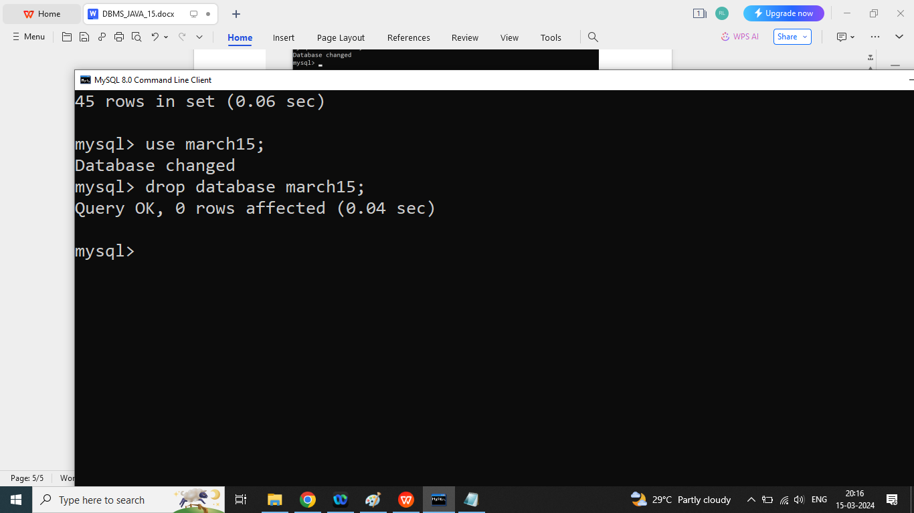

**Q4.How to create table in mysql Database?**

Ans:

Syntax:

If we want to create table then we should go for create command(DDL)

|  |
| --- |
| Create table tablename(  Column name data type constraint auto_increment,  Column name data type,  Column name data type,  Column name data type  ); |

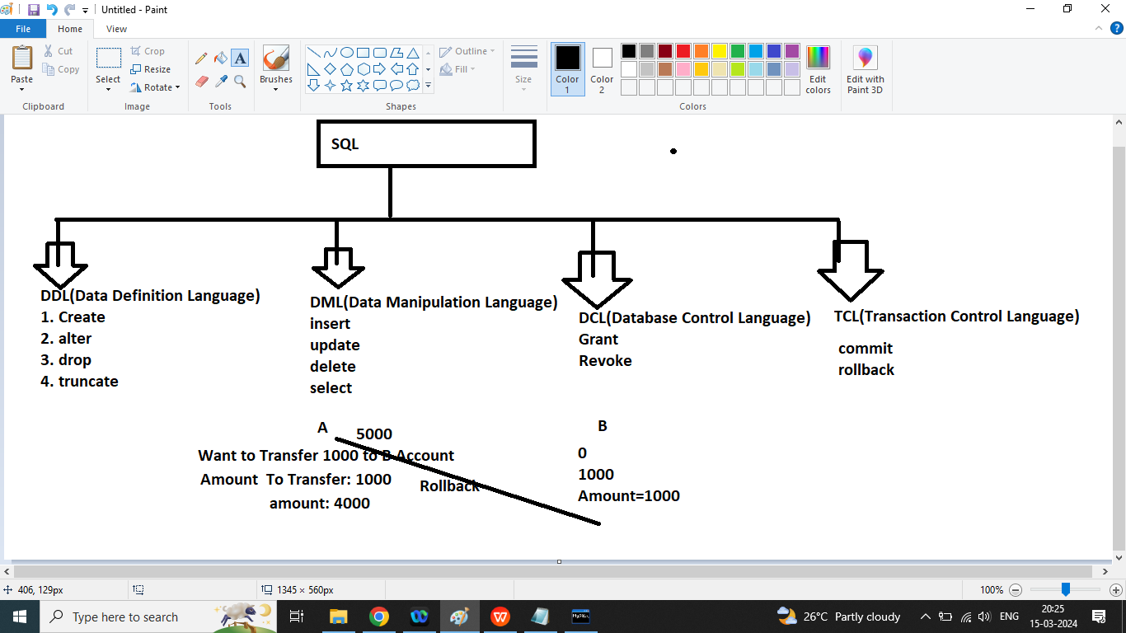

**Q1.Write a SQL Query to create a following table.**

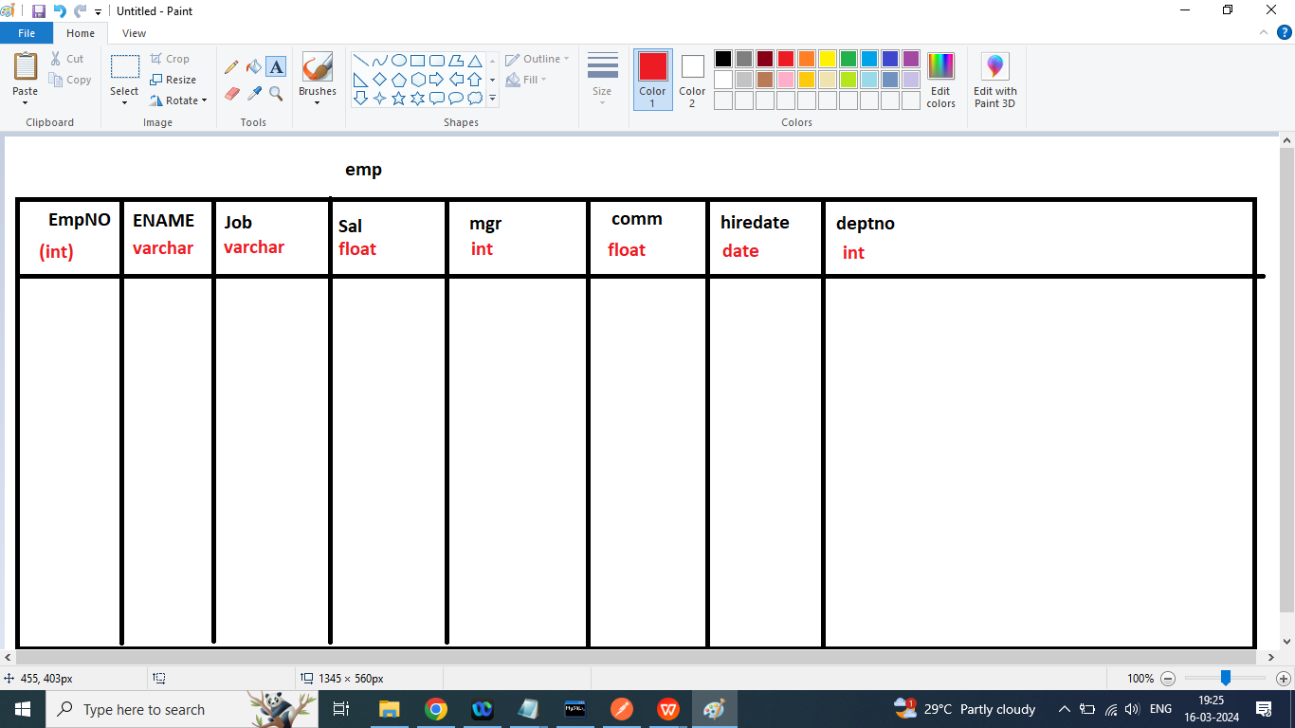

|  |
| --- |
| create table emp(  empno int primary key auto_increment,  ename varchar(45),  job varchar(45),  mgr int,  hiredate date,  sal float,  comm float,  deptno int  ); |

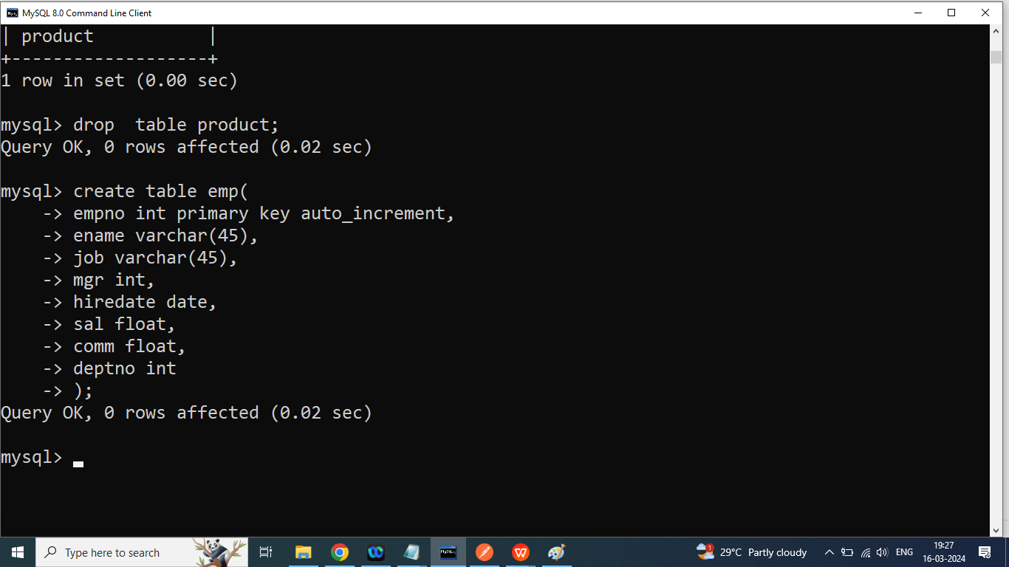

**Q2. Write a SQL Query to print structure of table?**

Syntax:

**Desc tablename;**

OR

Describe tablename;

**Q3.How to add new column in existing table in mysql?**

Ans:

If we want to add new column in existing table then we should go for alter commandd(DDL)

Syntax:

**Alter table tablname add column column name data type;**

Example:

Alter table emp add column country varchar(45)

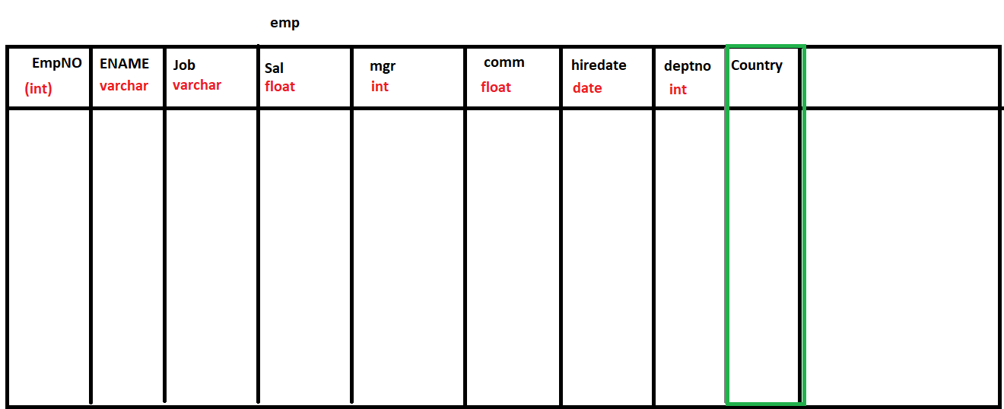

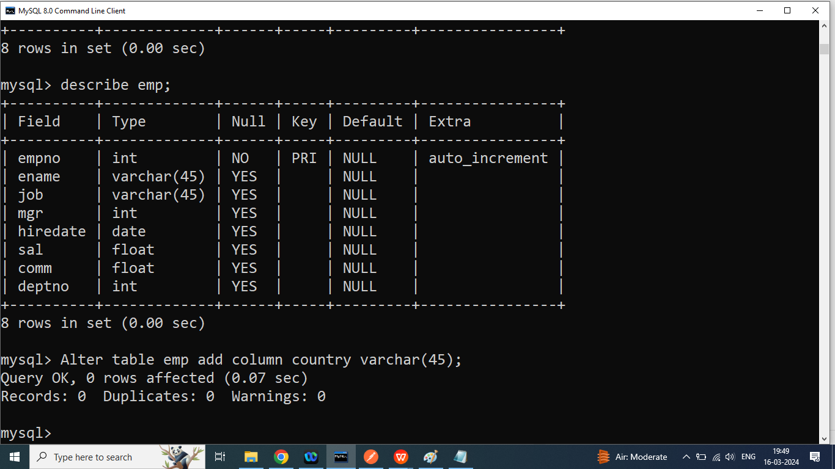

**Q4. How to change data type of a particular column from the existing table.**

Ans:

Syntax:

**Alter table tablename modify column column name;**

Example:

Alter table emp modify column abc int;

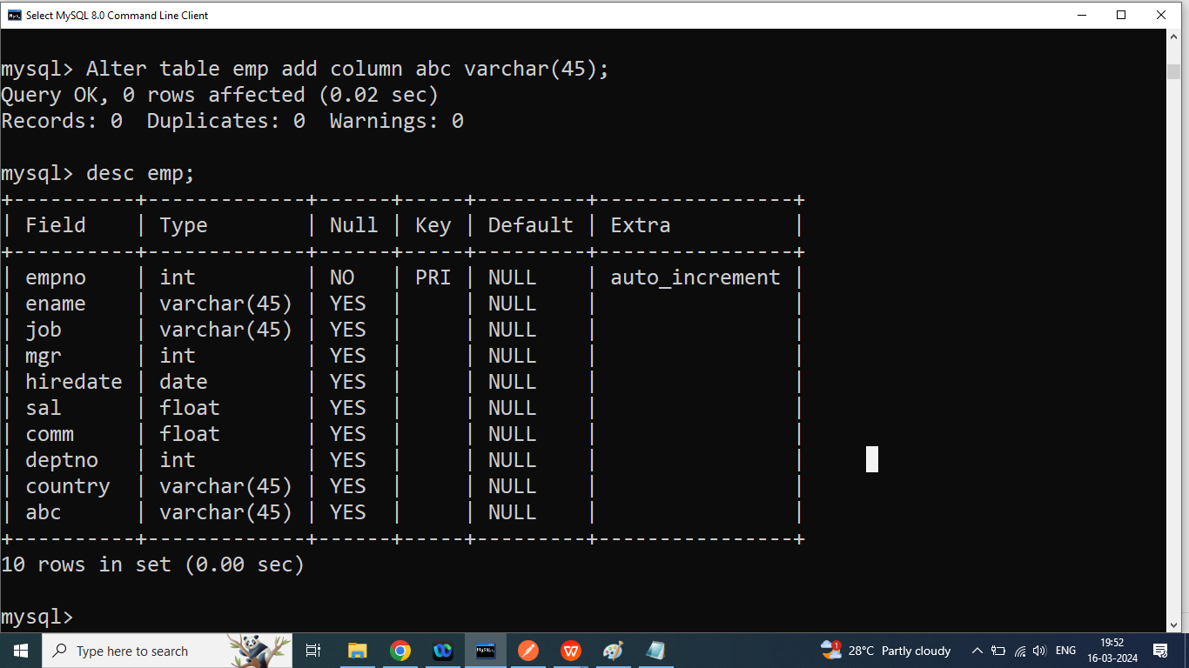

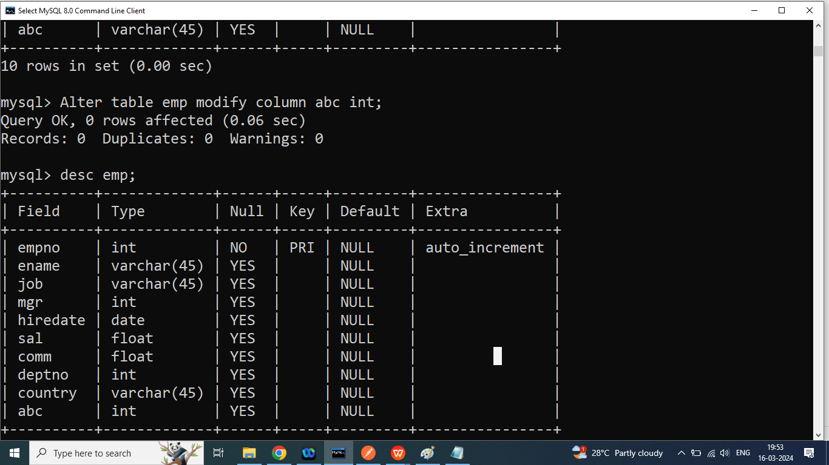

**Q5. How to rename column in mysql?**

Ans:

If we want to rename the column from existing table in mysql then we should go for rename command.

**Syntax:**

**Alter table tablename rename column old column to new column;**

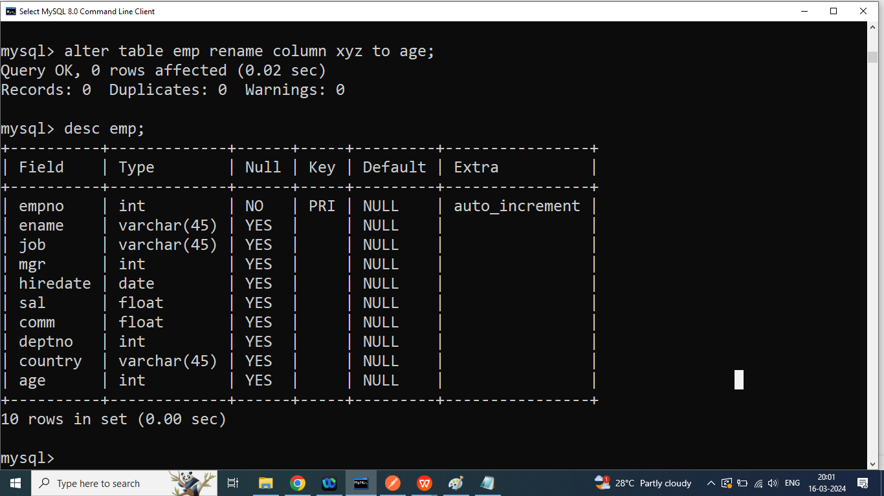

**Q6.How to delete column from the existing table in mysql?**

Ans:

If we want to delete a column from the existing table then we should go for drop command with alter.

Syntax:

Alter table tablename drop column column name;

Example:

Alter table emp drop column age;

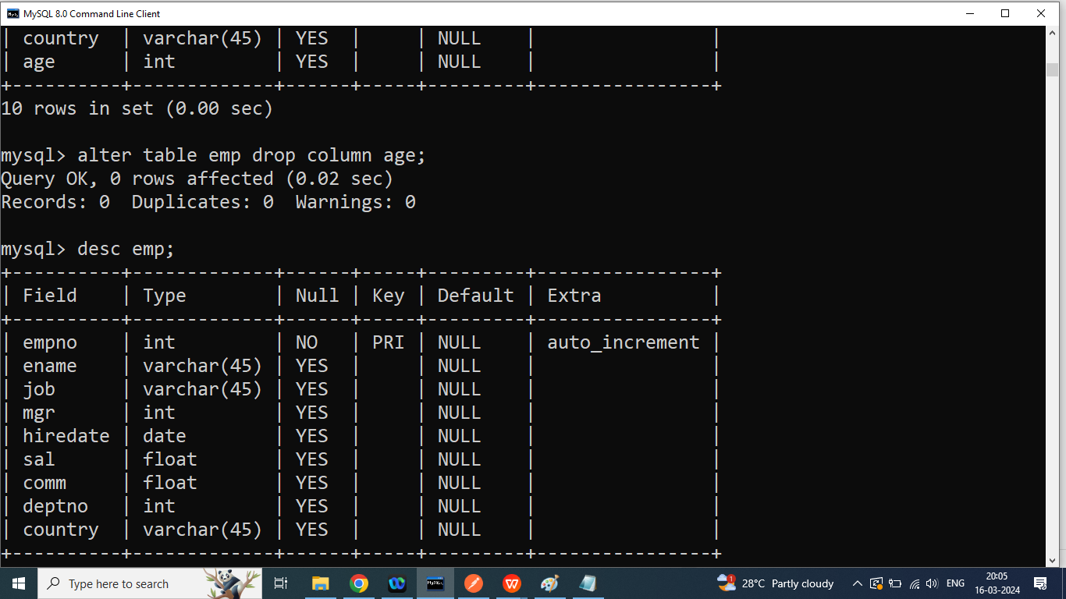

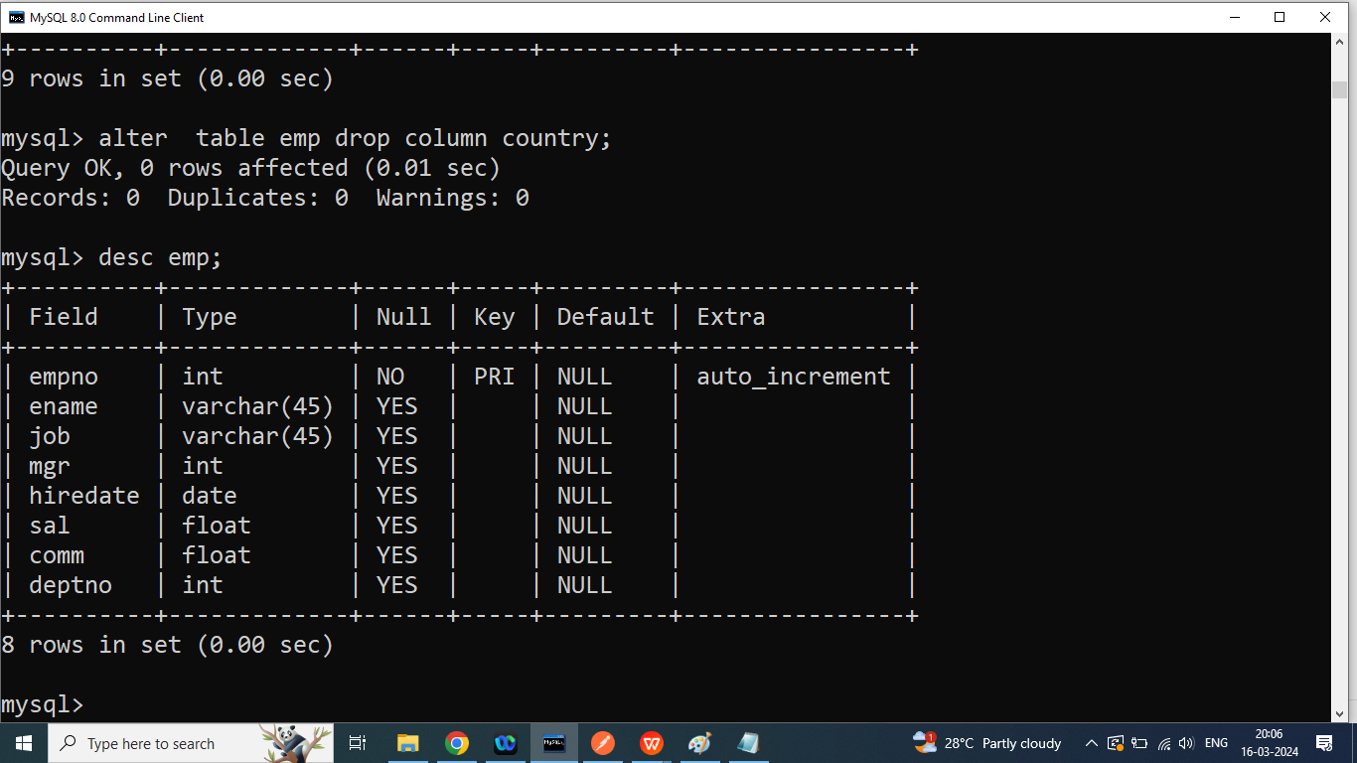

**Q7. How to rename table in mysql?**

Ans:

If we want to rename the table then we should go for rename command(DDL)

Syntax:

**Rename table oldName to newName;**

Rename table employee to emp;

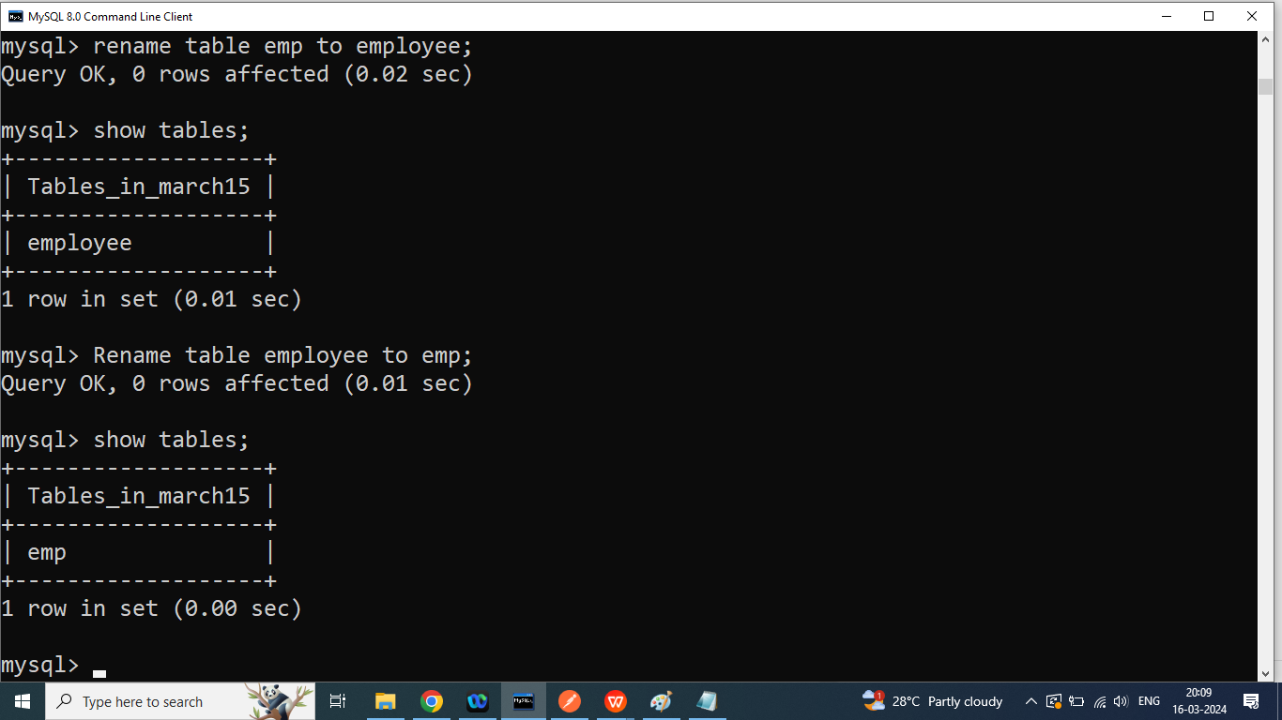

**Q3. How to create a table from another table with data and same column?**

Ans:

Syntax:

**Create table tableName as select * from tablename;**

Create table employee as select * from emp;

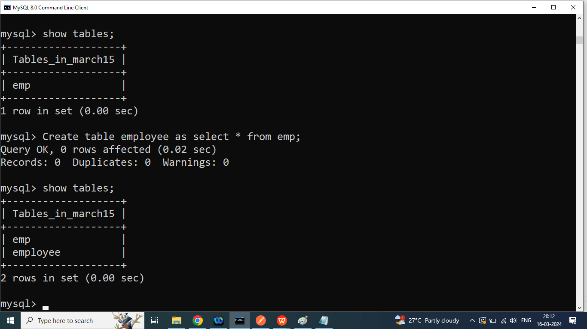

**Q7. How to insert data into the table?**

Ans: If we want to insert data into the table then we should go for insert command(DML).

There are two ways to insert data into the table

1. **Insert data into all columns**

Syntax:

**Insert into tablename values(value1,value2….value8);**

INSERT INTO EMP VALUES(7369,'SMITH','CLERK',7902,'1980-12-17',800,NULL,20);

Date Format:

‘YYYY-MONTH-DATE’

‘2024-03-16’

1. **Insert Data Into Specific Column**

Syntax:

Insert into tablename(column1, column2) values(value1,value);

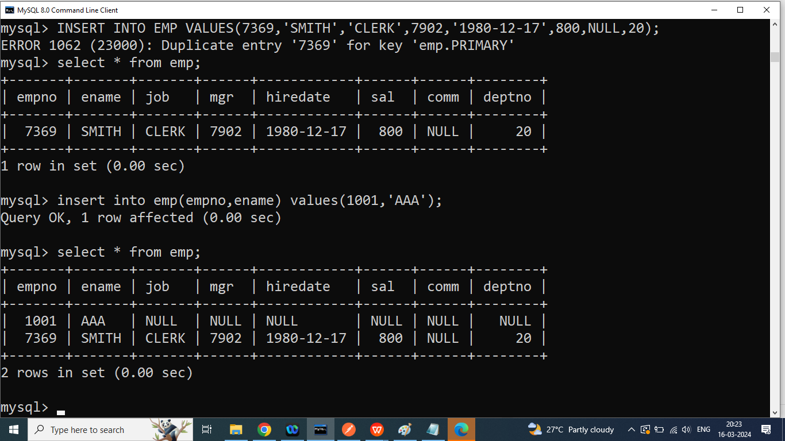

INSERT INTO EMP11 VALUES(7369,'SMITH','CLERK',7902,'**17-DEC-80**',800,NULL,20);  
INSERT INTO EMP VALUES (7499,'ALLEN','SALESMAN',7698,'**20-FEB-81**',1600,300,30);  
INSERT INTO EMP VALUES(7521,'WARD','SALESMAN',7698,'**22-FEB-81**',1250,500,30);  
INSERT INTO EMP VALUES(7566,'JONES','MANAGER',7839,'**2-APR-81**',2975,NULL,20);  
INSERT INTO EMP VALUES(7654,'MARTIN','SALESMAN',7698,'**28-SEP-81**',1250,1400,30);  
INSERT INTO EMP VALUES(7698,'BLAKE','MANAGER',7839,'**1-MAY-81**',2850,NULL,30);  
INSERT INTO EMP VALUES(7782,'CLARK','MANAGER',7839,'**9-JUN-81**',2450,NULL,10);  
INSERT INTO EMP VALUES(7788,'SCOTT','ANALYST',7566,'**09-DEC-82**',3000,NULL,20);  
INSERT INTO EMP VALUES(7839,'KING','PRESIDENT',NULL,'**17-NOV-81**',5000,NULL,10);  
INSERT INTO EMP VALUES(7844,'TURNER','SALESMAN',7698,'**8-SEP-81**',1500,0,30);  
INSERT INTO EMP VALUES(7876,'ADAMS','CLERK',7788,'**12-JAN-83'**,1100,NULL,20);  
INSERT INTO EMP VALUES(7900,'JAMES','CLERK',7698,'**3-DEC-81**',950,NULL,30);  
INSERT INTO EMP VALUES(7902,'FORD','ANALYST',7566,'**3-DEC-81**',3000,NULL,20);  
INSERT INTO EMP VALUES(7934,'MILLER','CLERK',7782,'**23-JAN-82**',1300,NULL,10);

**Q1. How to update data from the table?**

Ans: if we want to update data from the table then we should go for update command(DML)

Syntax:

Update tablename set column name=value, column name=value from tablename where pk=?

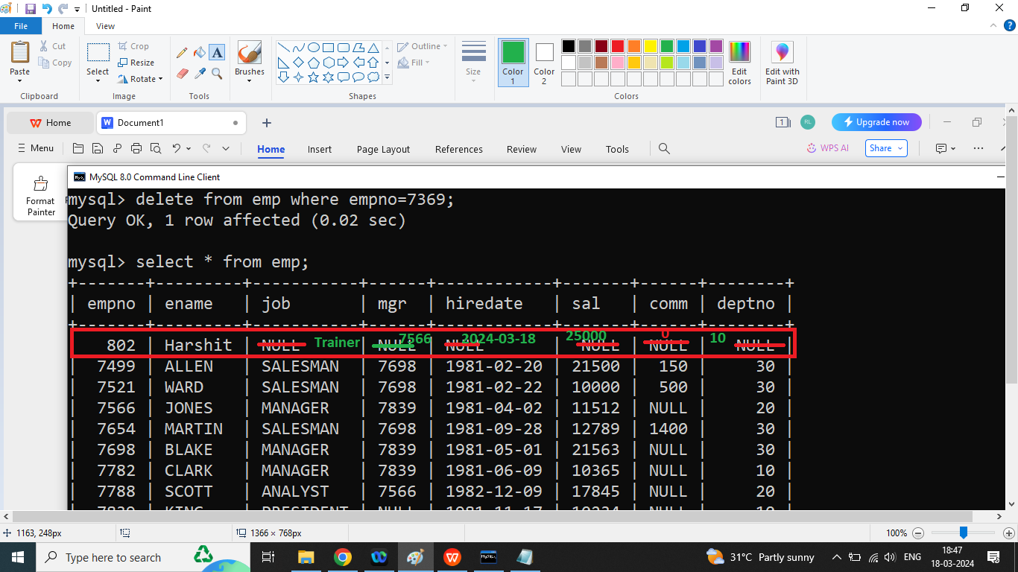

Syntax:

**Update tablename set column name=value, column name=value from tablename where pk=?**

Example

update emp set job='Trainer',sal=25000,comm=0,deptno=10,mgr=7566,hiredate='2024-03-18' where empno=802;

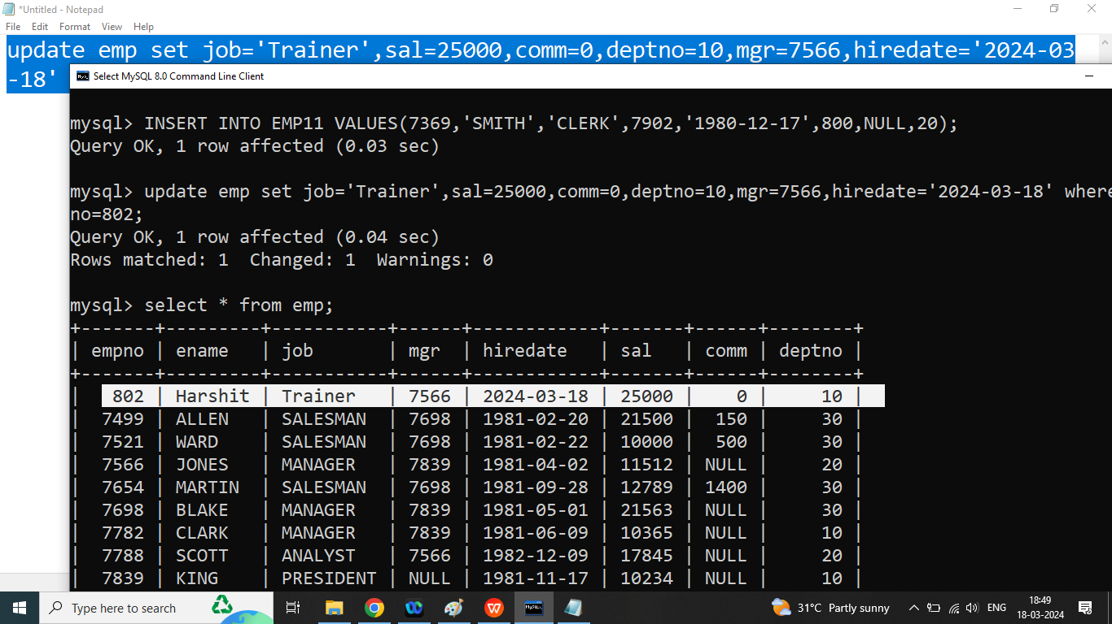

Q3. How to delete data from the table?

Ans: If we want to delete data from the table then we should go for delete command(DML)

Syntax:

**Delete from tablename where pk=?;**

Example:

Delete from emp where empno=802;

Q2. Write a SQL Query to update data of all employee whose empno is 101,102,103,104,105

Q1. How to select data from the database?

Ans: if we want to select data from the database then we should go for select command(DML).

There are two ways to select data from the table

1. Select all columns from the table

Syntax:

Select * from tablename;

Select * from emp;

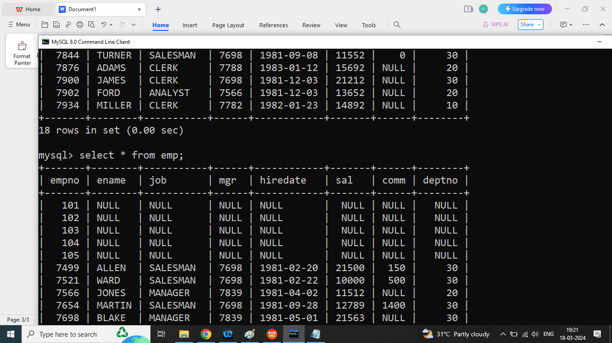

1. Select specific columns from the table

Syntax:

**Select column name,column name from tablename;**

Example:

Select ename,sal,hiredate from emp;

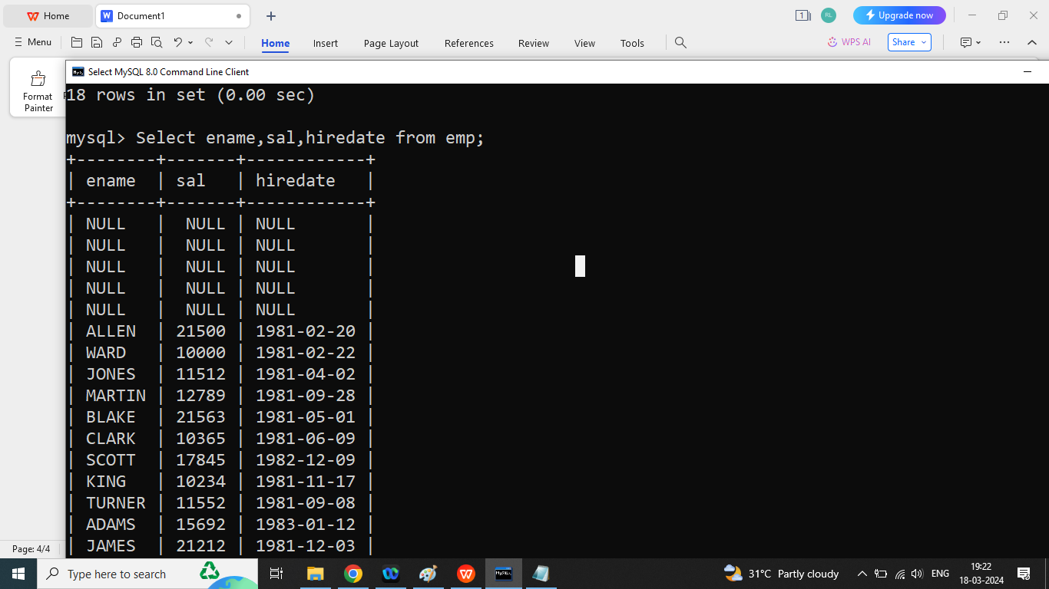

Q2. Write a SQL query to print data of employee whose empno is 7902

Ans: select * from emp where empno=7902;

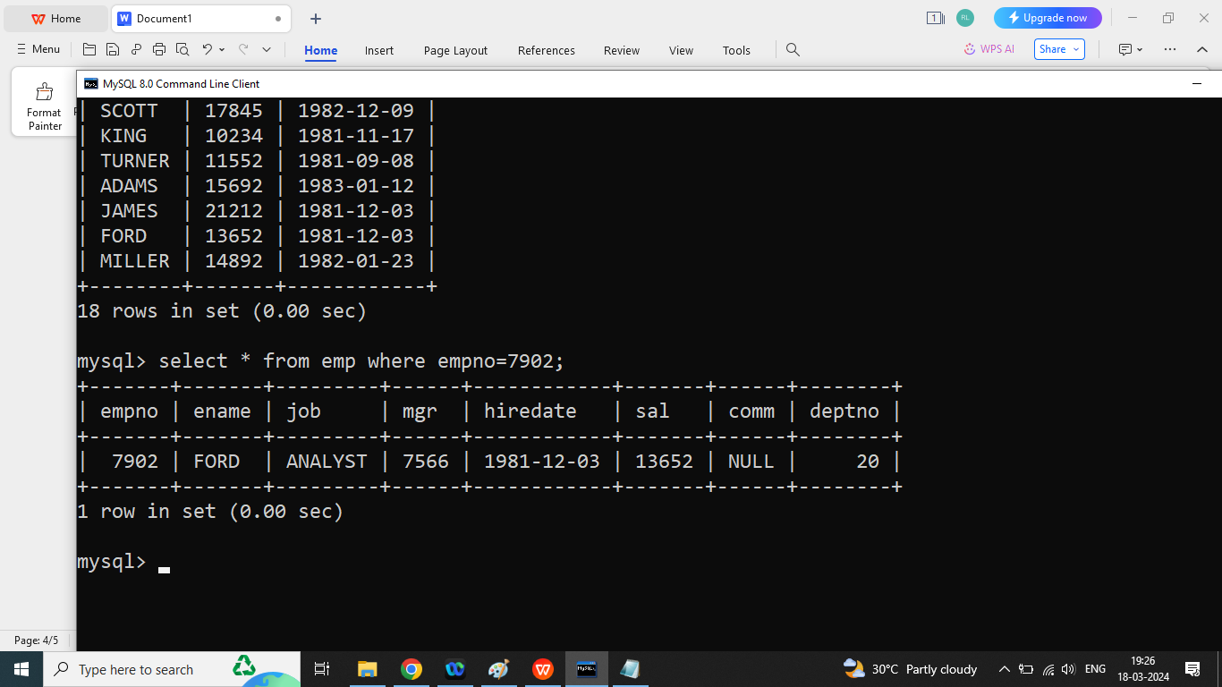

Q1. Write a syntax for Following operations

1. Insert
2. Update
3. Delete
4. Select all
5. Select by id

Q1. Write a java program to print data of all employee whose salary is less than 15000?

Ans:

Select * from emp where sal<15000;

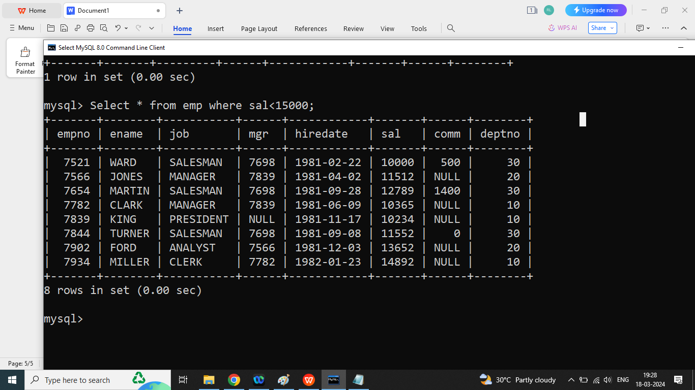

Q2. Write a SQL Query to print data of all employee whose salary is greater than 15000.

Ans:

Select * from emp where sal>15000;

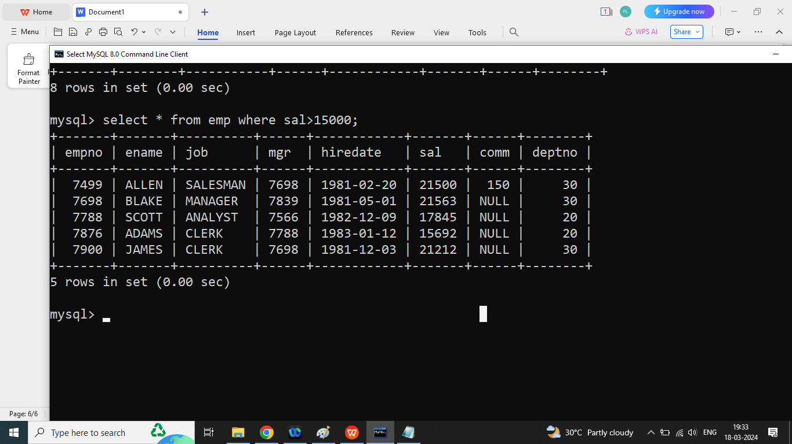

Q3. Write a SQL Query to print annual salary of all employee?

Ans:

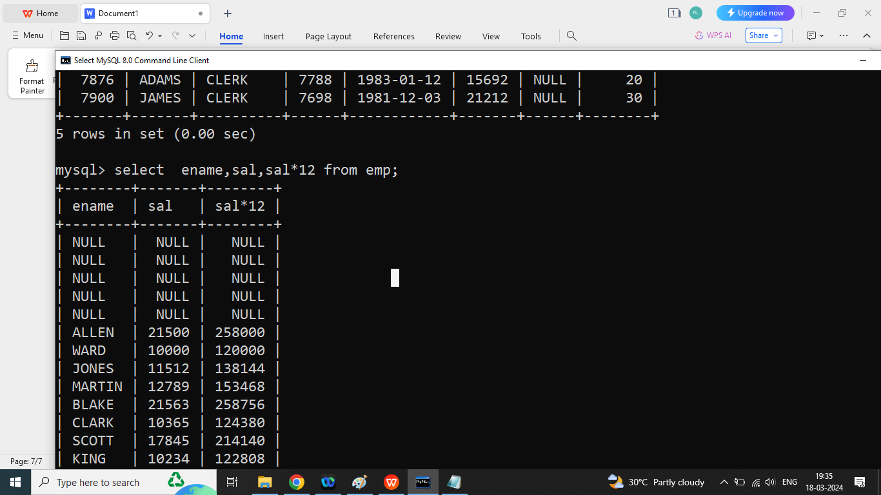

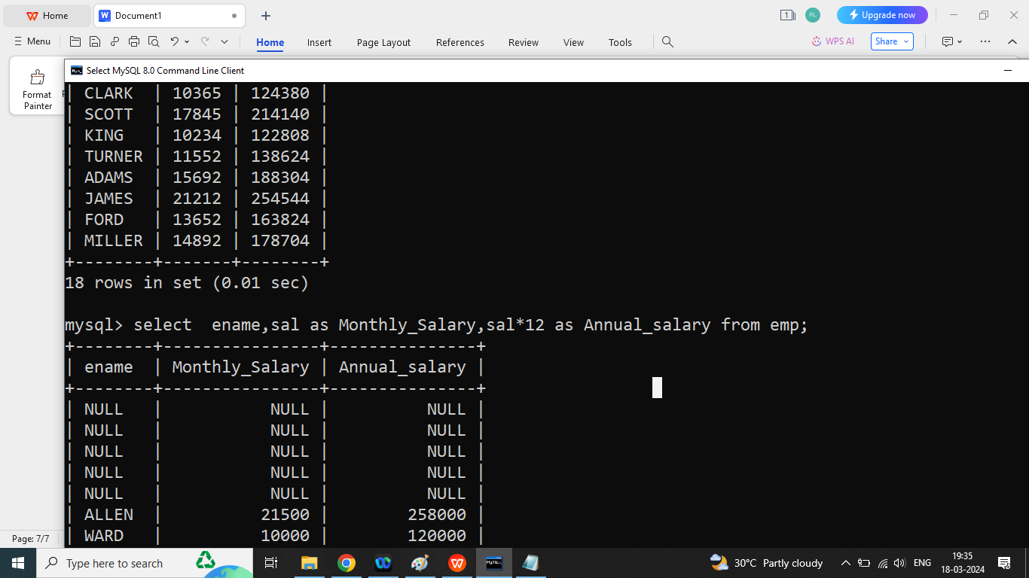

Q2. Write a SQL Query to print data of all employee whose deptno is 10?

Ans:

Select * from emp where deptno=10;

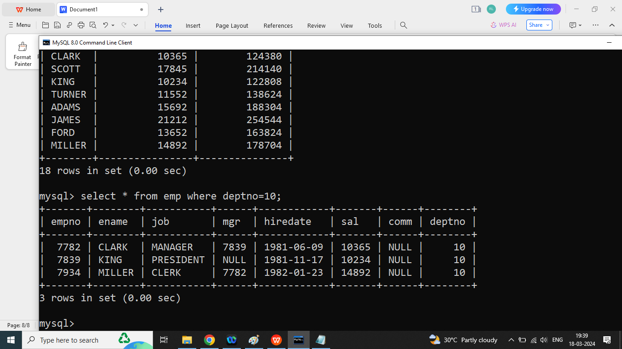

Q2. Write a SQL Query to print data of all employee whose deptno is not 10?

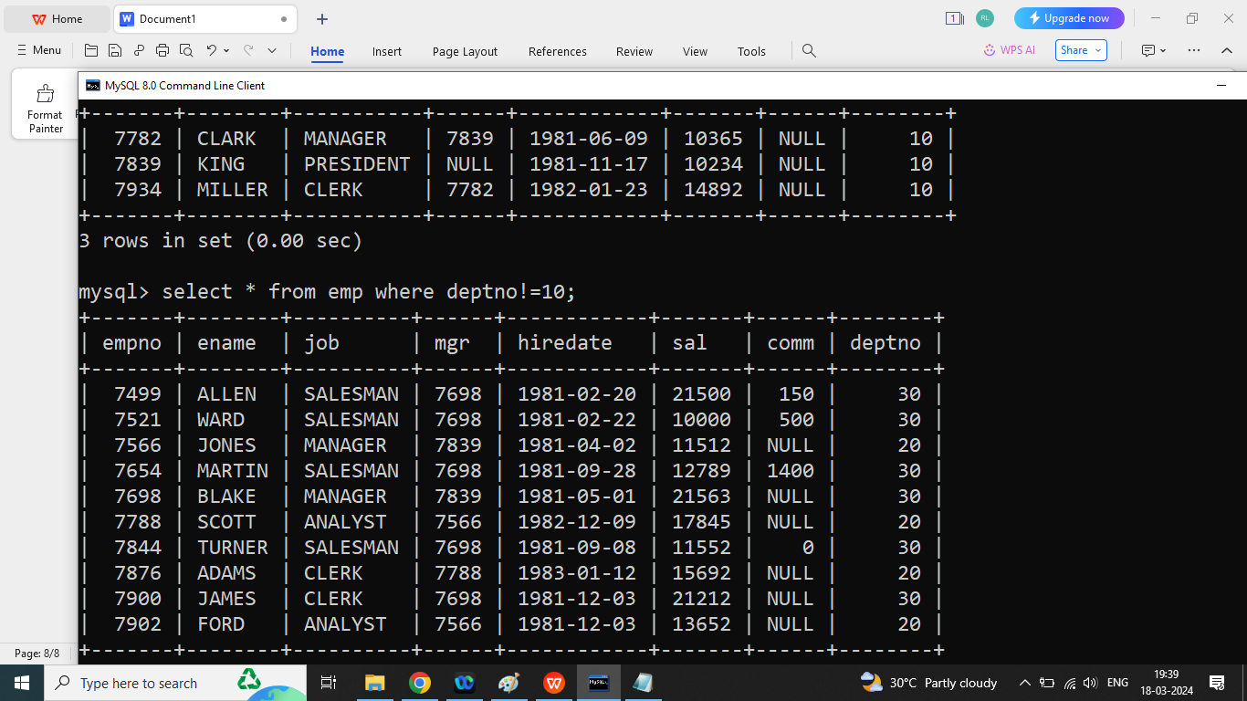

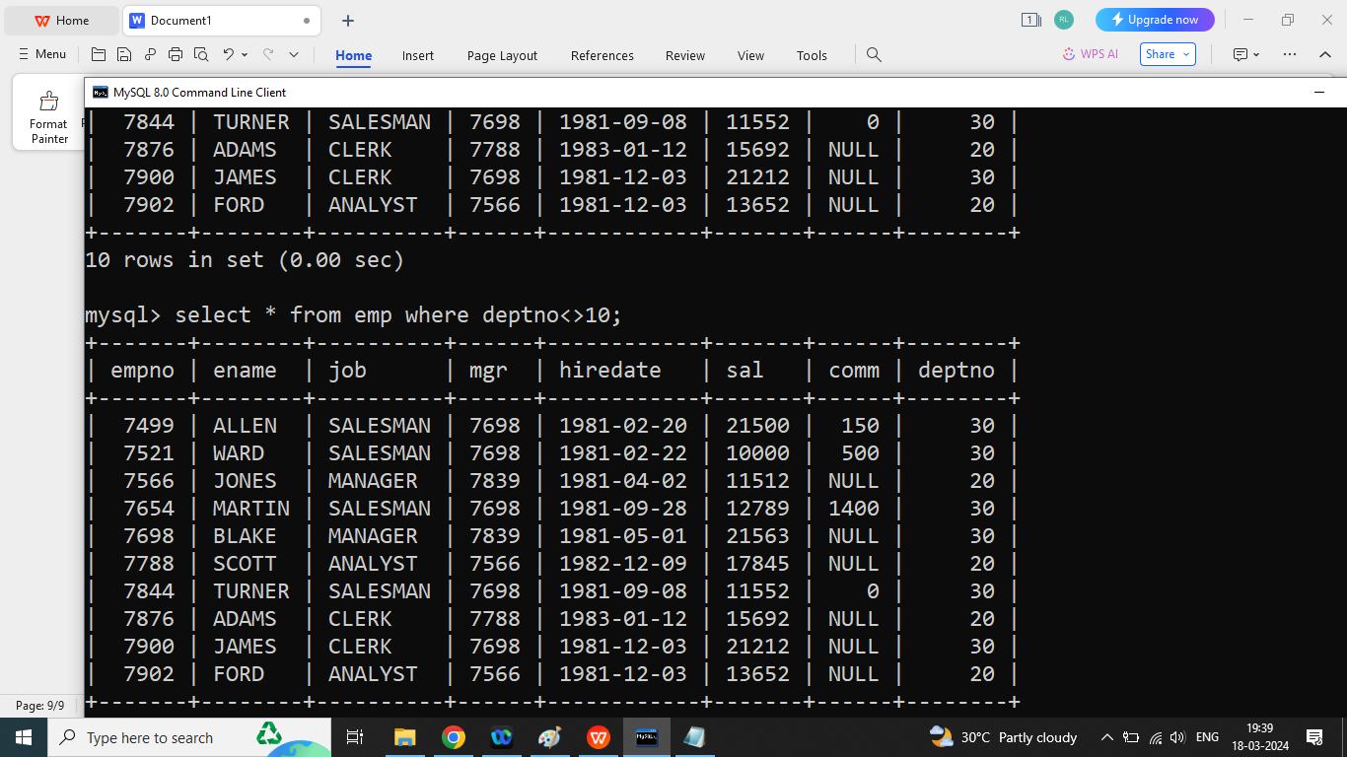

Q2. Write a SQL Query to print data of all employee whose deptno is 20?

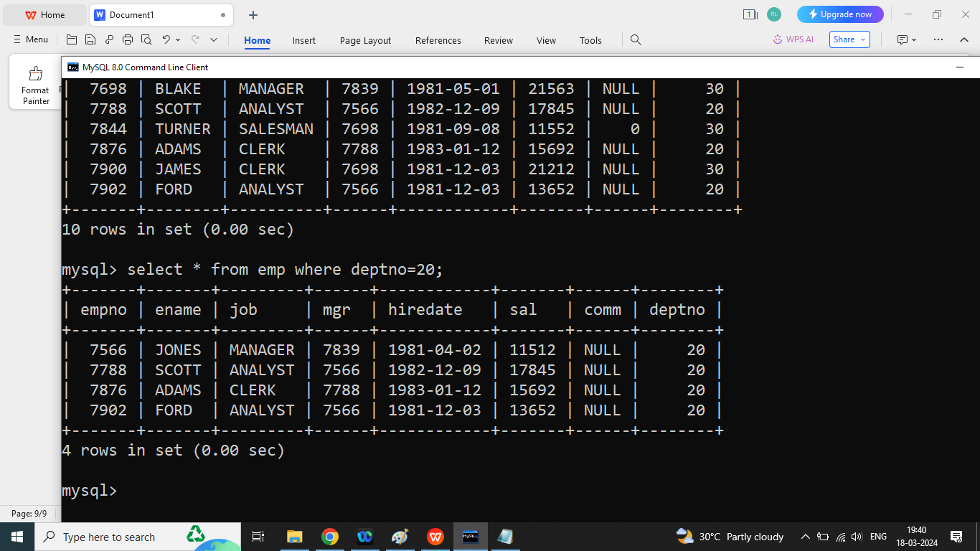

Q2. Write a SQL Query to print data of all employee whose deptno is not 20?

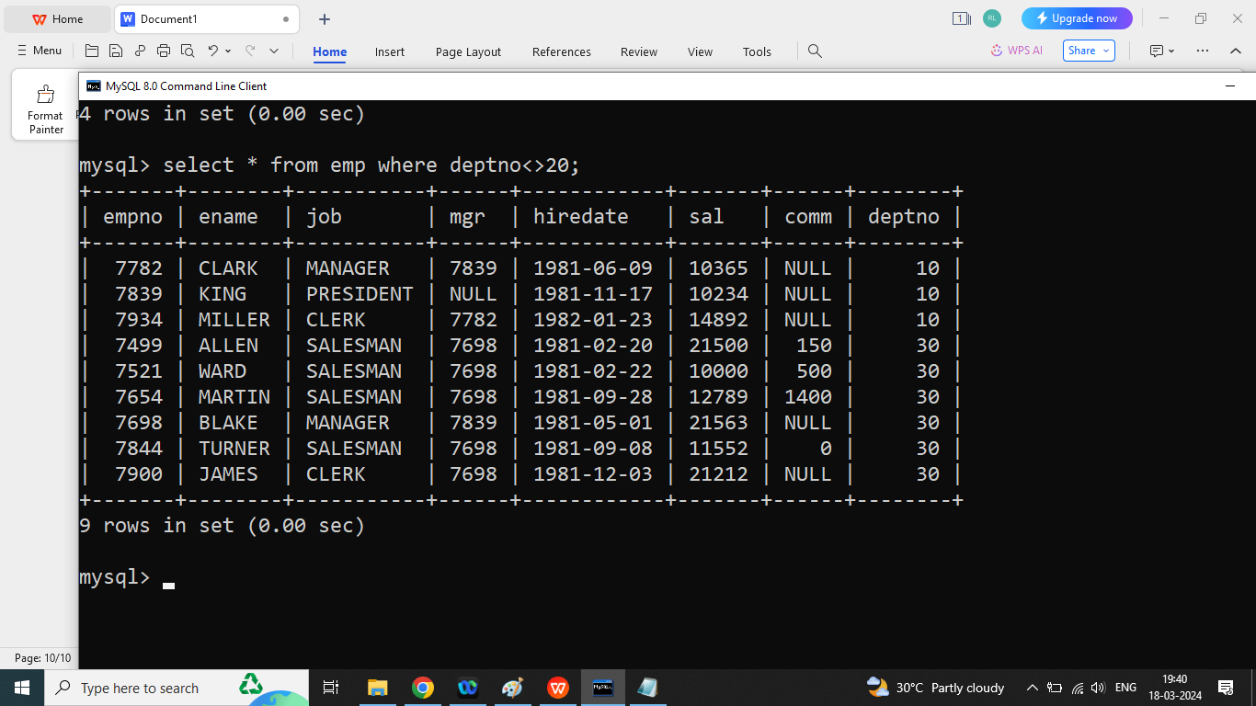

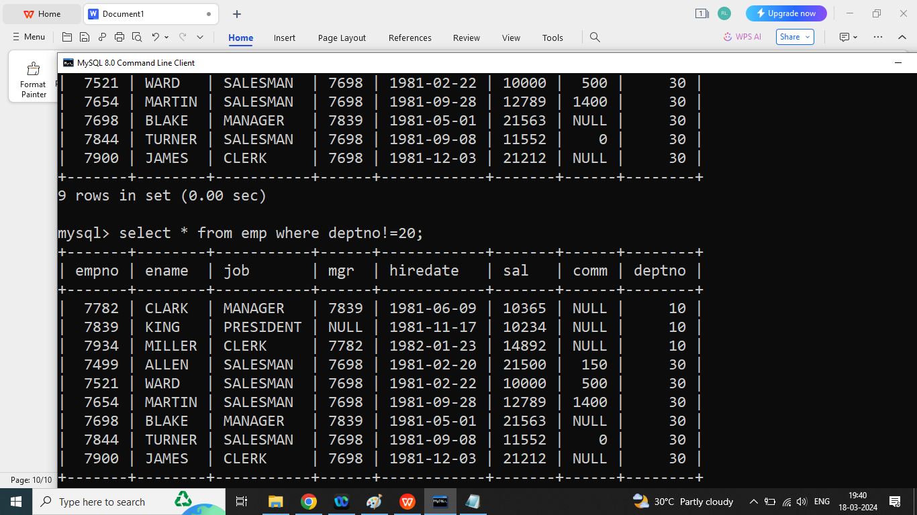

Q2. Write a SQL Query to print data of all employee whose deptno is 30?

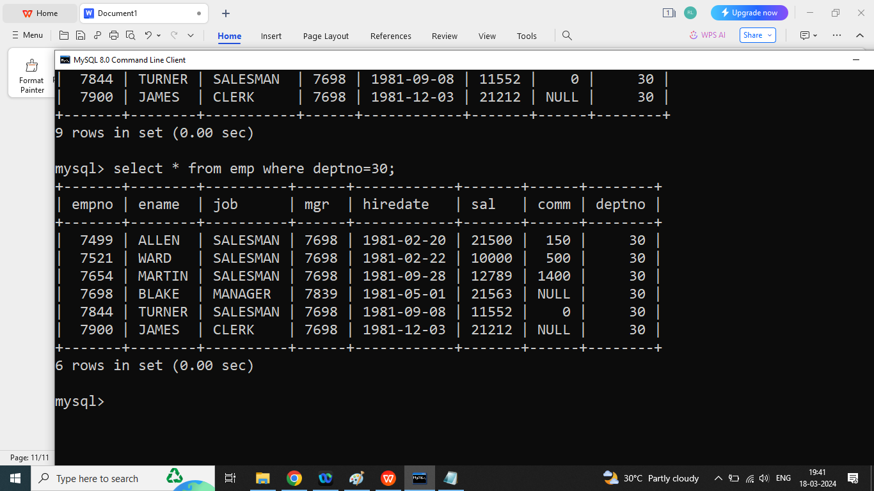

Q2. Write a SQL Query to print data of all employee whose deptno is not 30?

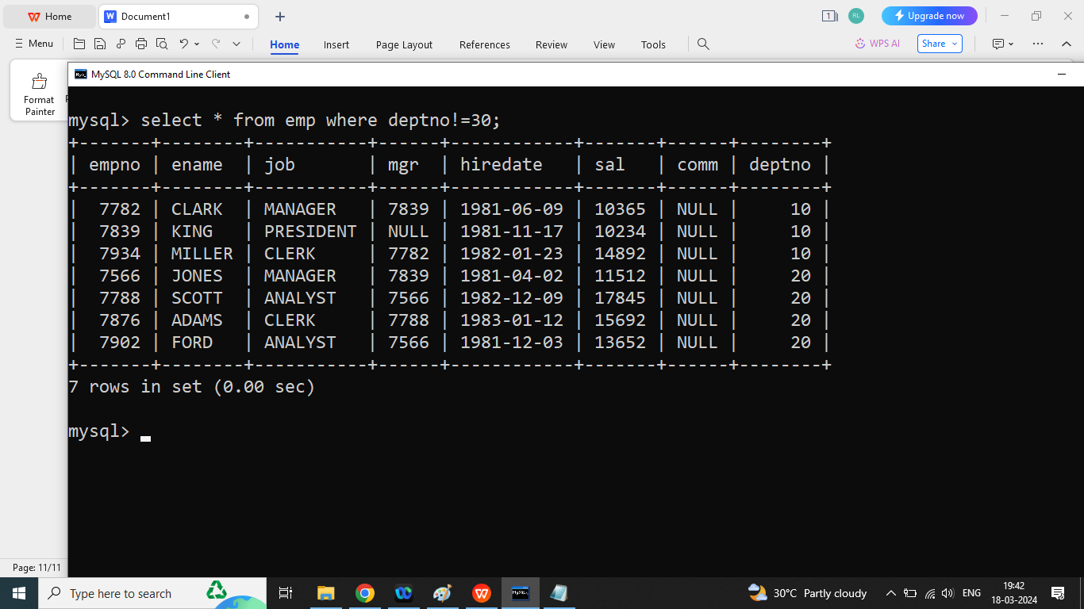

Q1. Write a SQL Query to print data of all employee whose job is ‘Clerk’?

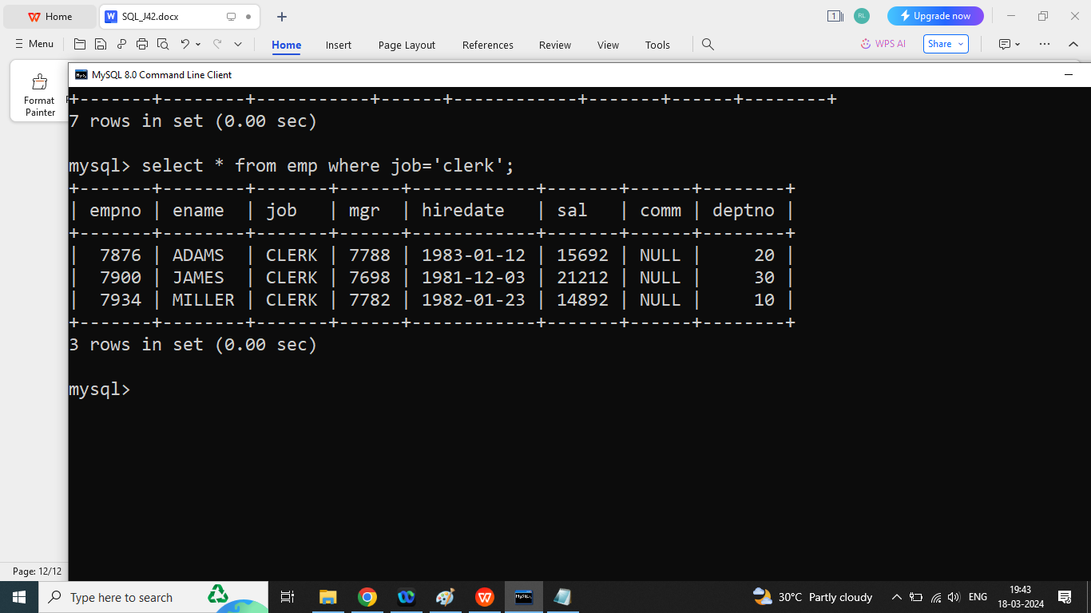

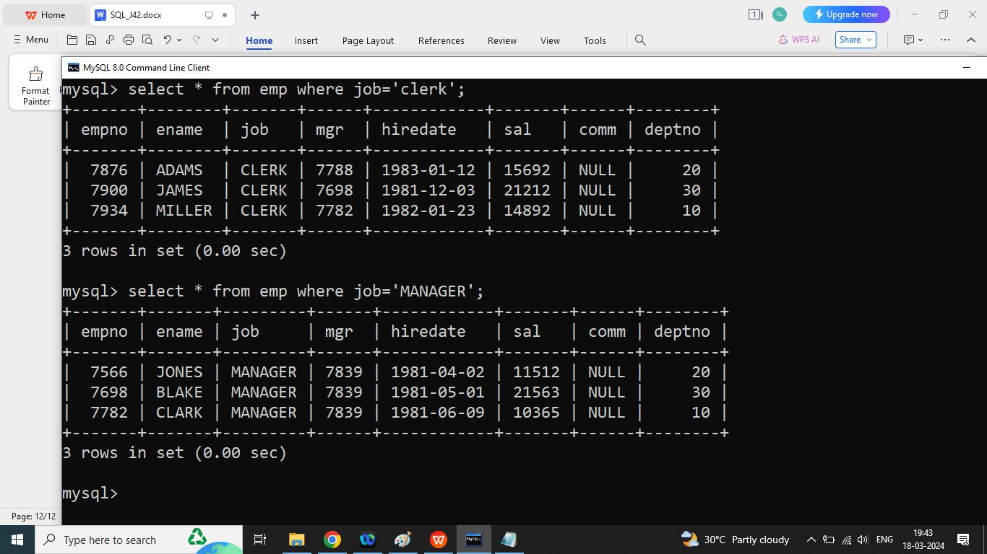

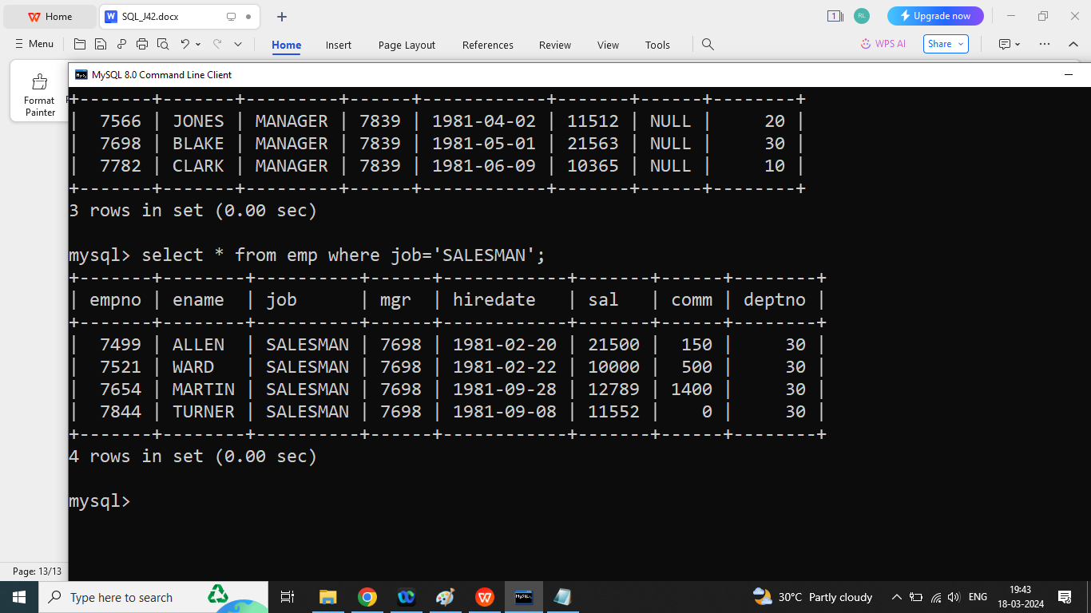

Q2. write a SQL Query to print data of all employee whose job is clerk or whose deptno is 10?

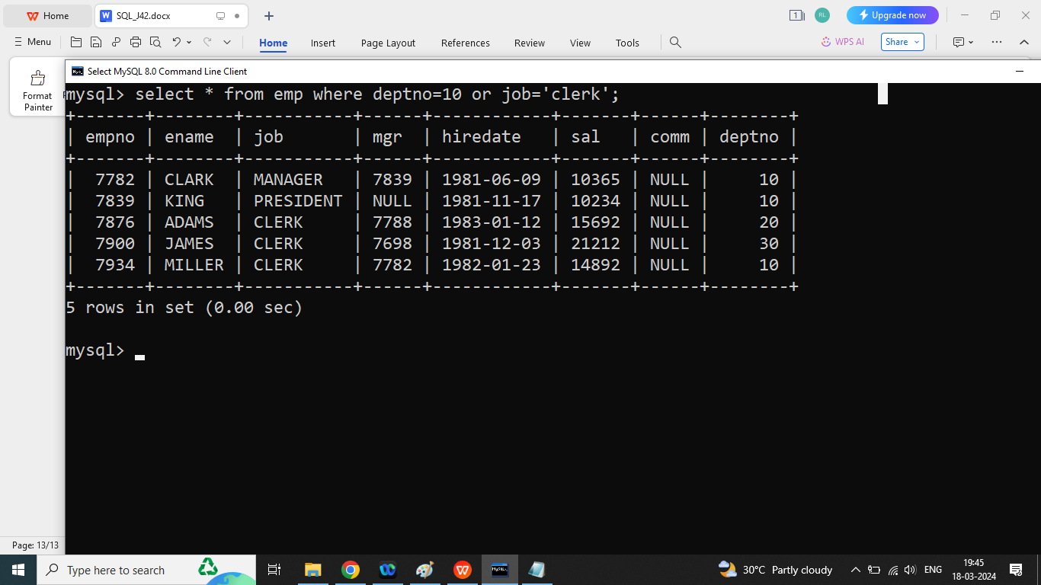

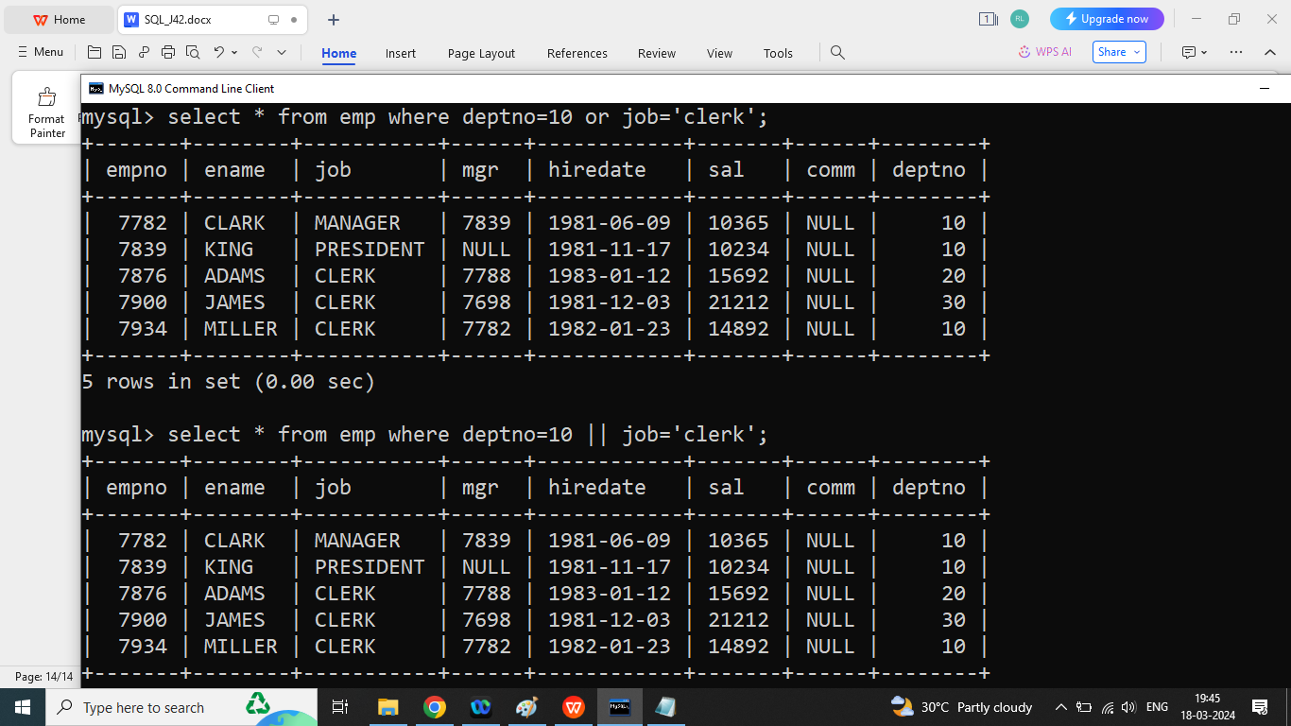

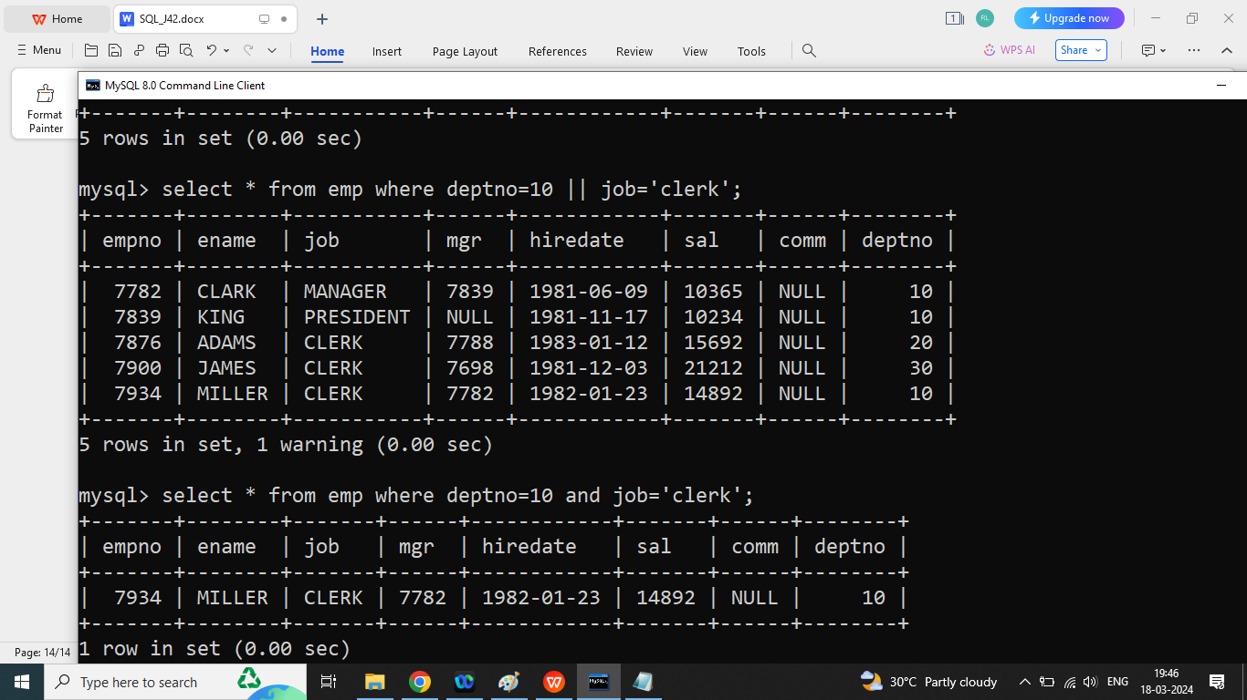

Q2. write a SQL Query to print data of all employee whose job is clerk and whose deptno is 10?

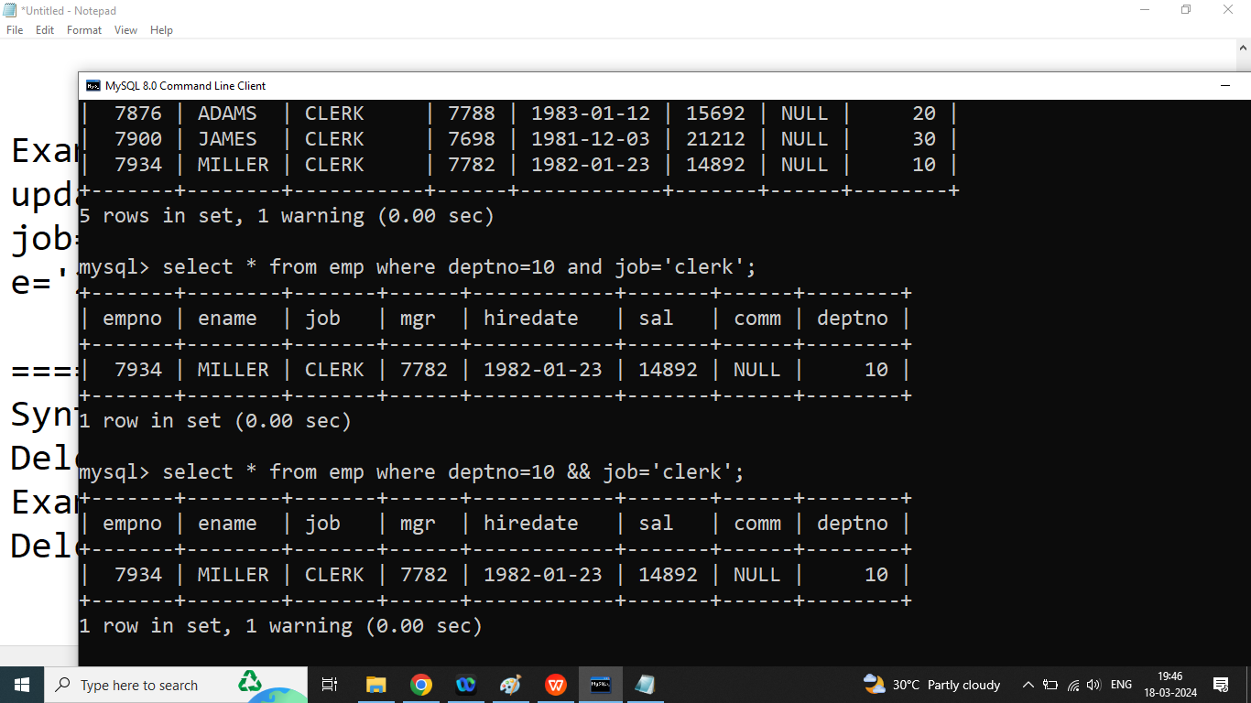

Q2. Write a SQL Query to print data of all employee whose joining is after 1981?

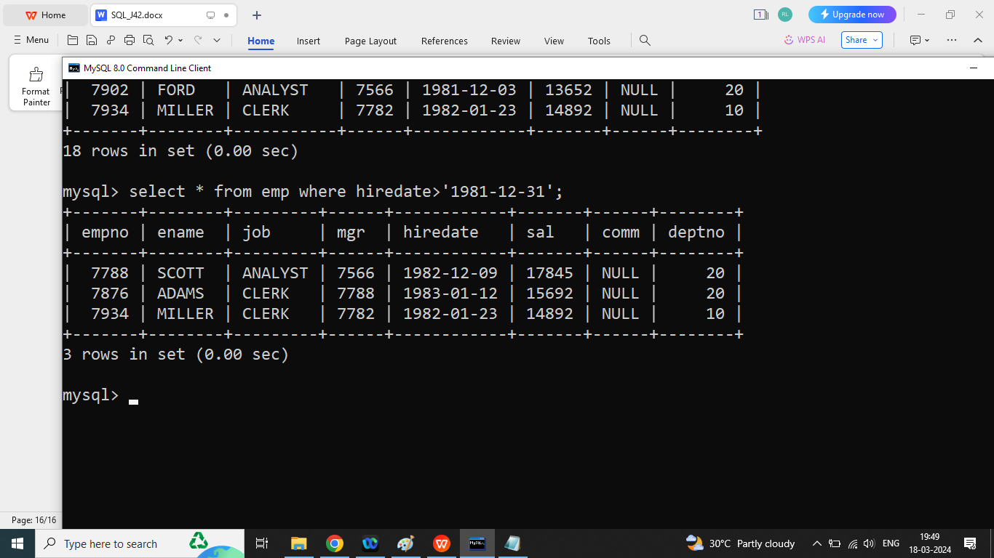

**Q1. Explain aggregate function in SQL?**

Ans: if we want to perform some mathematical operations on particular column then we should go for aggregate function /Group function

We discuss following Aggregate function

1. Sum(): it will return sum of all values from particular column except null

Syntax:

**Select sum(column name) from table name;**

Example:

Select sum(sal) from emp;

1. Avg(): it will return average value of a particular column

Syntax:

**Select avg(column name) from tablename;**

Select avg(sal) from emp;

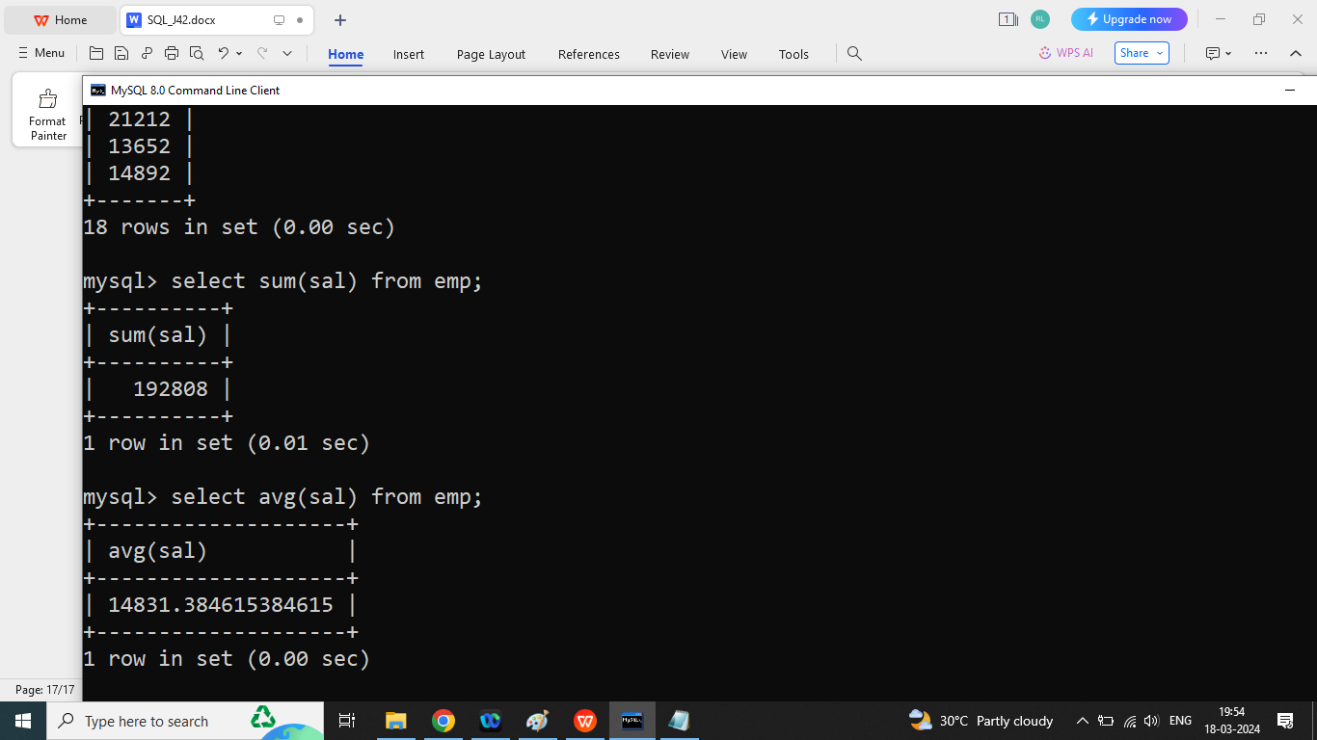

1. Max(): It will return maximum value from the particular column.

Syntax:

**Select max(column name) from tablname;**

Select max(sal) from emp;

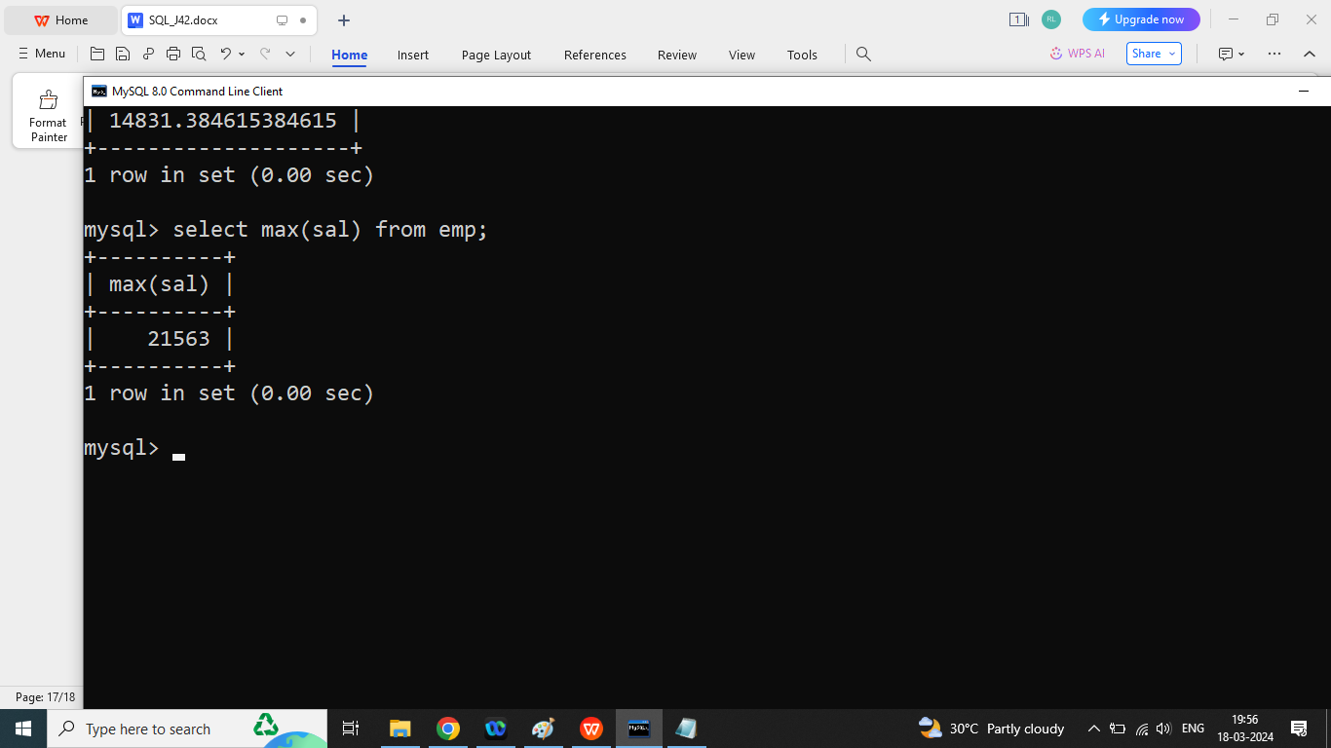

1. Min(): it will return minimum salary of a particular column except null;

Syntax:

**Select min(sal) from emp;**

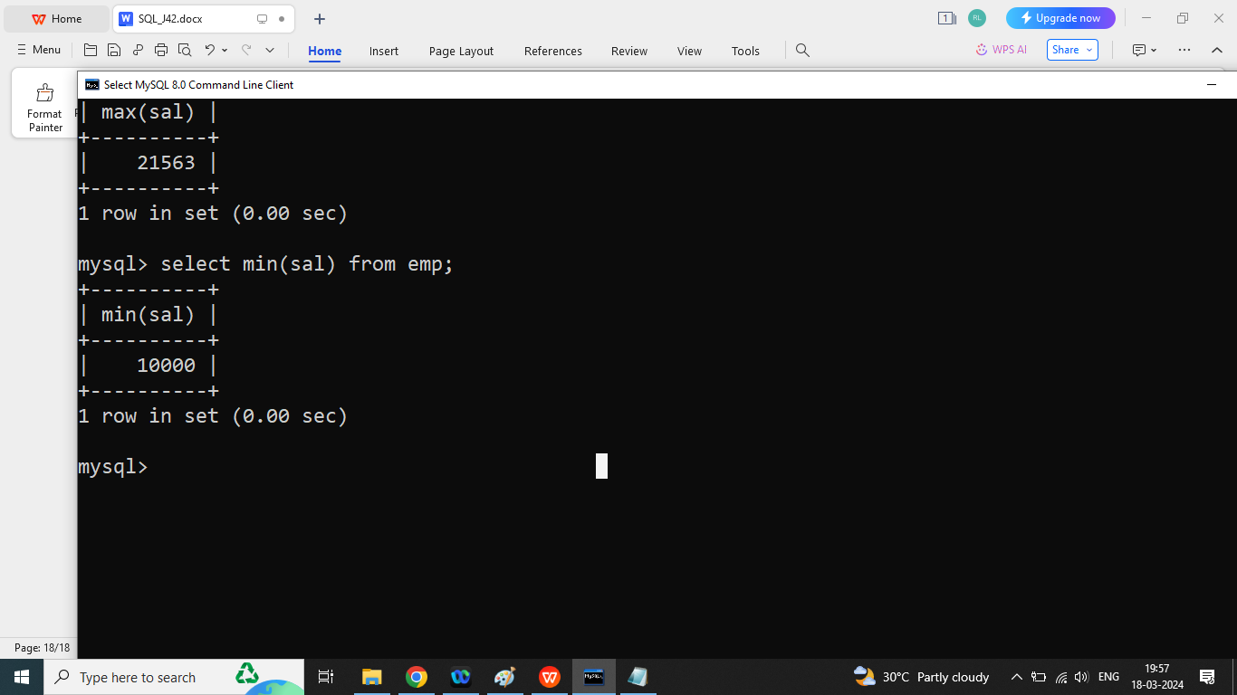

1. Count(): it will return number of values from the particular column except nulll value,

Syntax:

**Select count(*) from tablename;**

OR

Select count(column name) from tablename;

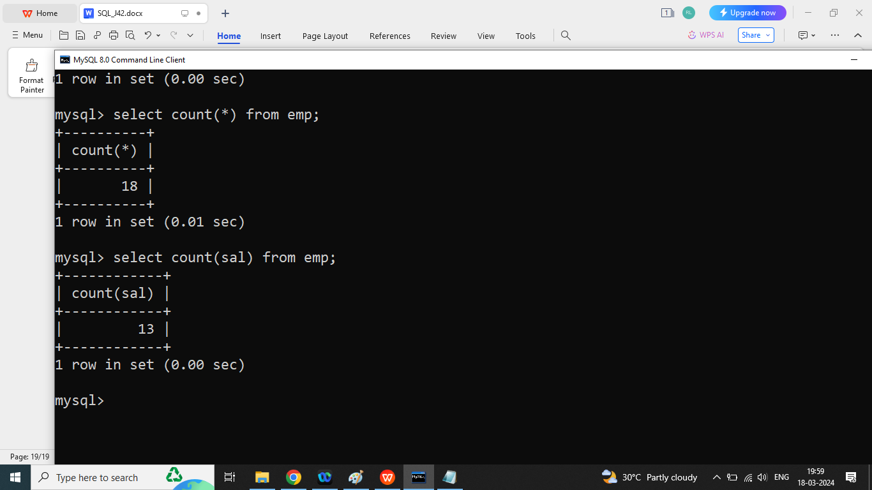

Q1. Write a SQL Query to print total salary of the employee.

Q1. Write a SQL Query to print Total salary of employee in deptno 10?

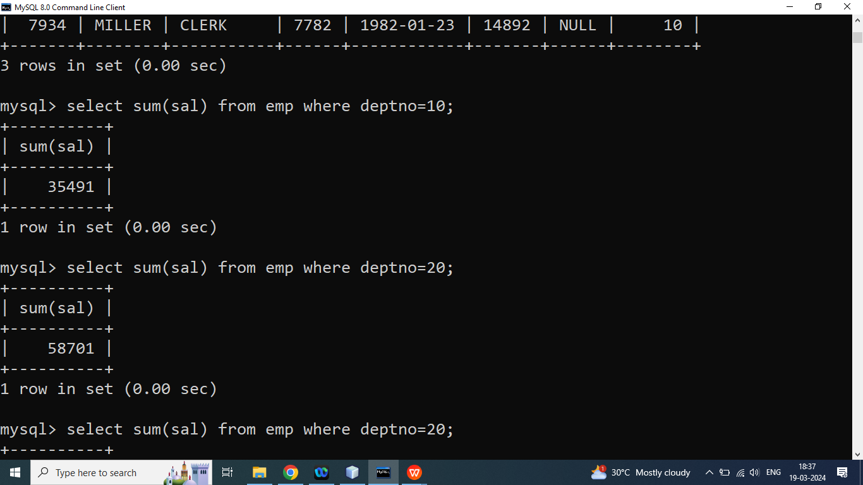

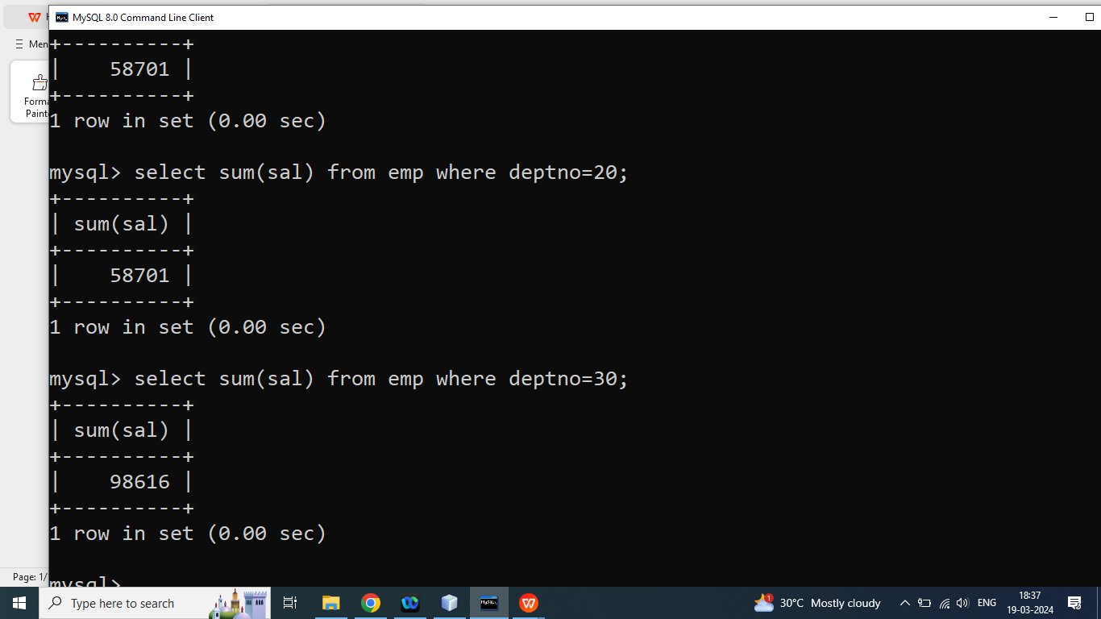

Q2.Write a SQL query to print average salary of deptno 10?

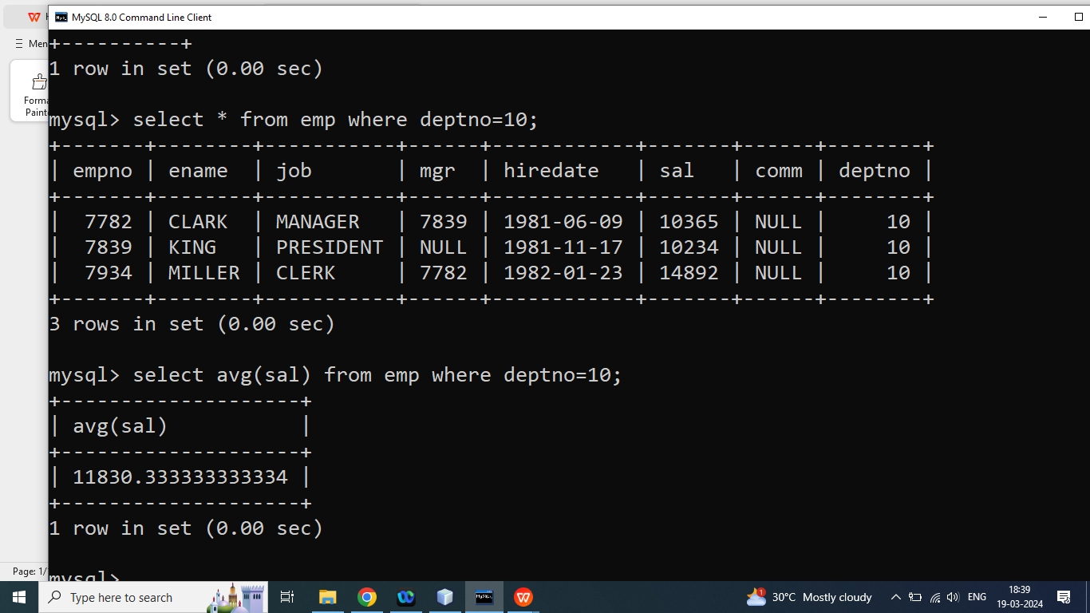

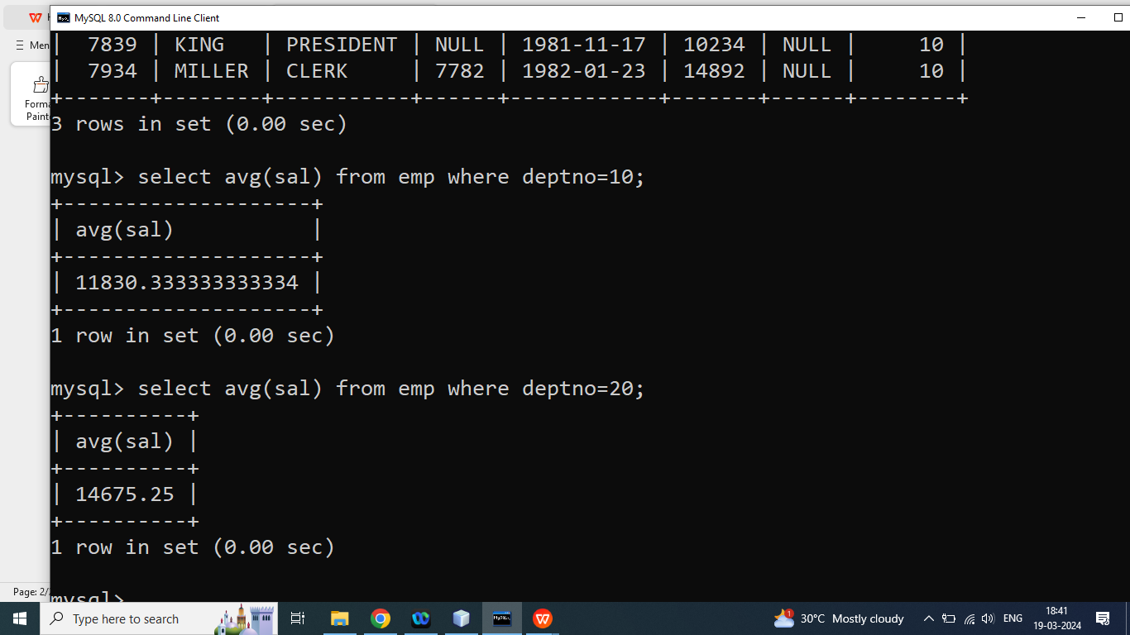

Q4. write a SQL query to print maximum salary in deptno 10?

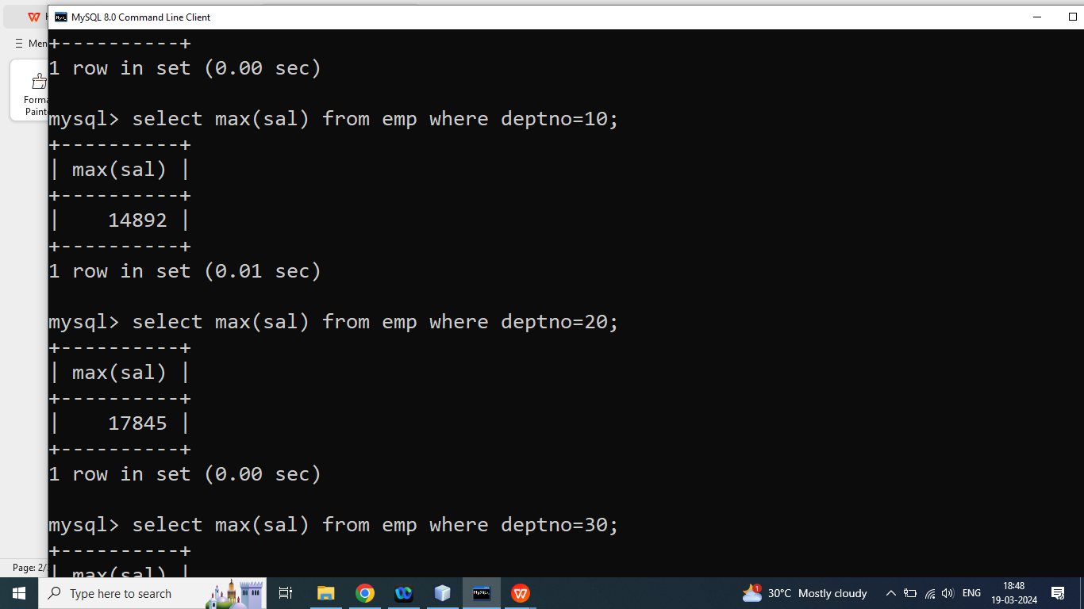

Q5. write a SQL query to print maximum salary in deptno 20?

Q6. write a SQL query to print maximum salary in deptno 30?

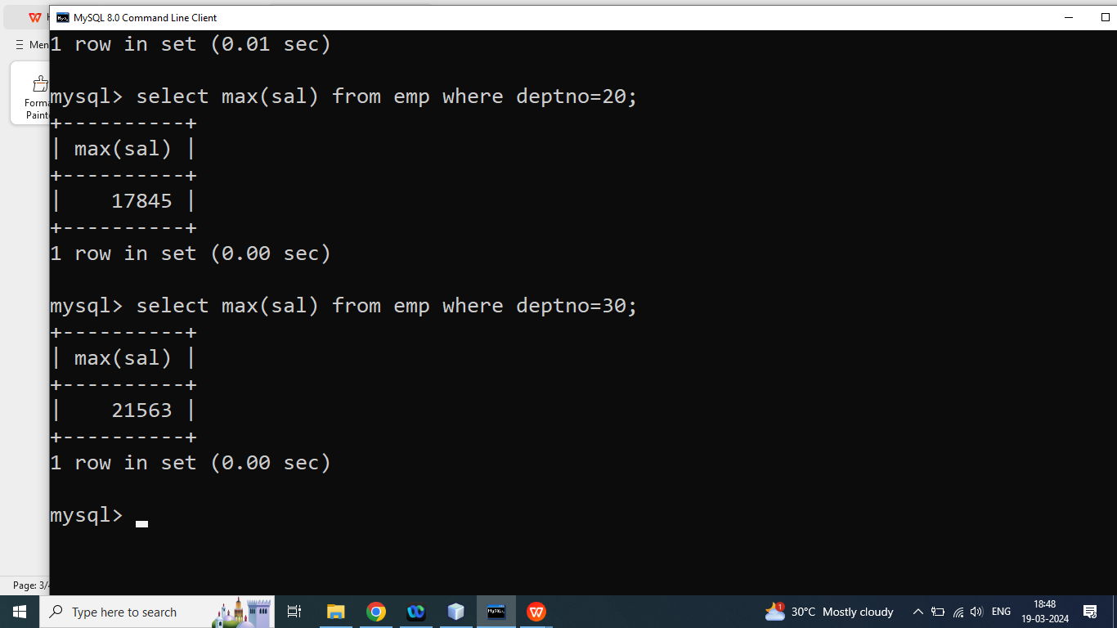

Q7. write a SQL query to print salary salary in deptno 10?

Q8. write a SQL query to print minimum salary in deptno 20?

Q9. write a SQL query to print minimum salary in deptno 30?

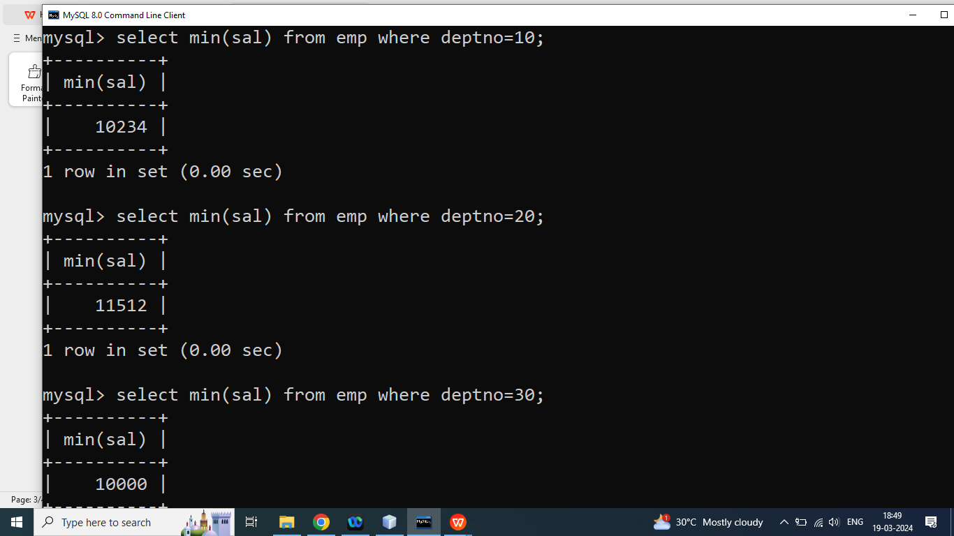

Q10. write a SQL query to count Number of employee in deptno 10?

Q11. write a SQL query to count Number of employee in deptno 20?

Q12. write a SQL query to count Number of employee in deptno 30?

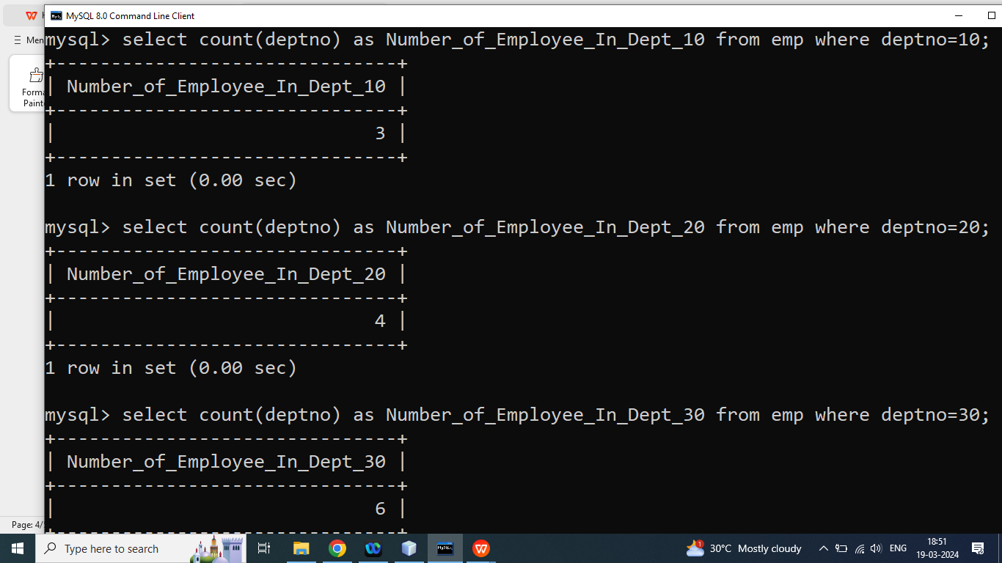

Q2.Explain Order by clause in SQL?

Ans: if we want to sort data in **ascending or descending** order then we should go for order by clause

Note:

In SQL order by sort data in ascending order by default.

Syntax:

**Select column list from table name order by column name ASC|DESC;**

Q2. Write a SQL Query to print Data of all employee in ascending order on the basis of salary?

Without Ascending Order

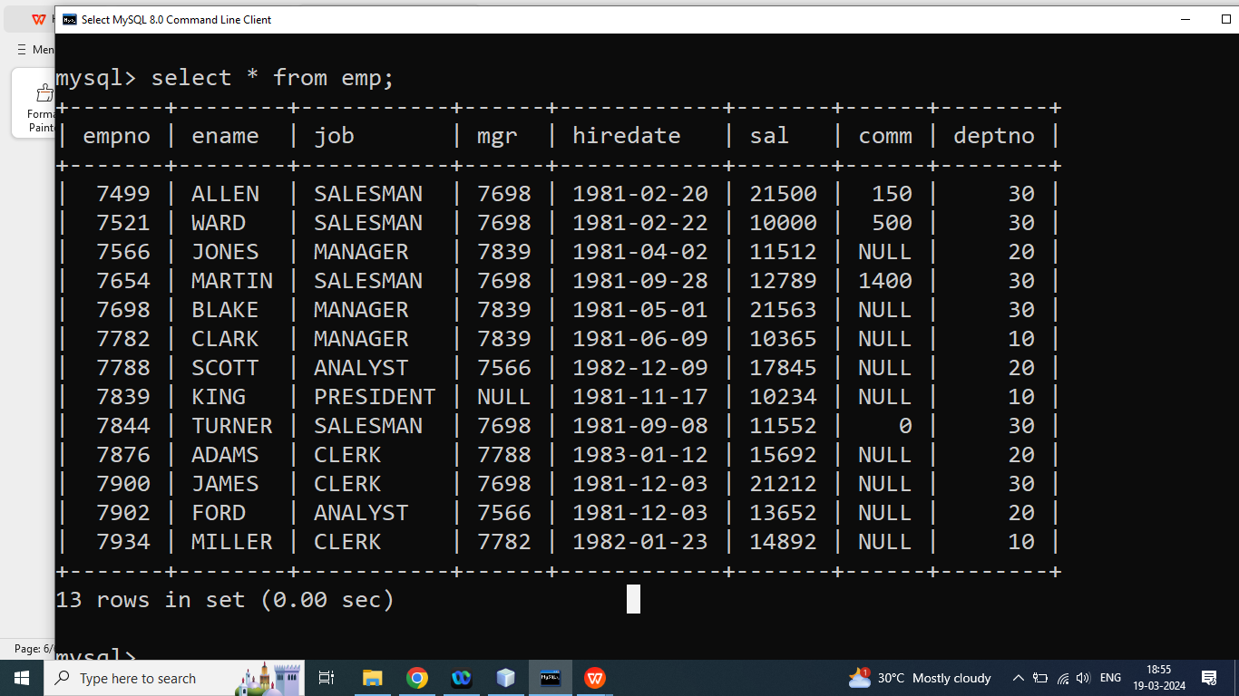

With Sorting Data in Ascending Order

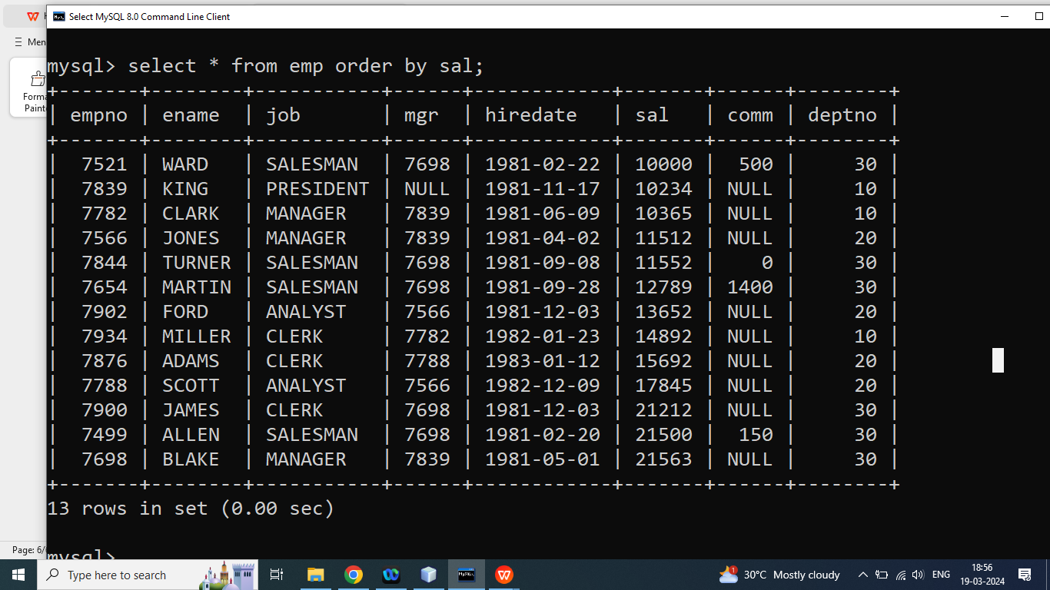

Q2. Write a SQL Query to print Data of all employee in Descending order on the basis of salary?

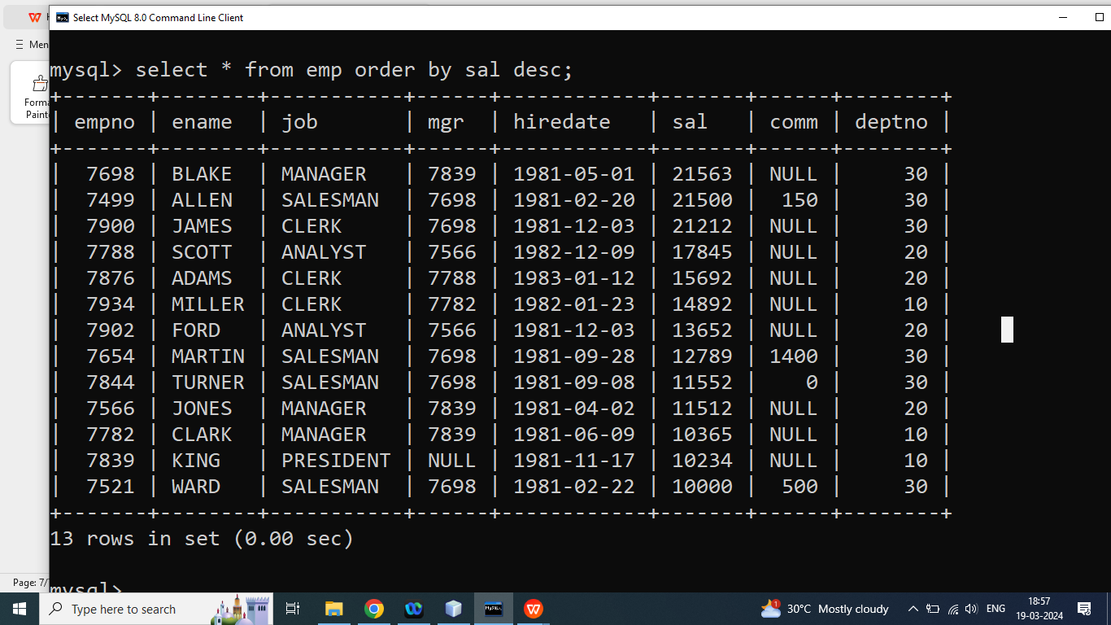

Q3. Write a SQL Query to print Data of employee who has highest salary in the employee table?

Ans: There are two ways to print Highest salaried employee Using Order by clause

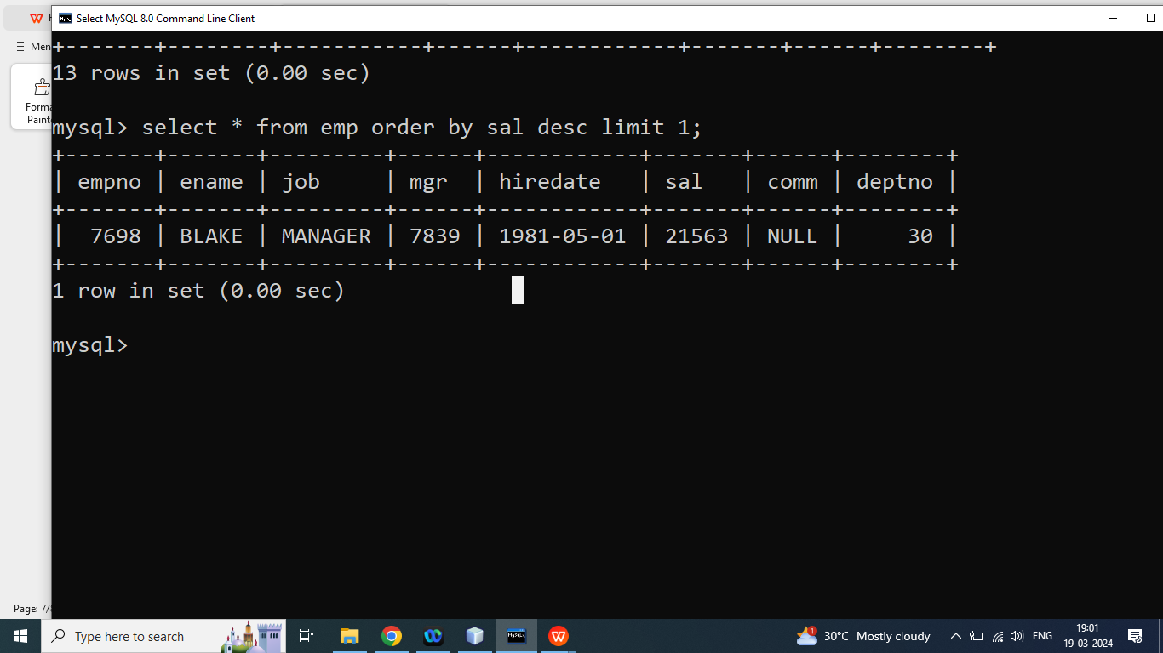

1. Using Sub Query

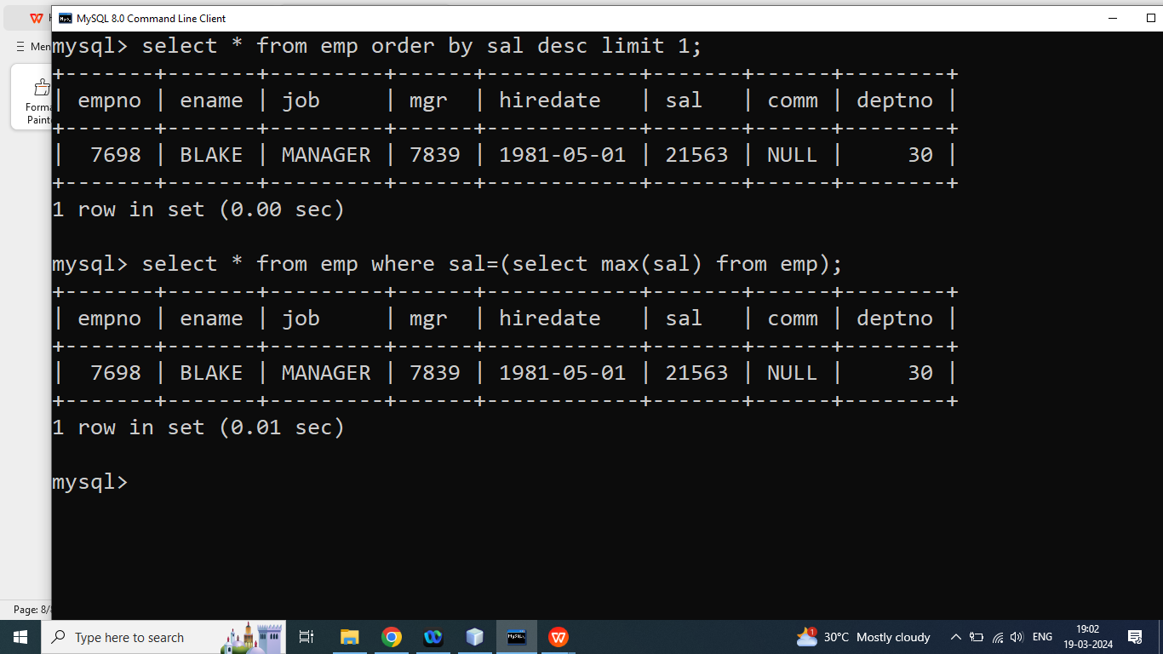

Q3. Write a SQL Query to print Data of employee who has lowest salary in the employee table?

Q4. Write a SQL Query to print data of employee whose salary is highest in the deptno 10(from the emp table)?

Q5. Write a SQL Query to print data of employee whose salary is highest in the deptno 20(from the emp table)?

Q6. Write a SQL Query to print data of employee whose salary is highest in the deptno 30(from the emp table)?

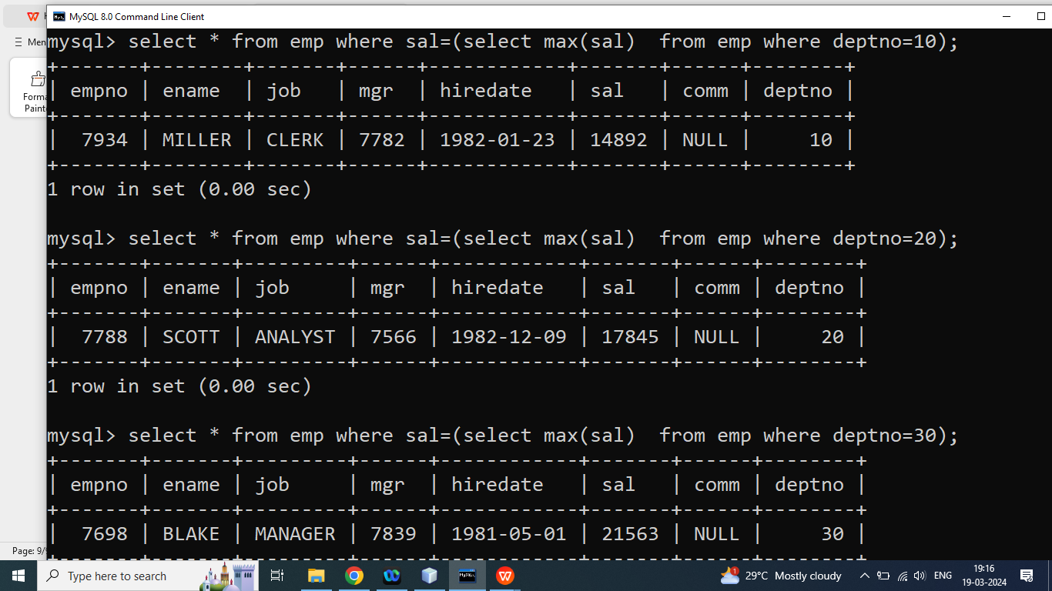

Q7. Write a SQL Query to print data of employee whose salary is lowest in the deptno 10(from the emp table)?

Q8. Write a SQL Query to print data of employee whose salary is lowest in the deptno 20(from the emp table)?

Q9. Write a SQL Query to print data of employee whose salary is lowest in the deptno 30(from the emp table)?

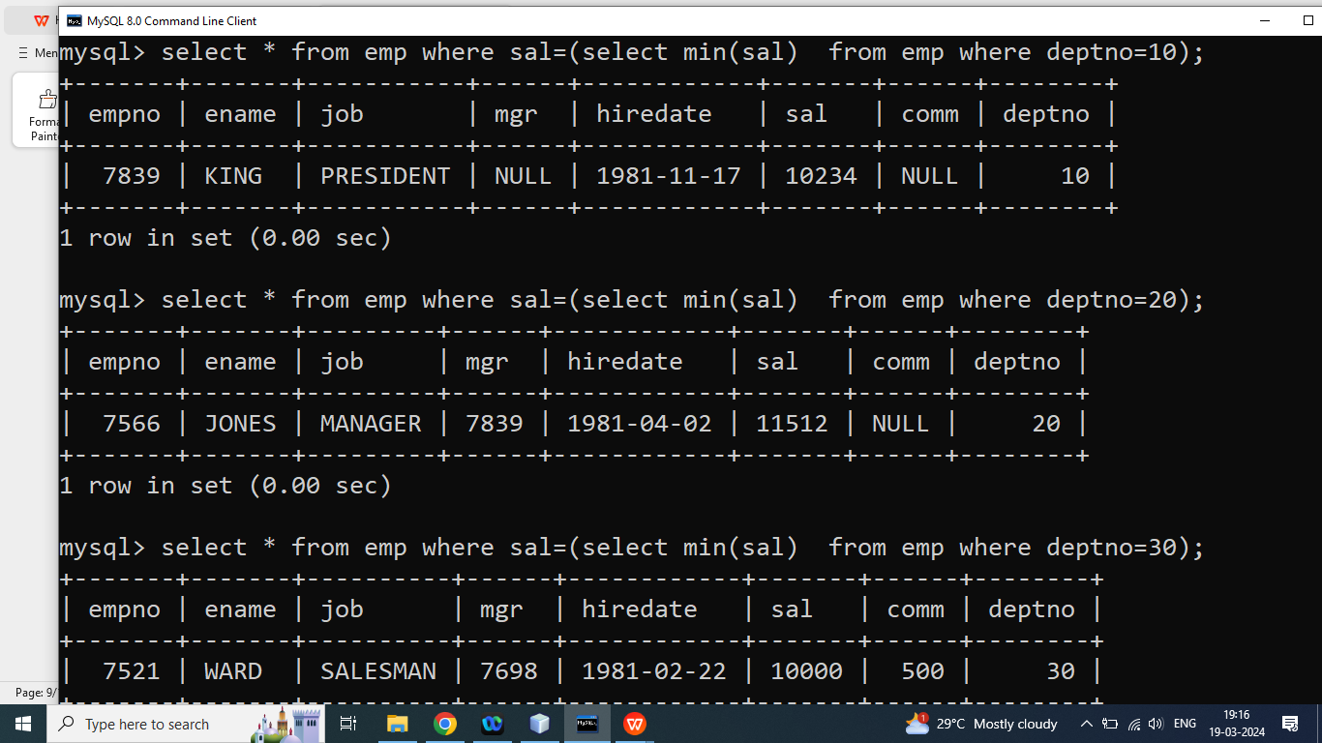

Q1. Write a SQL Query to print data of employee who has second highest salary from the employee?

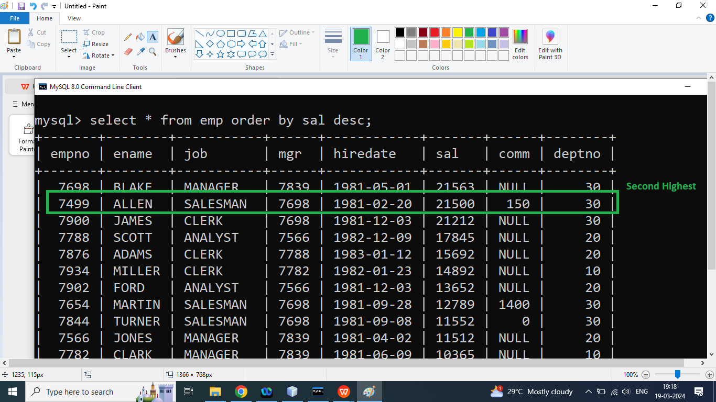

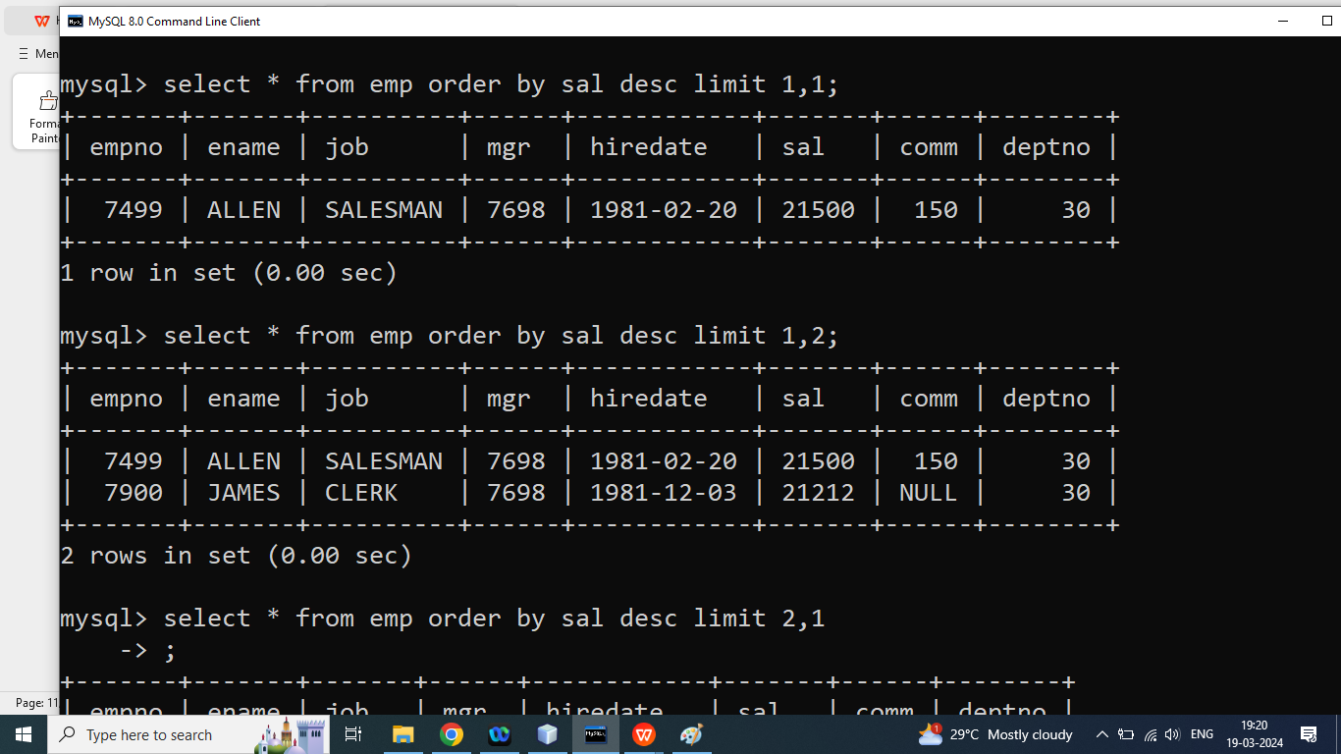

Q2. Write a SQL Query to print data of employee who has second lowest salary from the employee?

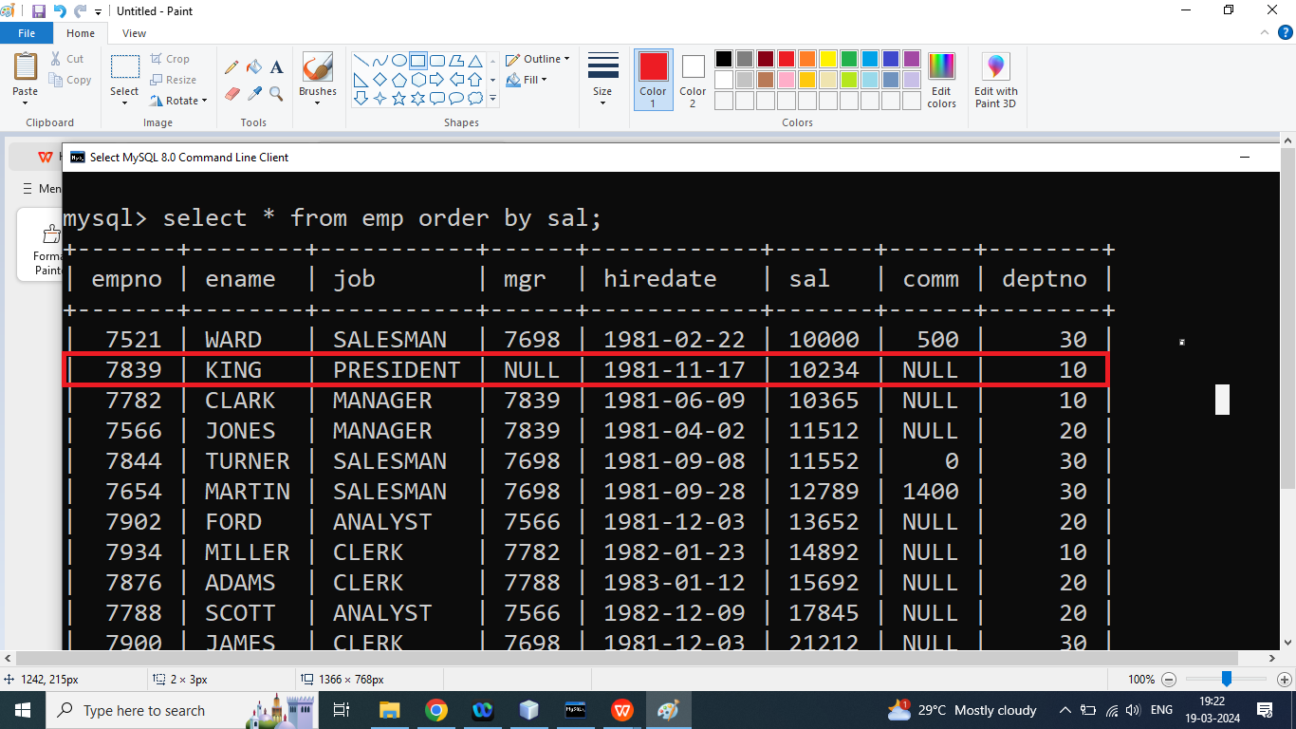

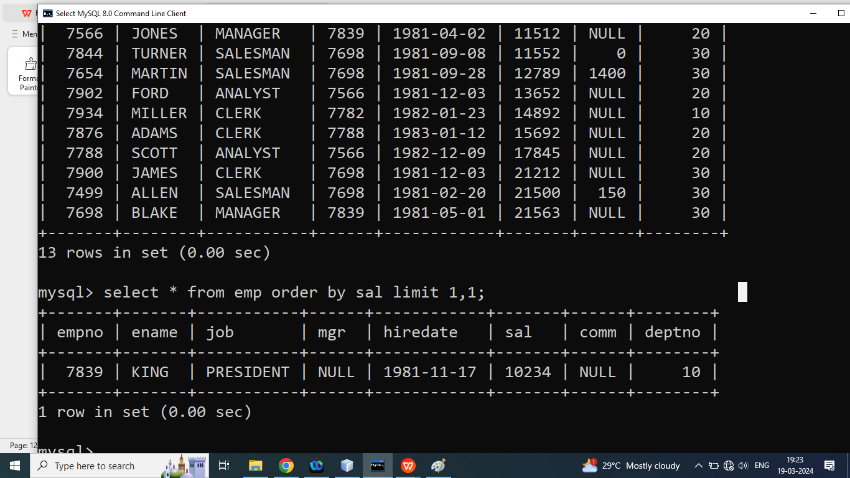

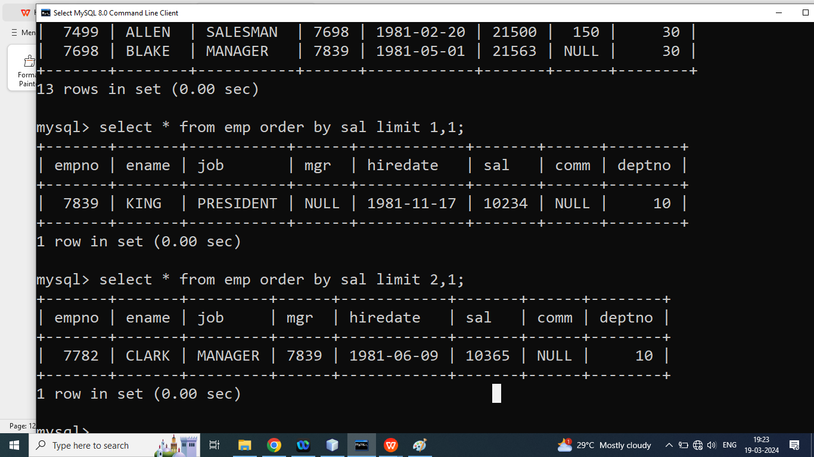

Q1. Write a SQL Query to print Data of all Employee in ascending order on the basis of name?

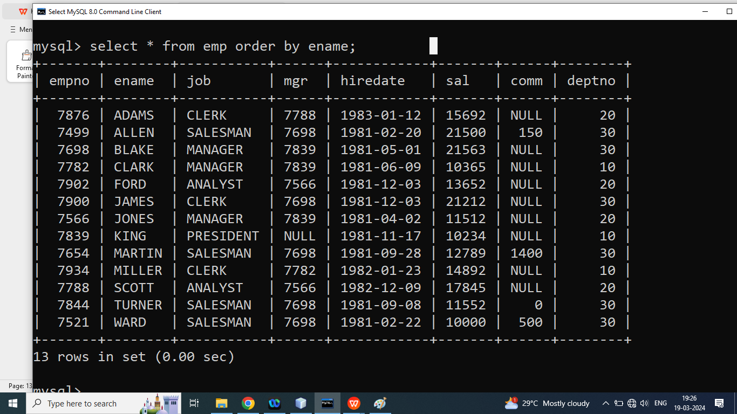

Q2. Write a SQL Query to print Data of all Employee in descending order on the basis of name?

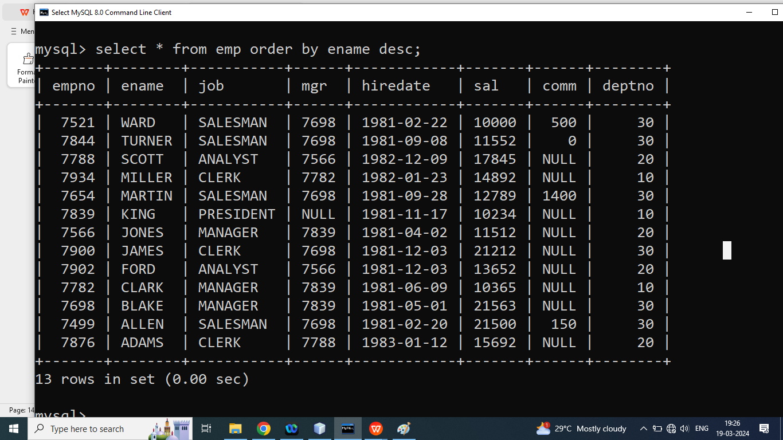

Q3. Write a SQL Query to print data of all employee in ascending order on the basis of hiredate?

Ans:

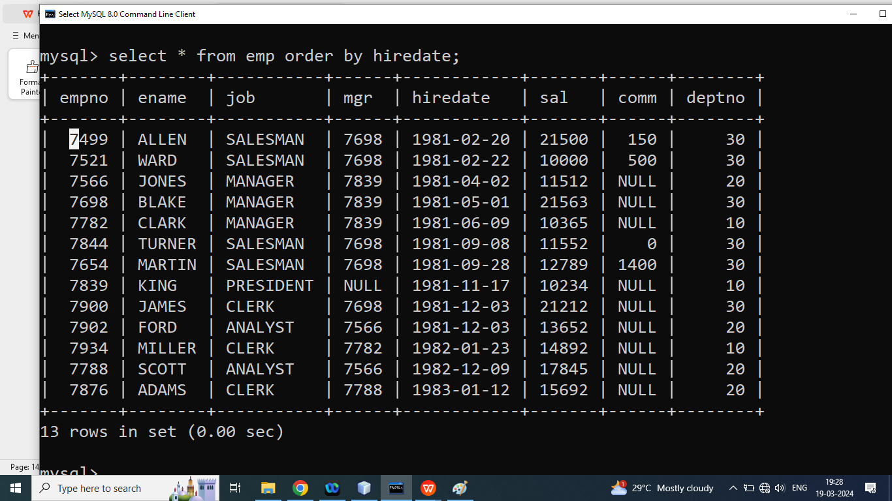

Syntax of group by:

Select Column list ,aggregate function from table name group by column name order by column name ASC|DESC;

**Q1. Write a SQL Query to print Number of Employee in each Department?**

DEPTNO No_Of_Employee

1. 3
2. 4
3. 6

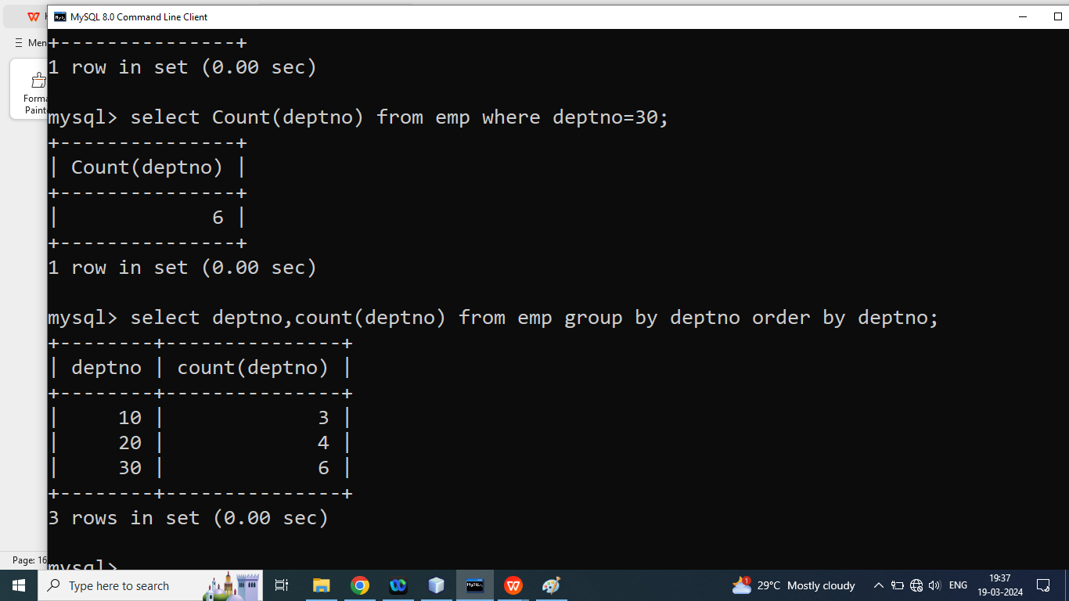

Q1. Write a SQL Query to print Number of Employee in each Job?

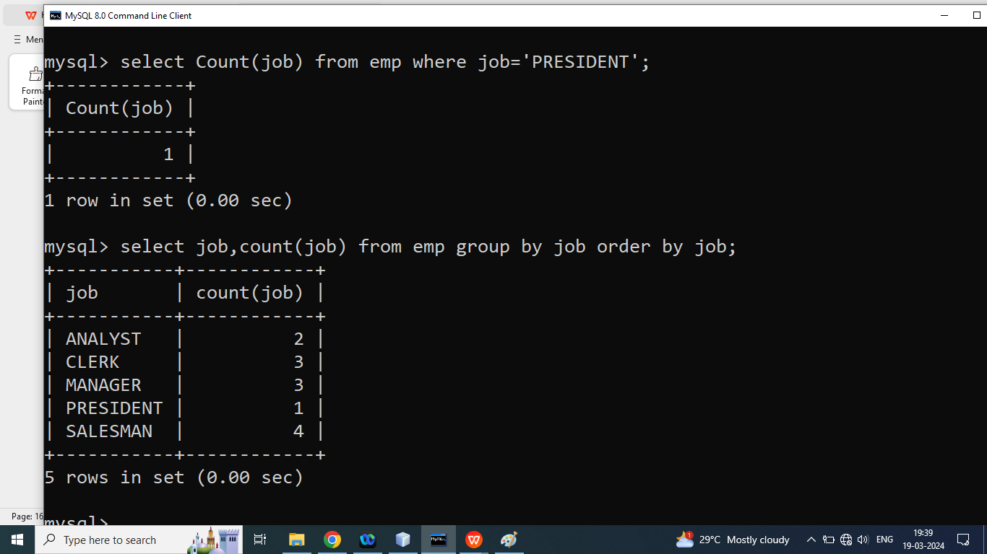

Q1. Write a SQL Query to print Job who have at least 2 Employee?

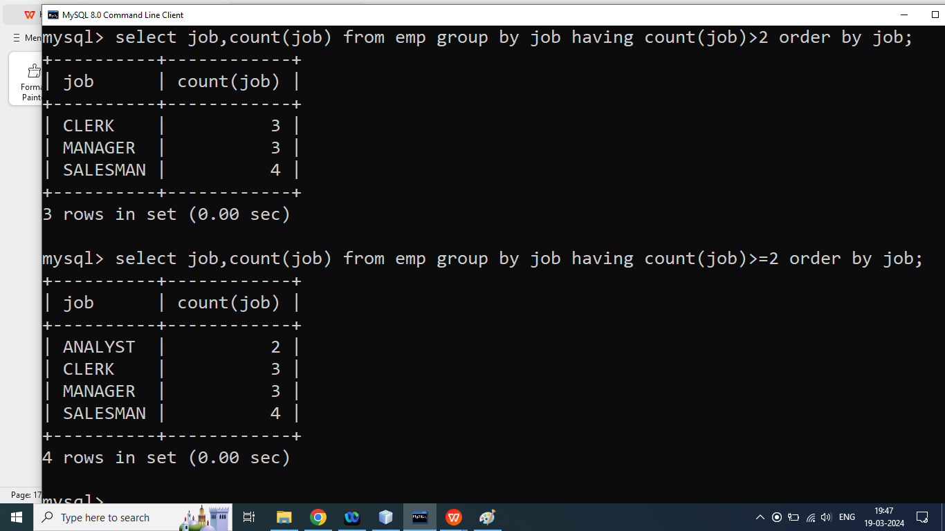

Next class:

Between

In

Like

Join

Sub query

DSA:

Searching:

Binary search:

Sorting:

1. Insertion sort
2. Bubble Sort
3. Selection Sort
4. Merge Sort
5. Quick Sort
6. Heap Sort

**Time and Space Complexity:**

Q1. Write a SQL Query to print data of all employee whose salary is greater than or equal 10000 and less than or equal to 20000.

Ans:

Select * from emp where sal>=10000 and sal<=20000;

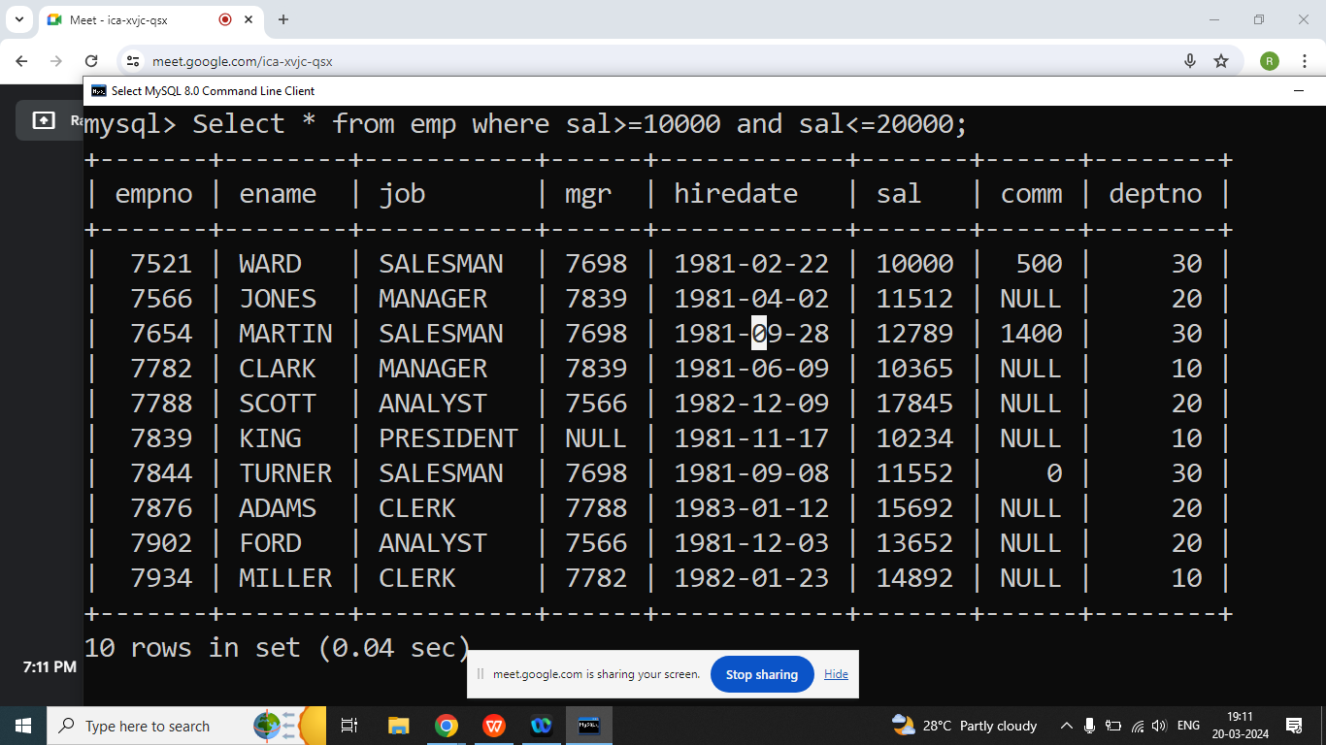

**Q2. Explain Between Operator in java programming?**

Ans: It is used to select data between the range where start and end both are inclusive

Syntax:

**Select column list from table name where column name between value1 and value2**;

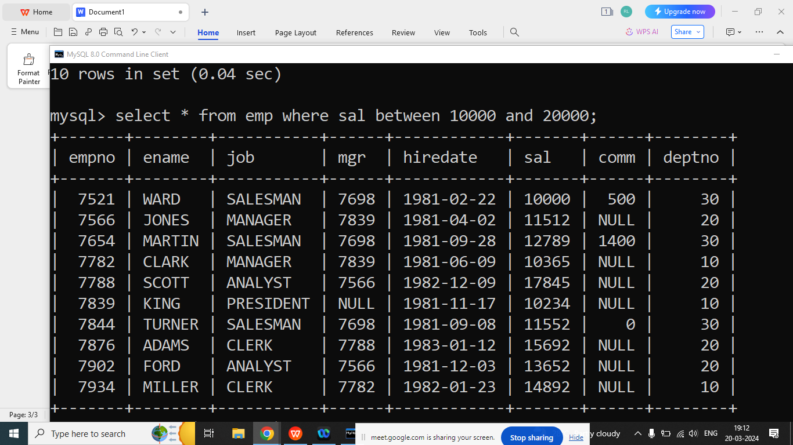

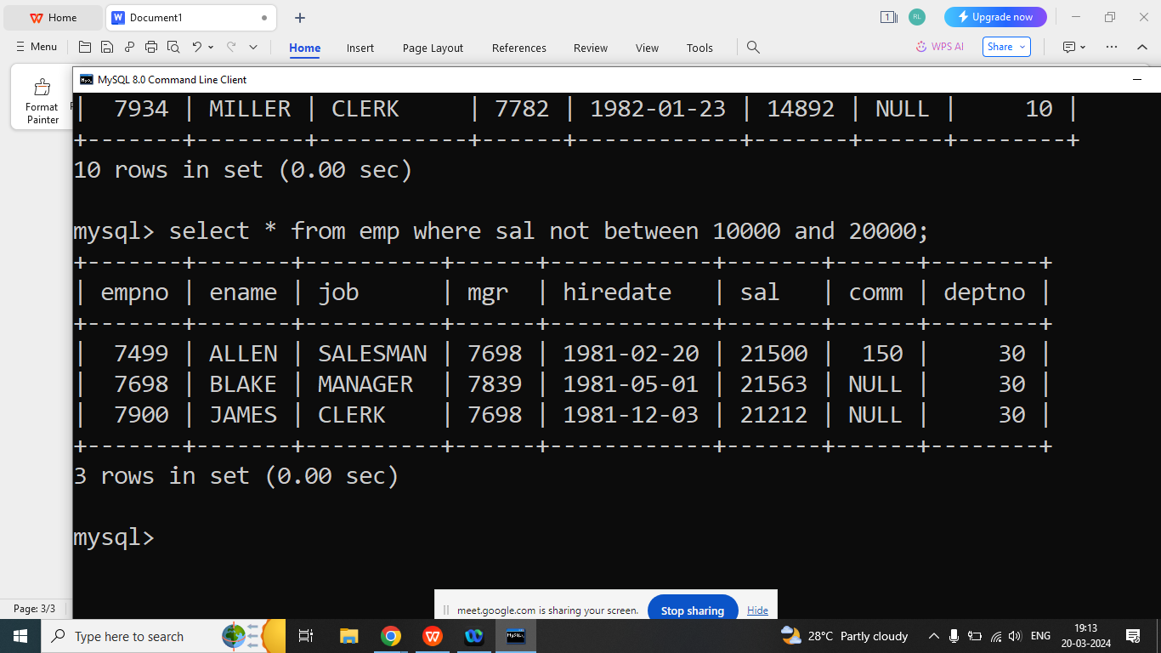

Q3. Write a SQL Query to print Data of all employee whose hiring date between 1981 to 1982.

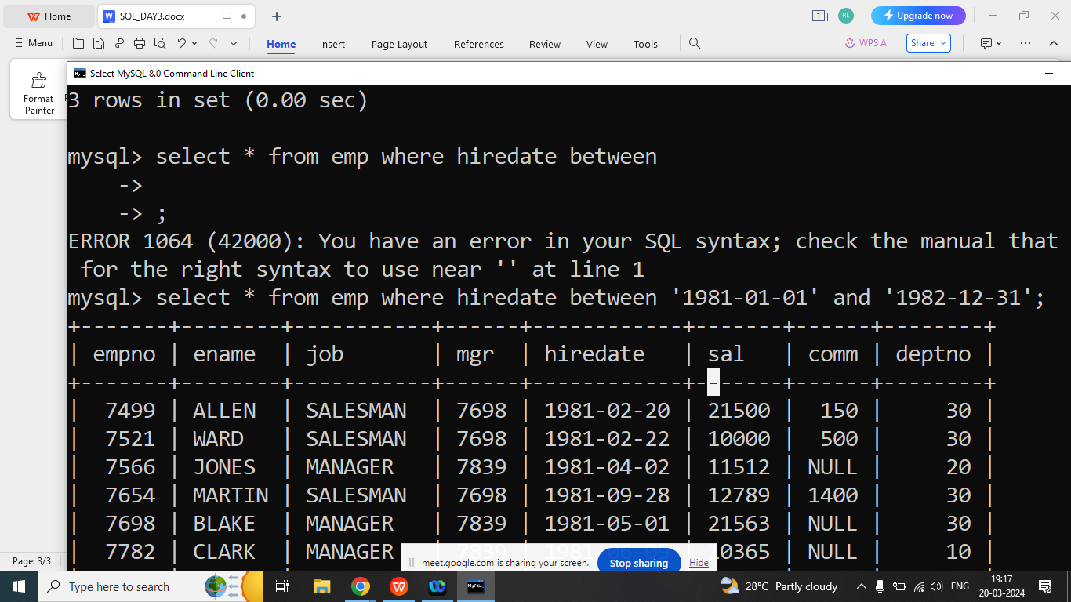

Q2. Write a SQL Query to print data of all employee whose job is Clerk or Manager or Salesman?

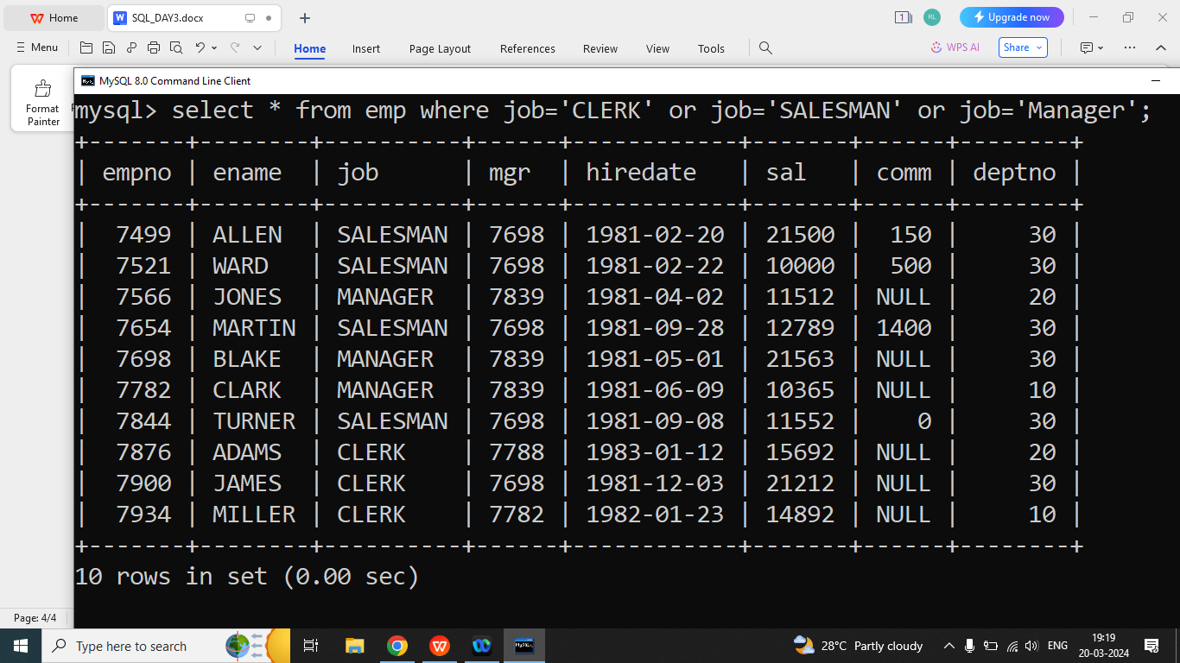

**Q2. Explain In Operator in SQL?**

Ans: The IN Operator allows you to specify multiple values in a where clause.

The In operator is used to in place of multiple OR Operators

Syntax:

**Select column list from table name where column name in(value1,value2,value3);**

Q2. Write a SQL Query to print data of all employee whose job is Clerk or Manager or Salesman?

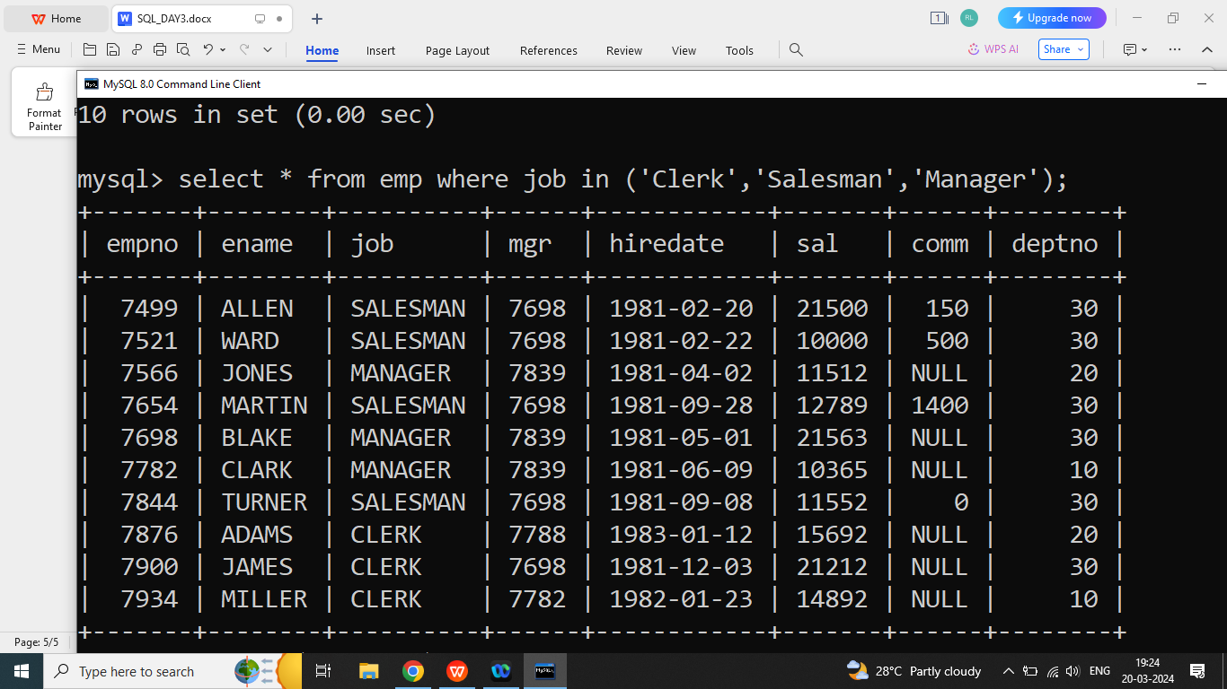

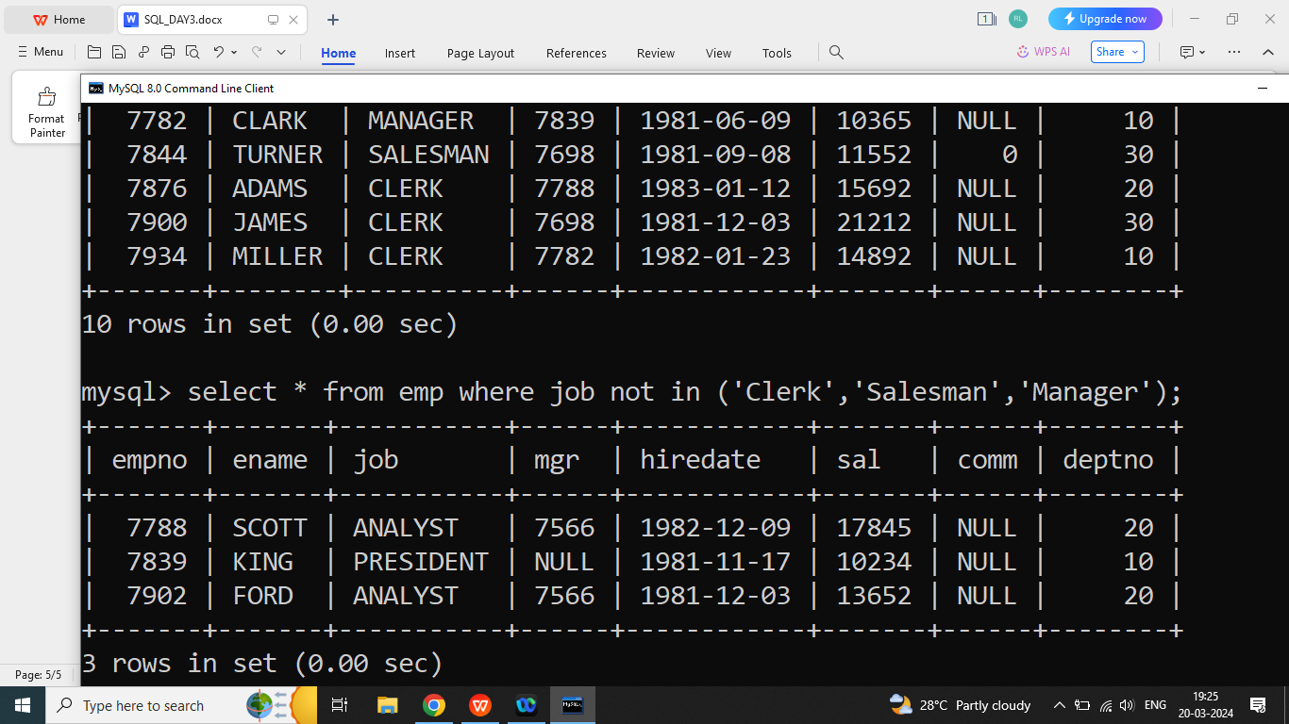

**Q2. Write a SQL Query to print data of all employee whose join in Month ‘JAN’.**

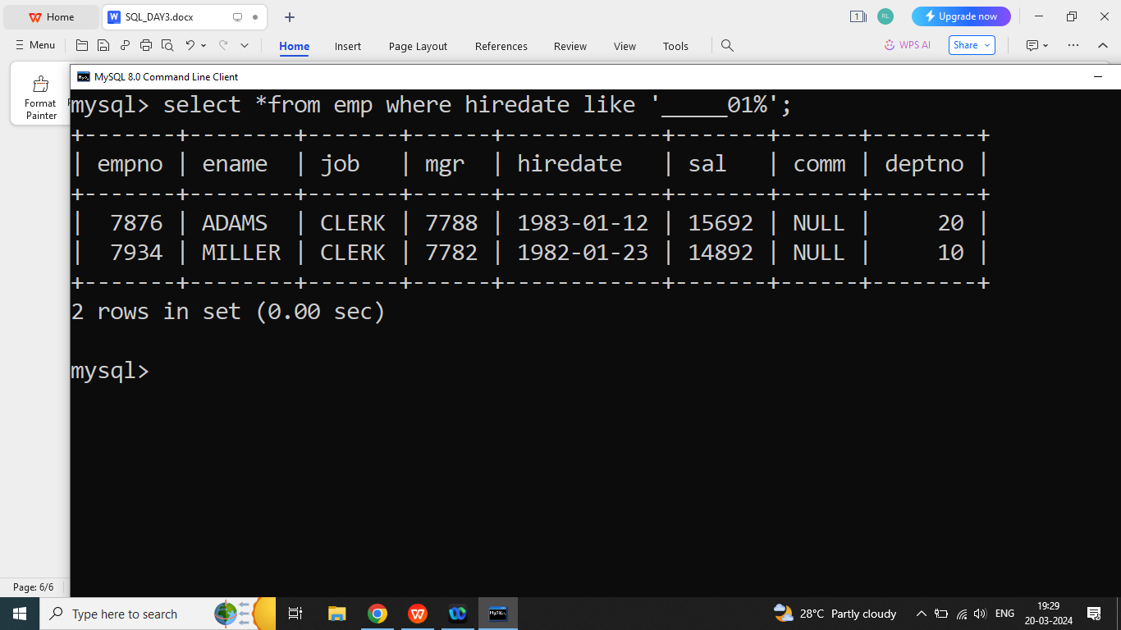

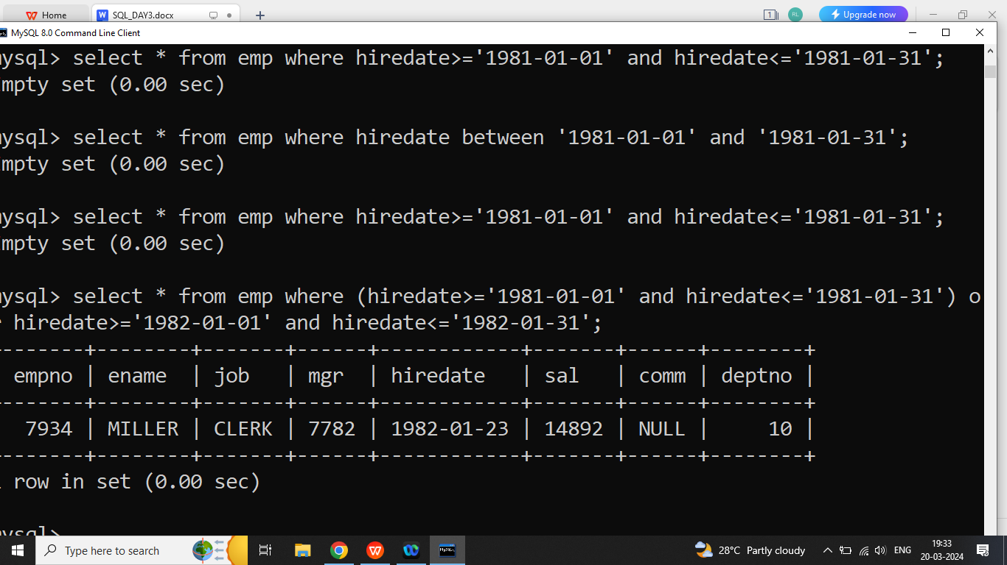

**Q2. Explain Like Operator in SQL?**

Ans:

The Like Operator is used to where clause to search for a specified pattern in a column.

**There are two wild card character used with Like operator**

1. (_) for single character
2. (%) for multiple character

Syntax:

**Select column list from table name where column name like ‘patttern’**

Example:

Write a SQL Query to print Data of all employee whose name starts with ‘A’.

Example:

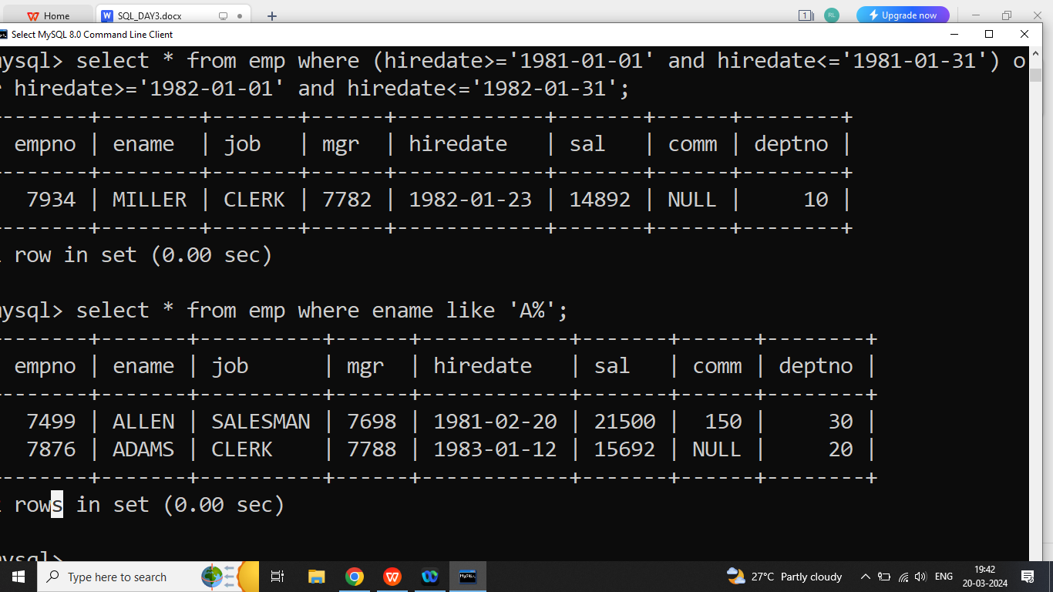

Q3. Write a SQL Query to print data of all employee whose name ends with ‘R’?

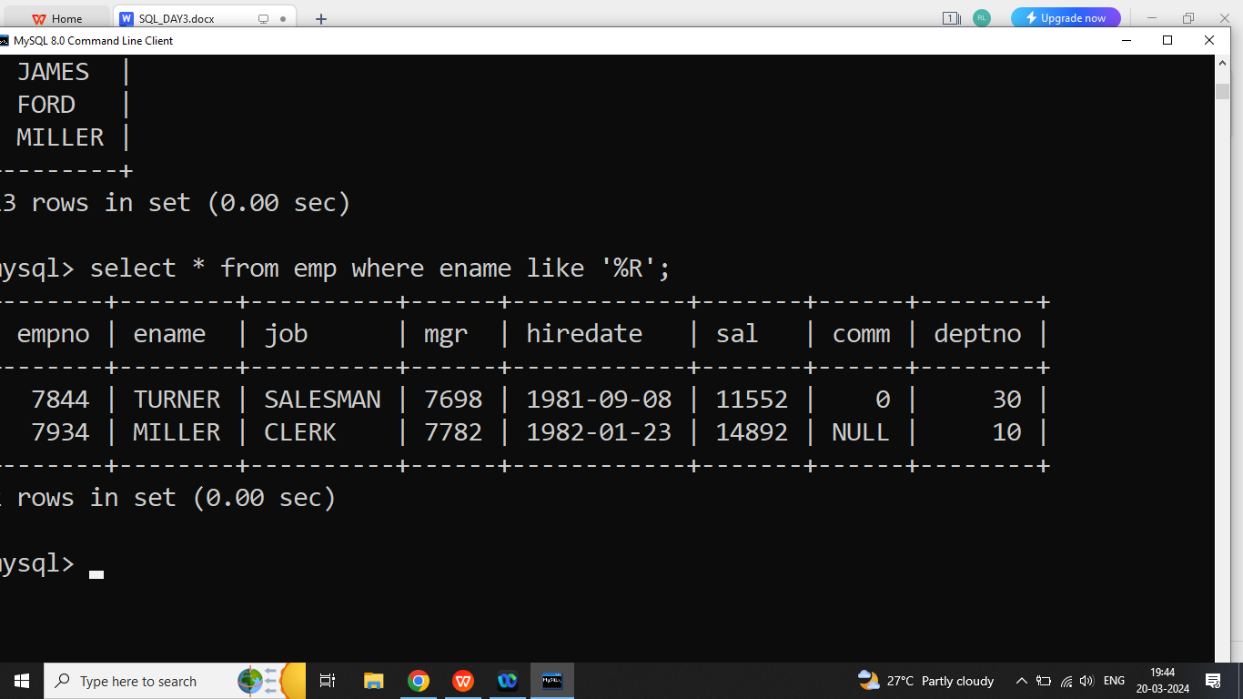

Q3. Write a SQL Query to print data of all employee whose names second character is ‘I’?

Ans:

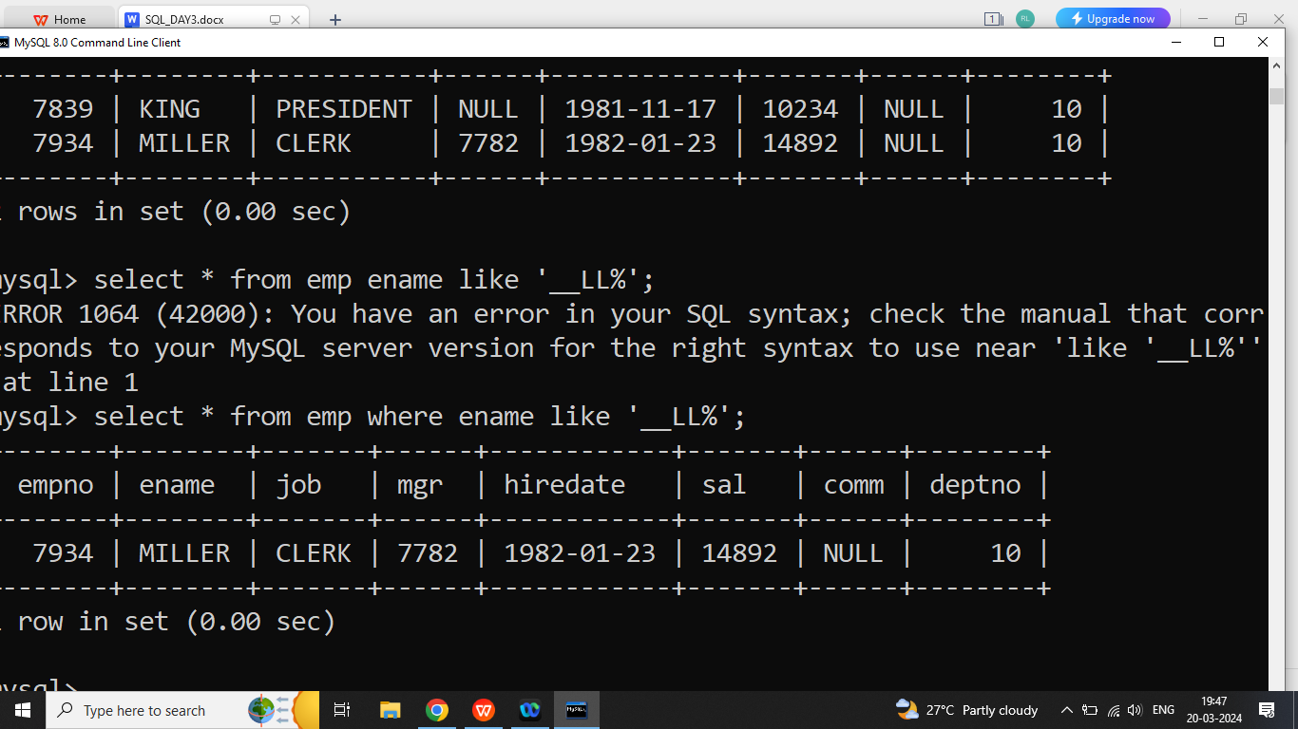

Q3. Write a SQL Query to print data of all employee whose names second last character is ‘E’?

Ans:

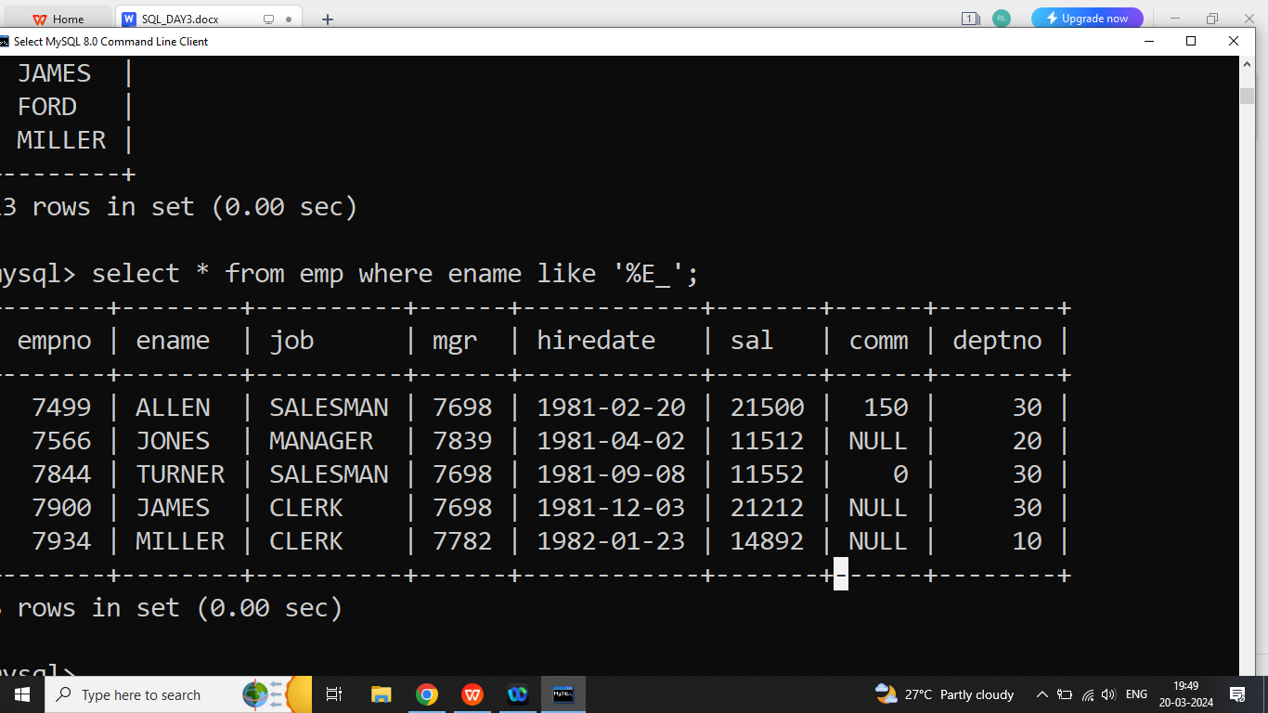

Q3. Write a SQL Query to print data of all employee whose hiring in 1981?

**Q1.Explain Join in SQL?**

Ans:

If we want to select data from the multiple tables then we should go for join.

A join clause is used to combine tuples from two or more attribute/fields, based on a related column between them.

**Types of join**

1. Inner Join
2. Left outer join
3. Right outer join
4. Full outer join
5. Self join

**Q2. Explain Inner Join in SQL?**

Ans: Inner join will return common data from the both tables.

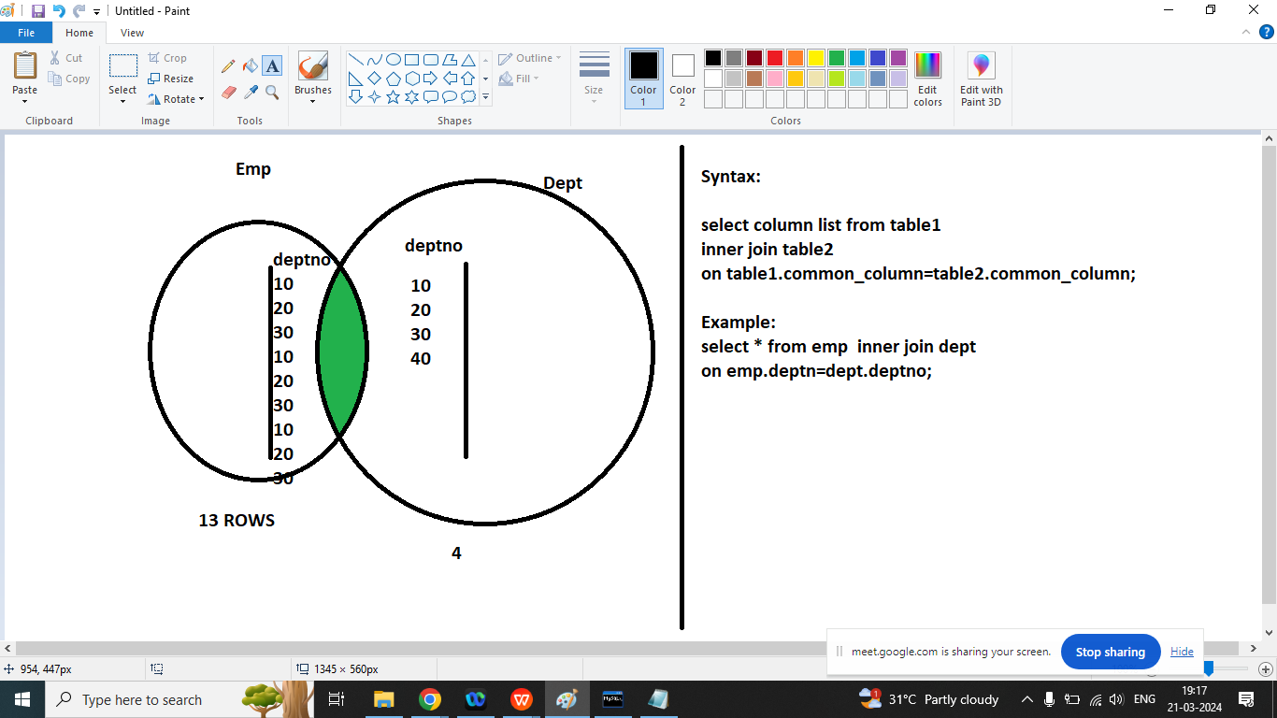

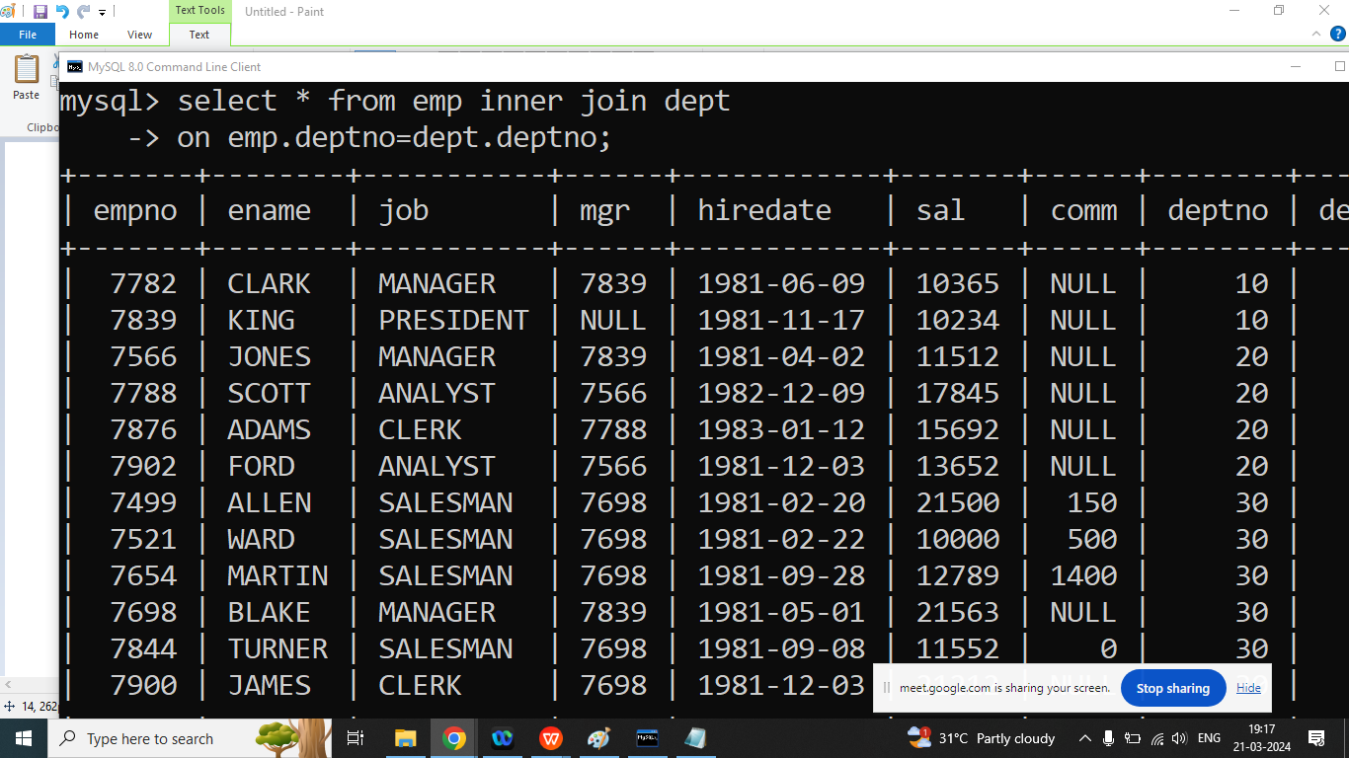

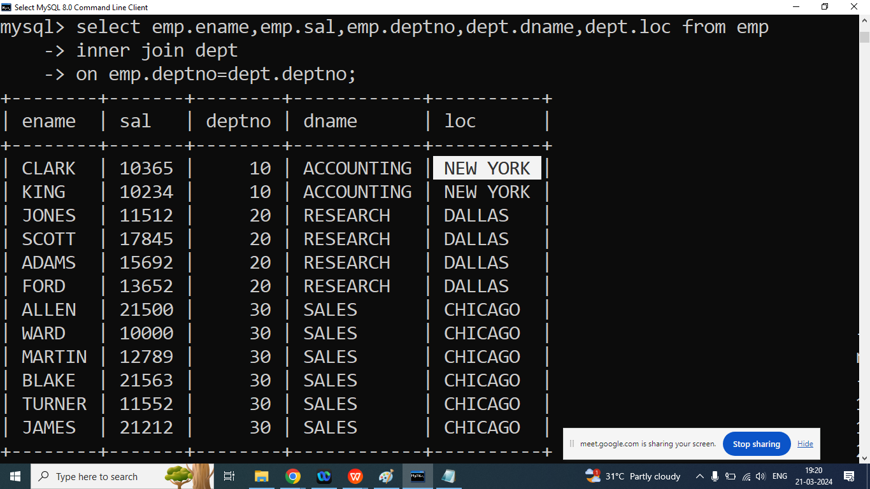

select e.ename,e.sal,e.deptno,d.dname,d.loc from emp e

inner join dept d

on e.deptno=d.deptno where d.loc='CHICAGO';

**Q2. Explain Left join / Left outer join in SQL?**

Ans:

It will return match rows from both tables and it will also return non matching records from left table.

select * from dept d

left join emp e

on e.deptno=d.deptno;

================================

Q3. Explain right join in SQL?

Ans:

It will return match rows from both tables and it will also return non matching records from right table.

select * from dept d

left join emp e

on e.deptno=d.deptno;

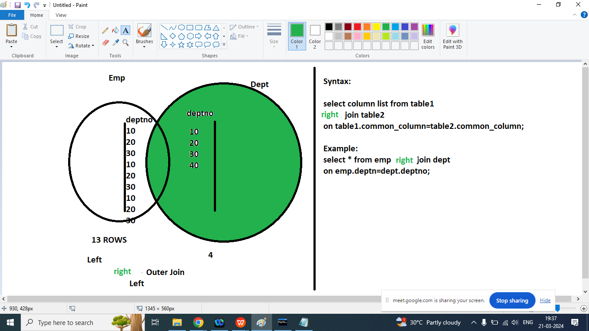

select * from emp e

right join dept d

on e.deptno=d.deptno;

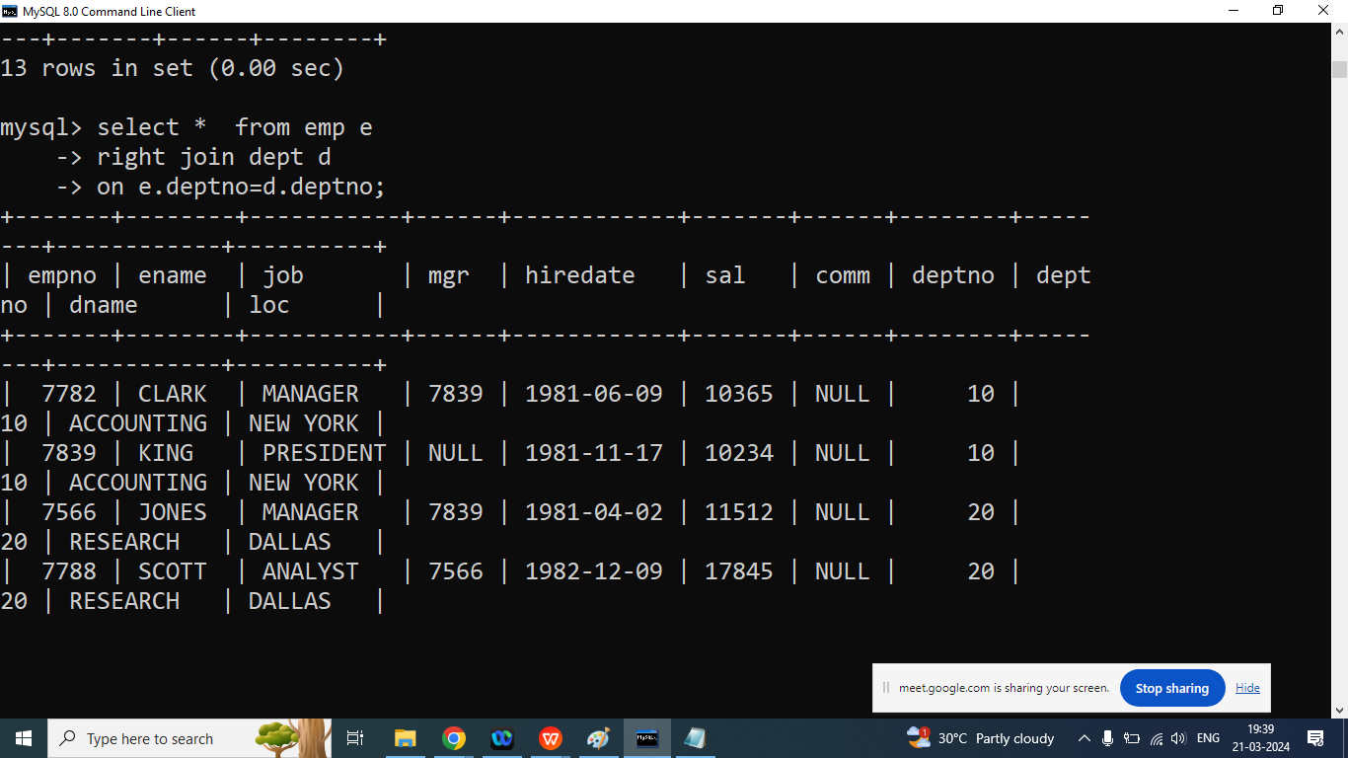

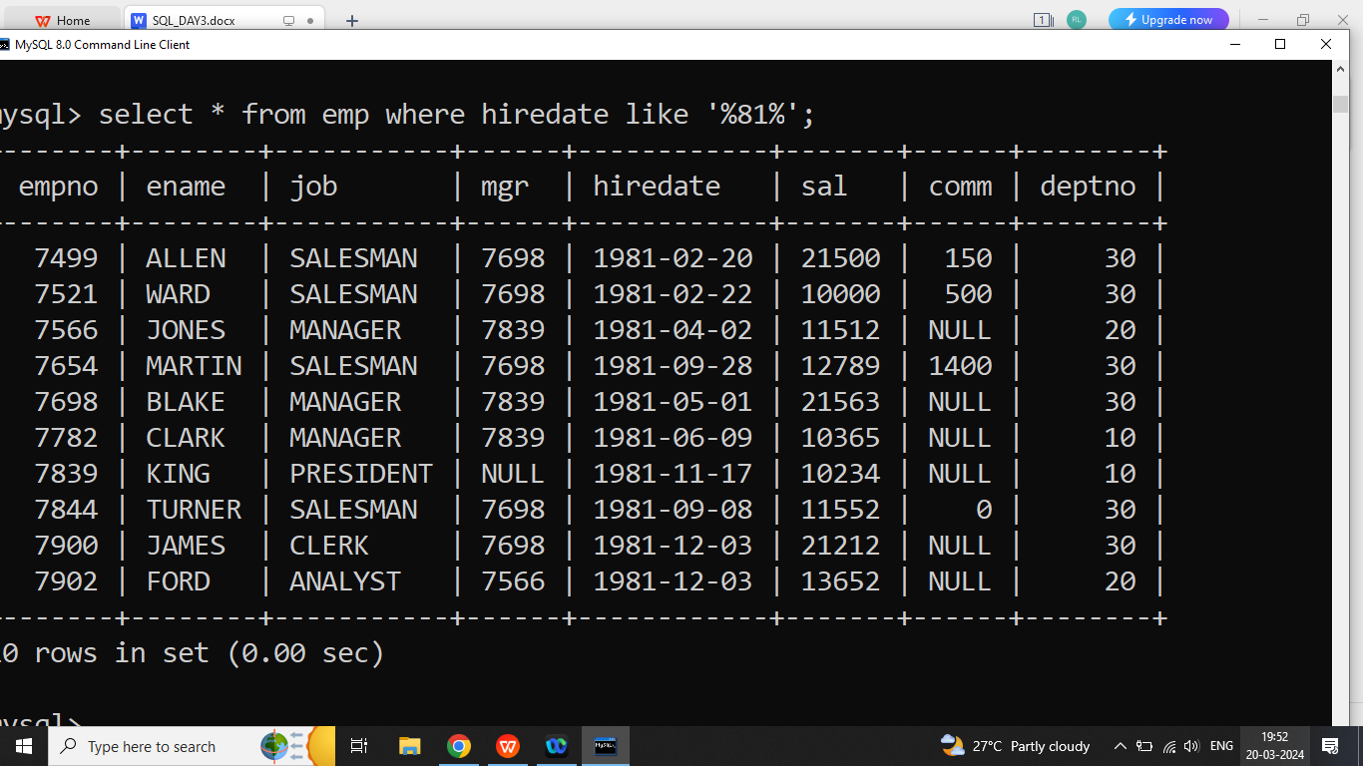

Before Next class:

1. Linear search
2. Binary Search

Sorting

1. Insertion Sort
2. Merge Sort
3. Quick Sort
4. Selection Sort
5. Bubble Sort

MySql Close

**jdbc(java database conectivity)**

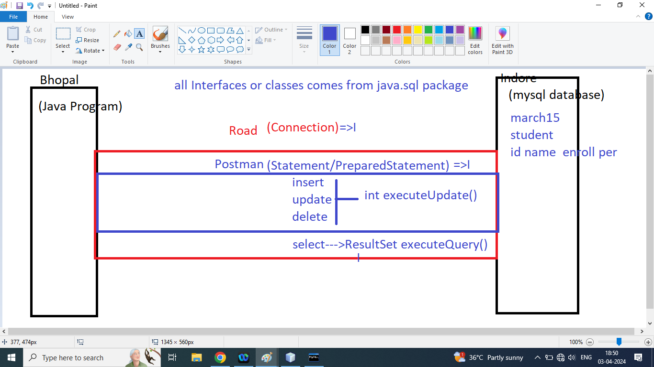

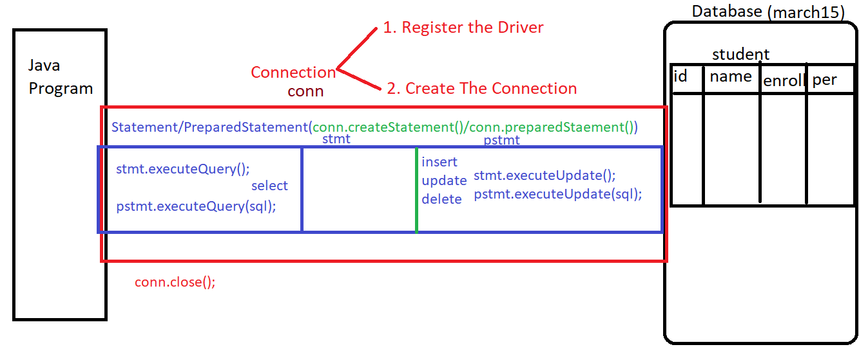

Q2. Write Steps to Java Database Connectivity?

Ans:

Note: first Import java.sql package

Step1: Register the Driver

Class.forName(“com.mysql.jdbc.Driver”);

Its throw ClassNotFoundException

**Step2: Create the Connection**

String url=”jdbc:mysql://localhost:3306/march15”;

String userName=”root”;

String password=”Ram@1234”

Connection conn=DriverManger.getConnection(url,userName,password);

Note:

1. It throws SQLException(Checked Exception)
2. Step1 and step2 are common for all database operations

**Step3: Write SQL Query and Create Object of Statement/PreparedStament**

Statement stmt=conn.createStatement();

**Option1:** if our frequent operation is data insertion/updation/deletion then we should call executeUpdate() method

int r=stmt.executeUpdate();

**Option2**: if our frequent operation is data select/reading from the database then we should call executeQuery() method

ResultSet rs=stmt.executeQuery();

while(rs.next()){

Sop(“”+rs.getInt(“id”)+” ”+rs.getString(“name”)+” ”+rs.getString(“enroll”)+” ”+rs.getFloat(“per”));

}

**Step4: Close the connection**

conn.close();

==============================================================================

**Q1. Write a Java Program to perform following operations?**

1. Insert Data into the Table using java Program
2. Update Data from the Table using java Program
3. Delete data from the Table using java Program
4. Select all data from the table
5. Select data of a particular student based on id or enrollment

Next Task(CRUD Operation ) Using Design Pattern [Beans & DAO]

Java Class (Beans)

Member data

Constructor

getter/setter

Java class (DAO)

Operations

addStudent()

updateStudent()

deleteStudent()

findAllStudent()

findByStudent()

main

<https://repo1.maven.org/maven2/com/mysql/mysql-connector-j/8.0.31/>

============================================================================

**—-----------------------------------------------------insert data —------------------------------------------------**

**Class Notes 4-APR-2024**

/*

* To change this license header, choose License Headers in Project Properties.

* To change this template file, choose Tools | Templates

* and open the template in the editor.

*/

package jdbcprojectapr4;

/**

*

* @author Admin

*/

import java.sql.*;

public class InsertData {

//shortcut of Netbeans:

//1. main: psvm press tab key

//2. System.out.println(): sout press tab key

public static void main(String[] args) throws ClassNotFoundException, SQLException {

//step1: Register the Driver

Class.forName("com.mysql.cj.jdbc.Driver");

//step2: Create the Connection

String url="jdbc:mysql://localhost:3306/march15";

String un="root";

String ps="Ram@1234";

Connection conn=DriverManager.getConnection(url, un, ps);

System.out.println("Database connectivity success");

//step3: write SQL Query

int id=104;

String name="Kartik";

String en="0103CS1814";

float per=56.45f;

String sql="insert into student values('"+id+"','"+name+"','"+en+"','"+per+"')";

//step4: create Object of Statement

Statement stmt=conn.createStatement();

int r=stmt.executeUpdate(sql);

if(r>0){

System.out.println("Data insert success");

}else{

System.out.println("Data insertion fail");

}

//step5 close the connection

conn.close();

}

}

—----------------------------------------------------------update data ------------------------------------------------------------------

/*

* To change this license header, choose License Headers in Project Properties.

* To change this template file, choose Tools | Templates

* and open the template in the editor.

*/

package jdbcprojectapr4;

//step1

import java.sql.*;

public class UpdateData {

public static void main(String[] args) throws ClassNotFoundException, SQLException {

//step2: Register the Driver

Class.forName("com.mysql.jdbc.Driver");

//step: 3 Create the Connection

String url="jdbc:mysql://localhost:3306/march15";

String un="root";

String ps="Ram@1234";

Connection conn=DriverManager.getConnection(url, un, ps);

//step4: write sql query update

int i=104;

String n="shubham";

String e="01752CS1";

float p=44.35f;

String sql="update student set name='"+n+"',enroll='"+e+"',per='"+p+"' where id='"+i+"'";

//step5 : create an Object of Statement

Statement stmt=conn.createStatement();

//step6: call executeUpdate method of Statement

int r=stmt.executeUpdate(sql);

if(r>0){

System.out.println("Data Updated success");

}else{

System.out.println("Data not updated");

}

//step7: close the connection

conn.close();

}

}

—----------------------------------------------------------delete data-----------------------------------------------------------------------

/*

* To change this license header, choose License Headers in Project Properties.

* To change this template file, choose Tools | Templates

* and open the template in the editor.

*/

package jdbcprojectapr4;

/**

*

* @author Admin

*/

/*

* To change this license header, choose License Headers in Project Properties.

* To change this template file, choose Tools | Templates

* and open the template in the editor.

*/

//step1

import java.sql.*;

public class DeleteData {

public static void main(String[] args) throws ClassNotFoundException, SQLException {

//step2: Register the Driver

Class.forName("com.mysql.jdbc.Driver");

//step: 3 Create the Connection

String url="jdbc:mysql://localhost:3306/march15";

String un="root";

String ps="Ram@1234";

Connection conn=DriverManager.getConnection(url, un, ps);

//step4: write sql query update

int i=103;

String sql=" delete from student where id='"+i+"'";

//step5 : create an Object of Statement

Statement stmt=conn.createStatement();

//step6: call executeUpdate method of Statement

int r=stmt.executeUpdate(sql);

if(r>0){

System.out.println("Data deleted success");

}else{

System.out.println("Data not deleted");

}

//step7: close the connection

conn.close();

}

}

—------------------------------------------find all —-----------------------------------------------------

FindAll Students:

/*

* To change this license header, choose License Headers in Project Properties.

* To change this template file, choose Tools | Templates

* and open the template in the editor.

*/

package jdbcprojectapr4;

/**

*

* @author Admin

*/

import java.sql.*;

public class FindAllStudent {

public static void main(String[] args) throws ClassNotFoundException, SQLException {

//step2: Register the Driver

Class.forName("com.mysql.jdbc.Driver");

//step: 3 Create the Connection

String url="jdbc:mysql://localhost:3306/march15";

String un="root";

String ps="Ram@1234";

Connection conn=DriverManager.getConnection(url, un, ps);

//step4: write sql select Query

String sql="select * from student";

//step5 : Create Object of Statement

Statement stmt=conn.createStatement();

//step6: Call executeQuery Metod

ResultSet rs=stmt.executeQuery(sql);

//step7:print Data one by one from ResultSet Object

while(rs.next()){

System.out.println(""+rs.getInt("id")+"\t "+rs.getString("name")+"\t"+rs.getString("enroll")+"\t"+rs.getFloat("per"));

}

//step8: close the Connection

conn.close();

}

}

—-----------------------------------------------------------------------------------------------------

Q2. Write a java program to update from the table using mysql database?

Ans:

Update :

Update tablename set column name=value, column name=value where pk=?

Step1: import java.sql.*;

Step2: Register the Driver

Class.forName(“com.mysql.jdbc.Driver”);

Step3: Create the Connction

Connection conn=DriverManager(“url”,”un”,”ps”);

Step4: Write SQL query(update)

Step5: create object of Statement

Statement stmt=conn.createStatement();

Step6: call executeUpdate method

Step7: Close the Connection

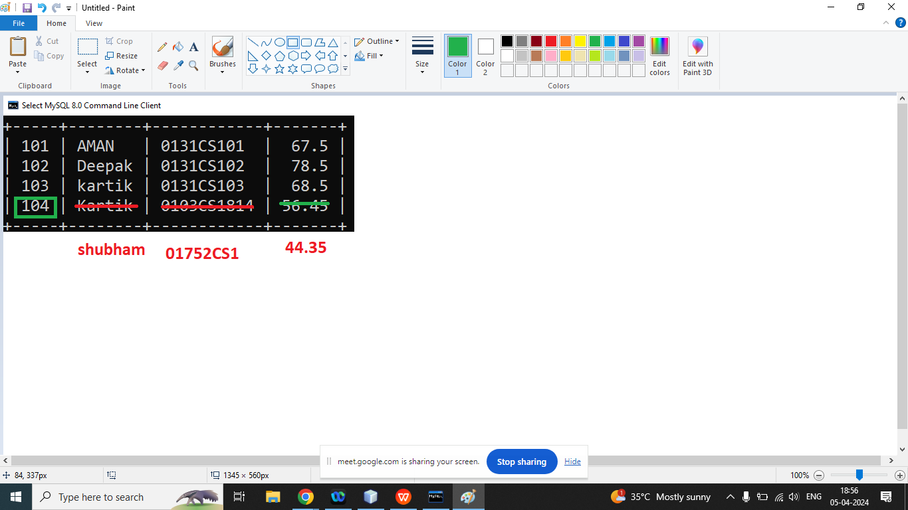

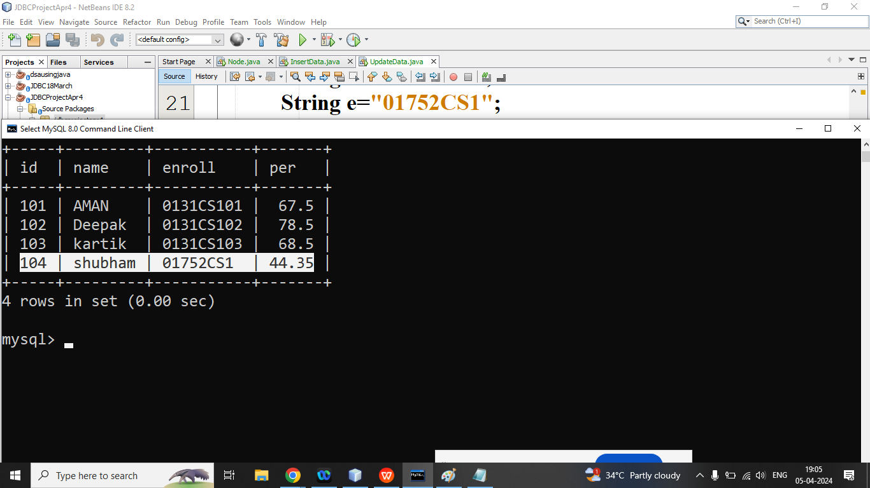

/*

* **To change this license header, choose License Headers in Project Properties.**

**\* To change this template file, choose Tools | Templates**

**\* and open the template in the editor.**

*/

package jdbcprojectapr4;

//step1

import java.sql.*;

public class UpdateData {

public static void main(String[] args) throws ClassNotFoundException, SQLException {

//step2: Register the Driver

Class.forName("com.mysql.jdbc.Driver");

//step: 3 Create the Connection

String url="jdbc:mysql://localhost:3306/march15";

String un="root";

String ps="Ram@1234";

Connection conn=DriverManager.getConnection(url, un, ps);

//step4: write sql query update

int i=104;

String n="shubham";

String e="01752CS1";

float p=44.35f;

String sql="update student set name='"+n+"',enroll='"+e+"',per='"+p+"' where id='"+i+"'";

//step5 : create an Object of Statement

Statement stmt=conn.createStatement();

//step6: call executeUpdate method of Statement

int r=stmt.executeUpdate(sql);

if(r>0){

System.out.println("Data Updated success");

}else{

System.out.println("Data not updated");

}

//step7: close the connection

conn.close();

}

}

Q3. Write a java program to delete from the table using mysql database?

Ans:

Update :

Udelete from tablename where pk=?

Step1: import java.sql.*;

Step2: Register the Driver

Class.forName(“com.mysql.jdbc.Driver”);

Step3: Create the Connction

Connection conn=DriverManager(“url”,”un”,”ps”);

Step4: Write SQL query(delete)

Step5: create object of Statement

Statement stmt=conn.createStatement();

Step6: call executeUpdate method

Step7: Close the Connection

/*

* To change this license header, choose License Headers in Project Properties.

* To change this template file, choose Tools | Templates

* and open the template in the editor.

*/

package jdbcprojectapr4;

/**

*

* @author Admin

*/

/*

* To change this license header, choose License Headers in Project Properties.

* To change this template file, choose Tools | Templates

* and open the template in the editor.

*/

//step1

import java.sql.*;

public class DeleteData {

public static void main(String[] args) throws ClassNotFoundException, SQLException {

//step2: Register the Driver

Class.forName("com.mysql.jdbc.Driver");

//step: 3 Create the Connection

String url="jdbc:mysql://localhost:3306/march15";

String un="root";

String ps="Ram@1234";

Connection conn=DriverManager.getConnection(url, un, ps);

//step4: write sql query update

int i=103;

String sql=" delete from student where id='"+i+"'";

//step5 : create an Object of Statement

Statement stmt=conn.createStatement();

//step6: call executeUpdate method of Statement

int r=stmt.executeUpdate(sql);

if(r>0){

System.out.println("Data deleted success");

}else{

System.out.println("Data not deleted");

}

//step7: close the connection

conn.close();

}

}

Q3. Write a Java Program to read all student data from the student table?

select * from student;

+-----+---------+-----------+-------+

| id | name | enroll | per |

+-----+---------+-----------+-------+

| 101 | AMAN | 0131CS101 | 67.5 |

| 102 | Deepak | 0131CS102 | 78.5 |

| 104 | shubham | 01752CS1 | 44.35 |

+-----+---------+-----------+-------+

Update :

Udelete from tablename where pk=?

Step1: import java.sql.*;

Step2: Register the Driver

Class.forName(“com.mysql.jdbc.Driver”);

Step3: Create the Connction

Connection conn=DriverManager(“url”,”un”,”ps”);

Step4: Write SQL query(select All)

Step5: create object of Statement

Statement stmt=conn.createStatement();

Step6: call executeQuery() method

Step7: Print Data one by one from ResultSet Object

Step8: Close the Connection

/*

* To change this license header, choose License Headers in Project Properties.

* To change this template file, choose Tools | Templates

* and open the template in the editor.

*/

package jdbcprojectapr4;

//Project:

// Registration

// Login

//CRUD: C(Create),R(Read),U(Update),D(Delete)

import java.sql.*;

public class FindById {

public static void main(String[] args) throws ClassNotFoundException, SQLException {

//step2: Register the Driver

Class.forName("com.mysql.jdbc.Driver");

//step: 3 Create the Connection

String url="jdbc:mysql://localhost:3306/march15";

String un="root";

String ps="Ram@1234";

Connection conn=DriverManager.getConnection(url, un, ps);

//step4: write sql select Query

int i=101;

String sql="select * from student where id='"+i+"'";

//step5 : Create Object of Statement

Statement stmt=conn.createStatement();

//step6: Call executeQuery Metod

ResultSet rs=stmt.executeQuery(sql);

//step7:print Data one by one from ResultSet Object

while(rs.next()){

System.out.println(""+rs.getInt("id")+"\t "+rs.getString("name")+"\t"+rs.getString("enroll")+"\t"+rs.getFloat("per"));

}

//step8: close the Connection

conn.close();

}

}

**Jdbc using dao class and BEANS**

Q1.JDBC Using Beans and DAO?

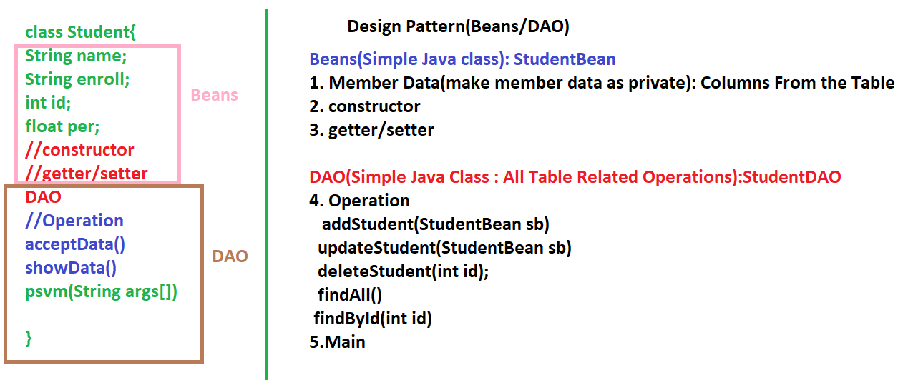

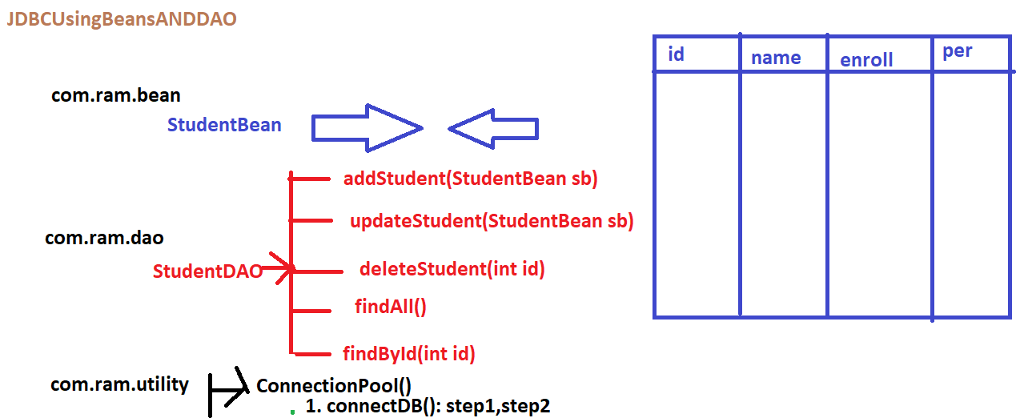

/*

**\* To change this license header, choose License Headers in Project Properties.**

**\* To change this template file, choose Tools | Templates**

**\* and open the template in the editor.**

*/

package com.ram.utility;

import java.sql.*;

import java.util.logging.Level;

import java.util.logging.Logger;

public class ConnectionPool {

static Connection conn;

//Member data static

public static Connection connectDB(){

try {

//step1: Register The Driver

Class.forName("com.mysql.cj.jdbc.Driver");

//step2: Create The Connection

String url="jdbc:mysql://localhost:3306/march15";

String un="root";

String ps="Ram@1234";

conn=DriverManager.getConnection(url, un, ps);

System.out.println("Database connectivity success");

} catch (ClassNotFoundException ex) {

Logger.getLogger(ConnectionPool.class.getName()).log(Level.SEVERE, null, ex);

} catch (SQLException ex) {

Logger.getLogger(ConnectionPool.class.getName()).log(Level.SEVERE, null, ex);

}

return conn;

}

public static void main(String[] args) {

connectDB();

}

}

/*

* To change this license header, choose License Headers in Project Properties.

* To change this template file, choose Tools | Templates

* and open the template in the editor.

*/

package com.ram.bean;

public class StudentBean {

private int id;

private String name;

private String enroll;

private float per;

public StudentBean() {

}

public StudentBean(int id, String name, String enroll, float per) {

this.id = id;

this.name = name;

this.enroll = enroll;

this.per = per;

}

public int getId() {

return id;

}

public void setId(int id) {

this.id = id;

}

public String getName() {

return name;

}

public void setName(String name) {

this.name = name;

}

public String getEnroll() {

return enroll;

}

public void setEnroll(String enroll) {

this.enroll = enroll;

}

public float getPer() {

return per;

}

public void setPer(float per) {

this.per = per;

}

}

/*

* **To change this license header, choose License Headers in Project Properties.**

**\* To change this template file, choose Tools | Templates**

**\* and open the template in the editor.**

*/

package com.ram.bean;

import java.util.Arrays;

/**

*

* @author Admin

*/

public class Test { //silent listen

public boolean isAnagram(String s,String t){

if(s.length()!=t.length()){

return false;

}

int count[]=new int[26];

for(char c1:s.toCharArray()){

count[c1-'a']++;//116-97=[19]++

}

for(char c1:t.toCharArray()){

count[c1-'a']--;//110-97=[4]--

}

for(int i=0;i<count.length;i++){

if(count[i]!=0){

return false;

}

}

return true;

}

public static void main(String[] args) {

Test t=new Test();

System.out.println(""+t.isAnagram("rat", "car"));

}

}

—------------------------------------------------------------------------------

/*

**\* To change this license header, choose License Headers in Project Properties.**

**\* To change this template file, choose Tools | Templates**

**\* and open the template in the editor.**

*/

package com.ram.dao;

import com.ram.bean.StudentBean;

import com.ram.utility.ConnectionPool;

import java.sql.*;

import java.util.logging.Level;

import java.util.logging.Logger;

public class StudentDAO {

static Connection conn;

public int addStudent(StudentBean sb) {

conn = ConnectionPool.connectDB();//step1 and step2

//step3: write SQL Query

String sql="insert into student values('"+sb.getId()+"','"+sb.getName()+"','"+sb.getEnroll()+"','"+sb.getPer()+"')";

//step4 Create Object of Statement via Connection

Statement stmt;

int r=0;

try {

stmt = conn.createStatement();

//step5 call exeuteUpdate method

r=stmt.executeUpdate(sql);

//step6: close the connection

conn.close();

} catch (SQLException ex) {

Logger.getLogger(StudentDAO.class.getName()).log(Level.SEVERE, null, ex);

}

return r;

}

public static void main(String[] args) {

StudentBean s=new StudentBean();

s.setId(105);

s.setName("kunal");

s.setEnroll("101CS34");

s.setPer(56.78f);

StudentDAO sd=new StudentDAO();

int r=sd.addStudent(s);

if(r>0){

System.out.println("Student Added Success");

}else{

System.out.println("Student Not Added");

}

}

}

—------------------------------------------------------------------

//JDBC. FIndALL Operations

/*

**\* To change this license header, choose License Headers in Project Properties.**

**\* To change this template file, choose Tools | Templates**

**\* and open the template in the editor.**

*/

package com.ram.dao;

import com.ram.bean.StudentBean;

import com.ram.utility.ConnectionPool;

import java.sql.*;

import java.util.logging.Level;

import java.util.logging.Logger;

public class StudentDAO {

static Connection conn;

public int addStudent(StudentBean sb) {

conn = ConnectionPool.connectDB();//step1 and step2

//step3: write SQL Query

String sql="insert into student values('"+sb.getId()+"','"+sb.getName()+"','"+sb.getEnroll()+"','"+sb.getPer()+"')";

//step4 Create Object of Statement via Connection

Statement stmt;

int r=0;

try {

stmt = conn.createStatement();

//step5 call exeuteUpdate method

r=stmt.executeUpdate(sql);

//step6: close the connection

conn.close();

} catch (SQLException ex) {

Logger.getLogger(StudentDAO.class.getName()).log(Level.SEVERE, null, ex);

}

return r;

}

public int updateStudent(StudentBean sb){

conn=ConnectionPool.connectDB();//step1 step2

//step3: Write SQL Query

String sql="update student set name='"+sb.getName()+"',enroll='"+sb.getEnroll()+"',per='"+sb.getPer()+"' where id='"+sb.getId()+"'";

int r=0;

try {

//step4: Create Object of Statement

Statement stmt=conn.createStatement();

//step5: call executeUpdate

r=stmt.executeUpdate(sql);

//step6: close the Connection

conn.close();

} catch (SQLException ex) {

Logger.getLogger(StudentDAO.class.getName()).log(Level.SEVERE, null, ex);

}

return r;

}

public int deleteStudent(int id){

conn=ConnectionPool.connectDB();//step1,step2

//step3: Write SQL Query

String sql="delete from student where id='"+id+"'";

//step4: Create Object of Statement

int r=0;

try {

Statement stmt=conn.createStatement();

//step5: call executeUpdate() method

r=stmt.executeUpdate(sql);

//step6: Close the Connection

} catch (SQLException ex) {

Logger.getLogger(StudentDAO.class.getName()).log(Level.SEVERE, null, ex);

}

return r;

}

public void findAll(){

conn=ConnectionPool.connectDB(); //step1,step2

//step3 :Write SQL Query

String sql="select * from student";

try {

//step4: Create Object of Statement

Statement stmt=conn.createStatement();

//step5: call executeQuery

ResultSet rs=stmt.executeQuery(sql);

//step6: Process Result

while(rs.next()){

System.out.println(""+rs.getInt("id")+"\t"+rs.getString("name")+"\t"+rs.getString("enroll")+"\t"+rs.getFloat("per"));

}

//step7: Close the Connections

conn.close();

} catch (SQLException ex) {

Logger.getLogger(StudentDAO.class.getName()).log(Level.SEVERE, null, ex);

}

}

public static void main(String[] args) {

StudentBean s=new StudentBean();

s.setId(105);

s.setName("XXXX");

s.setEnroll("YYYY");

s.setPer(1.0f);

StudentDAO sd=new StudentDAO();

//1. addStudent

// int r=sd.addStudent(s);

// if(r>0){

// System.out.println("Student Added Success");

// }else{

// System.out.println("Student Not Added");

// }

//2. call updateStudent() method

// int r=sd.updateStudent(s);

// if(r>0){

// System.out.println("Student updated Success");

// }else{

// System.out.println("Student Not updated");

// }

//3. call deleteStudent() method

//int r=sd.deleteStudent(101);

//if(r>0){

// System.out.println("Delete Student success");

//}else{

// System.out.println("Student Not Deleted");

//}

//4. Call findAll method

//StudentDAO sd=new StudentDAO();

sd.findAll();

}

}

—--------------------------------------------------------------------------

/*

**\* To change this license header, choose License Headers in Project Properties.**

**\* To change this template file, choose Tools | Templates**

**\* and open the template in the editor.**

*/

package dsausingjava;

import java.util.ArrayList;

import java.util.Iterator;

public class A3 {

public static void main(String[] args) {

ArrayList al=new ArrayList();

al.add(10);

al.add("Twenty");

al.add(30.0);

al.add(40.0f);

al.add('A');

al.add(true);

al.add(10);

System.out.println(al);

System.out.println("Size of Array List : "+al.size());

System.out.println("Print ArrayList Data Using get(int index)");

for(int i=0;i<al.size();i++){

System.out.println("==>"+al.get(i));

}

System.out.println("Print ArrayList Data Using Foreach Loop : ");

for(Object x:al){

System.out.println("===>"+x);

}

System.out.println("Print ArrayList Data Using Iterator : ");

Iterator itr=al.iterator();

while(itr.hasNext()){

Object i=itr.next();

if(i.equals(10)){

itr.remove();

}

}

System.out.println(""+al);

}

}

—----------------------------------------------------------------------------

/*

**\* To change this license header, choose License Headers in Project Properties.**

**\* To change this template file, choose Tools | Templates**

**\* and open the template in the editor.**

*/

package dsausingjava;

import java.util.ArrayList;

import java.util.Collections;

import java.util.Iterator;

public class A3 {

public static void main(String[] args) {

ArrayList<Integer> al = new ArrayList();

al.add(100);

al.add(10);

al.add(90);

al.add(20);

al.add(80);

al.add(30);

al.add(70);

al.add(40);

al.add(60);

al.add(50);

System.out.println("Data Before Sorting : " + al);

Collections.sort(al);

System.out.println("Data After Sorting : " + al);

int max = Collections.max(al);

System.out.println("Maximum Element : " + max);

int min = Collections.min(al);

System.out.println("Minimum Element : " + min);

}

}

—-------------------------------------------------------------------

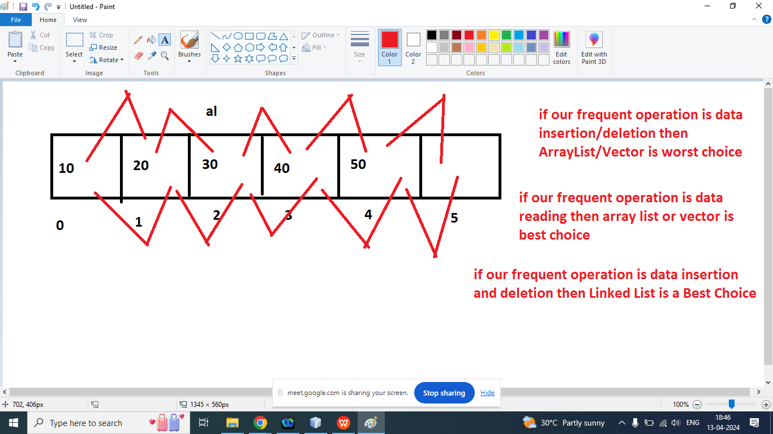

/*

* To change this license header, choose License Headers in Project Properties.

* To change this template file, choose Tools | Templates

* and open the template in the editor.

*/

package dsausingjava;

import java.util.ArrayList;

import java.util.LinkedList;

/**

*

* @author Admin

*/

public class A4 {

public static void main(String[] args) {

long startTime=System.currentTimeMillis();

ArrayList<Integer> al=new ArrayList();

for(int i=0;i<10000000;i++){

al.add(i);

}

long endTime=System.currentTimeMillis();

System.out.println("Time Taken By ArrayList : "+(endTime-startTime));

startTime=System.currentTimeMillis();

LinkedList<Integer> ld=new LinkedList();

for(int i=0;i<10000000;i++){

ld.add(i);

}

endTime=System.currentTimeMillis();

System.out.println("Time Taken By LinkedList : "+(endTime-startTime));

}

}

**/\***

**\* To change this license header, choose License Headers in Project Properties.**

**\* To change this template file, choose Tools | Templates**

**\* and open the template in the editor.**

*/

package dsausingjava;

import java.util.Enumeration;

import java.util.Iterator;

import java.util.Vector;

/**

*

* @author Admin

*/

public class V1 {

public static void main(String[] args) {

Vector v=new Vector();

v.add(10);

v.add("twenty");

v.add(30.0f);

v.add(40.0);

v.add(true);

v.add('A');

v.add(10);

System.out.println(""+v);

System.out.println("Print Vector element using get(int index)");

for(int i=0;i<v.size();i++){

System.out.println("==>"+v.get(i));

}

//print Vector Element Using Enumeration

System.out.println("Print Vector element using Enumeration ");

Enumeration e=v.elements();

while(e.hasMoreElements()){

System.out.println(""+e.nextElement());

}

//print Vector Element Using Enumerations

System.out.println("Print Vector element using Iterator ");

Iterator itr=v.iterator();

while(itr.hasNext()){

Object x=itr.next();

if(x.equals(10)){

itr.remove();

}else{

System.out.println("#####=>"+x);

}

}

System.out.println(""+v);

}

}

All Cursor Example

/*

**\* To change this license header, choose License Headers in Project Properties.**

**\* To change this template file, choose Tools | Templates**

**\* and open the template in the editor.**

*/

package dsausingjava;

import java.util.Enumeration;

import java.util.Iterator;

import java.util.ListIterator;

import java.util.Vector;

/**

*

* @author Admin

*/

public class V1 {

public static void main(String[] args) {

Vector v=new Vector();

v.add(10);

v.add("twenty");

v.add(30.0f);

v.add(40.0);

v.add(true);

v.add('A');

v.add(10);

System.out.println(""+v);

System.out.println("Print Vector element using get(int index)");

for(int i=0;i<v.size();i++){

System.out.println("==>"+v.get(i));

}

//print Vector Element Using Enumeration

System.out.println("Print Vector element using Enumeration ");

Enumeration e=v.elements();dl

while(e.hasMoreElements()){

System.out.println(""+e.nextElement());

}

//print Vector Element Using Enumerations

System.out.println("Print Vector element using Iterator ");

Iterator itr=v.iterator();

while(itr.hasNext()){

Object x=itr.next();

if(x.equals(10)){

// itr.remove();

}else{

System.out.println("#####=>"+x);

}

}

System.out.println(""+v);

System.out.println("Print Data of Vector using ListIterator , forward direction ");

ListIterator ltr=v.listIterator();

while(ltr.hasNext()){

Object x=ltr.next();

if(x.equals(10)){

ltr.set(111);//to update

}else if(x.equals(30.0f)){

ltr.add(333);//add new element

}

else if(x.equals(true)){

ltr.remove();//delete element

}

System.out.print("==>"+x);

}

System.out.println("Print Data of Vector using ListIterator , backward direction ");

while(ltr.hasPrevious()){

System.out.print("==>"+ltr.previous());

}

}

}

Q1. Remove Duplicates Element from the List?

Ans:

/*

**\* To change this license header, choose License Headers in Project Properties.**

**\* To change this template file, choose Tools | Templates**

**\* and open the template in the editor.**

*/

package dsausingjava;

import java.util.Vector;

/**

*

* @author Admin

*/

public class V2 {

public static void main(String[] args) {

Vector<Integer> v=new Vector();

v.add(10);

v.add(90);

v.add(20);

v.add(100);

for (int i = 0; i <=100; i+=10) {

v.add(i);

}

Vector unq=new Vector();

for(int x:v){

if(!unq.contains(x)){

unq.add(x);

}

}

System.out.println("after duplicates remove : "+unq);

}

}

Arrays.sort method

import java.util.Arrays;

/*

**\* To change this license header, choose License Headers in Project Properties.**

**\* To change this template file, choose Tools | Templates**

**\* and open the template in the editor.**

**\*/**

/**

*

* @author Admin

*/

public class A1 {

public static void main(String[] args) {

int nums[]={100,10,90,20,80,30,70,40,60,50};

System.out.println("Before Sorting : ");

for(int i=0;i<nums.length;i++){

System.out.print("\t"+nums[i]);

}

Arrays.sort(nums);

System.out.println("\nAfter Sorting : ");

for(int i=0;i<nums.length;i++){

System.out.print("\t"+nums[i]);

}

}

}

============

import java.util.Arrays;

import java.util.Comparator;

/*

**\* To change this license header, choose License Headers in Project Properties.**

**\* To change this template file, choose Tools | Templates**

**\* and open the template in the editor.**

**\*/**

/**

*

* @author Admin

*/

public class A1 implements Comparator<Integer>{

public static void main(String[] args) {

Integer nums[]={100,10,90,20,80,30,70,40,60,50};

System.out.println("Before Sorting : ");

for(int i=0;i<nums.length;i++){

System.out.print("\t"+nums[i]);

}

A1 c=new A1();

Arrays.sort(nums, c);

System.out.println("\nAfter Sorting : ");

for(int i=0;i<nums.length;i++){

System.out.print("\t"+nums[i]);

}

}

@Override

public int compare(Integer o1, Integer o2) {

if(o1>o2){

return -1;

}else if(o1<o2){

return +1;

}

else{

return 0;

}

}

}

==========================================

Ram sir youtube channel

<https://www.youtube.com/watch?v=6nso4tkTeXI&list=PL7_jGrBRCEHEAGKLL8OIb-fvI_qoSEHLE>

import java.util.Collection;

import java.util.HashMap;

import java.util.Set;

/*

**\* To change this license header, choose License Headers in Project Properties.**

**\* To change this template file, choose Tools | Templates**

**\* and open the template in the editor.**

**\*/**

/**

*

* @author Admin

*/

public class HM {

public static void main(String[] args) {

HashMap<String,Integer> m=new HashMap<>();

m.put("TEN", 10);

m.put("Twenty", 20);

m.put("Thirty", 30);

m.put("Fourty", 40);

m.put("Fifty", 50);

m.put("Sixty", 60);

m.put("Seventy", 70);

System.out.println(""+m);

Set allkeys=m.keySet();

System.out.println("All Keys : "+allkeys);

Collection c=m.values();

System.out.println("All Values : "+c);

System.out.println("Print Key Value Pair one by one : ");

for(Object k:allkeys){

System.out.println("Key is : "+k+" and Value is : "+m.get(k));

}

System.out.println("Contains : Fifty key : "+m.containsKey("Fifty"));

// m.clear();

m.remove("Fifty");

System.out.println(""+m);

}

}

====================================================

import java.util.Collection;

import java.util.HashMap;

import java.util.LinkedHashMap;

import java.util.Set;

/*

**\* To change this license header, choose License Headers in Project Properties.**

**\* To change this template file, choose Tools | Templates**

**\* and open the template in the editor.**

**\*/**

/**

*

* @author Admin

*/

public class HM {

public static void main(String[] args) {

LinkedHashMap<String,Integer> m=new LinkedHashMap<>();

m.put("TEN", 10);

m.put("Twenty", 20);

m.put("Thirty", 30);

m.put("Fourty", 40);

m.put("Fifty", 50);

m.put("Sixty", 60);

m.put("Seventy", 70);

System.out.println(""+m);

Set allkeys=m.keySet();

System.out.println("All Keys : "+allkeys);

Collection c=m.values();

System.out.println("All Values : "+c);

System.out.println("Print Key Value Pair one by one : ");

for(Object k:allkeys){

System.out.println("Key is : "+k+" and Value is : "+m.get(k));

}

System.out.println("Contains : Fifty key : "+m.containsKey("Fifty"));

// m.clear();

m.remove("Fifty");

System.out.println(""+m);

}

}

=============================================================

import java.util.Comparator;

import java.util.TreeMap;

**/\***

**\* To change this license header, choose License Headers in Project Properties.**

**\* To change this template file, choose Tools | Templates**

**\* and open the template in the editor.**

**\*/**

/**

*

* @author Admin

*/

public class Tm implements Comparator<Integer>{

public static void main(String[] args) {

Tm x=new Tm();

TreeMap<Integer,Integer> hm=new TreeMap(x);

hm.put(100, 2000);

hm.put(10, 20);

hm.put(200, 3000);

hm.put(30, 5000);

hm.put(300, 7000);

hm.put(400, 8000);

System.out.println(""+hm);

}

@Override

public int compare(Integer o1, Integer o2) {

if(o1>o2){

return -1;

}else if(o1<o2){

return +1;

}else{

return 0;

}

}

}

=========================

Q1. Write a java program to print duplicate and unique element?

import java.util.HashMap;

import java.util.Set;

/*

**\* To change this license header, choose License Headers in Project Properties.**

**\* To change this template file, choose Tools | Templates**

**\* and open the template in the editor.**

**\*/**

/**

*

* @author Admin

*/

public class Hm1 {

public static void main(String[] args) {

HashMap<Integer,Integer> en=new HashMap<>();

int arr[]={4,1,0,2,3,1,2,3};

for(int i=0;i<arr.length;i++){

if(en.containsKey(arr[i]))

{

en.put(arr[i],en.get(arr[i])+1);

}

else

{

en.put(arr[i],1);

}

}

System.out.println(""+en);

Set allkeys=en.keySet();

System.out.println("Print Duplicate Elements : ");

for(Object k:allkeys){

if(en.get(k)>1){

System.out.println(k+"====>"+en.get(k));

}

}

System.out.println("Print Unique Elements : ");

for(Object k:allkeys){

if(en.get(k)==1){

System.out.println(k+"====>"+en.get(k));

}

}

}

}

import java.util.Hashtable;

/*

**\* To change this license header, choose License Headers in Project Properties.**

**\* To change this template file, choose Tools | Templates**

**\* and open the template in the editor.**

**\*/**

/**

*

* @author Admin

*/

public class hs1 {

public static void main(String[] args) {

Hashtable<String,Integer> mp=new Hashtable<>();

mp.put("A", 65);

mp.put("Z", 90);

mp.put("B", 66);

mp.put("Y", 89);

System.out.println(""+mp);

}

}

**Q1. Write a java program to read data from the properties file**

**db.properties**

# To change this license header, choose License Headers in Project Properties.

# To change this template file, choose Tools | Templates

# and open the template in the editor.

url=jdbc:mysql://localhost:3306/march15

username=root

password=Ram@1234

import java.io.FileNotFoundException;

import java.io.FileReader;

import java.io.IOException;

import java.util.Properties;

/*

**\* To change this license header, choose License Headers in Project Properties.**

**\* To change this template file, choose Tools | Templates**

**\* and open the template in the editor.**

**\*/**

/**

*

* @author Admin

*/

public class P1 {

public static void main(String[] args) throws FileNotFoundException, IOException {

FileReader reader=new FileReader("db.properties");

Properties p=new Properties();

p.load(reader);

System.out.println("URL : "+p.getProperty("url"));

System.out.println("UserName : "+p.getProperty("username"));

System.out.println("Password : "+p.getProperty("password"));

}

}

Q2. Write a java program to write data into properties file?

import java.io.FileNotFoundException;

import java.io.FileReader;

import java.io.FileWriter;

import java.io.IOException;

import java.util.Properties;

/*

**\* To change this license header, choose License Headers in Project Properties.**

**\* To change this template file, choose Tools | Templates**

**\* and open the template in the editor.**

**\*/**

/**

*

* @author Admin

*/

public class P1 {

public static void main(String[] args) throws FileNotFoundException, IOException {

Properties p=new Properties();

p.setProperty("name", "Ram Lovewanshi");

p.setProperty("email", "ramsoftware786@gmail.com");

p.store(new FileWriter("db.properties"), "This is Data write into property file using java");

}

}

db.properties

#This is Data write into property file using java

#Sat Apr 20 19:18:42 IST 2024

email=ramsoftware786@gmail.com

name=Ram Lovewanshi

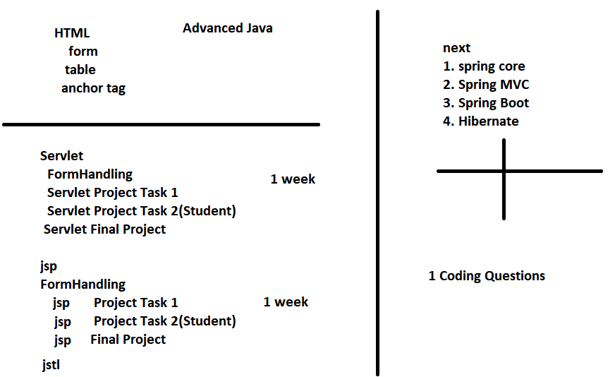

Next week: Screening Test

1. MCQ(Core Java + SQL +JDBC)
2. Coding Test

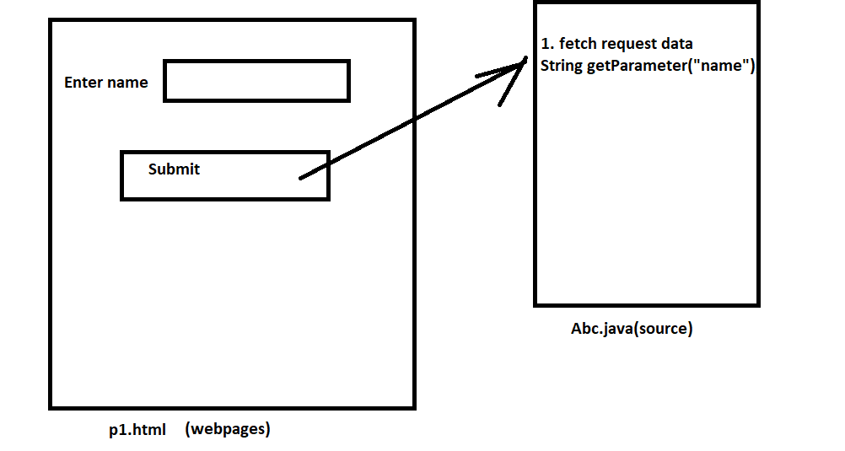

窗体顶端

Enter Name 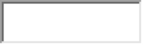  


窗体底端

Abc.java:

/*

**\* To change this license header, choose License Headers in Project Properties.**

**\* To change this template file, choose Tools | Templates**

**\* and open the template in the editor.**

**\*/**

import java.io.IOException;

import java.io.PrintWriter;

import javax.servlet.ServletException;

import javax.servlet.http.HttpServlet;

import javax.servlet.http.HttpServletRequest;

import javax.servlet.http.HttpServletResponse;

/**

*

* @author Admin

*/

public class Abc extends HttpServlet {

/**

* Processes requests for both HTTP <code>GET</code> and <code>POST</code>

* methods.

*

* @param request servlet request

* @param response servlet response

* @throws ServletException if a servlet-specific error occurs

* @throws IOException if an I/O error occurs

*/

protected void processRequest(HttpServletRequest request, HttpServletResponse response)

throws ServletException, IOException {

response.setContentType("text/html;charset=UTF-8");

try (PrintWriter out = response.getWriter()) {

/* TODO output your page here. You may use following sample code. */

out.println("<!DOCTYPE html>");

out.println("<html>");

out.println("<head>");

out.println("<title>Servlet Abc</title>");

out.println("</head>");

out.println("<body>");

String name=request.getParameter("myname");

out.println("<h1>Welcome " +name + "</h1>");

out.println("</body>");

out.println("</html>");

}

}

// <editor-fold defaultstate="collapsed" desc="HttpServlet methods. Click on the + sign on the left to edit the code.">

/**

* Handles the HTTP <code>GET</code> method.

*

* @param request servlet request

* @param response servlet response

* @throws ServletException if a servlet-specific error occurs

* @throws IOException if an I/O error occurs

*/

@Override

protected void doGet(HttpServletRequest request, HttpServletResponse response)

throws ServletException, IOException {

processRequest(request, response);

}

/**

* Handles the HTTP <code>POST</code> method.

*

* @param request servlet request

* @param response servlet response

* @throws ServletException if a servlet-specific error occurs

* @throws IOException if an I/O error occurs

*/

@Override

protected void doPost(HttpServletRequest request, HttpServletResponse response)

throws ServletException, IOException {

processRequest(request, response);

}

/**

* Returns a short description of the servlet.

*

* @return a String containing servlet description

*/

@Override

public String getServletInfo() {

return "Short description";

}// </editor-fold>

}

Q2. Explain Servlet?

Ans:

**Servlet is a small program written in java executed on Server**

Q2.

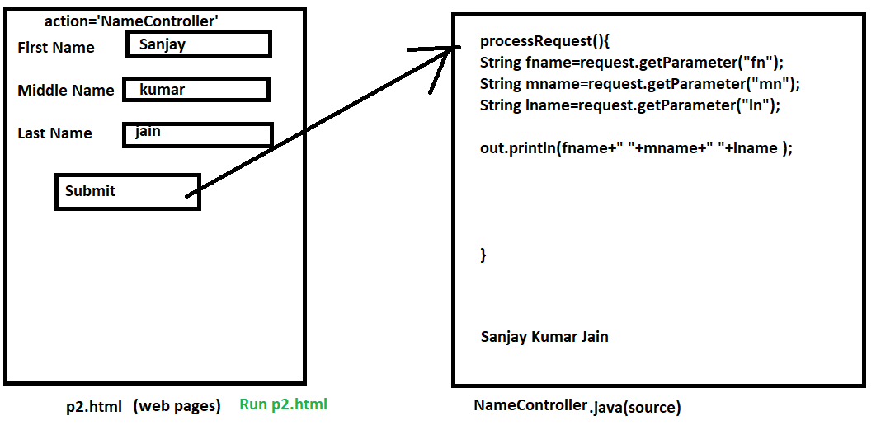

窗体顶端

First Name   
Middle Name   
Last Name   


窗体底端

NameController(Servlet)

/*

**\* To change this license header, choose License Headers in Project Properties.**

**\* To change this template file, choose Tools | Templates**

**\* and open the template in the editor.**

*/

import java.io.IOException;

import java.io.PrintWriter;

import javax.servlet.ServletException;

import javax.servlet.http.HttpServlet;

import javax.servlet.http.HttpServletRequest;

import javax.servlet.http.HttpServletResponse;

/**

*

* @author Admin

*/

public class NameController extends HttpServlet {

/**

* Processes requests for both HTTP <code>GET</code> and <code>POST</code>

* methods.

*

* @param request servlet request

* @param response servlet response

* @throws ServletException if a servlet-specific error occurs

* @throws IOException if an I/O error occurs

*/

protected void processRequest(HttpServletRequest request, HttpServletResponse response)

throws ServletException, IOException {

response.setContentType("text/html;charset=UTF-8");

try (PrintWriter out = response.getWriter()) {

/* TODO output your page here. You may use following sample code. */

out.println("<!DOCTYPE html>");

out.println("<html>");

out.println("<head>");

out.println("<title>Servlet NameController</title>");

out.println("</head>");

out.println("<body>");

String fname=request.getParameter("fn");

String mname=request.getParameter("mn");

String lname=request.getParameter("ln");

String fullname=fname+" "+mname+" "+lname;

out.println("<h1>" + fullname+ "</h1>");

out.println("</body>");

out.println("</html>");

}

}

// <editor-fold defaultstate="collapsed" desc="HttpServlet methods. Click on the + sign on the left to edit the code.">

/**

* Handles the HTTP <code>GET</code> method.

*

* @param request servlet request

* @param response servlet response

* @throws ServletException if a servlet-specific error occurs

* @throws IOException if an I/O error occurs

*/

@Override

protected void doGet(HttpServletRequest request, HttpServletResponse response)

throws ServletException, IOException {

processRequest(request, response);

}

/**

* Handles the HTTP <code>POST</code> method.

*

* @param request servlet request

* @param response servlet response

* @throws ServletException if a servlet-specific error occurs

* @throws IOException if an I/O error occurs

*/

@Override

protected void doPost(HttpServletRequest request, HttpServletResponse response)

throws ServletException, IOException {

processRequest(request, response);

}

/**

* Returns a short description of the servlet.

*

* @return a String containing servlet description

*/

@Override

public String getServletInfo() {

return "Short description";

}// </editor-fold>

}

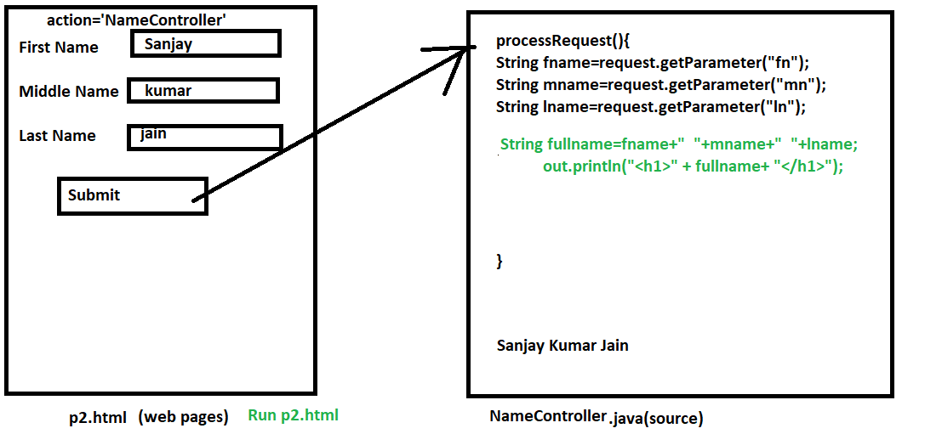

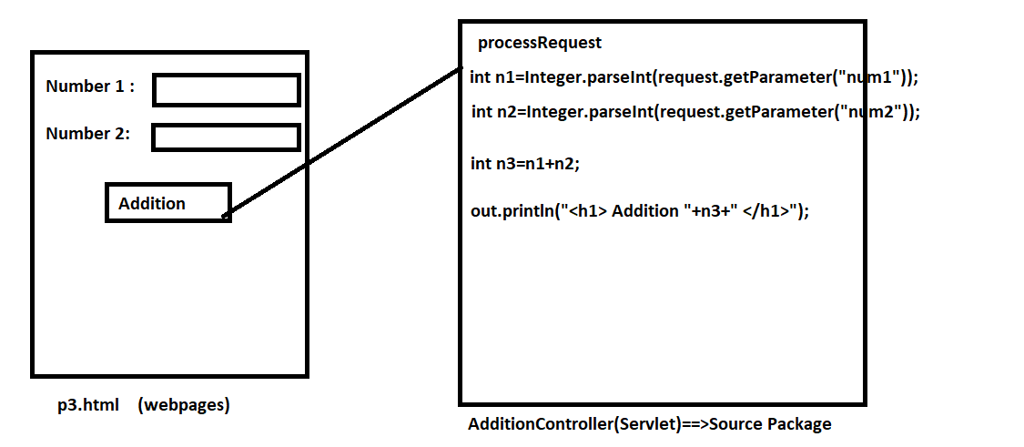

窗体顶端

Number 1 :   
Number 2 :   


窗体底端

AdditionController

/*

**\* To change this license header, choose License Headers in Project Properties.**

**\* To change this template file, choose Tools | Templates**

**\* and open the template in the editor.**

**\*/**

import java.io.IOException;

import java.io.PrintWriter;

import javax.servlet.ServletException;

import javax.servlet.http.HttpServlet;

import javax.servlet.http.HttpServletRequest;

import javax.servlet.http.HttpServletResponse;

/**

*

* @author Admin

*/

public class AdditionController extends HttpServlet {

/**

* Processes requests for both HTTP <code>GET</code> and <code>POST</code>

* methods.

*

* @param request servlet request

* @param response servlet response

* @throws ServletException if a servlet-specific error occurs

* @throws IOException if an I/O error occurs

*/

protected void processRequest(HttpServletRequest request, HttpServletResponse response)

throws ServletException, IOException {

response.setContentType("text/html;charset=UTF-8");

try (PrintWriter out = response.getWriter()) {

/* TODO output your page here. You may use following sample code. */

out.println("<!DOCTYPE html>");

out.println("<html>");

out.println("<head>");

out.println("<title>Servlet AdditionController</title>");

out.println("</head>");

out.println("<body>");

int n1=Integer.parseInt(request.getParameter("num1"));

int n2=Integer.parseInt(request.getParameter("num2"));

int n3=n1+n2;

out.println("<h1>Addition " +n3 + "</h1>");

out.println("</body>");

out.println("</html>");

}

}

// <editor-fold defaultstate="collapsed" desc="HttpServlet methods. Click on the + sign on the left to edit the code.">

/**

* Handles the HTTP <code>GET</code> method.

*

* @param request servlet request

* @param response servlet response

* @throws ServletException if a servlet-specific error occurs

* @throws IOException if an I/O error occurs

*/

@Override

protected void doGet(HttpServletRequest request, HttpServletResponse response)

throws ServletException, IOException {

processRequest(request, response);

}

/**

* Handles the HTTP <code>POST</code> method.

*

* @param request servlet request

* @param response servlet response

* @throws ServletException if a servlet-specific error occurs

* @throws IOException if an I/O error occurs

*/

@Override

protected void doPost(HttpServletRequest request, HttpServletResponse response)

throws ServletException, IOException {

processRequest(request, response);

}

/**

* Returns a short description of the servlet.

*

* @return a String containing servlet description

*/

@Override

public String getServletInfo() {

return "Short description";

}// </editor-fold>

}

Q1.

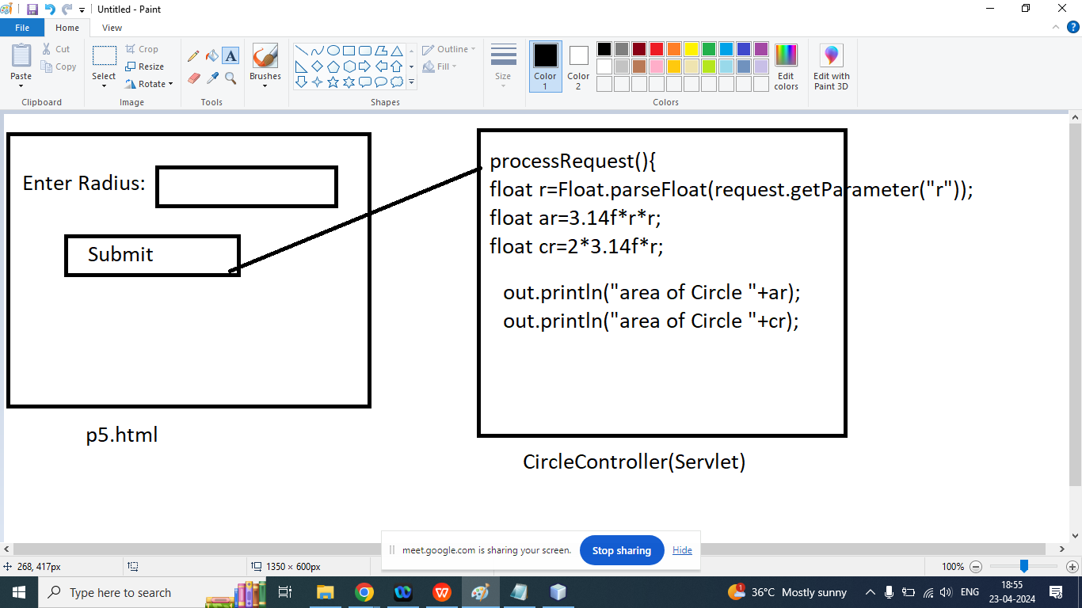

窗体顶端

Enter Radius :   


窗体底端

/*

**\* To change this license header, choose License Headers in Project Properties.**

**\* To change this template file, choose Tools | Templates**

**\* and open the template in the editor.**

**\*/**

import java.io.IOException;

import java.io.PrintWriter;

import javax.servlet.ServletException;

import javax.servlet.http.HttpServlet;

import javax.servlet.http.HttpServletRequest;

import javax.servlet.http.HttpServletResponse;

/**

*

* @author Admin

*/

public class CircleController extends HttpServlet {

/**

* Processes requests for both HTTP <code>GET</code> and <code>POST</code>

* methods.

*

* @param request servlet request

* @param response servlet response

* @throws ServletException if a servlet-specific error occurs

* @throws IOException if an I/O error occurs

*/

protected void processRequest(HttpServletRequest request, HttpServletResponse response)

throws ServletException, IOException {

response.setContentType("text/html;charset=UTF-8");

try (PrintWriter out = response.getWriter()) {

/* TODO output your page here. You may use following sample code. */

out.println("<!DOCTYPE html>");

out.println("<html>");

out.println("<head>");

out.println("<title>Servlet CircleController</title>");

out.println("</head>");

out.println("<body>");

float r=Float.parseFloat(request.getParameter("r"));

float ar=3.14f*r*r;

float cr=2*3.14f*r;

out.println("<h1>Area of Circle " + ar+ "</h1>");

out.println("<h1>Circumference of Circle " + cr+ "</h1>");

out.println("</body>");

out.println("</html>");

}

}

// <editor-fold defaultstate="collapsed" desc="HttpServlet methods. Click on the + sign on the left to edit the code.">

/**

* Handles the HTTP <code>GET</code> method.

*

* @param request servlet request

* @param response servlet response

* @throws ServletException if a servlet-specific error occurs

* @throws IOException if an I/O error occurs

*/

@Override

protected void doGet(HttpServletRequest request, HttpServletResponse response)

throws ServletException, IOException {

processRequest(request, response);

}

/**

* Handles the HTTP <code>POST</code> method.

*

* @param request servlet request

* @param response servlet response

* @throws ServletException if a servlet-specific error occurs

* @throws IOException if an I/O error occurs

*/

@Override

protected void doPost(HttpServletRequest request, HttpServletResponse response)

throws ServletException, IOException {

processRequest(request, response);

}

/**

* Returns a short description of the servlet.

*

* @return a String containing servlet description

*/

@Override

public String getServletInfo() {

return "Short description";

}// </editor-fold>

}

RadioControlls

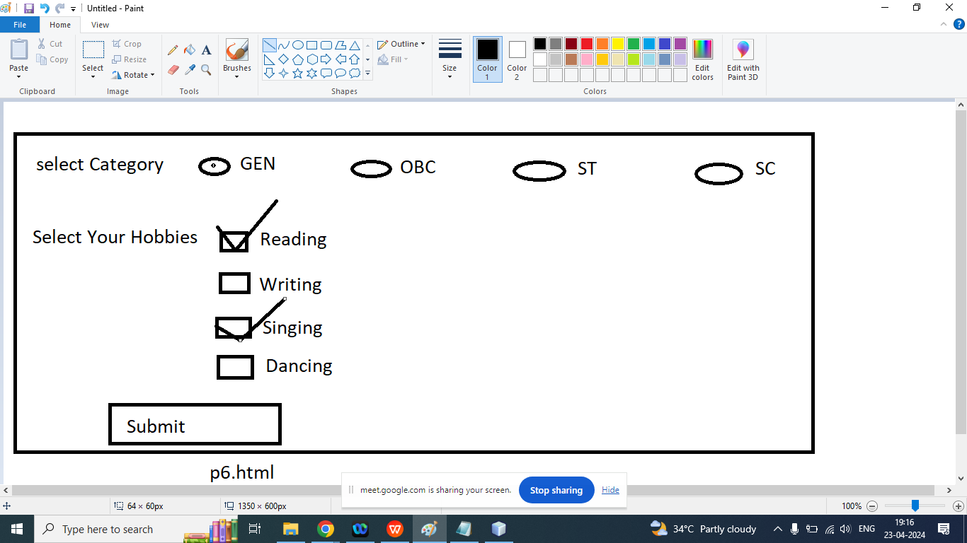

/*

* To change this license header, choose License Headers in Project Properties.

* To change this template file, choose Tools | Templates

* and open the template in the editor.

*/

import java.io.IOException;

import java.io.PrintWriter;

import javax.servlet.ServletException;

import javax.servlet.http.HttpServlet;

import javax.servlet.http.HttpServletRequest;

import javax.servlet.http.HttpServletResponse;

/**

*

* @author Admin

*/

public class RController extends HttpServlet {

/**

* Processes requests for both HTTP <code>GET</code> and <code>POST</code>

* methods.

*

* @param request servlet request

* @param response servlet response

* @throws ServletException if a servlet-specific error occurs

* @throws IOException if an I/O error occurs

*/

protected void processRequest(HttpServletRequest request, HttpServletResponse response)

throws ServletException, IOException {

response.setContentType("text/html;charset=UTF-8");

try (PrintWriter out = response.getWriter()) {

/* TODO output your page here. You may use following sample code. */

out.println("<!DOCTYPE html>");

out.println("<html>");

out.println("<head>");

out.println("<title>Servlet RController</title>");

out.println("</head>");

out.println("<body>");

String c=request.getParameter("cat");

out.println("<h1>Your Category is : " +c + "</h1>");

out.println("</body>");

out.println("</html>");

}

}

// <editor-fold defaultstate="collapsed" desc="HttpServlet methods. Click on the + sign on the left to edit the code.">

/**

* Handles the HTTP <code>GET</code> method.

*

* @param request servlet request

* @param response servlet response

* @throws ServletException if a servlet-specific error occurs

* @throws IOException if an I/O error occurs

*/

@Override

protected void doGet(HttpServletRequest request, HttpServletResponse response)

throws ServletException, IOException {

processRequest(request, response);

}

/**

* Handles the HTTP <code>POST</code> method.

*

* @param request servlet request

* @param response servlet response

* @throws ServletException if a servlet-specific error occurs

* @throws IOException if an I/O error occurs

*/

@Override

protected void doPost(HttpServletRequest request, HttpServletResponse response)

throws ServletException, IOException {

processRequest(request, response);

}

/**

* Returns a short description of the servlet.

*

* @return a String containing servlet description

*/

@Override

public String getServletInfo() {

return "Short description";

}// </editor-fold>

}

CheckBox

窗体顶端

Select Your Hobbies:  
Reading  
Writing  
Singing  
Dancing  
  


窗体底端

/*

**\* To change this license header, choose License Headers in Project Properties.**

**\* To change this template file, choose Tools | Templates**

**\* and open the template in the editor.**

**\*/**

import java.io.IOException;

import java.io.PrintWriter;

import javax.servlet.ServletException;

import javax.servlet.http.HttpServlet;

import javax.servlet.http.HttpServletRequest;

import javax.servlet.http.HttpServletResponse;

/**

*

* @author Admin

*/

public class CheckController extends HttpServlet {

/**

* Processes requests for both HTTP <code>GET</code> and <code>POST</code>

* methods.

*

* @param request servlet request

* @param response servlet response

* @throws ServletException if a servlet-specific error occurs

* @throws IOException if an I/O error occurs

*/

protected void processRequest(HttpServletRequest request, HttpServletResponse response)

throws ServletException, IOException {

response.setContentType("text/html;charset=UTF-8");

try (PrintWriter out = response.getWriter()) {

/* TODO output your page here. You may use following sample code. */

out.println("<!DOCTYPE html>");

out.println("<html>");

out.println("<head>");

out.println("<title>Servlet CheckController</title>");

out.println("</head>");

out.println("<body>");

String hb[]=request.getParameterValues("h");

out.println("<h1>Your Hobbies Are : </h1>");

for(String a:hb){

out.println("<h1>"+a+"</h1>");

}

out.println("</body>");

out.println("</html>");

}

}

// <editor-fold defaultstate="collapsed" desc="HttpServlet methods. Click on the + sign on the left to edit the code.">

/**

* Handles the HTTP <code>GET</code> method.

*

* @param request servlet request

* @param response servlet response

* @throws ServletException if a servlet-specific error occurs

* @throws IOException if an I/O error occurs

*/

@Override

protected void doGet(HttpServletRequest request, HttpServletResponse response)

throws ServletException, IOException {

processRequest(request, response);

}

/**

* Handles the HTTP <code>POST</code> method.

*

* @param request servlet request

* @param response servlet response

* @throws ServletException if a servlet-specific error occurs

* @throws IOException if an I/O error occurs

*/

@Override

protected void doPost(HttpServletRequest request, HttpServletResponse response)

throws ServletException, IOException {

processRequest(request, response);

}

/**

* Returns a short description of the servlet.

*

* @return a String containing servlet description

*/

@Override

public String getServletInfo() {

return "Short description";

}// </editor-fold>

}

<https://www.researchgate.net/figure/Student-basic-information-form_fig4_327201996>

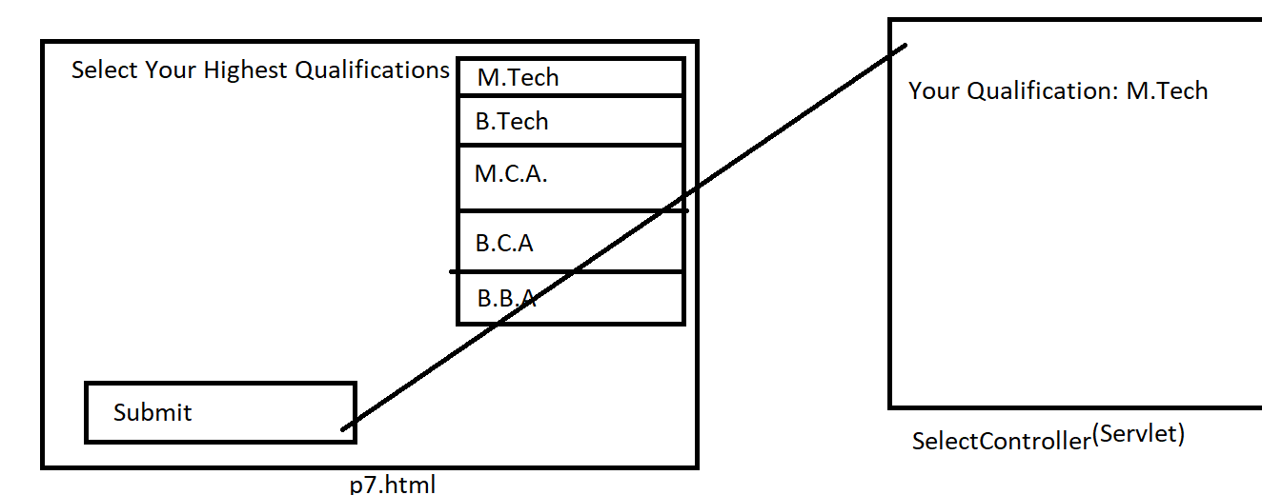

窗体顶端

Select Your Highest Qualification  

窗体底端

/*

**\* To change this license header, choose License Headers in Project Properties.**

**\* To change this template file, choose Tools | Templates**

**\* and open the template in the editor.**

**\*/**

import java.io.IOException;

import java.io.PrintWriter;

import javax.servlet.ServletException;

import javax.servlet.http.HttpServlet;

import javax.servlet.http.HttpServletRequest;

import javax.servlet.http.HttpServletResponse;

/**

*

* @author Admin

*/

public class SController extends HttpServlet {

/**

* Processes requests for both HTTP <code>GET</code> and <code>POST</code>

* methods.

*

* @param request servlet request

* @param response servlet response

* @throws ServletException if a servlet-specific error occurs

* @throws IOException if an I/O error occurs

*/

protected void processRequest(HttpServletRequest request, HttpServletResponse response)

throws ServletException, IOException {

response.setContentType("text/html;charset=UTF-8");

try (PrintWriter out = response.getWriter()) {

/* TODO output your page here. You may use following sample code. */

out.println("<!DOCTYPE html>");

out.println("<html>");

out.println("<head>");

out.println("<title>Servlet SController</title>");

out.println("</head>");

out.println("<body>");

String qual=request.getParameter("q");

out.println("<h1>Your Qualification : " + qual + "</h1>");

out.println("</body>");

out.println("</html>");

}

}

// <editor-fold defaultstate="collapsed" desc="HttpServlet methods. Click on the + sign on the left to edit the code.">

/**

* Handles the HTTP <code>GET</code> method.

*

* @param request servlet request

* @param response servlet response

* @throws ServletException if a servlet-specific error occurs

* @throws IOException if an I/O error occurs

*/

@Override

protected void doGet(HttpServletRequest request, HttpServletResponse response)

throws ServletException, IOException {

processRequest(request, response);

}

/**

* Handles the HTTP <code>POST</code> method.

*

* @param request servlet request

* @param response servlet response

* @throws ServletException if a servlet-specific error occurs

* @throws IOException if an I/O error occurs

*/

@Override

protected void doPost(HttpServletRequest request, HttpServletResponse response)

throws ServletException, IOException {

processRequest(request, response);

}

/**

* Returns a short description of the servlet.

*

* @return a String containing servlet description

*/

@Override

public String getServletInfo() {

return "Short description";

}// </editor-fold>

}

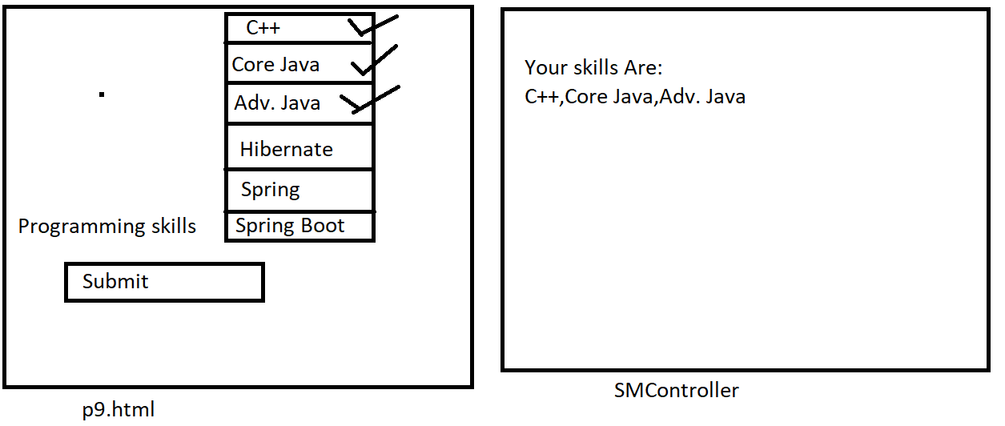

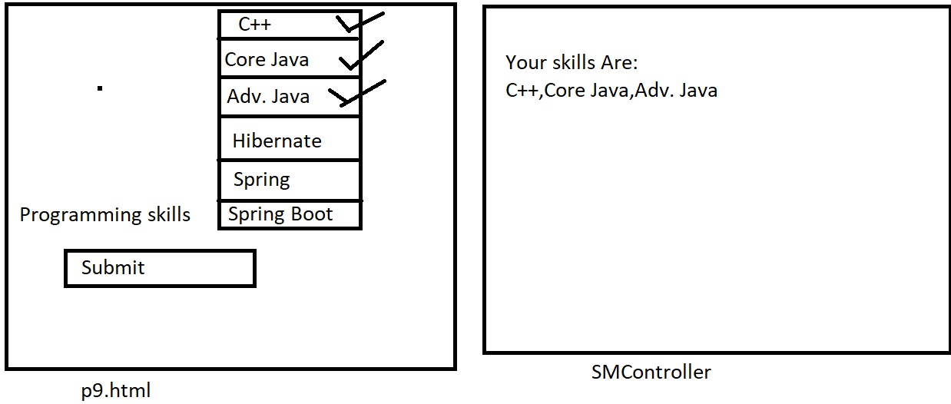

窗体顶端

Select Your Skills    


窗体底端

/*

**\* To change this license header, choose License Headers in Project Properties.**

**\* To change this template file, choose Tools | Templates**

**\* and open the template in the editor.**

**\*/**

import java.io.IOException;

import java.io.PrintWriter;

import javax.servlet.ServletException;

import javax.servlet.http.HttpServlet;

import javax.servlet.http.HttpServletRequest;

import javax.servlet.http.HttpServletResponse;

/**

*

* @author Admin

*/

public class SMController extends HttpServlet {

/**

* Processes requests for both HTTP <code>GET</code> and <code>POST</code>

* methods.

*

* @param request servlet request

* @param response servlet response

* @throws ServletException if a servlet-specific error occurs

* @throws IOException if an I/O error occurs

*/

protected void processRequest(HttpServletRequest request, HttpServletResponse response)

throws ServletException, IOException {

response.setContentType("text/html;charset=UTF-8");

try (PrintWriter out = response.getWriter()) {

/* TODO output your page here. You may use following sample code. */

out.println("<!DOCTYPE html>");

out.println("<html>");

out.println("<head>");

out.println("<title>Servlet SMController</title>");

out.println("</head>");

out.println("<body>");

String skills[]=request.getParameterValues("sk");

out.println("<h1>Your Skills Are : </h1>");

for(String s:skills){

out.println(", " + s+ "");

}

out.println("</body>");

out.println("</html>");

}

}

// <editor-fold defaultstate="collapsed" desc="HttpServlet methods. Click on the + sign on the left to edit the code.">

/**

* Handles the HTTP <code>GET</code> method.

*

* @param request servlet request

* @param response servlet response

* @throws ServletException if a servlet-specific error occurs

* @throws IOException if an I/O error occurs

*/

@Override

protected void doGet(HttpServletRequest request, HttpServletResponse response)

throws ServletException, IOException {

processRequest(request, response);

}

/**

* Handles the HTTP <code>POST</code> method.

*

* @param request servlet request

* @param response servlet response

* @throws ServletException if a servlet-specific error occurs

* @throws IOException if an I/O error occurs

*/

@Override

protected void doPost(HttpServletRequest request, HttpServletResponse response)

throws ServletException, IOException {

processRequest(request, response);

}

/**

* Returns a short description of the servlet.

*

* @return a String containing servlet description

*/

@Override

public String getServletInfo() {

return "Short description";

}// </editor-fold>

}

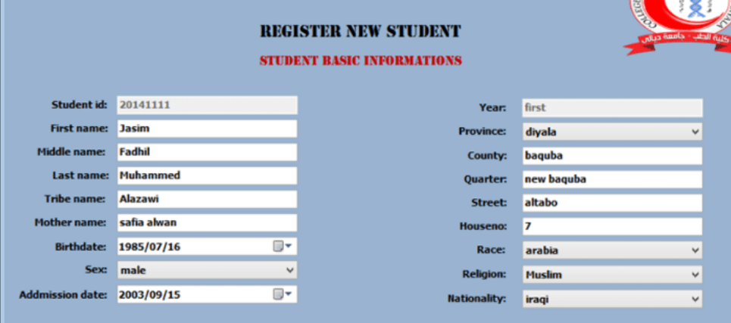

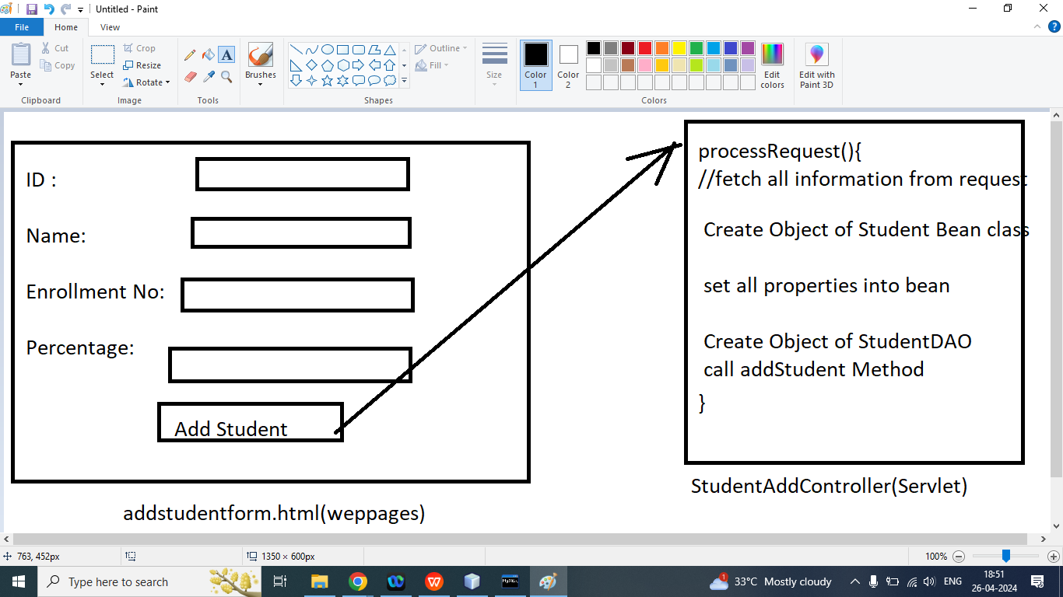

AddStudent Using DAO

top of form

| ID : |  |
| --- | --- |
| NAME: |  |
| Enrollment Number : |  |
| Percentage: |  |
|  |  |

bottom of form

/*

* To change this license header, choose License Headers in Project Properties.

* To change this template file, choose Tools | Templates

* and open the template in the editor.

*/

package com.ram.controller;

import com.ram.bean.StudentBean;

import com.ram.dao.StudentDAO;

import java.io.IOException;

import java.io.PrintWriter;

import javax.servlet.ServletException;

import javax.servlet.http.HttpServlet;

import javax.servlet.http.HttpServletRequest;

import javax.servlet.http.HttpServletResponse;

/**

*

* @author Admin

*/

public class StudentAddController extends HttpServlet {

/**

* Processes requests for both HTTP <code>GET</code> and <code>POST</code>

* methods.

*

* @param request servlet request

* @param response servlet response

* @throws ServletException if a servlet-specific error occurs

* @throws IOException if an I/O error occurs

*/

protected void processRequest(HttpServletRequest request, HttpServletResponse response)

throws ServletException, IOException {

response.setContentType("text/html;charset=UTF-8");

try (PrintWriter out = response.getWriter()) {

/* TODO output your page here. You may use following sample code. */

out.println("<!DOCTYPE html>");

out.println("<html>");

out.println("<head>");

out.println("<title>Servlet StudentAddController</title>");

out.println("</head>");

out.println("<body>");

int id = Integer.parseInt(request.getParameter("id"));

String name = request.getParameter("name");

String enroll = request.getParameter("enroll");

float per = Float.parseFloat(request.getParameter("per"));

StudentBean sb=new StudentBean(id, name, enroll, per);

StudentDAO sd=new StudentDAO();

int r=sd.addStudent(sb);

out.println("<h1>ID : " + id + "</h1>");

out.println("<h1>Name : " + name + "</h1>");

out.println("<h1>Enrollment No : " + enroll + "</h1>");

out.println("<h1>Percentage : " + per + "</h1>");

if(r>0){

out.println("<h1> <font color='green'>Student Added Success</font></h1>");

}else{

out.println("<h1> <font color='red'>Student not Added</font></h1>");

}

out.println("</body>");

out.println("</html>");

}

}

// <editor-fold defaultstate="collapsed" desc="HttpServlet methods. Click on the + sign on the left to edit the code.">

/**

* Handles the HTTP <code>GET</code> method.

*

* @param request servlet request

* @param response servlet response

* @throws ServletException if a servlet-specific error occurs

* @throws IOException if an I/O error occurs

*/

@Override

protected void doGet(HttpServletRequest request, HttpServletResponse response)

throws ServletException, IOException {

processRequest(request, response);

}

/**

* Handles the HTTP <code>POST</code> method.

*

* @param request servlet request

* @param response servlet response

* @throws ServletException if a servlet-specific error occurs

* @throws IOException if an I/O error occurs

*/

@Override

protected void doPost(HttpServletRequest request, HttpServletResponse response)

throws ServletException, IOException {

processRequest(request, response);

}

/**

* Returns a short description of the servlet.

*

* @return a String containing servlet description

*/

@Override

public String getServletInfo() {

return "Short description";

}// </editor-fold>

}

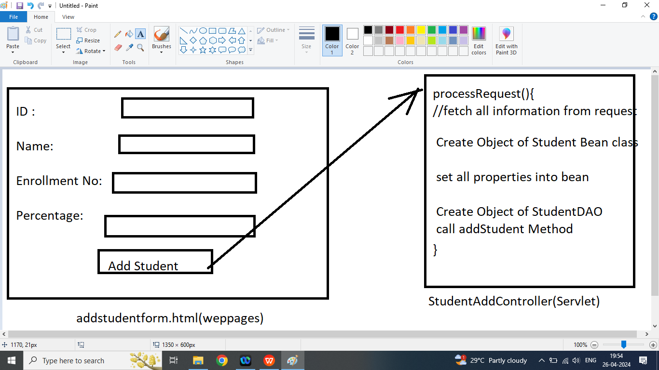

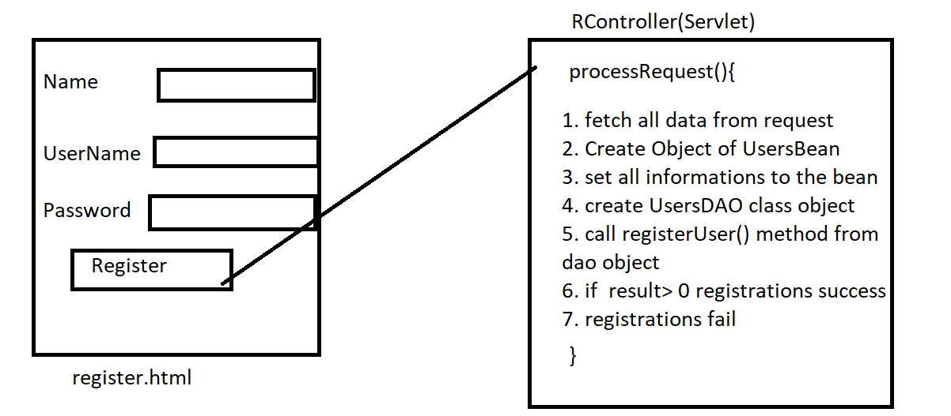

窗体顶端

| Name : |  |
| --- | --- |
| UserName : |  |
| Password : |  |
|  |  |

窗体底端

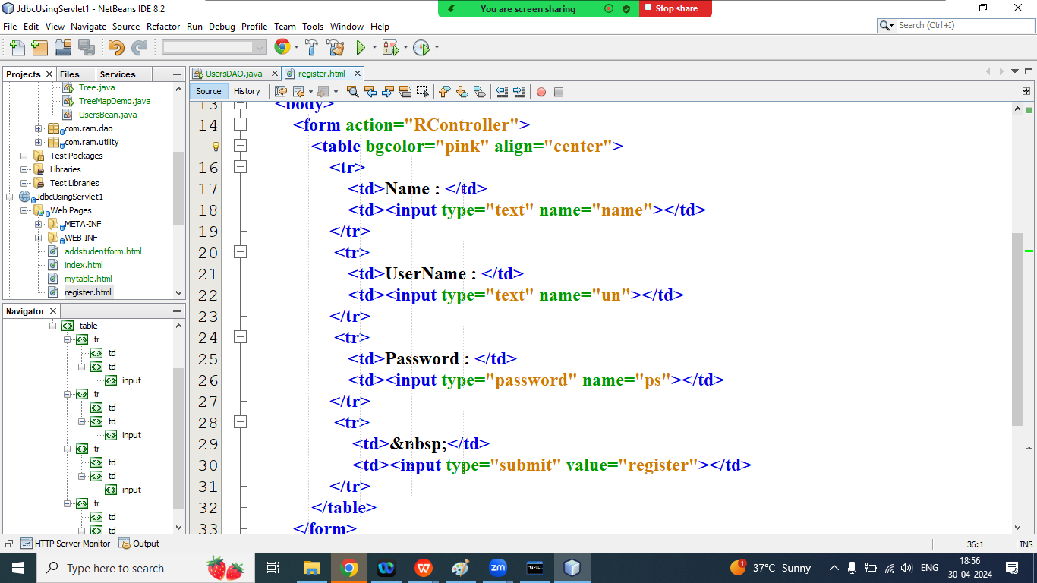

/*

**\* To change this license header, choose License Headers in Project Properties.**

**\* To change this template file, choose Tools | Templates**

**\* and open the template in the editor.**

**\*/**

package com.ram.controller;

import com.ram.bean.UsersBean;

import com.ram.dao.UsersDAO;

import java.io.IOException;

import java.io.PrintWriter;

import javax.servlet.ServletException;

import javax.servlet.http.HttpServlet;

import javax.servlet.http.HttpServletRequest;

import javax.servlet.http.HttpServletResponse;

/**

*

* @author Admin

*/

public class RController extends HttpServlet {

/**

* Processes requests for both HTTP <code>GET</code> and <code>POST</code>

* methods.

*

* @param request servlet request

* @param response servlet response

* @throws ServletException if a servlet-specific error occurs

* @throws IOException if an I/O error occurs

*/

protected void processRequest(HttpServletRequest request, HttpServletResponse response)

throws ServletException, IOException {

response.setContentType("text/html;charset=UTF-8");

try (PrintWriter out = response.getWriter()) {

/* TODO output your page here. You may use following sample code. */

out.println("<!DOCTYPE html>");

out.println("<html>");

out.println("<head>");

out.println("<title>Servlet RController</title>");

out.println("</head>");

out.println("<body>");

//step1: fetch all data from request

String name=request.getParameter("name");

String userName=request.getParameter("un");

String password=request.getParameter("ps");

//step2: create Object of UsersBean

UsersBean ub=new UsersBean();

//step3: set all information into bean

ub.setName(name);

ub.setPassword(password);

ub.setUserName(userName);

//step4: Create Object of UsersDAO

UsersDAO ud=new UsersDAO();

//step5: call registerUser() method via dao object

int r=ud.registerUser(ub);

//step6: check result value is greater than 0 or not

if(r>0){

out.println("<h1><font color='green'>Registration Success</font></h1>");

}else{

out.println("<h1><font color='red'>Registration Fail</font></h1>");

}

out.println("</body>");

out.println("</html>");

}

}

// <editor-fold defaultstate="collapsed" desc="HttpServlet methods. Click on the + sign on the left to edit the code.">

/**

* Handles the HTTP <code>GET</code> method.

*

* @param request servlet request

* @param response servlet response

* @throws ServletException if a servlet-specific error occurs

* @throws IOException if an I/O error occurs

*/

@Override

protected void doGet(HttpServletRequest request, HttpServletResponse response)

throws ServletException, IOException {

processRequest(request, response);

}

/**

* Handles the HTTP <code>POST</code> method.

*

* @param request servlet request

* @param response servlet response

* @throws ServletException if a servlet-specific error occurs

* @throws IOException if an I/O error occurs

*/

@Override

protected void doPost(HttpServletRequest request, HttpServletResponse response)

throws ServletException, IOException {

processRequest(request, response);

}

/**

* Returns a short description of the servlet.

*

* @return a String containing servlet description

*/

@Override

public String getServletInfo() {

return "Short description";

}// </editor-fold>

}

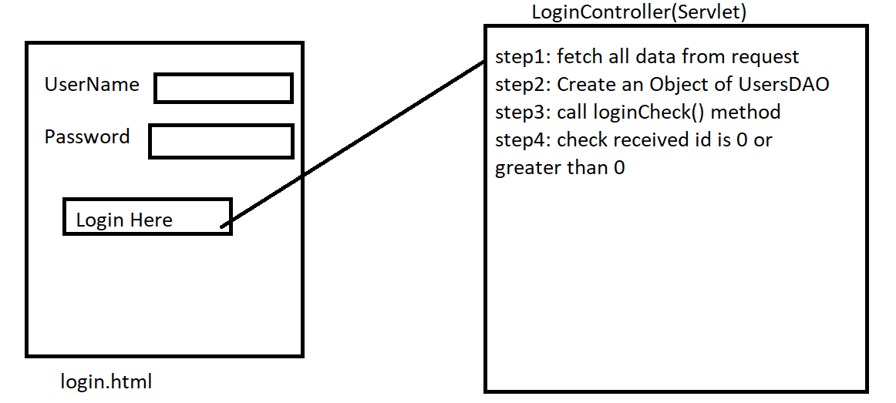

窗体顶端

| UserName : |  |
| --- | --- |
| Password : |  |
|  |  |

窗体底端

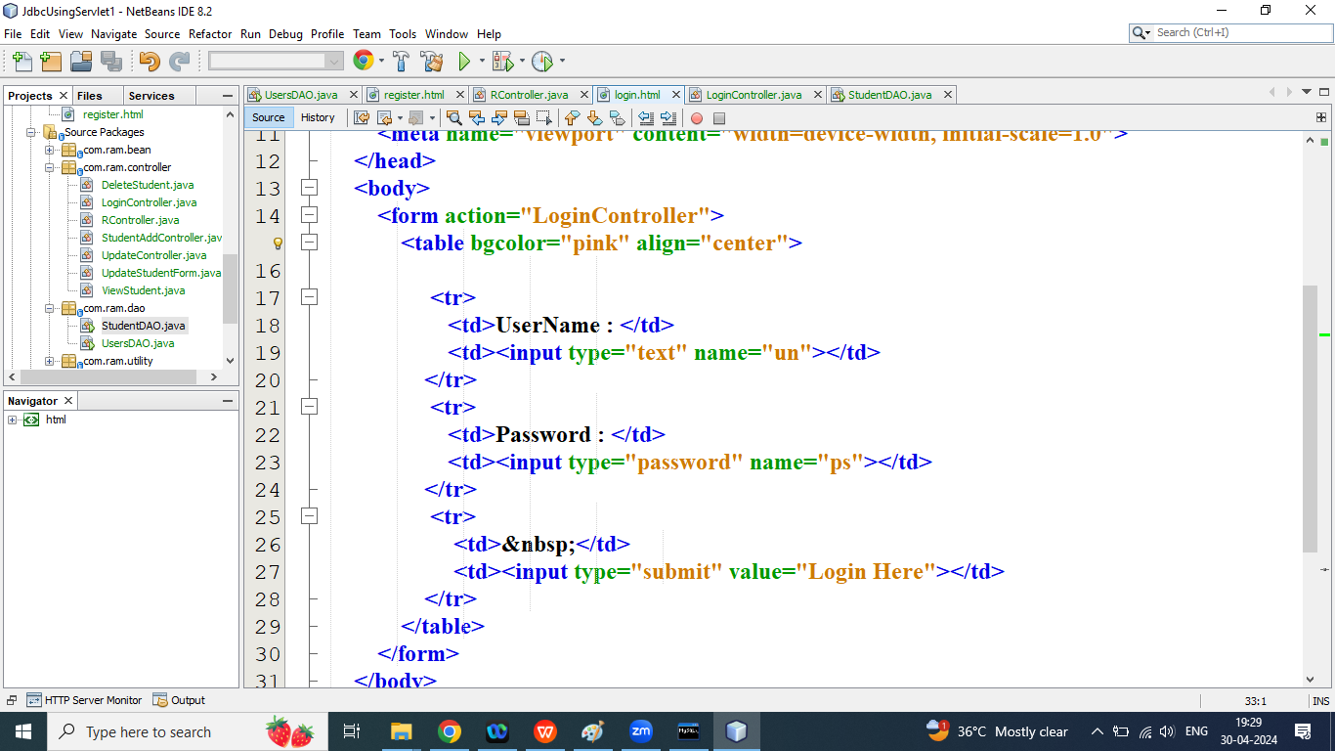

/*

* To change this license header, choose License Headers in Project Properties.

* To change this template file, choose Tools | Templates

* and open the template in the editor.

*/

package com.ram.controller;

import com.ram.dao.UsersDAO;

import java.io.IOException;

import java.io.PrintWriter;

import javax.servlet.ServletException;

import javax.servlet.http.HttpServlet;

import javax.servlet.http.HttpServletRequest;

import javax.servlet.http.HttpServletResponse;

/**

*

* @author Admin

*/

public class LoginController extends HttpServlet {

/**

* Processes requests for both HTTP <code>GET</code> and <code>POST</code>

* methods.

*

* @param request servlet request

* @param response servlet response

* @throws ServletException if a servlet-specific error occurs

* @throws IOException if an I/O error occurs

*/

protected void processRequest(HttpServletRequest request, HttpServletResponse response)

throws ServletException, IOException {

response.setContentType("text/html;charset=UTF-8");

try (PrintWriter out = response.getWriter()) {

/* TODO output your page here. You may use following sample code. */

out.println("<!DOCTYPE html>");

out.println("<html>");

out.println("<head>");

out.println("<title>Servlet LoginController</title>");

out.println("</head>");

out.println("<body>");

//step1: fetch all data from the request

String userName=request.getParameter("un");

String password=request.getParameter("ps");

//step2: create object of UsersDAO

UsersDAO ud=new UsersDAO();

//step3: call loginCheck method

int id=ud.loginCheck(userName, password);

//step4: check value of id

if(id>0){

response.sendRedirect("ViewStudent");

}else{

out.println("<h1><font color='red'>Login Fail </font></h1>");

}

out.println("</body>");

out.println("</html>");

}

}

// <editor-fold defaultstate="collapsed" desc="HttpServlet methods. Click on the + sign on the left to edit the code.">

/**

* Handles the HTTP <code>GET</code> method.

*

* @param request servlet request

* @param response servlet response

* @throws ServletException if a servlet-specific error occurs

* @throws IOException if an I/O error occurs

*/

@Override

protected void doGet(HttpServletRequest request, HttpServletResponse response)

throws ServletException, IOException {

processRequest(request, response);

}

/**

* Handles the HTTP <code>POST</code> method.

*

* @param request servlet request

* @param response servlet response

* @throws ServletException if a servlet-specific error occurs

* @throws IOException if an I/O error occurs

*/

@Override

protected void doPost(HttpServletRequest request, HttpServletResponse response)

throws ServletException, IOException {

processRequest(request, response);

}

/**

* Returns a short description of the servlet.

*

* @return a String containing servlet description

*/

@Override

public String getServletInfo() {

return "Short description";

}// </editor-fold>

}

Change your StudentDAO class

/*

**\* To change this license header, choose License Headers in Project Properties.**

**\* To change this template file, choose Tools | Templates**

**\* and open the template in the editor.**

**\*/**

package com.ram.dao;

import com.ram.bean.StudentBean;

import com.ram.utility.ConnectionPool;

import java.sql.*;

import java.util.ArrayList;

import java.util.logging.Level;

import java.util.logging.Logger;

public class StudentDAO {

static Connection conn;

public int addStudent(StudentBean sb) {

conn = ConnectionPool.connectDB();//step1 and step2

//step3: write SQL Query

String sql="insert into student values('"+sb.getId()+"','"+sb.getName()+"','"+sb.getEnroll()+"','"+sb.getPer()+"')";

//step4 Create Object of Statement via Connection

Statement stmt;

int r=0;

try {

stmt = conn.createStatement();

//step5 call exeuteUpdate method

r=stmt.executeUpdate(sql);

//step6: close the connection

conn.close();

} catch (SQLException ex) {

Logger.getLogger(StudentDAO.class.getName()).log(Level.SEVERE, null, ex);

}

return r;

}

public int updateStudent(StudentBean sb){

conn=ConnectionPool.connectDB();//step1 step2

//step3: Write SQL Query

String sql="update student set name='"+sb.getName()+"',enroll='"+sb.getEnroll()+"',per='"+sb.getPer()+"' where id='"+sb.getId()+"'";

int r=0;

try {

//step4: Create Object of Statement

Statement stmt=conn.createStatement();

//step5: call executeUpdate

r=stmt.executeUpdate(sql);

//step6: close the Connection

conn.close();

} catch (SQLException ex) {

Logger.getLogger(StudentDAO.class.getName()).log(Level.SEVERE, null, ex);

}

return r;

}

public int deleteStudent(int id){

conn=ConnectionPool.connectDB();//step1,step2

//step3: Write SQL Query

String sql="delete from student where id='"+id+"'";

//step4: Create Object of Statement

int r=0;

try {

Statement stmt=conn.createStatement();

//step5: call executeUpdate() method

r=stmt.executeUpdate(sql);

//step6: Close the Connection

} catch (SQLException ex) {

Logger.getLogger(StudentDAO.class.getName()).log(Level.SEVERE, null, ex);

}

return r;

}

public ArrayList<StudentBean> findAll(){

conn=ConnectionPool.connectDB(); //step1,step2

//step3 :Write SQL Query

ArrayList<StudentBean> al=new ArrayList<>();

String sql="select * from student";

try {

//step4: Create Object of Statement

Statement stmt=conn.createStatement();

//step5: call executeQuery

ResultSet rs=stmt.executeQuery(sql);

//step6: Process Result

while(rs.next()){

StudentBean sb=new StudentBean();

sb.setId(rs.getInt("id"));

sb.setName(rs.getString("name"));

sb.setEnroll(rs.getString("enroll"));

sb.setPer(rs.getFloat("per"));

al.add(sb);

}

//step7: Close the Connections

conn.close();

} catch (SQLException ex) {

Logger.getLogger(StudentDAO.class.getName()).log(Level.SEVERE, null, ex);

}

return al;

}

public StudentBean findById(int id){

conn=ConnectionPool.connectDB(); //step1,step2

//step3 :Write SQL Query

String sql="select * from student where id='"+id+"'";

StudentBean sb=new StudentBean();

try {

//step4: Create Object of Statement

Statement stmt=conn.createStatement();

//step5: call executeQuery

ResultSet rs=stmt.executeQuery(sql);

//step6: Process Result

if(rs.next()){

sb.setId(rs.getInt("id"));

sb.setName(rs.getString("name"));

sb.setEnroll(rs.getString("enroll"));

sb.setPer(rs.getFloat("per"));

}

//step7: Close the Connections

conn.close();

} catch (SQLException ex) {

Logger.getLogger(StudentDAO.class.getName()).log(Level.SEVERE, null, ex);

}

return sb;

}

public void findByEnrollment(String enroll){

conn=ConnectionPool.connectDB(); //step1,step2

//step3 :Write SQL Query

String sql="select * from student where enroll='"+enroll+"'";

try {

//step4: Create Object of Statement

Statement stmt=conn.createStatement();

//step5: call executeQuery

ResultSet rs=stmt.executeQuery(sql);

//step6: Process Result

while(rs.next()){

//System.out.println(""+rs.getInt("id")+"\t"+rs.getString("name")+"\t"+rs.getString("enroll")+"\t"+rs.getFloat("per"));

System.out.print("\t"+rs.getInt("id"));

System.out.print("\t"+rs.getString("name"));

System.out.print("\t"+rs.getString("enroll"));

System.out.print("\t"+rs.getFloat("per"));

}

//step7: Close the Connections

conn.close();

} catch (SQLException ex) {

Logger.getLogger(StudentDAO.class.getName()).log(Level.SEVERE, null, ex);

}

}

public static void main(String[] args) {

StudentBean s=new StudentBean();

s.setId(105);

s.setName("XXXX");

s.setEnroll("YYYY");

s.setPer(1.0f);

StudentDAO sd=new StudentDAO();

//1. addStudent

// int r=sd.addStudent(s);

// if(r>0){

// System.out.println("Student Added Success");

// }else{

// System.out.println("Student Not Added");

// }

//2. call updateStudent() method

// int r=sd.updateStudent(s);

// if(r>0){

// System.out.println("Student updated Success");

// }else{

// System.out.println("Student Not updated");

// }

//3. call deleteStudent() method

//int r=sd.deleteStudent(101);

//if(r>0){

// System.out.println("Delete Student success");

//}else{

// System.out.println("Student Not Deleted");

//}

//4. Call findAll method

//StudentDAO sd=new StudentDAO();

//sd.findAll();

//5. call findById method

//sd.findById(102);

//6. call findByEnrollment

sd.findByEnrollment("01752CS1");

}

}

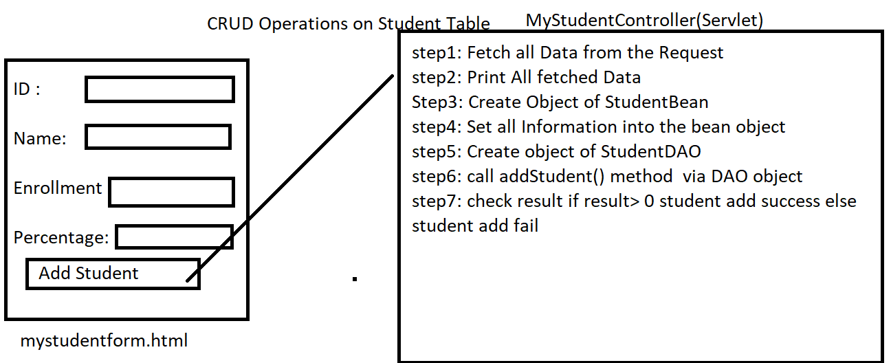

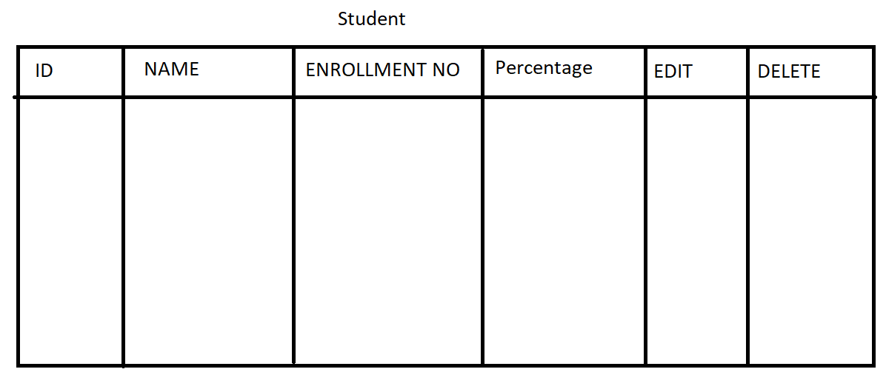

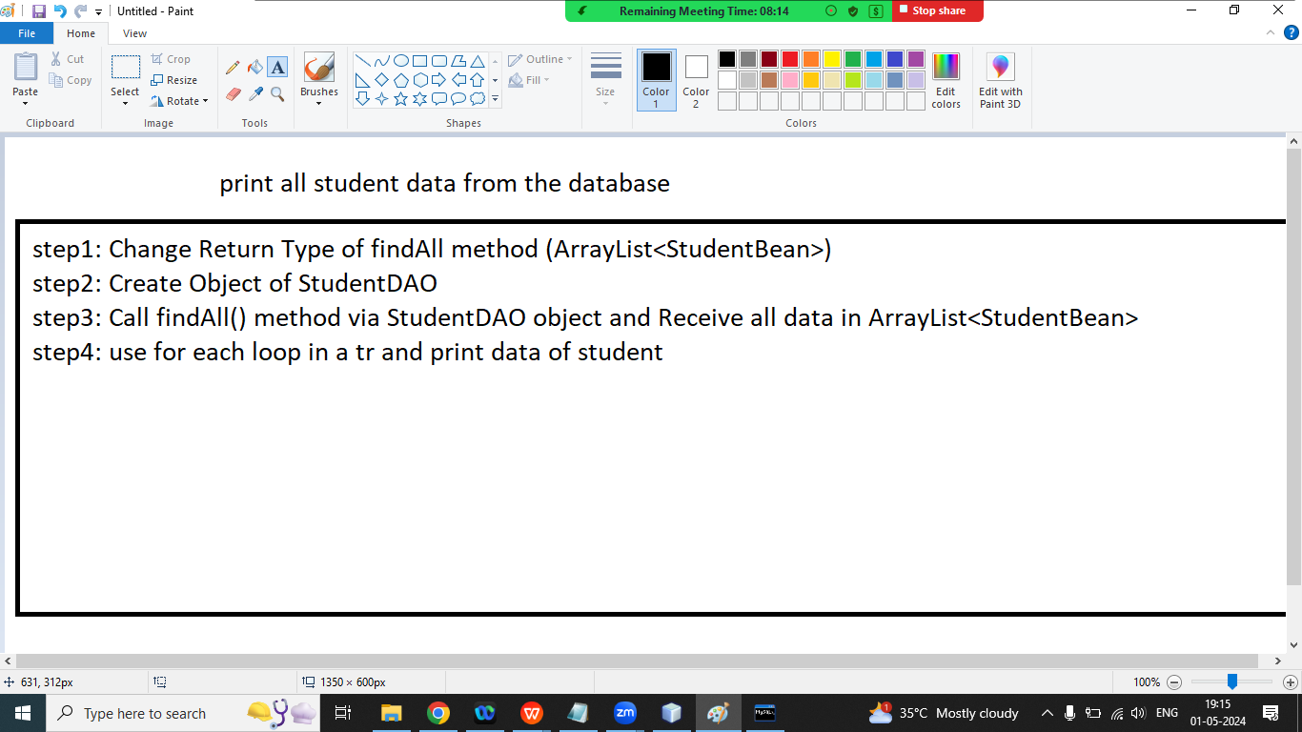

//mystudentform.html

<!DOCTYPE html>

<!--

To change this license header, choose License Headers in Project Properties.

To change this template file, choose Tools | Templates

and open the template in the editor.

-->

<html>

<head>

<title>Student Form</title>

<meta charset="UTF-8">

<meta name="viewport" content="width=device-width, initial-scale=1.0">

</head>

<body>

<h1>Student Add Form</h1>

<form action="MyStudentController">

<table>

<tr>

<td>ID :</td>

<td><input type="text" name="id"></td>

</tr>

<tr>

<td>NAME :</td>

<td><input type="text" name="name"></td>

</tr>

<tr>

<td>Enrollment No :</td>

<td><input type="text" name="enroll"></td>

</tr>

<tr>

<td>Percentage :</td>

<td><input type="text" name="per"></td>

</tr>

<tr>

<td>&nbsp;</td>

<td><input type="submit" value="Add Student"></td>

</tr>

</table>

</form>

</body>

</html>

=======================================

//MyStudentController(Servlet)

/*

* To change this license header, choose License Headers in Project Properties.

* To change this template file, choose Tools | Templates

* and open the template in the editor.

*/

package com.ram.controller;

import com.ram.bean.StudentBean;

import com.ram.dao.StudentDAO;

import java.io.IOException;

import java.io.PrintWriter;

import javax.servlet.ServletException;

import javax.servlet.http.HttpServlet;

import javax.servlet.http.HttpServletRequest;

import javax.servlet.http.HttpServletResponse;

/**

*

* @author Admin

*/

public class MyStudentController extends HttpServlet {

/**

* Processes requests for both HTTP <code>GET</code> and <code>POST</code>

* methods.

*

* @param request servlet request

* @param response servlet response

* @throws ServletException if a servlet-specific error occurs

* @throws IOException if an I/O error occurs

*/

protected void processRequest(HttpServletRequest request, HttpServletResponse response)

throws ServletException, IOException {

response.setContentType("text/html;charset=UTF-8");

try (PrintWriter out = response.getWriter()) {

/* TODO output your page here. You may use following sample code. */

out.println("<!DOCTYPE html>");

out.println("<html>");

out.println("<head>");

out.println("<title>Servlet MyStudentController</title>");

out.println("</head>");

out.println("<body>");

//step1: fetch all request data

int id = Integer.parseInt(request.getParameter("id"));

String name = request.getParameter("name");

String enroll = request.getParameter("enroll");

float per = Float.parseFloat(request.getParameter("per"));

//step2: print all fetched data

out.println("<h1>ID : " + id + "</h1>");

out.println("<h1>NAME : " + name + "</h1>");

out.println("<h1>Enrollment no : " + enroll + "</h1>");

out.println("<h1>Percentage : " + per + "</h1>");

//step3: Create object of Student Bean

StudentBean sb=new StudentBean();

//step4: set all information into bean

sb.setId(id);

sb.setEnroll(enroll);

sb.setName(name);

sb.setPer(per);

//step5: Create Object of StudentDAO

StudentDAO sd=new StudentDAO();

//step6: call addStudent()method via object of dao

int r= sd.addStudent(sb);

//step7: check result is greater than 0

if(r>0){

out.println("<h1><font color='green'>Student Added Succes</font></h1>");

}

else{

out.println("<h1><font color='red'>Student Not Added</font></h1>");

}

out.println("</body>");

out.println("</html>");

}

}

// <editor-fold defaultstate="collapsed" desc="HttpServlet methods. Click on the + sign on the left to edit the code.">

/**

* Handles the HTTP <code>GET</code> method.

*

* @param request servlet request

* @param response servlet response

* @throws ServletException if a servlet-specific error occurs

* @throws IOException if an I/O error occurs

*/

@Override

protected void doGet(HttpServletRequest request, HttpServletResponse response)

throws ServletException, IOException {

processRequest(request, response);

}

/**

* Handles the HTTP <code>POST</code> method.

*

* @param request servlet request

* @param response servlet response

* @throws ServletException if a servlet-specific error occurs

* @throws IOException if an I/O error occurs

*/

@Override

protected void doPost(HttpServletRequest request, HttpServletResponse response)

throws ServletException, IOException {

processRequest(request, response);

}

/**

* Returns a short description of the servlet.

*

* @return a String containing servlet description

*/

@Override

public String getServletInfo() {

return "Short description";

}// </editor-fold>

}

=================================================

3. MyView(Servlet)

/*

* To change this license header, choose License Headers in Project Properties.

* To change this template file, choose Tools | Templates

* and open the template in the editor.

*/

package com.ram.controller;

import com.ram.bean.StudentBean;

import com.ram.dao.StudentDAO;

import java.io.IOException;

import java.io.PrintWriter;

import java.util.ArrayList;

import javax.servlet.ServletException;

import javax.servlet.http.HttpServlet;

import javax.servlet.http.HttpServletRequest;

import javax.servlet.http.HttpServletResponse;

/**

*

* @author Admin

*/

public class MyView extends HttpServlet {

/**

* Processes requests for both HTTP <code>GET</code> and <code>POST</code>

* methods.

*

* @param request servlet request

* @param response servlet response

* @throws ServletException if a servlet-specific error occurs

* @throws IOException if an I/O error occurs

*/

protected void processRequest(HttpServletRequest request, HttpServletResponse response)

throws ServletException, IOException {

response.setContentType("text/html;charset=UTF-8");

try (PrintWriter out = response.getWriter()) {

/* TODO output your page here. You may use following sample code. */

out.println("<!DOCTYPE html>");

out.println("<html>");

out.println("<head>");

out.println("<title>Servlet MyView</title>");

out.println("</head>");

out.println("<body>");

out.println("<h1 align='center'>All Student Data</h1>");

out.println("<h1 align='left'><a href='mystudentform.html'>Add New Student</a></h1>");

out.println("<table align='center' border='1'>");

out.println(" <tr>");

out.println("<th>ID</th>");

out.println("<th>NAME</th>");

out.println("<th>ENROLLMENT NO</th>");

out.println(" <th>PERCENTAGE</th>");

out.println("<th>EDIT</th>");

out.println("<th>DELETE</th>");

out.println(" </tr>");

//step2: Create Object of StudentDAO

StudentDAO sd=new StudentDAO();

//step3: call findAll

ArrayList<StudentBean> al=sd.findAll();

for(StudentBean sb:al){

out.println("<tr>");

out.println("<td>"+sb.getId()+"</td>");

out.println(" <td>"+sb.getName()+"</td>");

out.println(" <td>"+sb.getEnroll()+"</td>");

out.println(" <td>"+sb.getPer()+"</td>");

out.println(" <td><a href=''>EDIT</a></td>");

out.println("<td><a href=''>DELETE</a></td>");

out.println("</tr>");

}

out.println("</table>");

out.println("</body>");

out.println("</html>");

}

}

// <editor-fold defaultstate="collapsed" desc="HttpServlet methods. Click on the + sign on the left to edit the code.">

/**

* Handles the HTTP <code>GET</code> method.

*

* @param request servlet request

* @param response servlet response

* @throws ServletException if a servlet-specific error occurs

* @throws IOException if an I/O error occurs

*/

@Override

protected void doGet(HttpServletRequest request, HttpServletResponse response)

throws ServletException, IOException {

processRequest(request, response);

}

/**

* Handles the HTTP <code>POST</code> method.

*

* @param request servlet request

* @param response servlet response

* @throws ServletException if a servlet-specific error occurs

* @throws IOException if an I/O error occurs

*/

@Override

protected void doPost(HttpServletRequest request, HttpServletResponse response)

throws ServletException, IOException {

processRequest(request, response);

}

/**

* Returns a short description of the servlet.

*

* @return a String containing servlet description

*/

@Override

public String getServletInfo() {

return "Short description";

}// </editor-fold>

}

============================

//4. StudentDAO(java class)

/*

* To change this license header, choose License Headers in Project Properties.

* To change this template file, choose Tools | Templates

* and open the template in the editor.

*/

package com.ram.dao;

import com.ram.bean.StudentBean;

import com.ram.utility.ConnectionPool;

import java.sql.*;

import java.util.ArrayList;

import java.util.logging.Level;

import java.util.logging.Logger;

public class StudentDAO {

static Connection conn;

public int addStudent(StudentBean sb) {

conn = ConnectionPool.connectDB();//step1 and step2

//step3: write SQL Query

String sql="insert into student values('"+sb.getId()+"','"+sb.getName()+"','"+sb.getEnroll()+"','"+sb.getPer()+"')";

//step4 Create Object of Statement via Connection

Statement stmt;

int r=0;

try {

stmt = conn.createStatement();

//step5 call exeuteUpdate method

r=stmt.executeUpdate(sql);

//step6: close the connection

conn.close();

} catch (SQLException ex) {

Logger.getLogger(StudentDAO.class.getName()).log(Level.SEVERE, null, ex);

}

return r;

}

public int updateStudent(StudentBean sb){

conn=ConnectionPool.connectDB();//step1 step2

//step3: Write SQL Query

String sql="update student set name='"+sb.getName()+"',enroll='"+sb.getEnroll()+"',per='"+sb.getPer()+"' where id='"+sb.getId()+"'";

int r=0;

try {

//step4: Create Object of Statement

Statement stmt=conn.createStatement();

//step5: call executeUpdate

r=stmt.executeUpdate(sql);

//step6: close the Connection

conn.close();

} catch (SQLException ex) {

Logger.getLogger(StudentDAO.class.getName()).log(Level.SEVERE, null, ex);

}

return r;

}

public int deleteStudent(int id){

conn=ConnectionPool.connectDB();//step1,step2

//step3: Write SQL Query

String sql="delete from student where id='"+id+"'";

//step4: Create Object of Statement

int r=0;

try {

Statement stmt=conn.createStatement();

//step5: call executeUpdate() method

r=stmt.executeUpdate(sql);

//step6: Close the Connection

} catch (SQLException ex) {

Logger.getLogger(StudentDAO.class.getName()).log(Level.SEVERE, null, ex);

}

return r;

}

public ArrayList<StudentBean> findAll(){

conn=ConnectionPool.connectDB(); //step1,step2

//step3 :Write SQL Query

ArrayList<StudentBean> al=new ArrayList<>();

String sql="select * from student";

try {

//step4: Create Object of Statement

Statement stmt=conn.createStatement();

//step5: call executeQuery

ResultSet rs=stmt.executeQuery(sql);

//step6: Process Result

while(rs.next()){

StudentBean sb=new StudentBean();

sb.setId(rs.getInt("id"));

sb.setName(rs.getString("name"));

sb.setEnroll(rs.getString("enroll"));

sb.setPer(rs.getFloat("per"));

al.add(sb);

}

//step7: Close the Connections

conn.close();

} catch (SQLException ex) {

Logger.getLogger(StudentDAO.class.getName()).log(Level.SEVERE, null, ex);

}

return al;

}

public StudentBean findById(int id){

conn=ConnectionPool.connectDB(); //step1,step2

//step3 :Write SQL Query

String sql="select * from student where id='"+id+"'";

StudentBean sb=new StudentBean();

try {

//step4: Create Object of Statement

Statement stmt=conn.createStatement();

//step5: call executeQuery

ResultSet rs=stmt.executeQuery(sql);

//step6: Process Result

if(rs.next()){

sb.setId(rs.getInt("id"));

sb.setName(rs.getString("name"));

sb.setEnroll(rs.getString("enroll"));

sb.setPer(rs.getFloat("per"));

}

//step7: Close the Connections

conn.close();

} catch (SQLException ex) {

Logger.getLogger(StudentDAO.class.getName()).log(Level.SEVERE, null, ex);

}

return sb;

}

public void findByEnrollment(String enroll){

conn=ConnectionPool.connectDB(); //step1,step2

//step3 :Write SQL Query

String sql="select * from student where enroll='"+enroll+"'";

try {

//step4: Create Object of Statement

Statement stmt=conn.createStatement();

//step5: call executeQuery

ResultSet rs=stmt.executeQuery(sql);

//step6: Process Result

while(rs.next()){

//System.out.println(""+rs.getInt("id")+"\t"+rs.getString("name")+"\t"+rs.getString("enroll")+"\t"+rs.getFloat("per"));

System.out.print("\t"+rs.getInt("id"));

System.out.print("\t"+rs.getString("name"));

System.out.print("\t"+rs.getString("enroll"));

System.out.print("\t"+rs.getFloat("per"));

}

//step7: Close the Connections

conn.close();

} catch (SQLException ex) {

Logger.getLogger(StudentDAO.class.getName()).log(Level.SEVERE, null, ex);

}

}

public static void main(String[] args) {

StudentBean s=new StudentBean();

s.setId(105);

s.setName("XXXX");

s.setEnroll("YYYY");

s.setPer(1.0f);

StudentDAO sd=new StudentDAO();

//1. addStudent

// int r=sd.addStudent(s);

// if(r>0){

// System.out.println("Student Added Success");

// }else{

// System.out.println("Student Not Added");

// }

//2. call updateStudent() method

// int r=sd.updateStudent(s);

// if(r>0){

// System.out.println("Student updated Success");

// }else{

// System.out.println("Student Not updated");

// }

//3. call deleteStudent() method

//int r=sd.deleteStudent(101);

//if(r>0){

// System.out.println("Delete Student success");

//}else{

// System.out.println("Student Not Deleted");

//}

//4. Call findAll method

//StudentDAO sd=new StudentDAO();

//sd.findAll();

//5. call findById method

//sd.findById(102);

//6. call findByEnrollment

sd.findByEnrollment("01752CS1");

}

}

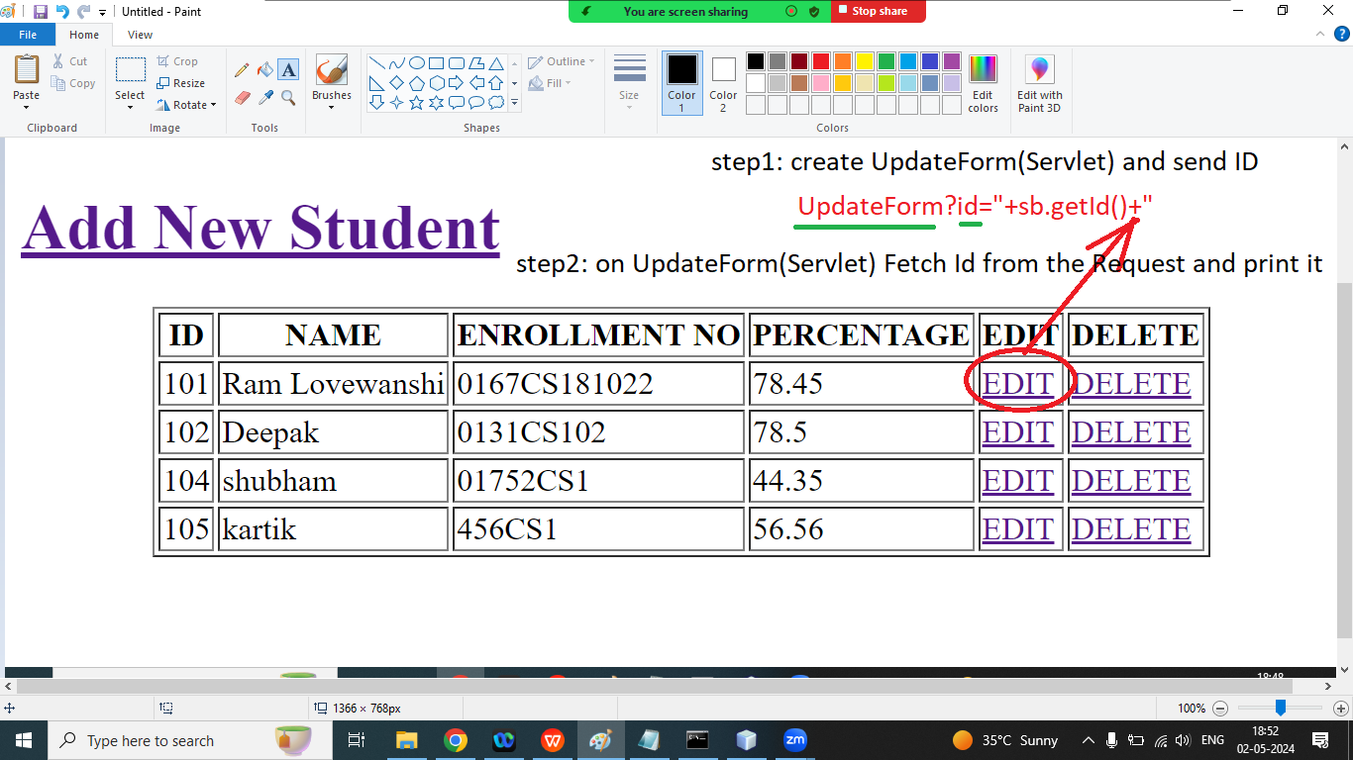

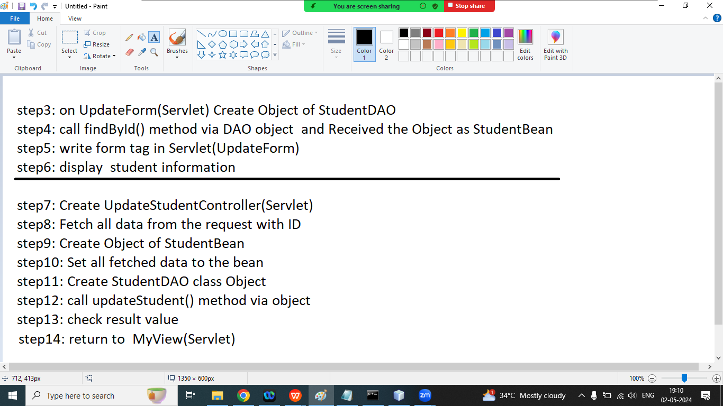

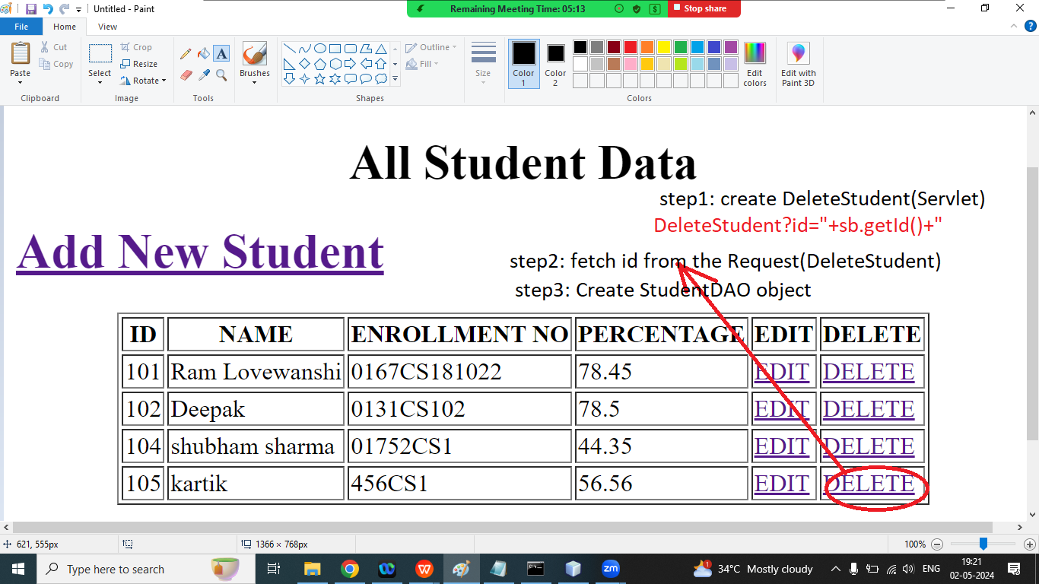

Step4: call deleteStudent() method

Step5: Check result and sendRedirect to MyView

Ram sir youtube channel link

<https://www.youtube.com/watch?v=-D7D0EQwz0A>

**Q1. Explain RequestDispatcher in servlet?**

Ans: The RequestDispatcher interface provides the facility of dispatching the request to another resource. It may be html, servlet or jsp. This interface can also be used to include the content of another resource also. It is the one of the way of servlet collaboration.

There are two methods defined in RequestDispatcher interface

1. public void forward(ServletRequest request, ServletResponse response):

Forward a request from a servlet to another resource (html, servlet, jsp) on the server

2. public void include(ServletRequest request, ServletResponse response):

includes the content of a resource(servlet, jsp, html)

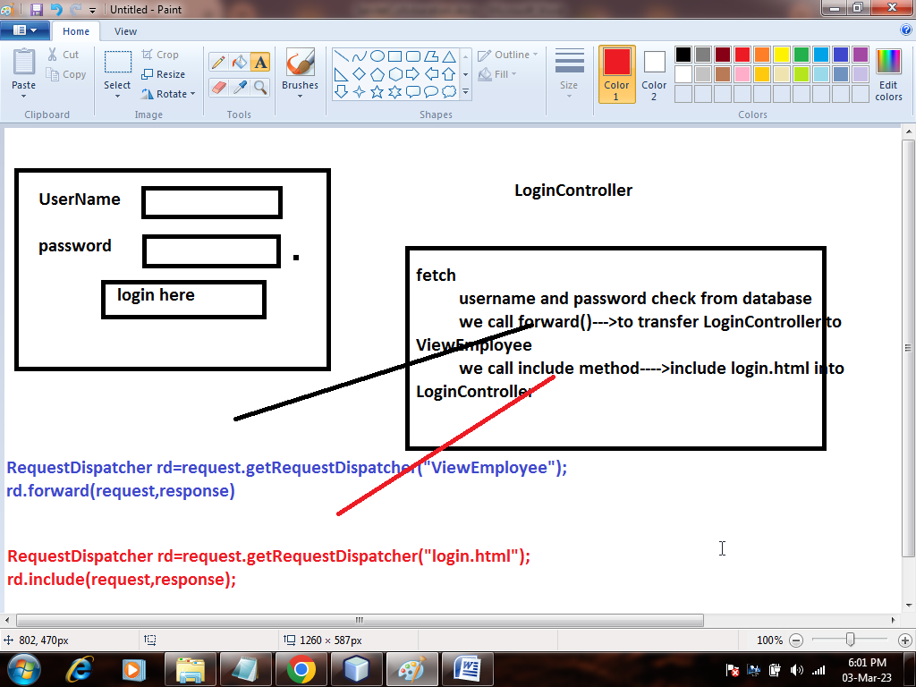

How to get object of RequestDispatcher

RequestDispatcher rd=request.getRequestDispacher("servlet2");

rd.forward(request,response)

| USERNAME: |  |
| --- | --- |
| Password: |  |
|  |  |

/*

**\* To change this license header, choose License Headers in Project Properties.**

**\* To change this template file, choose Tools | Templates**

**\* and open the template in the editor.**

*/

import com.ram.dao.UsersDao;

import java.io.IOException;

import java.io.PrintWriter;

import javax.servlet.RequestDispatcher;

import javax.servlet.ServletException;

import javax.servlet.http.HttpServlet;

import javax.servlet.http.HttpServletRequest;

import javax.servlet.http.HttpServletResponse;

import javax.servlet.http.HttpSession;

/**

*

* @author Admin

*/

public class LoginController extends HttpServlet {

/**

* Processes requests for both HTTP <code>GET</code> and <code>POST</code>

* methods.

*

* @param request servlet request

* @param response servlet response

* @throws ServletException if a servlet-specific error occurs

* @throws IOException if an I/O error occurs

*/

protected void processRequest(HttpServletRequest request, HttpServletResponse response)

throws ServletException, IOException {

response.setContentType("text/html;charset=UTF-8");

try (PrintWriter out = response.getWriter()) {

/* TODO output your page here. You may use following sample code. */

out.println("<!DOCTYPE html>");

out.println("<html>");

out.println("<head>");

out.println("<title>Servlet LoginController</title>");

out.println("</head>");

out.println("<body>");

String username=request.getParameter("un");

String password=request.getParameter("ps");

UsersDao ud=new UsersDao();

RequestDispatcher rd=null;

int id=ud.loginCheck(username, password);

if(id>0){

HttpSession s=request.getSession();

s.setAttribute("user", username);

rd=request.getRequestDispatcher("ViewEmployee");

rd.forward(request, response);

out.println("<h1><font color='green'>Login Success</font></h1>");

}

else{

out.println("<h1><font color='red'>Login Fail</font></h1>");

rd=request.getRequestDispatcher("login.html");

rd.include(request, response);

}

out.println("<h1>Servlet LoginController at " + request.getContextPath() + "</h1>");

out.println("</body>");

out.println("</html>");

}

}

// <editor-fold defaultstate="collapsed" desc="HttpServlet methods. Click on the + sign on the left to edit the code.">

/**

* Handles the HTTP <code>GET</code> method.

*

* @param request servlet request

* @param response servlet response

* @throws ServletException if a servlet-specific error occurs

* @throws IOException if an I/O error occurs

*/

@Override

protected void doGet(HttpServletRequest request, HttpServletResponse response)

throws ServletException, IOException {

processRequest(request, response);

}

/**

* Handles the HTTP <code>POST</code> method.

*

* @param request servlet request

* @param response servlet response

* @throws ServletException if a servlet-specific error occurs

* @throws IOException if an I/O error occurs

*/

@Override

protected void doPost(HttpServletRequest request, HttpServletResponse response)

throws ServletException, IOException {

processRequest(request, response);

}

/**

* Returns a short description of the servlet.

*

* @return a String containing servlet description

*/

@Override

public String getServletInfo() {

return "Short description";

}// </editor-fold>

}

=====================================================================================

**Q2. What is the difference between forward method and sendRedirect method**

| Forward | sendRedirect() |
| --- | --- |
| 1. The forward method works at server side | The sendRedirect() method works at client side |
| 2. It sends the same request and response object to another servlet | It always sends a new request |
| 3. It can work within the server only | It can be used within and outside the server |
|  |  |

==============================================================================================

Q1. Explain Servlet Filter?

Ans: A filter is an object that is invoked at the pre processing and post processing of a request

It is mainly used to to perform filtering task such as conversion, compression and input validation

The servlet filter is pluggable i.e its entry is defined in the web.xml file. if we remove the entry of filter from the web.xml files. filter will be removed automatically and we don't need to change the servlet

Filter API: Like servlet filter has its own API. The javax.servlet package contains the three interface of filter API

1. Filter

2. FilterChain

3. FilterConfig

1. Filter Interface:

For creating any filter, you must implement the filter interface. Filter Interface provides the life cycle method for Filter

1. public void init(FilterConfig f):

init() method is invoked only once. It is used to initialized the filter.

2. public void doFilter(request, response, FilterChain chain);

doFilter method is invoked every time when user request to any resource , to which the filter is mapped. it is used to perform filtering tasks.

3. public void destroy():

This is invoked only once when filter is taken out of the service

Q2. Explain FilterChain Interface?

Ans: The object of filter chain is responsible to invoke the next filter or resource in the chain. This object is passed in the doFilter method of filter Interface. The FilterChain interface contain only one method.

1. public void doFilter(request, response)

Example

index.html

<!DOCTYPE html>

<html>

<head>

<meta charset=*"ISO-8859-1"*>

<title>Filter Example</title>

</head>

<body>

<a href=*"FilterServlet"*>Click Here</a>

</body>

</html>

=================================================

//MyFilter

**import** java.io.IOException;

**import** java.io.PrintWriter;

**import** javax.servlet.Filter;

**import** javax.servlet.FilterChain;

**import** javax.servlet.FilterConfig;

**import** javax.servlet.ServletException;

**import** javax.servlet.ServletRequest;

**import** javax.servlet.ServletResponse;

**import** javax.servlet.annotation.WebFilter;

**import** javax.servlet.http.HttpFilter;

/**

* Servlet Filter implementation class MyFilter

*/

@WebFilter("/MyFilter")

**public** **class** MyFilter **extends** HttpFilter **implements** Filter {

/**

* **@see** HttpFilter#HttpFilter()

*/

**public** MyFilter() {

**super**();

// **TODO** Auto-generated constructor stub

}

/**

* **@see** Filter#destroy()

*/

**public** **void** destroy() {

// **TODO** Auto-generated method stub

}

/**

* **@see** Filter#doFilter(ServletRequest, ServletResponse, FilterChain)

*/

**public** **void** doFilter(ServletRequest request, ServletResponse response, FilterChain chain) **throws** IOException, ServletException {

// **TODO** Auto-generated method stub

// place your code here

PrintWriter out=response.getWriter();

out.println("Filter is invoked Before");

// pass the request along the filter chain

chain.doFilter(request, response);

out.println("Filter is invoked after");

}

/**

* **@see** Filter#init(FilterConfig)

*/

**public** **void** init(FilterConfig fConfig) **throws** ServletException {

// **TODO** Auto-generated method stub

}

}

============================================================================================

FilterServlet

**import** java.io.IOException;

**import** java.io.PrintWriter;

**import** javax.servlet.ServletException;

**import** javax.servlet.annotation.WebServlet;

**import** javax.servlet.http.HttpServlet;

**import** javax.servlet.http.HttpServletRequest;

**import** javax.servlet.http.HttpServletResponse;

/**

* Servlet implementation class FilterServlet

*/

**public** **class** FilterServlet **extends** HttpServlet {

**private** **static** **final** **long** ***serialVersionUID*** = 1L;

/**

* **@see** HttpServlet#HttpServlet()

*/

**public** FilterServlet() {

**super**();

// **TODO** Auto-generated constructor stub

}

/**

* **@see** HttpServlet#doGet(HttpServletRequest request, HttpServletResponse response)

*/

**protected** **void** doGet(HttpServletRequest request, HttpServletResponse response) **throws** ServletException, IOException {

// **TODO** Auto-generated method stub

PrintWriter out=response.getWriter();

out.println("Welcome to Filter Servlet");

}

/**

* **@see** HttpServlet#doPost(HttpServletRequest request, HttpServletResponse response)

*/

**protected** **void** doPost(HttpServletRequest request, HttpServletResponse response) **throws** ServletException, IOException {

// **TODO** Auto-generated method stub

doGet(request, response);

}

}

=========================================================================================

<?xml version=*"1.0"* encoding=*"UTF-8"*?>

<web-app>

<servlet>

<servlet-name>DemoServlet</servlet-name>

<servlet-class>DemoServlet</servlet-class>

</servlet>

<context-param>

<param-name>username</param-name>

<param-value>root</param-value>

</context-param>

<context-param>

<param-name>password</param-name>

<param-value>ram</param-value>

</context-param>

<servlet-mapping>

<servlet-name>DemoServlet</servlet-name>

<url-pattern>/DemoServlet</url-pattern>

</servlet-mapping>

<servlet>

<servlet-name>HelloServlet</servlet-name>

<servlet-class>HelloServlet</servlet-class>

</servlet>

<servlet-mapping>

<servlet-name>HelloServlet</servlet-name>

<url-pattern>/HelloServlet</url-pattern>

</servlet-mapping>

<servlet>

<servlet-name>UploadServlet</servlet-name>

<servlet-class>UploadServlet</servlet-class>

</servlet>

<servlet-mapping>

<servlet-name>UploadServlet</servlet-name>

<url-pattern>/go</url-pattern>

</servlet-mapping>

<servlet>

<servlet-name>FilterServlet</servlet-name>

<servlet-class>FilterServlet</servlet-class>

</servlet>

<servlet-mapping>

<servlet-name>FilterServlet</servlet-name>

<url-pattern>/FilterServlet</url-pattern>

</servlet-mapping>

<filter>

<filter-name>f1</filter-name>

<filter-class>MyFilter</filter-class>

</filter>

<filter-mapping>

<filter-name>f1</filter-name>

<url-pattern>/FilterServlet</url-pattern>

</filter-mapping>

</web-app>

=======================================================

Example2: Authenticate Filter

login.html

<!DOCTYPE html>

<html>

<head>

<meta charset=*"ISO-8859-1"*>

<title>Filter Login</title>

</head>

<body>

<form action=*"FilterServlet"*>

UserName: <input type=*"text"* name=*"un"*><br>

Password: <input type=*"password"* name=*"ps"*><br>

<input type=*"submit"* value=*"login"*>

</form>

</body>

</html>

=============================================================

MyFilter

import java.io.IOException;

import java.io.PrintWriter;

import javax.servlet.Filter;

import javax.servlet.FilterChain;

import javax.servlet.FilterConfig;

import javax.servlet.RequestDispatcher;

import javax.servlet.ServletException;

import javax.servlet.ServletRequest;

import javax.servlet.ServletResponse;

import javax.servlet.annotation.WebFilter;

import javax.servlet.http.HttpFilter;

/**

* Servlet Filter implementation class MyFilter

*/

@WebFilter("/MyFilter")

public class MyFilter extends HttpFilter implements Filter {

/**

* @see HttpFilter#HttpFilter()

*/

public MyFilter() {

super();

// TODO Auto-generated constructor stub

}

/**

* @see Filter#destroy()

*/

public void destroy() {

// TODO Auto-generated method stub

}

/**

* @see Filter#doFilter(ServletRequest, ServletResponse, FilterChain)

*/

public void doFilter(ServletRequest request, ServletResponse response, FilterChain chain) throws IOException, ServletException {

// TODO Auto-generated method stub

// place your code here

PrintWriter out=response.getWriter();

response.setContentType("text/html");

out.println("Filter is invoked Before");

// pass the request along the filter chain

String username=request.getParameter("un");

String password=request.getParameter("ps");

if(username.equals("ram")&&password.equals("123")) {

chain.doFilter(request, response);

}

else{

out.println("Invalid UserName and Password");

RequestDispatcher rd=request.getRequestDispatcher("filterlogin.html");

rd.include(request, response);

}

out.println("Filter is invoked after");

}

/**

* @see Filter#init(FilterConfig)

*/

public void init(FilterConfig fConfig) throws ServletException {

// TODO Auto-generated method stub

}

}

====================================================================

import java.io.IOException;

import java.io.PrintWriter;

import javax.servlet.ServletException;

import javax.servlet.annotation.WebServlet;

import javax.servlet.http.HttpServlet;

import javax.servlet.http.HttpServletRequest;

import javax.servlet.http.HttpServletResponse;

/**

* Servlet implementation class FilterServlet

*/

public class FilterServlet extends HttpServlet {

private static final long serialVersionUID = 1L;

/**

* @see HttpServlet#HttpServlet()

*/

public FilterServlet() {

super();

// TODO Auto-generated constructor stub

}

/**

* @see HttpServlet#doGet(HttpServletRequest request, HttpServletResponse response)

*/

protected void doGet(HttpServletRequest request, HttpServletResponse response) throws ServletException, IOException {

// TODO Auto-generated method stub

PrintWriter out=response.getWriter();

out.println("Welcome to Admin you are valid user");

}

/**

* @see HttpServlet#doPost(HttpServletRequest request, HttpServletResponse response)

*/

protected void doPost(HttpServletRequest request, HttpServletResponse response) throws ServletException, IOException {

// TODO Auto-generated method stub

doGet(request, response);

}

}

==================================================================================

<?xml version=*"1.0"* encoding=*"UTF-8"*?>

<web-app>

<servlet>

<servlet-name>DemoServlet</servlet-name>

<servlet-class>DemoServlet</servlet-class>

</servlet>

<context-param>

<param-name>username</param-name>

<param-value>root</param-value>

</context-param>

<context-param>

<param-name>password</param-name>

<param-value>ram</param-value>

</context-param>

<servlet-mapping>

<servlet-name>DemoServlet</servlet-name>

<url-pattern>/DemoServlet</url-pattern>

</servlet-mapping>

<servlet>

<servlet-name>HelloServlet</servlet-name>

<servlet-class>HelloServlet</servlet-class>

</servlet>

<servlet-mapping>

<servlet-name>HelloServlet</servlet-name>

<url-pattern>/HelloServlet</url-pattern>

</servlet-mapping>

<servlet>

<servlet-name>UploadServlet</servlet-name>

<servlet-class>UploadServlet</servlet-class>

</servlet>

<servlet-mapping>

<servlet-name>UploadServlet</servlet-name>

<url-pattern>/go</url-pattern>

</servlet-mapping>

<servlet>

<servlet-name>FilterServlet</servlet-name>

<servlet-class>FilterServlet</servlet-class>

</servlet>

<servlet-mapping>

<servlet-name>FilterServlet</servlet-name>

<url-pattern>/FilterServlet</url-pattern>

</servlet-mapping>

<filter>

<filter-name>f1</filter-name>

<filter-class>MyFilter</filter-class>

</filter>

<filter-mapping>

<filter-name>f1</filter-name>

<url-pattern>/FilterServlet</url-pattern>

</filter-mapping>

</web-app>

=====================================================

Servlet:(Project)

JSP

JSTL

**Q1. Explain RequestDispatcher in servlet?**

Ans: The RequestDispatcher interface provides the facility of dispatching the request to another resource. It may be html, servlet or jsp. This interface can also be used to include the content of another resource also. It is the one of the way of servlet collaboration.

There are two methods defined in RequestDispatcher interface

1. public void forward(ServletRequest request, ServletResponse response):

Forward a request from a servlet to another resource (html, servlet, jsp) on the server

2. public void include(ServletRequest request, ServletResponse response):

includes the content of a resource(servlet, jsp, html)



How to get object of RequestDispatcher

RequestDispatcher rd=request.getRequestDispacher("servlet2");

rd.forward(request,response)

| USERNAME: |  |
| --- | --- |
| Password: |  |
|  |  |

/*

* To change this license header, choose License Headers in Project Properties.

* To change this template file, choose Tools | Templates

* and open the template in the editor.

*/

import com.ram.dao.UsersDao;

import java.io.IOException;

import java.io.PrintWriter;

import javax.servlet.RequestDispatcher;

import javax.servlet.ServletException;

import javax.servlet.http.HttpServlet;

import javax.servlet.http.HttpServletRequest;

import javax.servlet.http.HttpServletResponse;

import javax.servlet.http.HttpSession;

/**

*

* @author Admin

*/

public class LoginController extends HttpServlet {

/**

* Processes requests for both HTTP <code>GET</code> and <code>POST</code>

* methods.

*

* @param request servlet request

* @param response servlet response

* @throws ServletException if a servlet-specific error occurs

* @throws IOException if an I/O error occurs

*/

protected void processRequest(HttpServletRequest request, HttpServletResponse response)

throws ServletException, IOException {

response.setContentType("text/html;charset=UTF-8");

try (PrintWriter out = response.getWriter()) {

/* TODO output your page here. You may use following sample code. */

out.println("<!DOCTYPE html>");

out.println("<html>");

out.println("<head>");

out.println("<title>Servlet LoginController</title>");

out.println("</head>");

out.println("<body>");

String username=request.getParameter("un");

String password=request.getParameter("ps");

UsersDao ud=new UsersDao();

RequestDispatcher rd=null;

int id=ud.loginCheck(username, password);

if(id>0){

HttpSession s=request.getSession();

s.setAttribute("user", username);

rd=request.getRequestDispatcher("ViewEmployee");

rd.forward(request, response);

out.println("<h1><font color='green'>Login Success</font></h1>");

}

else{

out.println("<h1><font color='red'>Login Fail</font></h1>");

rd=request.getRequestDispatcher("login.html");

rd.include(request, response);

}

out.println("<h1>Servlet LoginController at " + request.getContextPath() + "</h1>");

out.println("</body>");

out.println("</html>");

}

}

// <editor-fold defaultstate="collapsed" desc="HttpServlet methods. Click on the + sign on the left to edit the code.">

/**

* Handles the HTTP <code>GET</code> method.

*

* @param request servlet request

* @param response servlet response

* @throws ServletException if a servlet-specific error occurs

* @throws IOException if an I/O error occurs

*/

@Override

protected void doGet(HttpServletRequest request, HttpServletResponse response)

throws ServletException, IOException {

processRequest(request, response);

}

/**

* Handles the HTTP <code>POST</code> method.

*

* @param request servlet request

* @param response servlet response

* @throws ServletException if a servlet-specific error occurs

* @throws IOException if an I/O error occurs

*/

@Override

protected void doPost(HttpServletRequest request, HttpServletResponse response)

throws ServletException, IOException {

processRequest(request, response);

}

/**

* Returns a short description of the servlet.

*

* @return a String containing servlet description

*/

@Override

public String getServletInfo() {

return "Short description";

}// </editor-fold>

}

=====================================================================================

Q2. What is the difference between forward method and sendRedirect method

| Forward | sendRedirect() |
| --- | --- |
| 1. The forward method works at server side | The sendRedirect() method works at client side |
| 2. It sends the same request and response object to another servlet | It always sends a new request |
| 3. It can work within the server only | It can be used within and outside the server |
|  |  |

==============================================================================================

Q1. Explain Servlet Filter?

Ans: A filter is an object that is invoked at the pre processing and post processing of a request

It is mainly used to to perform filtering task such as conversion, compression and input validation

The servlet filter is pluggable i.e its entry is defined in the web.xml file. if we remove the entry of filter from the web.xml files. filter will be removed automatically and we don't need to change the servlet

Filter API: Like servlet filter has its own API. The javax.servlet package contains the three interface of filter API

1. Filter

2. FilterChain

3. FilterConfig

1. Filter Interface:

For creating any filter, you must implement the filter interface. Filter Interface provides the life cycle method for Filter

1. public void init(FilterConfig f):

init() method is invoked only once. It is used to initialized the filter.

2. public void doFilter(request, response, FilterChain chain);

doFilter method is invoked every time when user request to any resource , to which the filter is mapped. it is used to perform filtering tasks.

3. public void destroy():

This is invoked only once when filter is taken out of the service

**Q2. Explain FilterChain Interface?**

Ans: The object of filter chain is responsible to invoke the next filter or resource in the chain. This object is passed in the doFilter method of filter Interface. The FilterChain interface contain only one method.

1. public void doFilter(request, response)

Example

index.html

<!DOCTYPE html>

<html>

<head>

<meta charset=*"ISO-8859-1"*>

<title>Filter Example</title>

</head>

<body>

<a href=*"FilterServlet"*>Click Here</a>

</body>

</html>

=================================================

//MyFilter

**import** java.io.IOException;

**import** java.io.PrintWriter;

**import** javax.servlet.Filter;

**import** javax.servlet.FilterChain;

**import** javax.servlet.FilterConfig;

**import** javax.servlet.ServletException;

**import** javax.servlet.ServletRequest;

**import** javax.servlet.ServletResponse;

**import** javax.servlet.annotation.WebFilter;

**import** javax.servlet.http.HttpFilter;

/**

* Servlet Filter implementation class MyFilter

*/

@WebFilter("/MyFilter")

**public** **class** MyFilter **extends** HttpFilter **implements** Filter {

/**

* **@see** HttpFilter#HttpFilter()

*/

**public** MyFilter() {

**super**();

// **TODO** Auto-generated constructor stub

}

/**

* **@see** Filter#destroy()

*/

**public** **void** destroy() {

// **TODO** Auto-generated method stub

}

/**

* **@see** Filter#doFilter(ServletRequest, ServletResponse, FilterChain)

*/

**public** **void** doFilter(ServletRequest request, ServletResponse response, FilterChain chain) **throws** IOException, ServletException {

// **TODO** Auto-generated method stub

// place your code here

PrintWriter out=response.getWriter();

out.println("Filter is invoked Before");

// pass the request along the filter chain

chain.doFilter(request, response);

out.println("Filter is invoked after");

}

/**

* **@see** Filter#init(FilterConfig)

*/

**public** **void** init(FilterConfig fConfig) **throws** ServletException {

// **TODO** Auto-generated method stub

}

}

============================================================================================

FilterServlet

**import** java.io.IOException;

**import** java.io.PrintWriter;

**import** javax.servlet.ServletException;

**import** javax.servlet.annotation.WebServlet;

**import** javax.servlet.http.HttpServlet;

**import** javax.servlet.http.HttpServletRequest;

**import** javax.servlet.http.HttpServletResponse;

/**

* Servlet implementation class FilterServlet

*/

**public** **class** FilterServlet **extends** HttpServlet {

**private** **static** **final** **long** ***serialVersionUID*** = 1L;

/**

* **@see** HttpServlet#HttpServlet()

*/

**public** FilterServlet() {

**super**();

// **TODO** Auto-generated constructor stub

}

/**

* **@see** HttpServlet#doGet(HttpServletRequest request, HttpServletResponse response)

*/

**protected** **void** doGet(HttpServletRequest request, HttpServletResponse response) **throws** ServletException, IOException {

// **TODO** Auto-generated method stub

PrintWriter out=response.getWriter();

out.println("Welcome to Filter Servlet");

}

/**

* **@see** HttpServlet#doPost(HttpServletRequest request, HttpServletResponse response)

*/

**protected** **void** doPost(HttpServletRequest request, HttpServletResponse response) **throws** ServletException, IOException {

// **TODO** Auto-generated method stub

doGet(request, response);

}

}

=========================================================================================

<?xml version=*"1.0"* encoding=*"UTF-8"*?>

<web-app>

<servlet>

<servlet-name>DemoServlet</servlet-name>

<servlet-class>DemoServlet</servlet-class>

</servlet>

<context-param>

<param-name>username</param-name>

<param-value>root</param-value>

</context-param>

<context-param>

<param-name>password</param-name>

<param-value>ram</param-value>

</context-param>

<servlet-mapping>

<servlet-name>DemoServlet</servlet-name>

<url-pattern>/DemoServlet</url-pattern>

</servlet-mapping>

<servlet>

<servlet-name>HelloServlet</servlet-name>

<servlet-class>HelloServlet</servlet-class>

</servlet>

<servlet-mapping>

<servlet-name>HelloServlet</servlet-name>

<url-pattern>/HelloServlet</url-pattern>

</servlet-mapping>

<servlet>

<servlet-name>UploadServlet</servlet-name>

<servlet-class>UploadServlet</servlet-class>

</servlet>

<servlet-mapping>

<servlet-name>UploadServlet</servlet-name>

<url-pattern>/go</url-pattern>

</servlet-mapping>

<servlet>

<servlet-name>FilterServlet</servlet-name>

<servlet-class>FilterServlet</servlet-class>

</servlet>

<servlet-mapping>

<servlet-name>FilterServlet</servlet-name>

<url-pattern>/FilterServlet</url-pattern>

</servlet-mapping>

<filter>

<filter-name>f1</filter-name>

<filter-class>MyFilter</filter-class>

</filter>

<filter-mapping>

<filter-name>f1</filter-name>

<url-pattern>/FilterServlet</url-pattern>

</filter-mapping>

</web-app>

=======================================================

Example2: Authenticate Filter

login.html

<!DOCTYPE html>

<html>

<head>

<meta charset=*"ISO-8859-1"*>

<title>Filter Login</title>

</head>

<body>

<form action=*"FilterServlet"*>

UserName: <input type=*"text"* name=*"un"*><br>

Password: <input type=*"password"* name=*"ps"*><br>

<input type=*"submit"* value=*"login"*>

</form>

</body>

</html>

=============================================================

MyFilter

import java.io.IOException;

import java.io.PrintWriter;

import javax.servlet.Filter;

import javax.servlet.FilterChain;

import javax.servlet.FilterConfig;

import javax.servlet.RequestDispatcher;

import javax.servlet.ServletException;

import javax.servlet.ServletRequest;

import javax.servlet.ServletResponse;

import javax.servlet.annotation.WebFilter;

import javax.servlet.http.HttpFilter;

/**

* Servlet Filter implementation class MyFilter

*/

@WebFilter("/MyFilter")

public class MyFilter extends HttpFilter implements Filter {

/**

* @see HttpFilter#HttpFilter()

*/

public MyFilter() {

super();

// TODO Auto-generated constructor stub

}

/**

* @see Filter#destroy()

*/

public void destroy() {

// TODO Auto-generated method stub

}

/**

* @see Filter#doFilter(ServletRequest, ServletResponse, FilterChain)

*/

public void doFilter(ServletRequest request, ServletResponse response, FilterChain chain) throws IOException, ServletException {

// TODO Auto-generated method stub

// place your code here

PrintWriter out=response.getWriter();

response.setContentType("text/html");

out.println("Filter is invoked Before");

// pass the request along the filter chain

String username=request.getParameter("un");

String password=request.getParameter("ps");

if(username.equals("ram")&&password.equals("123")) {

chain.doFilter(request, response);

}

else{

out.println("Invalid UserName and Password");

RequestDispatcher rd=request.getRequestDispatcher("filterlogin.html");

rd.include(request, response);

}

out.println("Filter is invoked after");

}

/**

* @see Filter#init(FilterConfig)

*/

public void init(FilterConfig fConfig) throws ServletException {

// TODO Auto-generated method stub

}

}

====================================================================

import java.io.IOException;

import java.io.PrintWriter;

import javax.servlet.ServletException;

import javax.servlet.annotation.WebServlet;

import javax.servlet.http.HttpServlet;

import javax.servlet.http.HttpServletRequest;

import javax.servlet.http.HttpServletResponse;

/**

* Servlet implementation class FilterServlet

*/

public class FilterServlet extends HttpServlet {

private static final long serialVersionUID = 1L;

/**

* @see HttpServlet#HttpServlet()

*/

public FilterServlet() {

super();

// TODO Auto-generated constructor stub

}

/**

* @see HttpServlet#doGet(HttpServletRequest request, HttpServletResponse response)

*/

protected void doGet(HttpServletRequest request, HttpServletResponse response) throws ServletException, IOException {

// TODO Auto-generated method stub

PrintWriter out=response.getWriter();

out.println("Welcome to Admin you are valid user");

}

/**

* @see HttpServlet#doPost(HttpServletRequest request, HttpServletResponse response)

*/

protected void doPost(HttpServletRequest request, HttpServletResponse response) throws ServletException, IOException {

// TODO Auto-generated method stub

doGet(request, response);

}

}

==================================================================================

<?xml version=*"1.0"* encoding=*"UTF-8"*?>

<web-app>

<servlet>

<servlet-name>DemoServlet</servlet-name>

<servlet-class>DemoServlet</servlet-class>

</servlet>

<context-param>

<param-name>username</param-name>

<param-value>root</param-value>

</context-param>

<context-param>

<param-name>password</param-name>

<param-value>ram</param-value>

</context-param>

<servlet-mapping>

<servlet-name>DemoServlet</servlet-name>

<url-pattern>/DemoServlet</url-pattern>

</servlet-mapping>

<servlet>

<servlet-name>HelloServlet</servlet-name>

<servlet-class>HelloServlet</servlet-class>

</servlet>

<servlet-mapping>

<servlet-name>HelloServlet</servlet-name>

<url-pattern>/HelloServlet</url-pattern>

</servlet-mapping>

<servlet>

<servlet-name>UploadServlet</servlet-name>

<servlet-class>UploadServlet</servlet-class>

</servlet>

<servlet-mapping>

<servlet-name>UploadServlet</servlet-name>

<url-pattern>/go</url-pattern>

</servlet-mapping>

<servlet>

<servlet-name>FilterServlet</servlet-name>

<servlet-class>FilterServlet</servlet-class>

</servlet>

<servlet-mapping>

<servlet-name>FilterServlet</servlet-name>

<url-pattern>/FilterServlet</url-pattern>

</servlet-mapping>

<filter>

<filter-name>f1</filter-name>

<filter-class>MyFilter</filter-class>

</filter>

<filter-mapping>

<filter-name>f1</filter-name>

<url-pattern>/FilterServlet</url-pattern>

</filter-mapping>

</web-app>

=====================================================

Servlet:(Project)

JSP

JSTL

**Q1. Explain jsp and its life cycle?**

Ans: JSP is stands for java server pages which is used to create a dynamic web application just like Servlet technology

JSP page consist of HTML tags and jsp tags.

The jsp page easier to maintain than servlet because we can separate designing and development. It provides some additional features such as Expression language and JSTL.

Life cycle of the jsp page

1. Translation of jsp page

2. compilation of jsp page

3. class loading(the class loader loads the class file)

4. Instantiation (Object of the generated Servlet is created)

5. Initialization (the container invokes jspInit() method)

6. Request processing (the container invokes _jspService() method)

7. destroy (The container invokes jspDestroy() method)

Note: jspInit(), jspService(), jspDestroy() are the life cycle method of jsp.

====================================================

Q2. Creating a simple jsp page?

Ans: To create the first jsp page, write some html code

Jsp page create inside webapp

<%@ page language=*"java"* contentType=*"text/html; charset=ISO-8859-1"*

pageEncoding=*"ISO-8859-1"*%>

<!DOCTYPE html>

<html>

<head>

<meta charset=*"ISO-8859-1"*>

<title>My First JSP Page</title>

</head>

<body>

<h1>Welcome to JSP Page</h1>

</body>

</html>

=====================================================

Q2. How to write java code in jsp(scriptlet)

Ans: if we want to write any java code in jsp page then we should scriptlet tag

Syntax

<%

java code

%>

<html>

<head>

<title>JSP Page</title>

</head>

<%

int num=10;

out.println("Number is : "+num);

%>

<body>

<h1>Hello World! </h1>

</body>

</html>

====================================================

Q3. Explain Scriptlet tag(Scripting element)?

Ans:

In jsp, java code can be written inside jsp page using the scriptlet.

**JSP Scripting elements:** The Scripting elements provides the ability to insert java code inside the jsp. There are three types of scripting elements

1. Scriptlet Tag(<% %>)

2. Expression tag(<%= %>)

3. declaration

1. Scriptlet Tag:

A Scriptlet tag is used to execute java source code in jsp.

Syntax:

<%

java code

%>

<%@ page language=*"java"* contentType=*"text/html; charset=ISO-8859-1"*

pageEncoding=*"ISO-8859-1"*%>

<!DOCTYPE html>

<html>

<head>

<meta charset=*"ISO-8859-1"*>

<title>My First JSP Page</title>

</head>

<body>

<h1>Welcome to JSP Page</h1>

<%

out.println("Welcome to jsp Scriptlet");

%>

</body>

</html>

2. Create a jsp page and print username

p1.jsp

<%@ page language=*"java"* contentType=*"text/html; charset=ISO-8859-1"*

pageEncoding=*"ISO-8859-1"*%>

<!DOCTYPE html>

<html>

<head>

<meta charset=*"ISO-8859-1"*>

<title>My Form</title>

</head>

<body>

<form action=*"f1.jsp"*>

UserName: <input type=*"text"* name=*"n"*>

<input type=*"submit"* value=*"Submit"*>

</form>

</body>

</html>

=========================================================

f1.jsp

<%@ page language=*"java"* contentType=*"text/html; charset=ISO-8859-1"*

pageEncoding=*"ISO-8859-1"*%>

<!DOCTYPE html>

<html>

<head>

<meta charset=*"ISO-8859-1"*>

<title>First Page</title>

</head>

<body>

<%

String username=request.getParameter("n");

out.println("UserName : "+username);

%>

</body>

</html>

=========================================================

Q3. Explain jsp expression tag?

Ans: The code placed within jsp expression tag is written to the output stream of the response. so you need not write out.println() to write data. It is mainly used to print values of variables or method

Syntax:

<%=statement %>

Example:

<html>

<head>

<title>JSP Page</title>

</head>

<%

int num=10;

%>

<body>

<h1>Hello World! </h1>

<h1>Number is <%=num %></h1>

</body>

</html>

==========================================================

<%@ page language=*"java"* contentType=*"text/html; charset=ISO-8859-1"*

pageEncoding=*"ISO-8859-1"*%>

<!DOCTYPE html>

<html>

<head>

<meta charset=*"ISO-8859-1"*>

<title>First Page</title>

</head>

<body>

<%

String username=request.getParameter("n");

%>

<h1>Welcome :

<%= username %> </h1>

</body>

</html>

==========================================================

Q3. Explain jsp Declaration Tag?

Ans: The JSP declaration tag is used to declare fields and methods.

The code written inside jsp declaration tag is placed outside the service method of auto generated servlet.

so it does not get memory at each request.

Syntax for jsp declaration

<%! field or method declaration %>

<html>

<head>

<title>JSP Page</title>

</head>

<%!

int num=10;

int square(){

return num*num;

}

%>

<body>

<h1>Hello World! </h1>

<h1>Number is <%=num %></h1>

<h1>Square is <%=square() %></h1>

</body>

</html>

=========================================================

<%--

Document : page1

Created on : Mar 14, 2023, 6:10:37 PM

Author : Admin

--%>

<%@page contentType="text/html" pageEncoding="UTF-8"%>

<!DOCTYPE html>

<html>

<head>

<meta http-equiv="Content-Type" content="text/html; charset=UTF-8">

<title>JSP Page</title>

</head>

<body>

<form action="page2.jsp">

Name<input type="text" name="name"><br>

Email<input type="text" name="email"><br>

<input type="submit" value="submit">

</form>

</body>

</html>

==================================================

<%--

Document : page2

Created on : Mar 14, 2023, 6:12:36 PM

Author : Admin

--%>

<%@page contentType="text/html" pageEncoding="UTF-8"%>

<!DOCTYPE html>

<html>

<head>

<meta http-equiv="Content-Type" content="text/html; charset=UTF-8">

<title>JSP Page</title>

</head>

<body>

<%

String name=request.getParameter("name");

String email=request.getParameter("email");

%>

<h1>Name : <%=name %></h1>

<h1>Email : <%=email %></h1>

</body>

</html>

==========================================

<%--

Document : page1

Created on : Mar 14, 2023, 6:10:37 PM

Author : Admin

--%>

<%@page contentType="text/html" pageEncoding="UTF-8"%>

<!DOCTYPE html>

<html>

<head>

<meta http-equiv="Content-Type" content="text/html; charset=UTF-8">

<title>JSP Page</title>

</head>

<body>

<form action="page2.jsp">

Number 1<input type="text" name="n1"><br>

Number 2<input type="text" name="n2"><br>

<input type="submit" value="submit">

</form>

</body>

</html>

=============================================

<%--

Document : page2

Created on : Mar 14, 2023, 6:12:36 PM

Author : Admin

--%>

<%@page contentType="text/html" pageEncoding="UTF-8"%>

<!DOCTYPE html>

<html>

<head>

<meta http-equiv="Content-Type" content="text/html; charset=UTF-8">

<title>JSP Page</title>

</head>

<body>

<%

int n1=Integer.parseInt(request.getParameter("n1"));

int n2=Integer.parseInt(request.getParameter("n2"));

int n3=n1+n2;

%>

<h1>Addition : <%=n3 %></h1>

</body>

</html>

===================================================

=====================================================

Q4. What is the difference between JSP Scriptlet tag and jsp Declaration tag?

| JSP SCRIPTLET | JSP DECLARATION |
| --- | --- |
| 1. The jsp scriptlet tag can only declare variables not methods | 1. The jsp declaration tag can declare variables as well as methods |
| 2. The declaration of Scriptlet tag is placed inside the _jspService() method | 2. The declaration of jsp declaration tag is placed outside the _jspService() method |

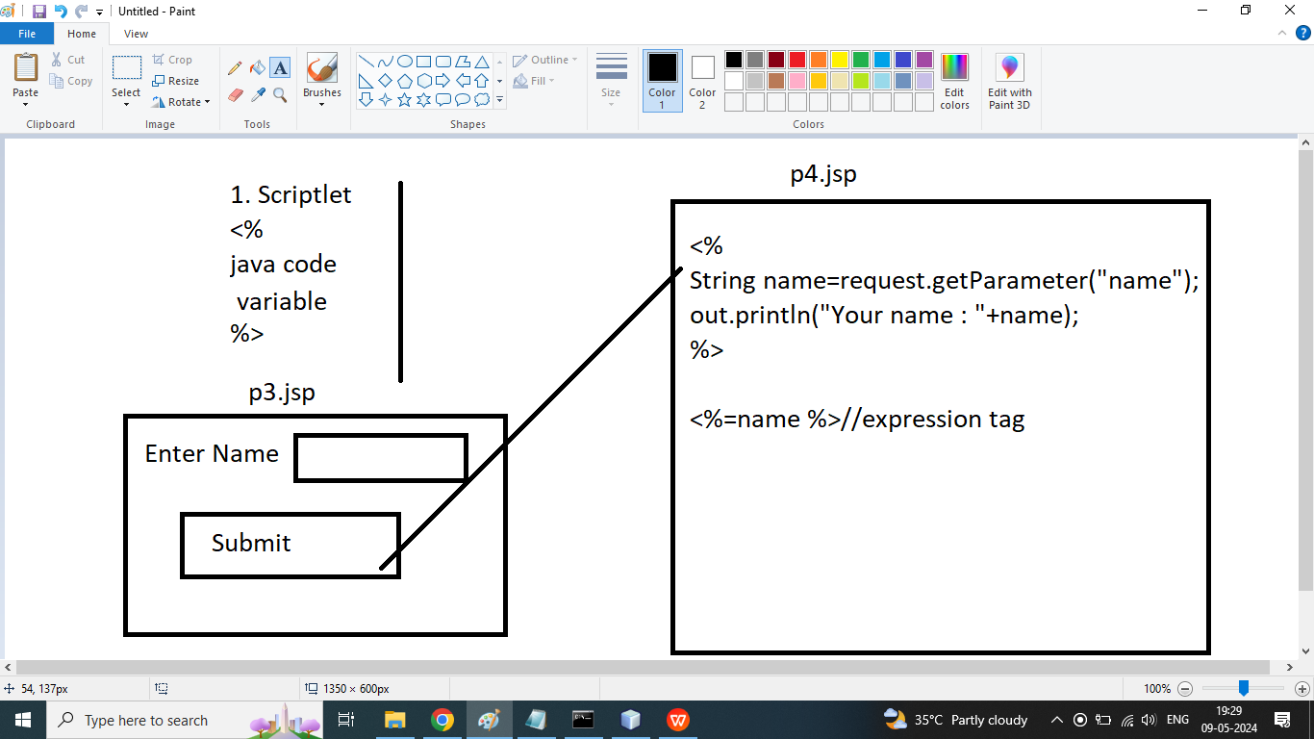

P3.jsp

<%--

Document : p3

Created on : 9 May, 2024, 7:30:03 PM

Author : Admin

--%>

<%@page contentType="text/html" pageEncoding="UTF-8"%>

<!DOCTYPE html>

<html>

<head>

<meta http-equiv="Content-Type" content="text/html; charset=UTF-8">

<title>JSP Page</title>

</head>

<body>

<form action="p4.jsp">

Enter Name : <input type="text" name="name"><br>

<input type="submit" value="submit">

</form>

</body>

</html>

P4.jsp

<%@page contentType="text/html" pageEncoding="UTF-8"%>

<!DOCTYPE html>

<html>

<head>

<meta http-equiv="Content-Type" content="text/html; charset=UTF-8">

<title>JSP Page</title>

</head>

<body>

<%

String name=request.getParameter("name");

out.println("Your name : "+name);

%>

<h1>Your name : <%=name %></h1>

</body>

</html>

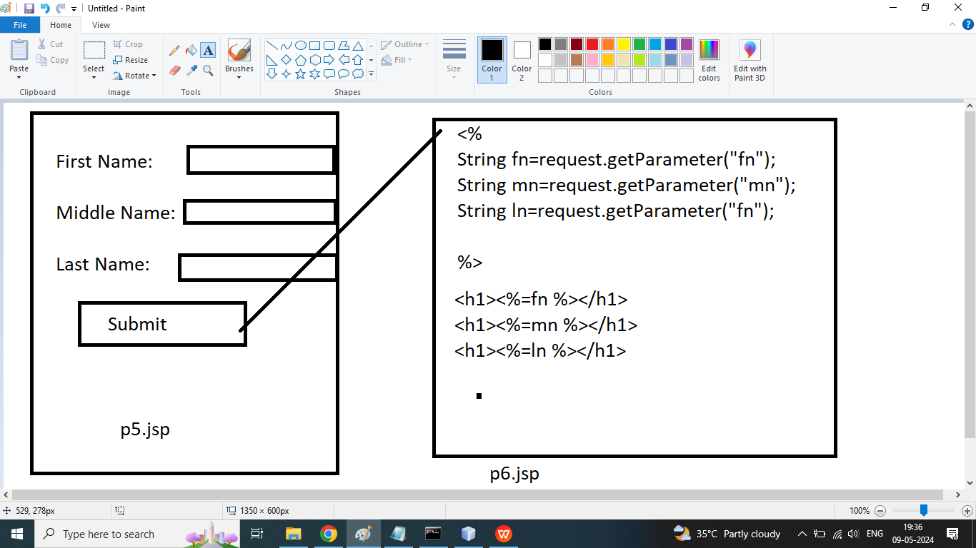

p5.jsp

<%--

Document : p5

Created on : 9 May, 2024, 7:36:55 PM

Author : Admin

--%>

<%@page contentType="text/html" pageEncoding="UTF-8"%>

<!DOCTYPE html>

<html>

<head>

<meta http-equiv="Content-Type" content="text/html; charset=UTF-8">

<title>JSP Page</title>

</head>

<body>

<form action="p6.jsp">

First Name : <input type="text" name="fn"><br>

Middle Name : <input type="text" name="mn"><br>

Last Name : <input type="text" name="ln"><br>

<input type="submit" value="submit">

</form>

</body>

</html>

P6.jsp

<%--

Document : p6

Created on : 9 May, 2024, 7:38:05 PM

Author : Admin

--%>

<%@page contentType="text/html" pageEncoding="UTF-8"%>

<!DOCTYPE html>

<html>

<head>

<meta http-equiv="Content-Type" content="text/html; charset=UTF-8">

<title>JSP Page</title>

</head>

<body>

<%

String fn=request.getParameter("fn");

String mn=request.getParameter("mn");

String ln=request.getParameter("ln");

%>

<h1><%=fn %></h1>

<h1><%=mn %></h1>

<h1><%=ln %></h1>

</body>

</html>

FindByID

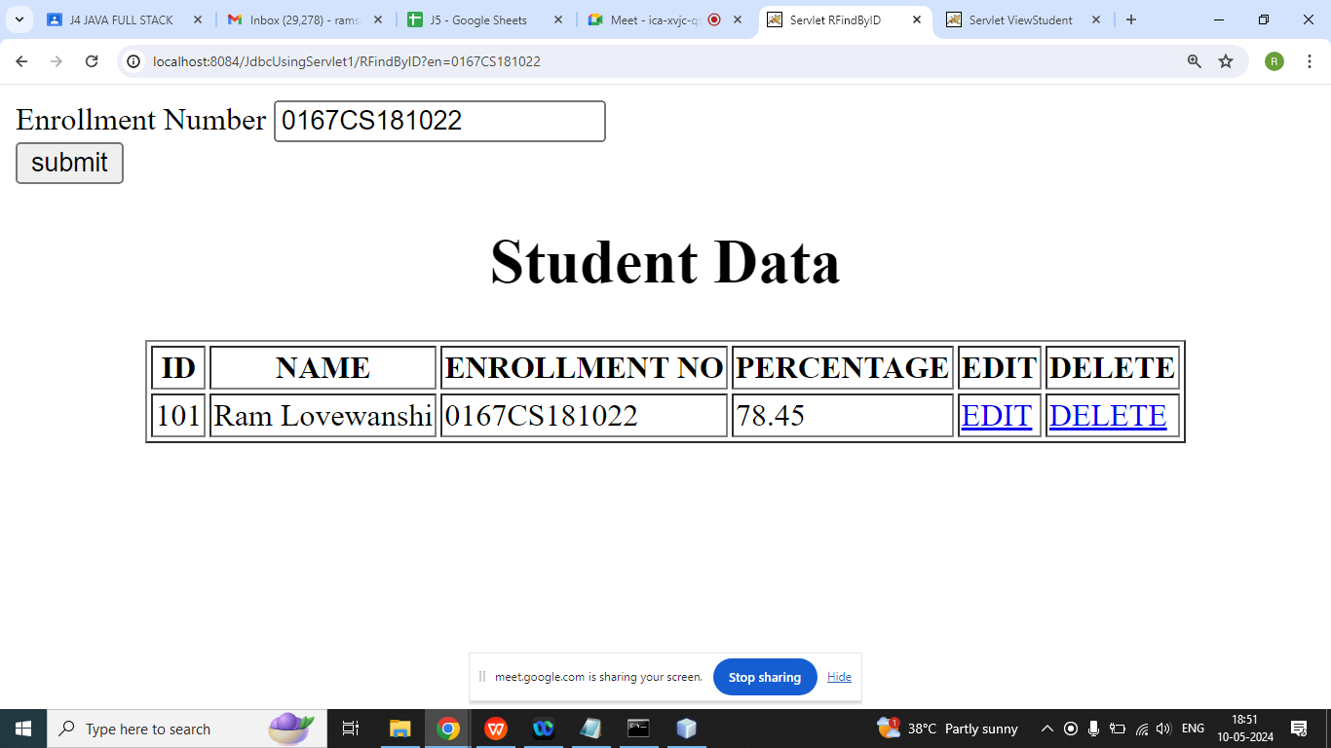

/*

**\* To change this license header, choose License Headers in Project Properties.**

**\* To change this template file, choose Tools | Templates**

**\* and open the template in the editor.**

**\*/**

package com.ram.controller;

import com.ram.bean.StudentBean;

import com.ram.dao.StudentDAO;

import java.io.IOException;

import java.io.PrintWriter;

import java.util.ArrayList;

import javax.servlet.ServletException;

import javax.servlet.http.HttpServlet;

import javax.servlet.http.HttpServletRequest;

import javax.servlet.http.HttpServletResponse;

/**

*

* @author Admin

*/

public class RFindByID extends HttpServlet {

/**

* Processes requests for both HTTP <code>GET</code> and <code>POST</code>

* methods.

*

* @param request servlet request

* @param response servlet response

* @throws ServletException if a servlet-specific error occurs

* @throws IOException if an I/O error occurs

*/

protected void processRequest(HttpServletRequest request, HttpServletResponse response)

throws ServletException, IOException {

response.setContentType("text/html;charset=UTF-8");

try (PrintWriter out = response.getWriter()) {

/* TODO output your page here. You may use following sample code. */

out.println("<!DOCTYPE html>");

out.println("<html>");

out.println("<head>");

out.println("<title>Servlet RFindByID</title>");

out.println("</head>");

out.println("<body>");

out.println("<form action='RFindByID'>");

out.println("Enrollment Number <input type='text' name='en'><br>");

out.println("<input type='submit' value='submit'>");

out.println("<form>");

out.println("<h1 align='center'>Student Data</h1>");

out.println("<table align='center' border='1'>");

out.println("<tr>");

out.println("<th>ID</th>");

out.println("<th>NAME</th>");

out.println("<th>ENROLLMENT NO</th>");

out.println("<th>PERCENTAGE</th>");

out.println("<th>EDIT</th>");

out.println(" <th>DELETE</th>");

out.println(" </tr>");

StudentDAO sd=new StudentDAO();

String x=request.getParameter("en");

StudentBean sb=sd.findByEnrollment(x);

out.println("<tr>");

out.println(" <td>"+sb.getId()+"</td>");

out.println("<td>"+sb.getName()+"</td>");

out.println("<td>"+sb.getEnroll()+"</td>");

out.println("<td>"+sb.getPer()+"</td>");

out.println("<td><a href='UpdateStudentForm?id="+sb.getId()+"'>EDIT</a></td>");

out.println("<td><a href='DeleteStudent?id="+sb.getId()+"'>DELETE</a></td>");

out.println("</tr>");

out.println(" </table>");

out.println("</body>");

out.println("</html>");

}

}

// <editor-fold defaultstate="collapsed" desc="HttpServlet methods. Click on the + sign on the left to edit the code.">

/**

* Handles the HTTP <code>GET</code> method.

*

* @param request servlet request

* @param response servlet response

* @throws ServletException if a servlet-specific error occurs

* @throws IOException if an I/O error occurs

*/

@Override

protected void doGet(HttpServletRequest request, HttpServletResponse response)

throws ServletException, IOException {

processRequest(request, response);

}

/**

* Handles the HTTP <code>POST</code> method.

*

* @param request servlet request

* @param response servlet response

* @throws ServletException if a servlet-specific error occurs

* @throws IOException if an I/O error occurs

*/

@Override

protected void doPost(HttpServletRequest request, HttpServletResponse response)

throws ServletException, IOException {

processRequest(request, response);

}

/**

* Returns a short description of the servlet.

*

* @return a String containing servlet description

*/

@Override

public String getServletInfo() {

return "Short description";

}// </editor-fold>

}

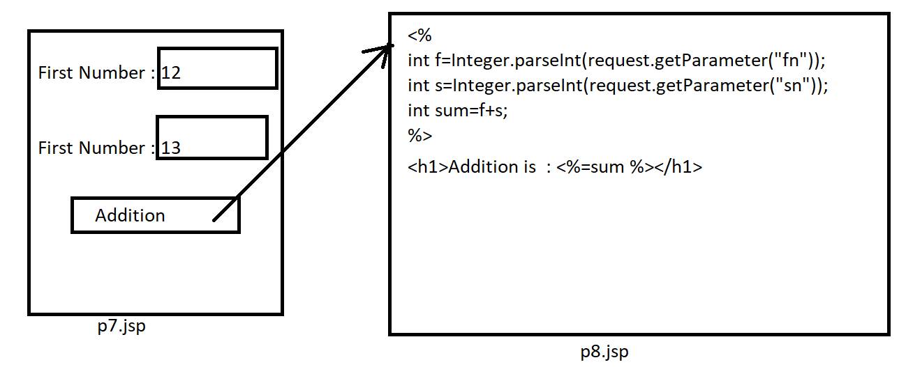

P7.jsp

<%--

Document : p7

Created on : 10 May, 2024, 7:04:00 PM

Author : Admin

--%>

<%@page contentType="text/html" pageEncoding="UTF-8"%>

<!DOCTYPE html>

<html>

<head>

<meta http-equiv="Content-Type" content="text/html; charset=UTF-8">

<title>JSP Page</title>

</head>

<body>

<form action="p8.jsp">

<table border="0" bgcolor="pink" align="center">

<tr>

<td>First Number</td>

<td><input type="text" name="fn"></td>

</tr>

<tr>

<td>Second Number</td>

<td><input type="text" name="sn"></td>

</tr>

<tr>

<td>&nbsp;</td>

<td><input type="submit" value="submit"></td>

</tr>

</table>

</form>

</body>

</html>

P8.jsp

<%--

Document : p8

Created on : 10 May, 2024, 7:06:36 PM

Author : Admin

--%>

<%@page contentType="text/html" pageEncoding="UTF-8"%>

<!DOCTYPE html>

<html>

<head>

<meta http-equiv="Content-Type" content="text/html; charset=UTF-8">

<title>JSP Page</title>

</head>

<body>

<%

int f=Integer.parseInt(request.getParameter("fn"));

int s=Integer.parseInt(request.getParameter("sn"));

int sum=f+s;

%>

<h1>Addition : <%=sum %></h1>

</body>

</html>

Q1. fetch request data in jsp on sam page

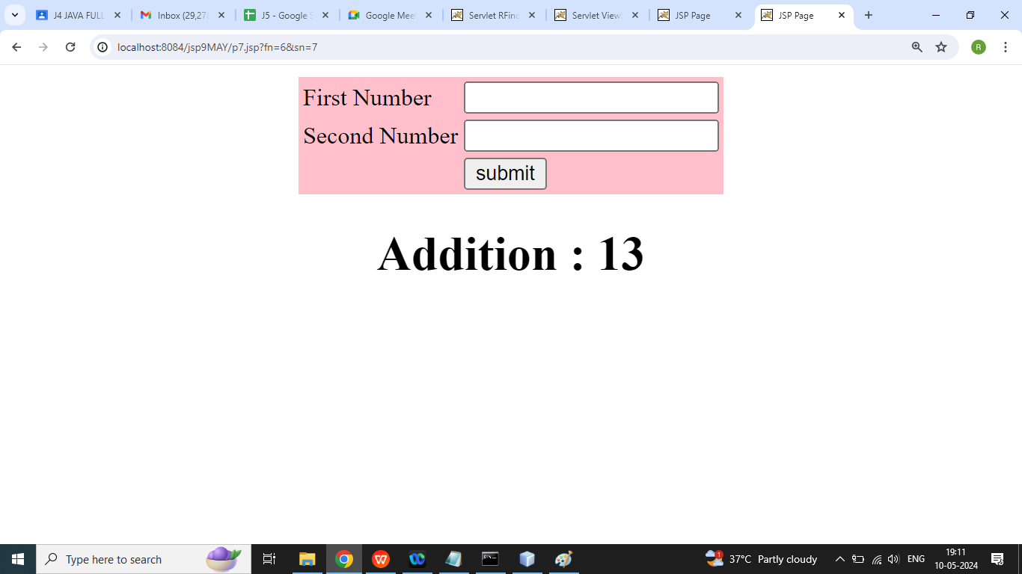

<%@page contentType="text/html" pageEncoding="UTF-8"%>

<!DOCTYPE html>

<html>

<head>

<meta http-equiv="Content-Type" content="text/html; charset=UTF-8">

<title>JSP Page</title>

</head>

<body>

<form action="p7.jsp">

<table border="0" bgcolor="pink" align="center">

<tr>

<td>First Number</td>

<td><input type="text" name="fn"></td>

</tr>

<tr>

<td>Second Number</td>

<td><input type="text" name="sn"></td>

</tr>

<tr>

<td>&nbsp;</td>

<td><input type="submit" value="submit"></td>

</tr>

</table>

</form>

<%

int sum=0;

if(request.getParameter("fn")!=null&&request.getParameter("sn")!=

int f=Integer.parseInt(request.getParameter("fn"));

int s=Integer.parseInt(request.getParameter("sn"));

sum=f+s;

}

%>

<h1 align="center">Addition : <%=sum %></h1>

</body>

</html>

Q3. Example declaration tag in jsp?

Syntax:

<%!

Java code

%>

<%--

Document : p10

Created on : 10 May, 2024, 7:12:45 PM

Author : Admin

--%>

<%@page contentType="text/html" pageEncoding="UTF-8"%>

<!DOCTYPE html>

<html>

<head>

<meta http-equiv="Content-Type" content="text/html; charset=UTF-8">

<title>JSP Page</title>

</head>

<body>

<%!

int square(int n){

return n*n;

}

%>

<h1>

Square of 5 is : <%=square(5) %>

</h1>

</body>

</html>

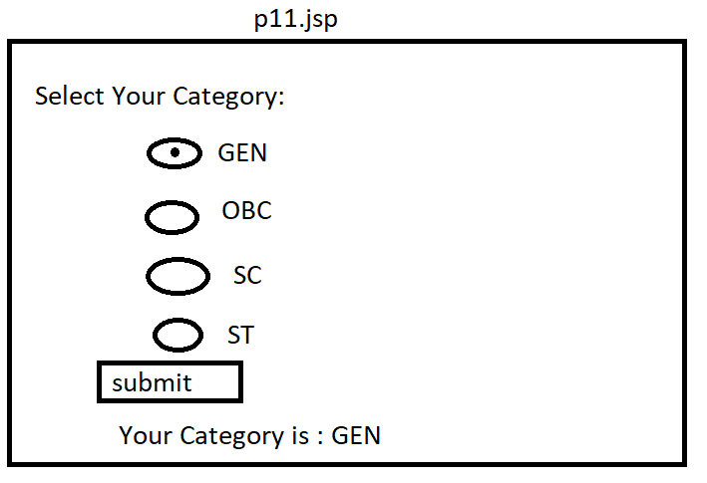

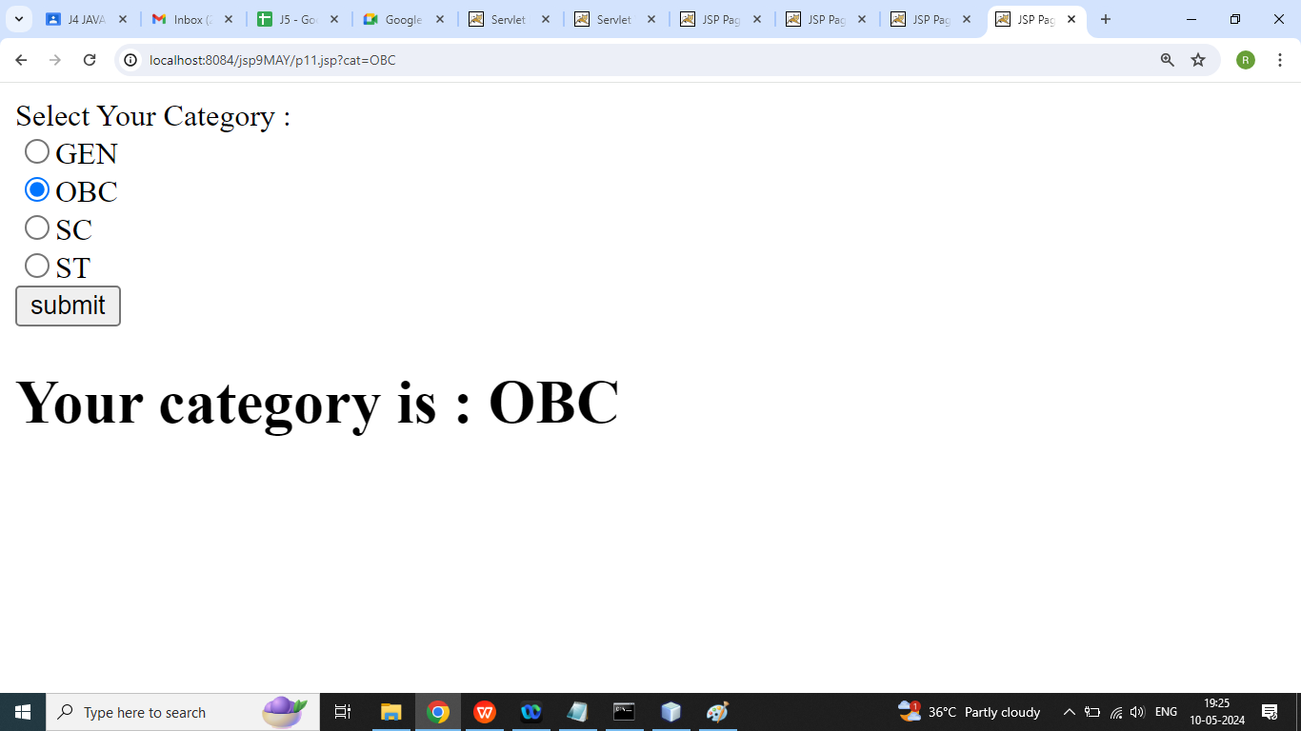

P11.jsp

<%--

Document : p11

Created on : 10 May, 2024, 7:22:25 PM

Author : Admin

--%>

<%@page contentType="text/html" pageEncoding="UTF-8"%>

<!DOCTYPE html>

<html>

<head>

<meta http-equiv="Content-Type" content="text/html; charset=UTF-8">

<title>JSP Page</title>

</head>

<body>

<form>

Select Your Category : <br>

<input type="radio" name="cat" value="GEN">GEN <br>

<input type="radio" name="cat" value="OBC">OBC <br>

<input type="radio" name="cat" value="SC">SC <br>

<input type="radio" name="cat" value="ST">ST <br>

<input type="submit" value="submit">

</form>

<%

String s="";

if(request.getParameter("cat")!=null){

s=request.getParameter("cat");

}

%>

<h1>Your category is : <%=s %></h1>

</body>

</html>

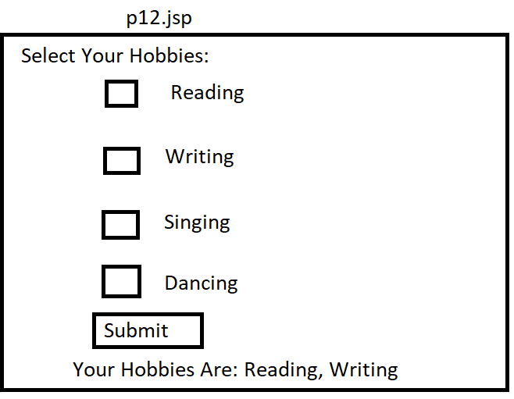

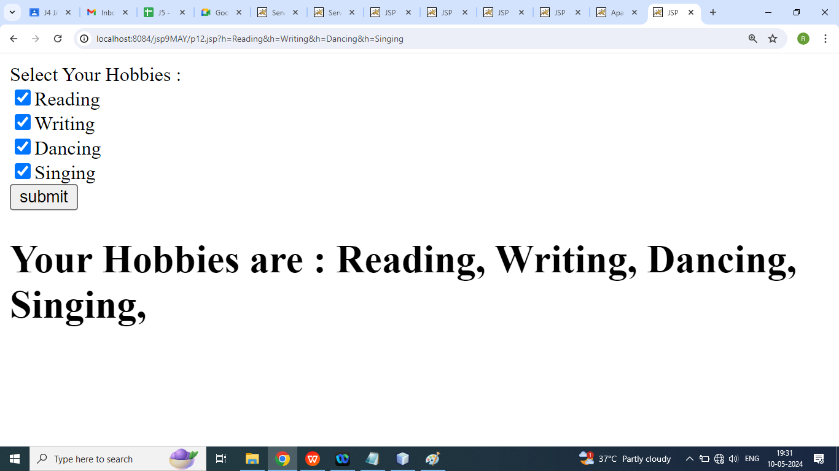

<%--

Document : p11

Created on : 10 May, 2024, 7:22:25 PM

Author : Admin

--%>

<%@page contentType="text/html" pageEncoding="UTF-8"%>

<!DOCTYPE html>

<html>

<head>

<meta http-equiv="Content-Type" content="text/html; charset=UTF-8">

<title>JSP Page</title>

</head>

<body>

<form>

Select Your Hobbies : <br>

<input type="checkbox" name="h" value="Reading">Reading <br>

<input type="checkbox" name="h" value="Writing">Writing <br>

<input type="checkbox" name="h" value="Dancing">Dancing <br>

<input type="checkbox" name="h" value="Singing">Singing <br>

<input type="submit" value="submit">

</form>

<%

String s="";

if(request.getParameter("h")!=null){

String arr[]=request.getParameterValues("h");

for(String a:arr){

s=s+a+", ";

}

}

%>

<h1>Your Hobbies are : <%=s %></h1>

</body>

</html>

addstudent.jsp

<%--

Document : addstudent

Created on : 11 May, 2024, 7:23:45 PM

Author : Admin

--%>

<%@page import="java.util.ArrayList"%>

<%@page import="com.ram.dao.StudentDAO"%>

<%@page import="com.ram.bean.StudentBean"%>

<%@page contentType="text/html" pageEncoding="UTF-8"%>

<!DOCTYPE html>

<html>

<head>

<meta http-equiv="Content-Type" content="text/html; charset=UTF-8">

<title>Student Registration Form</title>

</head>

<body>

<h1 align="center">Student Registration Form</h1>

<form>

<table bgcolor="cyan" align="center">

<tr>

<td>ID : </td>

<td><input type="text" name="id"></td>

</tr>

<tr>

<td>Name : </td>

<td><input type="text" name="name"></td>

</tr>

<tr>

<td>Enrollment : </td>

<td><input type="text" name="enroll"></td>

</tr>

<tr>

<td>Percentage : </td>

<td><input type="text" name="per"></td>

</tr>

<tr>

<td>&nbsp; </td>

<td><input type="submit" value="submit"></td>

</tr>

</table>

</form>

<%

String str = "";

String str1 = "";

if (request.getParameter("id") != null & request.getParameter("name") != null && request.getParameter("enroll") != null && request.getParameter("per") != null) {

int id = Integer.parseInt(request.getParameter("id"));

String name = request.getParameter("name");

String enroll = request.getParameter("enroll");

float per = Float.parseFloat(request.getParameter("per"));

StudentBean sb = new StudentBean();

sb.setEnroll(enroll);

sb.setId(id);

sb.setName(name);

sb.setPer(per);

StudentDAO sd = new StudentDAO();

int r = sd.addStudent(sb);

if (r > 0) {

str = "Registration Success";

}

}

%>

<h1 align='center'><font color='green'><%=str%></font></h1>

<h1 align="center">All Students Data</h1>

<table align="center" border="1">

<tr>

<th>ID</th>

<th>NAME</th>

<th>Enrollment</th>

<th>Percentage</th>

<th>EDIT</th>

<th>DELETE</th>

</tr>

<%

StudentDAO sd = new StudentDAO();

ArrayList<StudentBean> al = sd.findAll();

for (StudentBean sb : al) {

%>

<tr>

<td><%=sb.getId()%></td>

<td><%=sb.getName()%></td>

<td><%=sb.getEnroll()%></td>

<td><%=sb.getPer()%></td>

<td><a href="updatestudent.jsp?id=<%=sb.getId() %>">EDIT</a></td>

<td><a href="addstudent.jsp?sid=<%=sb.getId()%>">DELETE</a></td>

</tr>

<%

}

%>

</table>

<%

if (request.getParameter("sid") != null) {

int id = Integer.parseInt(request.getParameter("sid"));

sd.deleteStudent(id);

response.sendRedirect("addstudent.jsp");

}

%>

</body>

</html>

=======================================

updatestudent.jsp

<%--

Document : updatestudent

Created on : 14 May, 2024, 6:41:48 PM

Author : Admin

--%>

<%@page import="com.ram.dao.StudentDAO"%>

<%@page import="com.ram.bean.StudentBean"%>

<%@page contentType="text/html" pageEncoding="UTF-8"%>

<!DOCTYPE html>

<html>

<head>

<meta http-equiv="Content-Type" content="text/html; charset=UTF-8">

<title>JSP Page</title>

</head>

<body>

<%

int id=Integer.parseInt(request.getParameter("id"));

StudentDAO sd=new StudentDAO();

StudentBean sb=sd.findById(id);

if(request.getParameter("id")!=null&& request.getParameter("name")!=null && request.getParameter("enroll")!=null && request.getParameter("per")!=null){

int idx=Integer.parseInt(request.getParameter("id"));

String name=request.getParameter("name");

String enroll=request.getParameter("enroll");

float per=Float.parseFloat(request.getParameter("per"));

sb.setId(idx);

sb.setEnroll(enroll);

sb.setName(name);

sb.setPer(per);

int r=sd.updateStudent(sb);

if(r>0){

response.sendRedirect("addstudent.jsp");

}

}

%>

<h1 align="center">Student Update Form</h1>

<form>

<table bgcolor="cyan" align="center">

<tr>

<td>ID : </td>

<td><input type="text" name="id" value=<%=sb.getId() %>></td>

</tr>

<tr>

<td>Name : </td>

<td><input type="text" name="name" value=<%=sb.getName() %>></td>

</tr>

<tr>

<td>Enrollment : </td>

<td><input type="text" name="enroll" value=<%=sb.getEnroll() %>></td>

</tr>

<tr>

<td>Percentage : </td>

<td><input type="text" name="per" value= <%=sb.getPer() %>></td>

</tr>

<tr>

<td>&nbsp; </td>

<td><input type="submit" value="Update Student"></td>

</tr>

</table>

</form>

</body>

</html>

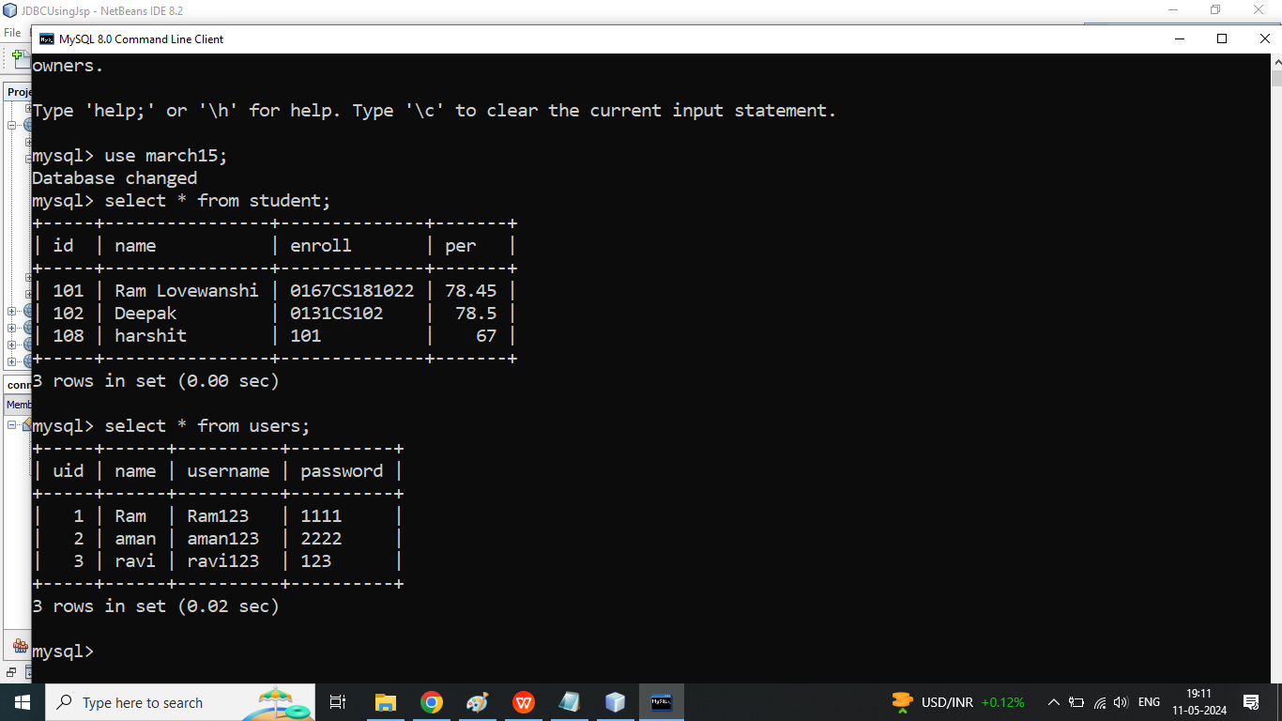

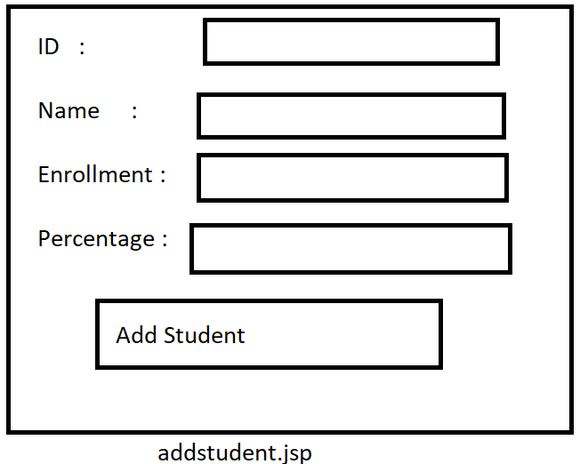s

import java.time.chrono.ThaiBuddhistChronology;

import java.util.logging.Level;

import java.util.logging.Logger;

/*

* To change this license header, choose License Headers in Project Properties.

* To change this template file, choose Tools | Templates

* and open the template in the editor.

*/

/**

*

* @author Admin

*/

public class T1 extends Thread{

public void run(){

for (int i = 0; i < 100; i++) {

try {

Thread.sleep(100);

} catch (InterruptedException ex) {

Logger.getLogger(T1.class.getName()).log(Level.SEVERE, null, ex);

}

System.out.println("-------->This is Child Thread : "+i);

}

}

}

class Demo{

public static void main(String[] args) throws InterruptedException {

T1 t=new T1();

t.start();

for (int i = 0; i < 100; i++) {

Thread.sleep(100);

System.out.println("======>This is Main Thread : "+i);

}

}

}

==============================

import java.time.chrono.ThaiBuddhistChronology;

import java.util.logging.Level;

import java.util.logging.Logger;

/*

* To change this license header, choose License Headers in Project Properties.

* To change this template file, choose Tools | Templates

* and open the template in the editor.

*/

/**

*

* @author Admin

*/

public class T1 implements Runnable{

public void run(){

for (int i = 0; i < 100; i++) {

try {

Thread.sleep(100);

} catch (InterruptedException ex) {

Logger.getLogger(T1.class.getName()).log(Level.SEVERE, null, ex);

}

System.out.println("-------->This is Child Thread : "+i);

}

}

public void run(int x){

System.out.println("Hello X ");

}

}

class Demo{

public static void main(String[] args) throws InterruptedException {

Thread t=new Thread(new T1());

t.start();

for (int i = 0; i < 100; i++) {

Thread.sleep(100);

System.out.println("======>This is Main Thread : "+i);

}

}

}

==================================

Synchronization

Synchronization

/*

* To change this license header, choose License Headers in Project Properties.

* To change this template file, choose Tools | Templates

* and open the template in the editor.

*/

package com.ram.mthread;

import java.util.logging.Level;

import java.util.logging.Logger;

/**

*

* @author Admin

*/

public class Display {

public synchronized void wish(String name){

for (int i = 1; i < 5; i++) {

System.out.println("Hello "+name);

try {

Thread.sleep(1000);

} catch (InterruptedException ex) {

Logger.getLogger(Display.class.getName()).log(Level.SEVERE, null, ex);

}

}

}

}

======================================

/*

* To change this license header, choose License Headers in Project Properties.

* To change this template file, choose Tools | Templates

* and open the template in the editor.

*/

package com.ram.mthread;

/**

*

* @author Admin

*/

public class MyThread extends Thread{

Display d1;

String name;

public MyThread(Display d1, String name) {

this.d1 = d1;

this.name = name;

}

public void run(){

d1.wish(name);

}

}

============================================================

package com.ram.mthread;

public class Test {

public static void main(String[] args) {

Display d1=new Display();

MyThread t1=new MyThread(d1,"Dhoni");

MyThread t2=new MyThread(d1,"Virat");

t1.start();

t2.start();

}

}

===================================================================

Insert image in jsp page

Example:

File Uploading text/pdf/image/excel

============================

Step1: create jsp file for file input

(action.jsp)

Step2: download jar file

1. org.apache.commons.fileupload

2. org.apache.commons.io

step3: create upload servlet

step4: create result.jsp file

===================================

step1(action.jsp):

<%@ page language="java" contentType="text/html; charset=ISO-8859-1"

pageEncoding="ISO-8859-1"%>

<!DOCTYPE html PUBLIC "-//W3C//DTD HTML 4.01 Transitional//EN" "http://www.w3.org/TR/html4/loose.dtd">

<html>

<head>

<meta http-equiv="Content-Type" content="text/html; charset=ISO-8859-1">

<title>Uploading File</title>

</head>

<body>

File:

<br />

<form action="upload" method="post" enctype="multipart/form-data">

<input type="file" name="file" size="50" /> <br /> <input

type="submit" value="Upload" />

</form>

</body>

</html>

=====================================

step2:jar file download and add

Step3 : (create upload servlet)

/*

* To change this license header, choose License Headers in Project Properties.

* To change this template file, choose Tools | Templates

* and open the template in the editor.

*/

import java.io.File;

import java.io.IOException;

import java.util.List;

import javax.servlet.ServletException;

import javax.servlet.http.HttpServlet;

import javax.servlet.http.HttpServletRequest;

import javax.servlet.http.HttpServletResponse;

import org.apache.commons.fileupload.FileItem;

import org.apache.commons.fileupload.disk.DiskFileItemFactory;

import org.apache.commons.fileupload.servlet.ServletFileUpload;

public class upload extends HttpServlet {

private static final long serialVersionUID = 1L;

public upload() {

super();

// TODO Auto-generated constructor stub

}

protected void doPost(HttpServletRequest request, HttpServletResponse response)

throws ServletException, IOException {

if (ServletFileUpload.isMultipartContent(request)) {

try {

List<FileItem> multiparts = new ServletFileUpload(new DiskFileItemFactory()).parseRequest(request);

for (FileItem item : multiparts) {

if (!item.isFormField()) {

String name = new File(item.getName()).getName();

int i=name.indexOf(".");

String ext=name.substring(i);

name="R123"+ext;

String path="C:\\Users\\Admin\\Documents\\NetBeansProjects\\MyImageFileUpload\\web\\img\\"+name;

System.out.println("File Path : "+path);

item.write(new File("C:\\Users\\Admin\\Documents\\NetBeansProjects\\MyImageFileUpload\\web\\img\\" + File.separator + name));

}

}

// File uploaded successfully

request.setAttribute("message", "File Uploaded Successfully");

} catch (Exception ex) {

request.setAttribute("message", "File Upload Failed due to " + ex);

}

} else {

request.setAttribute("message", "No File found");

}

request.getRequestDispatcher("/result.jsp").forward(request, response);

}

}

=============================================================================

step4: create result.jsp

<%@ page language="java" contentType="text/html; charset=ISO-8859-1"

pageEncoding="ISO-8859-1"%>

<!DOCTYPE html PUBLIC "-//W3C//DTD HTML 4.01 Transitional//EN" "http://www.w3.org/TR/html4/loose.dtd">

<html>

<head>

<meta http-equiv="Content-Type" content="text/html; charset=ISO-8859-1">

<title> Result</title>

</head>

<body>

<%

String msg = (String) request.getAttribute("message");

out.println(msg);

%>

</body>

</html>

========================================

File Display Using Jsp

<%--

Document : display

Created on : 23 May, 2024, 7:32:10 PM

Author : Admin

--%>

<%@page contentType="text/html" pageEncoding="UTF-8"%>

<!DOCTYPE html>

<html>

<head>

<meta http-equiv="Content-Type" content="text/html; charset=UTF-8">

<title>JSP Page</title>

</head>

<body>

<%

String s="R123.png";

%>

<img src="img/<%=s%>"/>

<button>Add To Cart</button>

</body>

</html>a

—-----------------------------------------------------------------------------------------

Onetomany - manytoone

/*

* To change this license header, choose License Headers in Project Properties.

* To change this template file, choose Tools | Templates

* and open the template in the editor.

*/

package com.ram.bean;

import javax.persistence.Entity;

import javax.persistence.Id;

@Entity

public class Address {

@Id

private int addressId;

private String addressLine;

private String city;

private String state;

private String country;

private String pincode;

public Address() {

}

public Address(int addressId, String addressLine, String city, String state, String country, String pincode) {

this.addressId = addressId;

this.addressLine = addressLine;

this.city = city;

this.state = state;

this.country = country;

this.pincode = pincode;

}

public int getAddressId() {

return addressId;

}

public void setAddressId(int addressId) {

this.addressId = addressId;

}

public String getAddressLine() {

return addressLine;

}

public void setAddressLine(String addressLine) {

this.addressLine = addressLine;

}

public String getCity() {

return city;

}

public void setCity(String city) {

this.city = city;

}

public String getState() {

return state;

}

public void setState(String state) {

this.state = state;

}

public String getCountry() {

return country;

}

public void setCountry(String country) {

this.country = country;

}

public String getPincode() {

return pincode;

}

public void setPincode(String pincode) {

this.pincode = pincode;

}

@Override

public String toString() {

return "Address{" + "addressId=" + addressId + ", addressLine=" + addressLine + ", city=" + city + ", state=" + state + ", country=" + country + ", pincode=" + pincode + '}';

}

}

===========================

/*

**\* To change this license header, choose License Headers in Project Properties.**

**\* To change this template file, choose Tools | Templates**

**\* and open the template in the editor.**

**\*/**

package com.ram.bean;

import javax.persistence.CascadeType;

import javax.persistence.Entity;

import javax.persistence.Id;

import javax.persistence.OneToOne;

@Entity

public class Employee {

@Id

private int employeeId;

private String name;

private String email;

@OneToOne(targetEntity = Address.class,cascade = CascadeType.ALL)

private Address address;

public Employee() {

}

public Employee(int employeeId, String name, String email, Address address) {

this.employeeId = employeeId;

this.name = name;

this.email = email;

this.address = address;

}

public int getEmployeeId() {

return employeeId;

}

public void setEmployeeId(int employeeId) {

this.employeeId = employeeId;

}

public String getName() {

return name;

}

public void setName(String name) {

this.name = name;

}

public String getEmail() {

return email;

}

public void setEmail(String email) {

this.email = email;

}

public Address getAddress() {

return address;

}

public void setAddress(Address address) {

this.address = address;

}

@Override

public String toString() {

return "Employee{" + "employeeId=" + employeeId + ", name=" + name + ", email=" + email + ", address=" + address + '}';

}

}

<?xml version="1.0" encoding="UTF-8"?>

<!DOCTYPE hibernate-configuration PUBLIC "-//Hibernate/Hibernate Configuration DTD 3.0//EN" "http://hibernate.sourceforge.net/hibernate-configuration-3.0.dtd">

<!--

DO NOT ALTER OR REMOVE COPYRIGHT NOTICES OR THIS HEADER.

Copyright (c) 2008, 2016 Oracle and/or its affiliates. All rights reserved.

Oracle and Java are registered trademarks of Oracle and/or its affiliates.

Other names may be trademarks of their respective owners.

The contents of this file are subject to the terms of either the GNU

General Public License Version 2 only ("GPL") or the Common

Development and Distribution License("CDDL") (collectively, the

"License"). You may not use this file except in compliance with the

License. You can obtain a copy of the License at

http://www.netbeans.org/cddl-gplv2.html

or nbbuild/licenses/CDDL-GPL-2-CP. See the License for the

specific language governing permissions and limitations under the

License. When distributing the software, include this License Header

Notice in each file and include the License file at

nbbuild/licenses/CDDL-GPL-2-CP. Oracle designates this

particular file as subject to the "Classpath" exception as provided

by Oracle in the GPL Version 2 section of the License file that

accompanied this code. If applicable, add the following below the

License Header, with the fields enclosed by brackets [] replaced by

your own identifying information:

"Portions Copyrighted [year] [name of copyright owner]"

If you wish your version of this file to be governed by only the CDDL

or only the GPL Version 2, indicate your decision by adding

"[Contributor] elects to include this software in this distribution

under the [CDDL or GPL Version 2] license." If you do not indicate a

single choice of license, a recipient has the option to distribute

your version of this file under either the CDDL, the GPL Version 2 or

to extend the choice of license to its licensees as provided above.

However, if you add GPL Version 2 code and therefore, elected the GPL

Version 2 license, then the option applies only if the new code is

made subject to such option by the copyright holder.

Contributor(s):

-->

<hibernate-configuration>

<session-factory>

<property name="hibernate.dialect">org.hibernate.dialect.MySQLDialect</property>

<property name="hibernate.connection.driver_class">com.mysql.jdbc.Driver</property>

<property name="hibernate.connection.url">jdbc:mysql://localhost:3306/jun3?zeroDateTimeBehavior=convertToNull</property>

<property name="hibernate.connection.username">root</property>

<property name="show_sql">true</property>

<property name="hibernate.hbm2ddl.auto">update</property>

<property name="hibernate.connection.password">Ram@1234</property>

<mapping class="com.ram.bean.Address"/>

<mapping class="com.ram.bean.Employee"/>

</session-factory>

</hibernate-configuration>

============================

/*

* To change this license header, choose License Headers in Project Properties.

* To change this template file, choose Tools | Templates

* and open the template in the editor.

*/

package com.ram.operation;

import com.ram.bean.Address;

import com.ram.bean.Employee;

import com.ram.utility.HibernateUtil;

import org.hibernate.Session;

import org.hibernate.SessionFactory;

import org.hibernate.Transaction;

/**

*

* @author Admin

*/

public class ExampleOneToOneMapping {

public static void main(String[] args) {

SessionFactory sf=HibernateUtil.getSessionFactory();

Session session=sf.openSession();

Address ad=new Address();

ad.setAddressId(2);

ad.setAddressLine("Zone 2");

ad.setCity("Bhopal");

ad.setCountry("INIDA");

ad.setPincode("462001");

ad.setState("MP");

Employee e=new Employee();

e.setEmployeeId(102);

e.setEmail("aman@gmail.com");

e.setName("aman");

e.setAddress(ad);

session.save(e);

Transaction tx=session.beginTransaction();

tx.commit();

System.out.println("Data Inser Success");

}

}

=======================================

Example : OneToMany and ManyToOne

/*

* To change this license header, choose License Headers in Project Properties.

* To change this template file, choose Tools | Templates

* and open the template in the editor.

*/

package com.ram.bean;

import javax.persistence.CascadeType;

import javax.persistence.Entity;

import javax.persistence.Id;

import javax.persistence.ManyToOne;

@Entity

public class Address {

@Id

private int addressId;

private String addressLine;

private String city;

private String state;

private String country;

private String pincode;

@ManyToOne(targetEntity = Employee.class,cascade = CascadeType.ALL)

private Employee employee;

public Address() {

}

public Address(int addressId, String addressLine, String city, String state, String country, String pincode, Employee employee) {

this.addressId = addressId;

this.addressLine = addressLine;

this.city = city;

this.state = state;

this.country = country;

this.pincode = pincode;

this.employee = employee;

}

public int getAddressId() {

return addressId;

}

public void setAddressId(int addressId) {

this.addressId = addressId;

}

public String getAddressLine() {

return addressLine;

}

public void setAddressLine(String addressLine) {

this.addressLine = addressLine;

}

public String getCity() {

return city;

}

public void setCity(String city) {

this.city = city;

}

public String getState() {

return state;

}

public void setState(String state) {

this.state = state;

}

public String getCountry() {

return country;

}

public void setCountry(String country) {

this.country = country;

}

public String getPincode() {

return pincode;

}

public void setPincode(String pincode) {

this.pincode = pincode;

}

public Employee getEmployee() {

return employee;

}

public void setEmployee(Employee employee) {

this.employee = employee;

}

@Override

public String toString() {

return "Address{" + "addressId=" + addressId + ", addressLine=" + addressLine + ", city=" + city + ", state=" + state + ", country=" + country + ", pincode=" + pincode + ", employee=" + employee + '}';

}

}

=======================

/*

* To change this license header, choose License Headers in Project Properties.

* To change this template file, choose Tools | Templates

* and open the template in the editor.

*/

package com.ram.bean;

import java.util.List;

import javax.persistence.CascadeType;

import javax.persistence.Entity;

import javax.persistence.Id;

import javax.persistence.OneToMany;

@Entity

public class Employee {

@Id

private int employeeId;

private String name;

private String email;

@OneToMany(targetEntity = Address.class,cascade = CascadeType.ALL)

private List<Address> address;

public Employee() {

}

public Employee(int employeeId, String name, String email, List<Address> address) {

this.employeeId = employeeId;

this.name = name;

this.email = email;

this.address = address;

}

public int getEmployeeId() {

return employeeId;

}

public void setEmployeeId(int employeeId) {

this.employeeId = employeeId;

}

public String getName() {

return name;

}

public void setName(String name) {

this.name = name;

}

public String getEmail() {

return email;

}

public void setEmail(String email) {

this.email = email;

}

public List<Address> getAddress() {

return address;

}

public void setAddress(List<Address> address) {

this.address = address;

}

@Override

public String toString() {

return "Employee{" + "employeeId=" + employeeId + ", name=" + name + ", email=" + email + ", address=" + address + '}';

}

}

========================================================

<?xml version="1.0" encoding="UTF-8"?>

<!DOCTYPE hibernate-configuration PUBLIC "-//Hibernate/Hibernate Configuration DTD 3.0//EN" "http://hibernate.sourceforge.net/hibernate-configuration-3.0.dtd">

<!--

DO NOT ALTER OR REMOVE COPYRIGHT NOTICES OR THIS HEADER.

Copyright (c) 2008, 2016 Oracle and/or its affiliates. All rights reserved.

Oracle and Java are registered trademarks of Oracle and/or its affiliates.

Other names may be trademarks of their respective owners.

The contents of this file are subject to the terms of either the GNU

General Public License Version 2 only ("GPL") or the Common

Development and Distribution License("CDDL") (collectively, the

"License"). You may not use this file except in compliance with the

License. You can obtain a copy of the License at

http://www.netbeans.org/cddl-gplv2.html

or nbbuild/licenses/CDDL-GPL-2-CP. See the License for the

specific language governing permissions and limitations under the

License. When distributing the software, include this License Header

Notice in each file and include the License file at

nbbuild/licenses/CDDL-GPL-2-CP. Oracle designates this

particular file as subject to the "Classpath" exception as provided

by Oracle in the GPL Version 2 section of the License file that

accompanied this code. If applicable, add the following below the

License Header, with the fields enclosed by brackets [] replaced by

your own identifying information:

"Portions Copyrighted [year] [name of copyright owner]"

If you wish your version of this file to be governed by only the CDDL

or only the GPL Version 2, indicate your decision by adding

"[Contributor] elects to include this software in this distribution

under the [CDDL or GPL Version 2] license." If you do not indicate a

single choice of license, a recipient has the option to distribute

your version of this file under either the CDDL, the GPL Version 2 or

to extend the choice of license to its licensees as provided above.

However, if you add GPL Version 2 code and therefore, elected the GPL

Version 2 license, then the option applies only if the new code is

made subject to such option by the copyright holder.

Contributor(s):

-->

<hibernate-configuration>

<session-factory>

<property name="hibernate.dialect">org.hibernate.dialect.MySQLDialect</property>

<property name="hibernate.connection.driver_class">com.mysql.jdbc.Driver</property>

<property name="hibernate.connection.url">jdbc:mysql://localhost:3306/jun3?zeroDateTimeBehavior=convertToNull</property>

<property name="hibernate.connection.username">root</property>

<property name="show_sql">true</property>

<property name="hibernate.hbm2ddl.auto">create</property>

<property name="hibernate.connection.password">Ram@1234</property>

<mapping class="com.ram.bean.Address"/>

<mapping class="com.ram.bean.Employee"/>

</session-factory>

</hibernate-configuration>

=========================

/*

* To change this license header, choose License Headers in Project Properties.

* To change this template file, choose Tools | Templates

* and open the template in the editor.

*/

package com.ram.operation;

import com.ram.bean.Address;

import com.ram.bean.Employee;

import com.ram.utility.HibernateUtil;

import java.util.ArrayList;

import java.util.List;

import org.hibernate.Session;

import org.hibernate.SessionFactory;

import org.hibernate.Transaction;

/**

*

* @author Admin

*/

public class ExampleOneToManyandManyToOne {

public static void main(String[] args) {

SessionFactory sf=HibernateUtil.getSessionFactory();

Session session=sf.openSession();

Address ad=new Address();

ad.setAddressId(1);

ad.setAddressLine("Zone 2");

ad.setCity("Bhopal");

ad.setCountry("INIDA");

ad.setPincode("462001");

ad.setState("MP");

Address ad1=new Address();

ad1.setAddressId(2);

ad1.setAddressLine("Vijayvada");

ad1.setCity("Indore");

ad1.setCountry("INIDA");

ad1.setPincode("461234");

ad1.setState("MP");

Employee e=new Employee();

e.setEmployeeId(102);

e.setEmail("aman@gmail.com");

e.setName("aman");

List<Address> listOfAddress=new ArrayList<Address>();

listOfAddress.add(ad);

listOfAddress.add(ad1);

ad.setEmployee(e);

ad1.setEmployee(e);

e.setAddress(listOfAddress);

session.save(e);

Transaction tx=session.beginTransaction();

tx.commit();

System.out.println("Data Inser Success");

}

}

—--------------------------------------------------------------------

Hibernate Mapping ManyToMany

Project Doubt Session

/*

**\* To change this license header, choose License Headers in Project Properties.**

**\* To change this template file, choose Tools | Templates**

**\* and open the template in the editor.**

**\*/**

package com.ram.bean;

import java.util.List;

import javax.persistence.Entity;

import javax.persistence.Id;

import javax.persistence.JoinColumn;

import javax.persistence.JoinTable;

import javax.persistence.ManyToMany;

@Entity

public class Emp {

@Id

private int eid;

private String name;

@ManyToMany

@JoinTable(name="emp_learn",joinColumns = {@JoinColumn(name="eid")},inverseJoinColumns = {@JoinColumn(name="pid")})

private List<Project> projects;

public Emp() {

}

public Emp(int eid, String name, List<Project> projects) {

this.eid = eid;

this.name = name;

this.projects = projects;

}

public int getEid() {

return eid;

}

public void setEid(int eid) {

this.eid = eid;

}

public String getName() {

return name;

}

public void setName(String name) {

this.name = name;

}

public List<Project> getProjects() {

return projects;

}

public void setProjects(List<Project> projects) {

this.projects = projects;

}

}

=================================

/*

**\* To change this license header, choose License Headers in Project Properties.**

**\* To change this template file, choose Tools | Templates**

**\* and open the template in the editor.**

**\*/**

package com.ram.bean;

import java.util.List;

import javax.persistence.Entity;

import javax.persistence.Id;

import javax.persistence.ManyToMany;

@Entity

public class Project {

@Id

private int pid;

private String projectName;

@ManyToMany(mappedBy ="projects")

private List<Emp> employees;

public Project() {

}

public Project(int pid, String projectName, List<Emp> employees) {

this.pid = pid;

this.projectName = projectName;

this.employees = employees;

}

public int getPid() {

return pid;

}

public void setPid(int pid) {

this.pid = pid;

}

public String getProjectName() {

return projectName;

}

public void setProjectName(String projectName) {

this.projectName = projectName;

}

public List<Emp> getEmployees() {

return employees;

}

public void setEmployees(List<Emp> employees) {

this.employees = employees;

}

@Override

public String toString() {

return "Project{" + "pid=" + pid + ", projectName=" + projectName + ", employees=" + employees + '}';

}

}

=====================================

<?xml version="1.0" encoding="UTF-8"?>

<!DOCTYPE hibernate-configuration PUBLIC "-//Hibernate/Hibernate Configuration DTD 3.0//EN" "http://hibernate.sourceforge.net/hibernate-configuration-3.0.dtd">

<!--

DO NOT ALTER OR REMOVE COPYRIGHT NOTICES OR THIS HEADER.

Copyright (c) 2008, 2016 Oracle and/or its affiliates. All rights reserved.

Oracle and Java are registered trademarks of Oracle and/or its affiliates.

Other names may be trademarks of their respective owners.

The contents of this file are subject to the terms of either the GNU

General Public License Version 2 only ("GPL") or the Common

Development and Distribution License("CDDL") (collectively, the

"License"). You may not use this file except in compliance with the

License. You can obtain a copy of the License at

http://www.netbeans.org/cddl-gplv2.html

or nbbuild/licenses/CDDL-GPL-2-CP. See the License for the

specific language governing permissions and limitations under the

License. When distributing the software, include this License Header

Notice in each file and include the License file at

nbbuild/licenses/CDDL-GPL-2-CP. Oracle designates this

particular file as subject to the "Classpath" exception as provided

by Oracle in the GPL Version 2 section of the License file that

accompanied this code. If applicable, add the following below the

License Header, with the fields enclosed by brackets [] replaced by

your own identifying information:

"Portions Copyrighted [year] [name of copyright owner]"

If you wish your version of this file to be governed by only the CDDL

or only the GPL Version 2, indicate your decision by adding

"[Contributor] elects to include this software in this distribution

under the [CDDL or GPL Version 2] license." If you do not indicate a

single choice of license, a recipient has the option to distribute

your version of this file under either the CDDL, the GPL Version 2 or

to extend the choice of license to its licensees as provided above.

However, if you add GPL Version 2 code and therefore, elected the GPL

Version 2 license, then the option applies only if the new code is

made subject to such option by the copyright holder.

Contributor(s):

-->

<hibernate-configuration>

<session-factory>

<property name="hibernate.dialect">org.hibernate.dialect.MySQLDialect</property>

<property name="hibernate.connection.driver_class">com.mysql.jdbc.Driver</property>

<property name="hibernate.connection.url">jdbc:mysql://localhost:3306/jun4?zeroDateTimeBehavior=convertToNull</property>

<property name="hibernate.connection.username">root</property>

<property name="show_sql">true</property>

<property name="hibernate.hbm2ddl.auto">create</property>

<property name="hibernate.connection.password">Ram@1234</property>

<mapping class="com.ram.bean.Project"/>

<mapping class="com.ram.bean.Emp"/>

</session-factory>

</hibernate-configuration>

=================================

/*

* To change this license header, choose License Headers in Project Properties.

* To change this template file, choose Tools | Templates

* and open the template in the editor.

*/

package com.ram.operation;

/**

*

* @author Admin

*/

import com.ram.bean.Emp;

import com.ram.bean.Project;

import com.ram.utility.HibernateUtil;

import java.util.ArrayList;

import java.util.List;

import org.hibernate.Session;

import org.hibernate.SessionFactory;

import org.hibernate.Transaction;

import org.hibernate.cfg.Configuration;

public class ManyToManyMapping {

public static void main(String[] args) {

SessionFactory sf=HibernateUtil.getSessionFactory();

Session s=sf.openSession();

Emp e1 = new Emp();

e1.setEid(34);

e1.setName("Ram");

Emp e2 = new Emp();

e2.setEid(35);

e2.setName("Shyam");

Project p1 = new Project();

p1.setPid(1212);

p1.setProjectName("Library Management System");

Project p2 = new Project();

p2.setPid(1213);

p2.setProjectName("Employee Management System");

List<Emp> list1=new ArrayList<Emp>();

List<Project> list2=new ArrayList<Project>();

list1.add(e1);

list1.add(e2);

list2.add(p1);

list2.add(p2);

e1.setProjects(list2);

e2.setProjects(list2);

p2.setEmployees(list1);

Transaction tx=s.beginTransaction();

s.save(e1);

s.save(e2);

s.save(p1);

s.save(p2);

tx.commit();

System.out.println("Data insert success");

sf.close();

}

}

================================================